**International School**

**Capstone Project 2**

CMU-SE 451

**Proposal**

**Version 1.4**

**Date: 22nd May, 2021**

**Submitted by**

Huynh Dac Vinh  
 Tran Quoc Trung

Ton That Minh Huy

Dang Van Duan

**Approved by**

**Proposal Review Panel Representative:**

NameSignature Date

**Capstone Project 2-Mentor:**

Name Signature Date

**Dang Viet Hung**

**PROJECT INFORMATION**

|  |  |  |  |
| --- | --- | --- | --- |
| **Project acronym** | FC | | |
| **Project Title** |  | | |
| **Start Date** | 01 Mar, 2021 | **End Date** | 25 May, 2021 |
| **Lead Institution** | International School, Duy Tan University | | |
| **Project Mentor** | Ph.D Hung, Dang Viet | | |
| **Scrum master / Project Leader & contact details** | Vinh, Huynh Dac  Email: dacvinh98@gmail.com  Tel: 0347191925 | | |
| **Partner Organization** |  | | |
| **Project Web URL** |  | | |
| **Team members** | Name | Email | Tel |
| 1 | Vinh, Huynh Dac | dacvinh98@gmail.com | 0347191925 |
| 2 | Trung, Tran Quoc | quoctrung.tran210@gmail.com | 0935420530 |
| 3 | Huy, Ton That Minh | tonthatminhh@gmail.com | 0935432561 |
| 4 | Duan, Dang Van | dangvanduan755@gmail.com | 0769710126 |

REVISION HISTORY

|  |  |  |  |  |
| --- | --- | --- | --- | --- |
| **Version** | **Date** | **Comments** | **Author** | **Approval** |
| 1.0 | 02/03/2021 | Initial Release | C2SE.18 team |  |
| 1.1 | 12/03/2021 | Update for sprint 1 | Trung, Tran Quoc |  |
| 1.2 | 10/04/2021 | Update for sprint 2 | Trung, Tran Quoc |  |
| 1.3 | 13/05/2021 | Update for sprint 3 | Trung, Tran Quoc |  |
| 1.4 | 22/05/2021 | Final | Vinh, Huynh Dac |  |
|  |  |  |  |  |

**Document Approval**

The following signatures are required for approval of this document

|  |  |  |
| --- | --- | --- |
| **Mentor** | Dang Viet Hung | Date: |
| **Scrum Master** | Huynh Dac Vinh | Date: |
| **Product Owner** | Tran Quoc Trung | Date: |
| **Team Member** | Ton That Minh Huy | Date: |
| **Team Member** | Dang Van Duan | Date: |

**Contents**

**1.** **Introduction:** 2

**1.1.** Purpose: 2

**1.2.** Goal: 2

**1.3.** Scope: 2

**1.4.** Definitions, Acronyms and Abbreviations: 2

**2.** **Database Design for Sprint 1:** 3

**2.1.** Schema Overview: 3

**2.2.** Entity Relationship Diagram: 3

**2.3.** Table Diagram: 5

**2.4.** Detail 6

**2.4.1.** Users: 6

**2.4.2.** Foods 6

**2.4.3.** probabilityofUser 8

**3.** **Database Design for Sprint 2:** 10

**3.1.** Schema Overview: 10

**3.2.** Entity Relationship Diagram: 10

**3.3.** Table Diagram: 12

**3.4.** Detail 13

**3.4.1.** Users: 13

**3.4.2.** Foods 13

**3.4.3.** ProbabilityofUser 15

**3.4.4.** Menus 16

**4.** **Database Design for Sprint 3:** 17

**4.1.** Schema Overview: 17

**4.2.** Entity Relationship Diagram: 18

**4.3.** Table Diagram: 19

**4.4.** Detail 20

**4.4.1.** Users: 20

**4.4.2.** Foods 20

**4.4.3.** Tokens 22

**4.4.4.** Collections 22

**4.4.5.** Favorites 22

**4.4.6.** Menus 23

# **Introduction:**

## Purpose:

Place information system’s database design document describes the structure of the database and file structure of the system. The database Design document will introduce all attributes of the System that will help developers and testers base on this design to implement and test.

## Goal:

To create the most accurate database for the system.

## Scope:

* This Database Design Document provides the basic for the Food Care Database design.
* It defines the Database which will support the “Food Care” Data Model.
* “Food Care” uses the No-SQL as MongoDB to store the data. Each Schema could be a table or be a field in the other table

## Definitions, Acronyms and Abbreviations:

|  |  |  |
| --- | --- | --- |
| **Abbreviations** | **Description** | **Comment** |
| PK | Primary | Use to indicate a file is a Primary key in a schema |
| FC | FoodCare – Diet Building System | Project title |
| R | Randomized | Randomized |
| CT | Current_Timestamp | On update Current_Timestamp |

# **Database Design for Sprint 1:**

## Schema Overview:

|  |  |  |
| --- | --- | --- |
| **No** | **Schema name** | **Short Description** |
| 1 | users | This table contains the information about users |
| 2 | foods | This table contains the information about the listed foods on the system |
| 3 | nutrients | This table contains the nutrient information of each ingredient |
| 4 | menus | This table contains the menu information of each user |

## Entity Relationship Diagram:

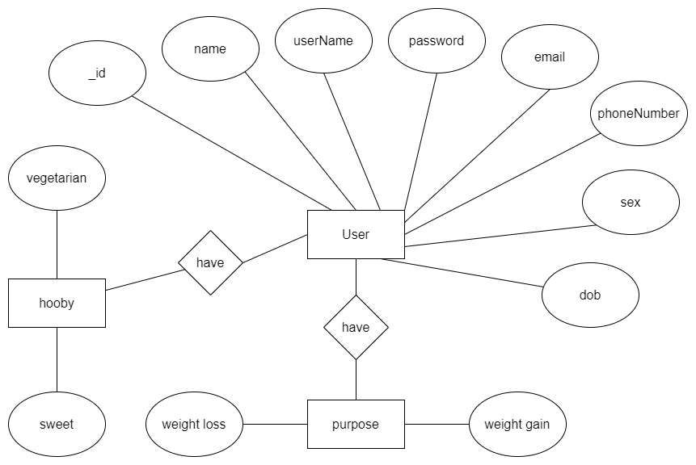

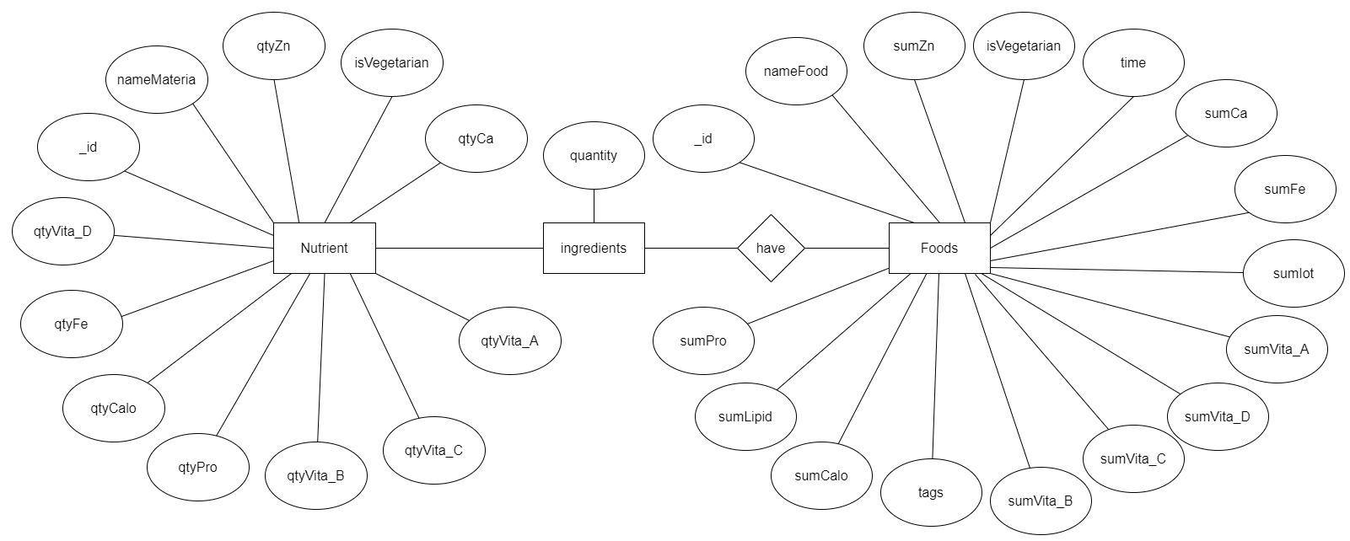

## Table Diagram:

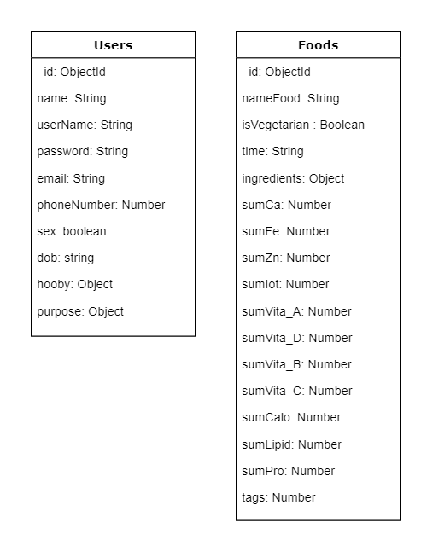

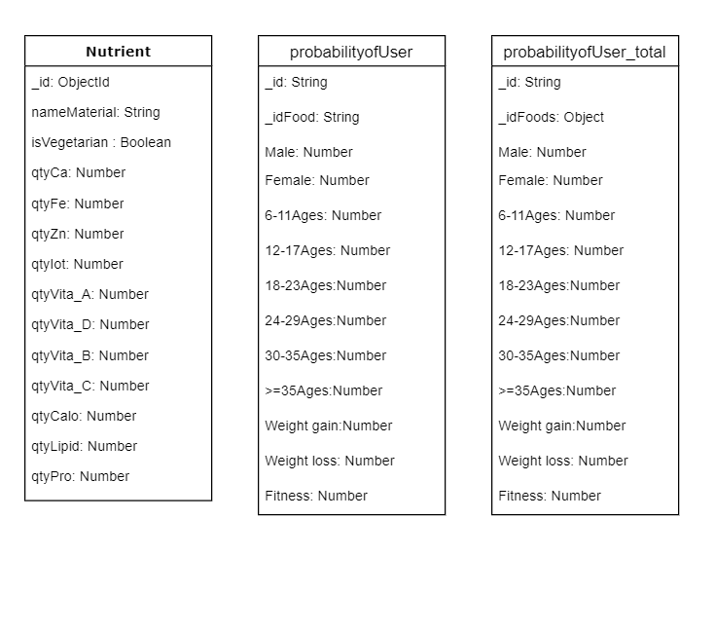

## Detail

### Users:

**This includes the attribute:**

**users**

|  |  |  |  |  |  |
| --- | --- | --- | --- | --- | --- |
| **Attributes** | **Datatype** | **Null** | **Key** | **Default** | **Extra** |
| _id | string | not | PK |  | R |
| name | string |  |  |  |  |
| userName | string |  |  |  |  |
| Password | string | not |  |  |  |
| email | string | not |  |  |  |
| phoneNumber | string |  |  |  |  |
| sex | boolean |  |  |  |  |
| dob | string |  |  |  |  |
| hooby | number |  |  |  |  |
| purpose | object |  |  |  |  |

### Foods

**This includes the attribute:**

**Foods**

|  |  |  |  |  |  |
| --- | --- | --- | --- | --- | --- |
| **Attributes** | **Datatype** | **Null** | **Key** | **Default** | **Extra** |
| _id | string | not | PK |  | R |
| nameFood | string | not |  |  |  |
| isVegetarian | boolean |  |  |  |  |
| Time | string |  |  |  |  |
| ingredients | object |  |  |  |  |
| sumCa | number |  |  |  |  |
| sumFe | number |  |  |  |  |
| sumZn | number |  |  |  |  |
| sumIot | number |  |  |  |  |
| sumVita_A | number |  |  |  |  |
| sumVita_D | number |  |  |  |  |
| sumVita_B | string |  |  |  |  |
| sumVita_C | number |  |  |  |  |
| sumCalo | number |  |  |  |  |
| sumLipid | number |  |  |  |  |
| sumPro | number |  |  |  |  |
| tags | number |  |  |  |  |

**Nutrient**

|  |  |  |  |  |  |
| --- | --- | --- | --- | --- | --- |
| **Attributes** | **Datatype** | **Null** | **Key** | **Default** | **Extra** |
| __id | string | not | PK |  | R |
| nameMaterial | string | not |  |  |  |
| isVegetarian | boolean |  |  |  |  |
| Time | string |  |  |  |  |
| ingredients | object |  |  |  |  |
| qtyCa | number |  |  |  |  |
| qtyFe | number |  |  |  |  |
| qtyZn | number |  |  |  |  |
| qtyIot | number |  |  |  |  |
| qtyVita_A | number |  |  |  |  |
| qtyVita_D | number |  |  |  |  |
| qtyVita_B | string |  |  |  |  |
| qtyVita_C | number |  |  |  |  |
| qtyCalo | number |  |  |  |  |
| qtyLipid | number |  |  |  |  |
| qtyPro | number |  |  |  |  |

### probabilityofUser

**This includes the attribute:**

**probabilityofUser**

|  |  |  |  |  |  |
| --- | --- | --- | --- | --- | --- |
| **Attributes** | **Datatype** | **Null** | **Key** | **Default** | **Extra** |
| _id | string | not | PK |  | R |
| _idFood | string | not |  |  |  |
| Male | number | not |  |  |  |
| Female | number | not |  |  |  |
| 6-11Ages | number | not |  |  |  |
| 12-17Ages | number | not |  |  |  |
| 18-23Ages | number | not |  |  |  |
| 24-29Ages | number | not |  |  |  |
| 30-35Ages | number | not |  |  |  |
| >=35Ages | number | not |  |  |  |
| Weight gain | number | not |  |  |  |
| Weight loss | number | not |  |  |  |
| Fitness | number | not |  |  |  |

**probabilityofUser_total**

|  |  |  |  |  |  |
| --- | --- | --- | --- | --- | --- |
| **Attributes** | **Datatype** | **Null** | **Key** | **Default** | **Extra** |
| _id | string | not | PK |  | R |
| _idFood | string | not |  |  |  |
| Male | number | not |  |  |  |
| Female | number | not |  |  |  |
| 6-11Ages | number | not |  |  |  |
| 12-17Ages | number | not |  |  |  |
| 18-23Ages | number | not |  |  |  |
| 24-29Ages | number | not |  |  |  |
| 30-35Ages | number | not |  |  |  |
| >=35Ages | number | not |  |  |  |
| Weight gain | number | not |  |  |  |
| Weight loss | number | not |  |  |  |
| Fitness | number | not |  |  |  |

# **Database Design for Sprint 2:**

## Schema Overview:

|  |  |  |
| --- | --- | --- |
| **No** | **Schema name** | **Short Description** |
| 1 | users | This table contains the information about users |
| 2 | foods | This table contains the information about the listed foods on the system |
| 3 | nutrients | This table contains the nutrient information of each ingredient |
| 4 | menus | This table contains the menu information of each user |

## Entity Relationship Diagram:





## Table Diagram:

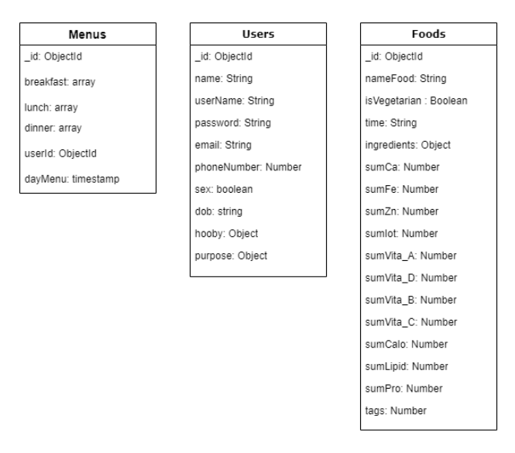



## Detail

### Users:

**This includes the attribute:**

**users**

|  |  |  |  |  |  |
| --- | --- | --- | --- | --- | --- |
| **Attributes** | **Datatype** | **Null** | **Key** | **Default** | **Extra** |
| _id | string | not | PK |  | R |
| name | string |  |  |  |  |
| userName | string |  |  |  |  |
| Password | string | not |  |  |  |
| email | string | not |  |  |  |
| phoneNumber | string |  |  |  |  |
| sex | boolean |  |  |  |  |
| dob | string |  |  |  |  |
| hooby | number |  |  |  |  |
| purpose | object |  |  |  |  |

### Foods

**This includes the attribute:**

**Foods**

|  |  |  |  |  |  |
| --- | --- | --- | --- | --- | --- |
| **Attributes** | **Datatype** | **Null** | **Key** | **Default** | **Extra** |
| _id | string | not | PK |  | R |
| nameFood | string | not |  |  |  |
| isVegetarian | boolean |  |  |  |  |
| Time | string |  |  |  |  |
| ingredients | object |  |  |  |  |
| sumCa | number |  |  |  |  |
| sumFe | number |  |  |  |  |
| sumZn | number |  |  |  |  |
| sumIot | number |  |  |  |  |
| sumVita_A | number |  |  |  |  |
| sumVita_D | number |  |  |  |  |
| sumVita_B | string |  |  |  |  |
| sumVita_C | number |  |  |  |  |
| sumCalo | number |  |  |  |  |
| sumLipid | number |  |  |  |  |
| sumPro | number |  |  |  |  |
| tags | number |  |  |  |  |

**Nutrient**

|  |  |  |  |  |  |
| --- | --- | --- | --- | --- | --- |
| **Attributes** | **Datatype** | **Null** | **Key** | **Default** | **Extra** |
| __id | string | not | PK |  | R |
| nameMaterial | string | not |  |  |  |
| isVegetarian | boolean |  |  |  |  |
| Time | string |  |  |  |  |
| ingredients | object |  |  |  |  |
| qtyCa | number |  |  |  |  |
| qtyFe | number |  |  |  |  |
| qtyZn | number |  |  |  |  |
| qtyIot | number |  |  |  |  |
| qtyVita_A | number |  |  |  |  |
| qtyVita_D | number |  |  |  |  |
| qtyVita_B | string |  |  |  |  |
| qtyVita_C | number |  |  |  |  |
| qtyCalo | number |  |  |  |  |
| qtyLipid | number |  |  |  |  |
| qtyPro | number |  |  |  |  |

### ProbabilityofUser

**This includes the attribute:**

**probabilityofUser**

|  |  |  |  |  |  |
| --- | --- | --- | --- | --- | --- |
| **Attributes** | **Datatype** | **Null** | **Key** | **Default** | **Extra** |
| _id | string | not | PK |  | R |
| _idFood | string | not |  |  |  |
| Male | number | not |  |  |  |
| Female | number | not |  |  |  |
| 6-11Ages | number | not |  |  |  |
| 12-17Ages | number | not |  |  |  |
| 18-23Ages | number | not |  |  |  |
| 24-29Ages | number | not |  |  |  |
| 30-35Ages | number | not |  |  |  |
| >=35Ages | number | not |  |  |  |
| Weight gain | number | not |  |  |  |
| Weight loss | number | not |  |  |  |
| Fitness | number | not |  |  |  |

**probabilityofUser_total**

|  |  |  |  |  |  |
| --- | --- | --- | --- | --- | --- |
| **Attributes** | **Datatype** | **Null** | **Key** | **Default** | **Extra** |
| _id | string | not | PK |  | R |
| _idFood | string | not |  |  |  |
| Male | number | not |  |  |  |
| Female | number | not |  |  |  |
| 6-11Ages | number | not |  |  |  |
| 12-17Ages | number | not |  |  |  |
| 18-23Ages | number | not |  |  |  |
| 24-29Ages | number | not |  |  |  |
| 30-35Ages | number | not |  |  |  |
| >=35Ages | number | not |  |  |  |
| Weight gain | number | not |  |  |  |
| Weight loss | number | not |  |  |  |
| Fitness | number | not |  |  |  |

### Menus

**This includes the attribute:**

**Menu**

|  |  |  |  |  |  |
| --- | --- | --- | --- | --- | --- |
| **Attributes** | **Datatype** | **Null** | **Key** | **Default** | **Extra** |
| _ id | ObjectId | not | PK |  | R |
| _breakfast | Array | not |  |  |  |
| lunch | Array | not |  |  |  |
| dinner | Array | not |  |  |  |
| userId | String | not |  |  |  |
| Date | Date | not |  |  |  |

# **Database Design for Sprint 3:**

## Schema Overview:

|  |  |  |
| --- | --- | --- |
| **No** | **Schema name** | **Short Description** |
| 1 | users | This table contains the information about users |
| 2 | foods | This table contains the information about the listed foods on the system |
| 3 | menus | This table contains the menu information of each user |
| 4 | tokens | This table contains tokens for login verification |
| 5 | collections | This table contains the food collections of the users |

## Entity Relationship Diagram:

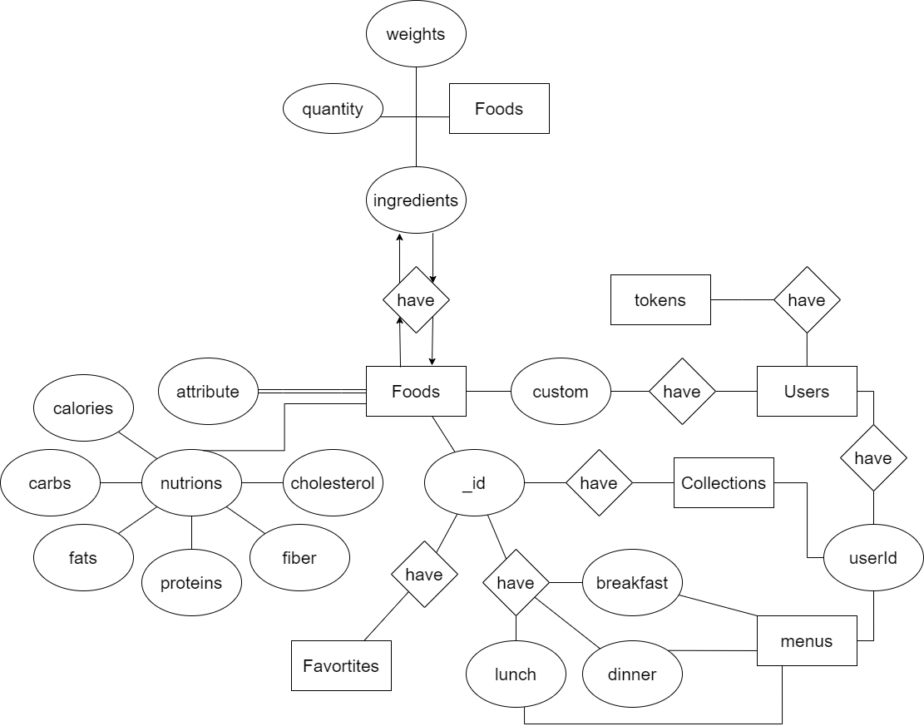

## Table Diagram:

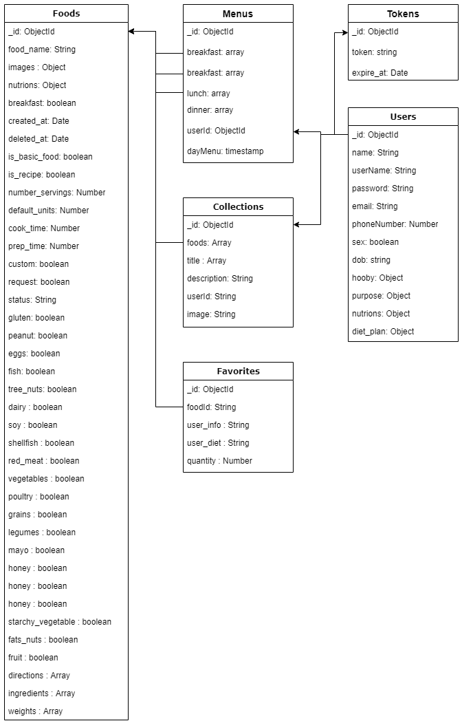

## Detail

### Users:

**This includes the attribute:**

**users**

|  |  |  |  |  |  |
| --- | --- | --- | --- | --- | --- |
| **Attributes** | **Datatype** | **Null** | **Key** | **Default** | **Extra** |
| _id | string | not | PK |  | R |
| name | string |  |  |  |  |
| userName | string |  |  |  |  |
| Password | string | not |  |  |  |
| email | string | not |  |  |  |
| phoneNumber | string |  |  |  |  |
| sex | boolean |  |  |  |  |
| dob | string |  |  |  |  |
| hooby | number |  |  |  |  |
| purpose | object |  |  |  |  |

### Foods

**This includes the attribute:**

**Foods**

|  |  |  |  |  |  |
| --- | --- | --- | --- | --- | --- |
| **Attributes** | **Datatype** | **Null** | **Key** | **Default** | **Extra** |
| _id | ObjectId | not | PK |  | R |
| id | number | not |  |  |  |
| food_name | string |  |  |  |  |
| images | object |  |  |  |  |
| nutrions | object |  |  |  |  |
| breakfast | boolean |  |  |  |  |
| created_at | Date |  |  |  |  |
| deleted_at | Date |  |  |  |  |
| is_basic_food | boolean |  |  |  |  |
| is_recipe | boolean |  |  |  |  |
| number_servings | number |  |  |  |  |
| default_units | number |  |  |  |  |
| cook_time | number |  |  |  |  |
| prep_time | number |  |  |  |  |
| custom | boolean |  |  |  |  |
| request | boolean |  |  |  |  |
| status | string |  |  |  |  |
| gluten | boolean |  |  |  |  |
| peanut | boolean |  |  |  |  |
| eggs | boolean |  |  |  |  |
| fish | boolean |  |  |  |  |
| tree_nuts | boolean |  |  |  |  |
| dairy | boolean |  |  |  |  |
| soy | boolean |  |  |  |  |
| shellfish | boolean |  |  |  |  |
| red_meat | boolean |  |  |  |  |
| vegetables | boolean |  |  |  |  |
| poultry | boolean |  |  |  |  |
| grains | boolean |  |  |  |  |
| legumes | boolean |  |  |  |  |
| mayo | boolean |  |  |  |  |
| honey | boolean |  |  |  |  |
| starchy_vegetables | boolean |  |  |  |  |
| fats_nuts | boolean |  |  |  |  |
| fruit | boolean |  |  |  |  |
| directions | Array |  |  |  |  |
| ingredients | Array |  |  |  |  |
| weights | Array |  |  |  |  |

### Tokens

**This includes the attribute:**

**Tokens**

|  |  |  |  |  |  |
| --- | --- | --- | --- | --- | --- |
| **Attributes** | **Datatype** | **Null** | **Key** | **Default** | **Extra** |
| _id | ObjectId | not | PK |  | R |
| token | string | not |  |  |  |
| expire_at | Date | not |  |  |  |

### Collections

**This includes the attribute:**

**Collections**

|  |  |  |  |  |  |
| --- | --- | --- | --- | --- | --- |
| **Attributes** | **Datatype** | **Null** | **Key** | **Default** | **Extra** |
| _ id | ObjectId | not | PK |  | R |
| foods | Array | not |  |  |  |
| title | Array | not |  |  |  |
| description | Array | not |  |  |  |
| userId | String | not |  |  |  |
| image | String | not |  |  |  |

### Favorites

**This includes the attribute:**

**Favorites**

|  |  |  |  |  |  |
| --- | --- | --- | --- | --- | --- |
| **Attributes** | **Datatype** | **Null** | **Key** | **Default** | **Extra** |
| _ id | ObjectId | not | PK |  | R |
| foodId | String | not |  |  |  |
| user_info | String | not |  |  |  |
| user_diet | String | not |  |  |  |
| quantity | number | not |  |  |  |

### Menus

**This includes the attribute:**

**Menu**

|  |  |  |  |  |  |
| --- | --- | --- | --- | --- | --- |
| **Attributes** | **Datatype** | **Null** | **Key** | **Default** | **Extra** |
| _ id | ObjectId | not | PK |  | R |
| breakfast | Array | not |  |  |  |
| lunch | Array | not |  |  |  |
| dinner | Array | not |  |  |  |
| userId | String | not |  |  |  |