

**International School**

**Capstone Project 2**

CMU-SE 451

**Project Plan**

**Version 1.4**

**Date:** **25th May 2021**

**Food Care**

**Submitted by**

Huynh Dac Vinh

Dang Van Duan

Tran Quoc Trung

Ton That Minh Huy

**Approved by**

**Proposal Review Panel Representative:**

NameSignature Date

**Capstone Project 2-Mentor:**

Name Signature Date

**Dang Viet Hung**

**PROJECT INFORMATION**

|  |  |  |  |
| --- | --- | --- | --- |
| **Project acronym** | FC | | |
| **Project Title** | Food Care | | |
| **Start Date** | 01 Mar, 2021 | **Start Date** | 25 May, 2021 |
| **Lead Institution** | International School, Duy Tan University | | |
| **Project Mentor** | Ph.D Hung, Dang Viet | | |
| **Scrum master / Project Leader & contact details** | Vinh, Huynh Dac  Email: dacvinh98@gmail.com  Tel: 0347191925 | | |
| **Partner Organization** |  | | |
| **Project Web URL** |  | | |
| **Team members** | Name | Email | Tel |
| 1 | Vinh, Huynh Dac | dacvinh98@gmail.com | 0347191925 |
| 2 | Trung, Tran Quoc | quoctrung.tran210@gmail.com | 0935420530 |
| 3 | Huy, Ton That Minh | tonthatminhh@gmail.com | 0935432561 |
| 4 | Duan, Dang Van | dangvanduan755@gmail.com | 0769710126 |

REVISION HISTORY

|  |  |  |  |  |
| --- | --- | --- | --- | --- |
| **Version** | **Date** | **Comments** | **Author** | **Approval** |
| 1.0 | 29/3/2021 | Initial Release | C2SE.18 team |  |
| 1.1 | 25/4/2021 | Updated Release | Dang Van Duan |  |
| 1.2 | 4/5/2021 | Updated Release | Tran Quoc Trung |  |
| 1.3 | 12/5/2021 | Updated Release | Ton That Minh Huy |  |
| 1.4 | 25/5/2021 | Final | Huynh Dac Vinh |  |
|  |  |  |  |  |

**Document Approval**

The following signatures are required for approval of this document

|  |  |  |
| --- | --- | --- |
| **Mentor** | Dang Viet Hung | Date: |
| **Scrum Master** | Huynh Dac Vinh | Date: |
| **Product Owner** | Tran Quoc Trung | Date: |
| **Team member** | Ton That Minh Huy | Date: |
| **Team member** | Dang Van Duan | Date: |

**TABLE OF CONTENTS**

1. PROJECT OVERVIEW 6
   1. Project Description 6
   2. Scope and Purpose 6
   3. Assumptions and Constraints 6
   4. Project Objectives 7
   5. Critical Dependencies 8
   6. Project Risk 8
2. PROJECT DEVELOPMENT APPROACH 9
   1. Project Process 9
   2. Requirement Change Management 9
   3. Product Integration Strategy 9
   4. Quality Management 10
   5. Unit Testing Strategy 12
   6. Integration Testing Strategy 13
   7. System Testing Strategy 13
3. ESTIMATE 14
   1. Size 14
   2. Effort 14
   3. Schedule 15
   4. Resource 17
   5. Infrastructure 17
   6. Training Plan 18
   7. Finance 18
4. PROJECT ORGANIZATION 20
   1. Organization Structure 20
   2. Project Team 20
   3. External Interfaces 22
5. COMMUNICATION & REPORTING 25
6. CONFIGURATION MANAGEMENT 27
7. SECURITY ASPECTS 28

# PROJECT OVERVIEW

## Project Description

|  |  |  |  |
| --- | --- | --- | --- |
| **Project code** | HDVT | **Contract type** | Internal Project |
| **Customer** | Teacher | **2nd Customer** | University |
| **Project Level** | Group | **Project rank** | A |
| **Group** | C2.SE18 | **Division** |  |
| **Project Type** | External | **Project Manager/ Scrum master** | Huynh Dac Vinh |
| **Project Category** | Captone2 | **Business domain** | Application |
| **Application type** | Website |  |  |

## Scope and Purpose

* Food Care is a system which allows users to build, adjust their own diet plan with the available food while having the nutrition calculated. User will also receive a warning if the chosen one do not match their body’s need.
* The system will also recommend diet for users that based on their information and target. Users can also adjust the given diet plan with their favorite food and the nutrition will be re-calculate.
* Users can provide feedback for the meal, food, or the combination of them, which will help the system give a more precise suggestion next time.

## Assumptions and Constraints

|  |  |  |
| --- | --- | --- |
| **No** | **Description** | **Note** |
| **Assumptions** | | |
| 1 | Provide nutrition according to the condition of all subjects (food, diets, ...) | Scope |
| 2 | Provide all ingredients information in the dish, the interface must be clear and easy to use | External Interfaces |
| 3 | Suggest the same menu for people with similar tastes and needs | Scope |
| **Constraints** | | |
| 1 | All sprint tasks must be completed as soon as possible before the sprint deadline | Schedule |
| 2 | Information security for users and Anti network attacks, altering data | Security |
| 3 | Define the correctness and transparency of the formula, Data and content must be clear and sourced | Safety |

## Project Objectives

* + 1. **Standard Objectives**

|  |  |  |  |  |
| --- | --- | --- | --- | --- |
| **Metrics** | **Unit** | **Committed** | **Re-committed** | **Note** |
| Start Date | 01-03-2021 |  |  |  |
| End Date | 25-5-2021 |  |  |  |
| Duration | 85 days |  |  |  |
| Maximum Team Size | 4 Persons |  |  |  |
| Billable Effort | 6 hours/ 5days/ 1 Month |  |  |  |
| Calendar effort | 6 hours/ 5days/ 1 Month |  |  |  |
| Effort Usage | 6 hours/ 5days/ 1 Month |  |  |  |

* + 1. **Specific Objectives**

Functional goals:

* + Works correctly
  + Don’t have conflict
  + Correct to the requirement

Strategic goals:

* + Satisfactory requirement documents
  + Bringing knowledge and health to users
  + Provide income for developers

Business goals:

* + Income is based on effort

Quality goals

* + Correct to the requirement

Organizational goals

* + Update later

Other goals

* + Update later

## Critical Dependencies

|  |  |  |  |
| --- | --- | --- | --- |
| **No** | **Dependency** | **Expected delivery date** | **Note** |
| 1 | Does not depend on another project |  |  |

## Project Risk

|  |  |  |  |  |
| --- | --- | --- | --- | --- |
| **Risk** | **Description** | **Probability** | **Impact** | **Mitigation Strategy** |
| **Estimates of project planning** | The plan may be delayed for the initial estimate of the project. | 1 | 1 | Analysis and assessment of the scale.  Reduce requirements. |
| **Not enough knowledge to implement the project** | Members' knowledge may or may not be consistent with their expertise | 2 | 2 | Spend more time for learning and training. |
| **Requirements** | Important requirements may be missing from the formal requirements specification. | 3 | 3 | Try to ensure to get as much of the requirements before we start development. |
| **Estimated project schedule** | Programming Languages and technology | 3 | 2 | Experience sharing used to reduce the research time. |
| **Technical processes** | The standard procedure cannot meet the requirements of specific solutions.  The new process may be required.  The process can be improved and more efficient. | 2 | 3 | Analysis of requirements and processes to ensure appropriate levels.  If the new process is needed, we need to evaluate this response has improved over the old process. |
| **Network** | Block by Limited Bandwidth | 4 | 4 | Upgrade transmission line network |
| **Time** | Project implementation period is too short, so our team cannot complete this project in a short time.  During project implementation, our team learns and has more work to do, our team cannot focus all their time to carry out this project. | 4 | 5 | Reduce time and increase individual personal time working in their stay on the 7th day and Sunday. |
| **Project Management** | Project management systems may not be sufficient to support the requirements of the project | 1 | 4 | Discuss with the group to offer solutions and consistent accuracy. |

# PROJECT DEVELOPMENT APPROACH

## Technical Process

## Reasons for selecting

This is the first time the whole group has worked together, with not much experience, and will surely encounter many difficulties in the development process. As for the traditional model we are not allowed to make mistakes but for our scrum it allows us to make mistakes, through each sprint we will discuss, test and adjust to work better.

Scrum process is a flexible development model so in this project we think it is suitable for workflow creation and communication among members.

## Agile Methodology

**Definition**:

* Agile methodology is a type of project management process, mainly used for software development, where demands and solutions evolve through the collaborative effort of self-organizing and cross-functional teams and their customers. It is a collection of principles that value adaptability and flexibility. Agile aims to provide better responsiveness to changing business needs and focuses on enabling teams to deliver in workable increments.

**Process:**

* **Concept**: Projects are envisioned and prioritized
* Inception: Team members are identified, funding is put in place, and initial environments and requirements are discussed
* Iteration/Construction: The development team works to deliver working software based on iteration requirements and feedback
* Release: QA (Quality Assurance) testing, internal and external training, documentation development, and final release of the iteration into production
* Production: Ongoing support of the software
* Retirement: End-of-life activities, including customer notification and migration

**Manifesto:**

* When the IT industry talks about the Scrum framework, It's also often we hear the term "Agile Scrum" along the same lines as "Scrum". It led some of us in the industry to think and look for differences between the terms "Agile Scrum" and "Scrum".
* We have discovered a better way to develop the software by doing it and helping others to do it.
* Individuals and interactions rather than processes and tools;
* Software that runs better is full documentation;
* Collaborate with customers rather than negotiate contracts;
* Respond to changes rather than stick to the plan.

**2.1.2.1. Scrum Process**

**Scrum Process**

* Scrum is an iterative and incremental agile software development framework for managing software projects and product or application development.
* Scrum focuses on project management institutions where it is difficult to plan ahead.
* Mechanisms of empirical process control, where feedback loops that constitute the core management technique are used as opposed to traditional command-and-control management.
* Its approach to planning and managing projects is by bringing decision-making authority to the level of operation properties and certainties.
* Scrum has three roles: product owner, scrum master and the development team members.

**Benefit of the methodology:**

* Project can respond easily to change.
* Problems are identified early.
* Customer gets most beneficial work first.
* Work done will better meet the customer’s needs.
* Improved productivity.
* Ability to maintain a predictable schedule for delivery.

## Quality Management

* + 1. **Estimates of Defects to be detected**

**Pre-release review defects**

|  |  |  |
| --- | --- | --- |
| **Process** | **Planned found by review** | **Actual found by review** |
| **Requirement** | 10 | 5 |
| **Design** | 10 | 20 |
| **Coding** | 40 | 20 |
| **Other** | 15 | 10 |
| Total | 75 | 55 |

**Pre-release test defects**

|  |  |  |
| --- | --- | --- |
| **Process** | **Planned found by review** | **Actual found by review** |
| **Requirement** | 10 | 5 |
| **Design** | 10 | 20 |
| **Coding** | 40 | 20 |
| **Other** | 15 | 10 |
| Total | 75 | 55 |

* + 1. **Measurements Program**

|  |  |
| --- | --- |
| **Strategy** | **Expected Benefits** |
| Do defect prevention using the standard defect prevention guidelines and process; use standards developed in ABC for coding. | 10–20% reduction in defect injection rate and about 2% improvement in productivity |
| Group review of program specs for first few/logically complex use cases.  Group review of design docs/first time-generated code by project leader, developer, and one consultant. | Improvement in quality as overall defect removal efficiency will improve; some benefits in productivity as defects will be detected early |
| Introduction of RUP methodology and implementing the project in iterations. Milestone analysis and defect prevention exercise will be done after each Iteration. | Approximately 5% reduction in defect injection rate and 1% improvement in overall productivity |

**2.2.3 Quality Control**

|  |  |  |  |
| --- | --- | --- | --- |
| **Review Item** | **Type of Review** | **Reviewer** | **When** |
| Project plan  Project schedule  CM Plan | Group review Group review  One-person review | Huynh Dac Vinh  Tran Quoc Trung  Ton That Minh Huy  Dang Van Duan | End of Initiation stage |
| Business analysis and requirements specification document, Use Case catalog | Group review | Huynh Dac Vinh  Tran Quoc Trung | 90% |
| Design document, object model | Group review | Huynh Dac Vinh  Tran Quoc Trung  Ton That Minh Huy  Dang Van Duan | End of 90% design |
| Stage plans | One-person review | Huynh Dac Vinh  Tran Quoc Trung | Beginning of each stage |
| Complex/first specs incl. diagramstime test generated cases, program interactive | Group review | Huynh Dac Vinh  Tran Quoc Trung  Ton That Minh Huy  Dang Van Duan | End of detailed design |
| Code | Group review | Huynh Dac Vinh  Tran Quoc Trung  Ton That Minh Huy  Dang Van Duan | After coding for first few programs |

**2.2.4 Measurements Program**

|  |  |  |  |
| --- | --- | --- | --- |
| **Data to be collected** | **Purpose** | **Responsible** | **When** |
| Size: No. of KLOC// FP |  | PM/SM | At the end of stages |
| Effort: No. person-day |  | Team members | Daily |
| Quality: No. defects detected |  | Reviewer, Tester | Right after the review/test |
| Schedule |  | PM/SM | Weekly and at the end of stages |

## Unit Testing Strategy

**Completion criteria:**

Completion criteria are stated to for two purposes:

* Identify acceptance criteria for product quality.
* Identify when the testing is successfully executed

A clear statement of completion criteria should include the following items:

* Function, behavior, or condition being measured
* Method of measurement

Criteria or degree of conformance to measurement

**Special considerations:**

This section should identify any influences or dependencies, which may impact or influence the test effort described in the test strategy. Influences might include:

Human resources (such as availability or need for non-test resources to support / participate in test)

Constraints, (such as equipment limitations or availability, or the need / lack of special equipment)

Special requirements, such as test scheduling or access to systems

Testing may be stopped when:

* It becomes unproductive
* It requires a certain coverage
* It requires a certain number of errors to be found
* Schedule time runs out

## Integration Testing Strategy

Using Big Bang Testing for an Integration testing approach in which all the components or modules are integrated together at once and then tested as a unit. This combined set of components is considered as an entity while testing. If all of the components in the unit are not completed, the integration process will not execute.

## System Testing Strategy

Participating in test cases of each function created in the test case document assesses whether the functions created by the programmers meet the set criteria or not and checks the integrity of the system

# ESTIMATION

## Size

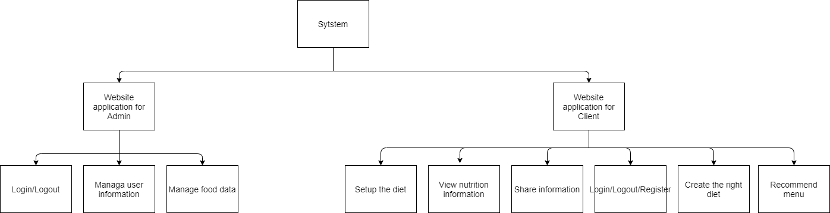

**3.2 Effort**

The Effort estimation is documented in Sprint Backlog

|  |  |  |  |  |  |  |  |  |
| --- | --- | --- | --- | --- | --- | --- | --- | --- |
| **Activity/Process** | **Total budgeted Effort Usage (pd)** | **Total % budgeted Effort Usage (%)** | **Stage 1/ Sprint 1** | | **Stage 2/ Sprint 2** | | **Stage 3 / sprint 3** | |
| **No.** | **%** | **No.** | **%** | **No.** | **%** |
| Requirement | 100 | 2.6% | 100 | 3.3% | 100 | 3.3% | 0 | 0% |
| Design | 800 | 20.5% | 300 | 7.7% | 350 | 9% | 150 | 3.8% |
| Coding | 1700 | 43.6% | 500 | 12.8% | 400 | 10.3% | 800 | 20.5% |
| Unit Testing | 150 | 3.9% | 50 | 1.3% | 50 | 1.3% | 50 | 1.3% |
| Testing | 400 | 10.2% | 100 | 2.6% | 100 | 2.6% | 200 | 5.1% |
| Deployment | 100 | 2.6% | 0 | 0% | 0 | 0 | 100 | 2.6% |
| Support for Acceptance Test | 90 | 2.3% | 30 | 0.8% | 30 | 0.8% | 30 | 0.8% |
| Project Planning | 90 | 2.3% | 30 | 0.8% | 30 | 0.8% | 30 | 0.8% |
| Project monitoring | 90 | 2.3% | 30 | 0.8% | 30 | 0.8% | 30 | 0.8% |
| Quality Assurance | 80 | 2.1% | 30 | 0.8% | 30 | 0.8% | 30 | 0.8% |
| Training | 300 | 7.6% | 100 | 2.6% | 100 | 2.6% | 100 | 2.6% |
| Total | 3900$ | 100% |  |  |  |  |  |  |

## 3.3. Schedule

**3.3.1. Project Milestone & Deliverables**

|  |  |  |  |  |
| --- | --- | --- | --- | --- |
| No | Milestones | Time | Product | Delivery |
| 1. | Initial | 01/03/2021 | Proposal document  Project Plan  User Story  Product Backlog  Architecture Design | Bringing many new ideas for the project, building the project structure more and more carefully |
| 2. | Development | 08/03/2021 | Database Design |  |
| 2.1 | Sprint1 | 08/03/2021 | Test Plan | Design, code login/logout/register UI and API for User |
| 2.2 | Sprint2 | 05/04/2021 | Test Case | - Design, code menu, add, remove food UI and API for User,  - Give ways to fix the process and affordable way of working for each member |
| 2.3 | Sprint3 | 03/05/2021 | Sprint Backlog, Meeting Document | Make Dashboard for Admin |
| 3. | Final Release | 29/05/2021 | Reflection Document | Evaluate the ability of each member |

**3.3.2.** **Work Breakdown Structure**

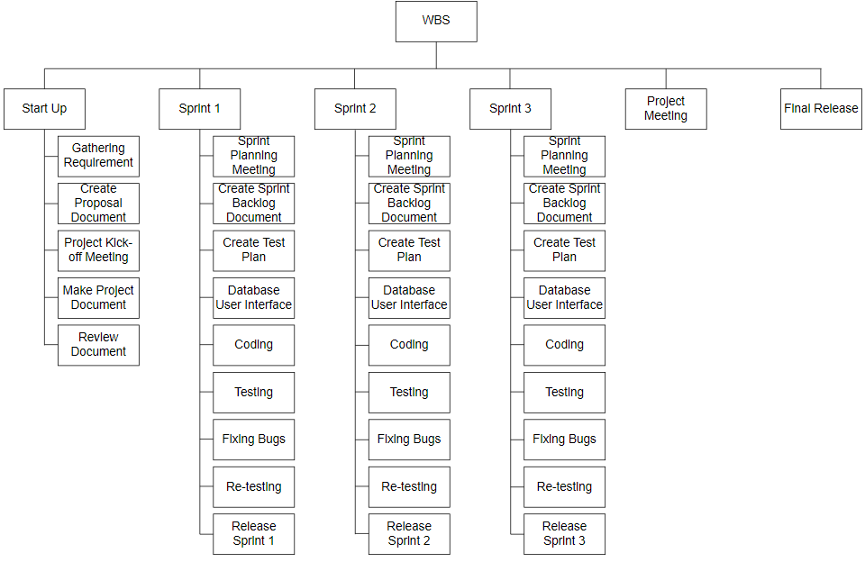

**3.3.3 Detailed Schedule**

|  |  |  |  |  |  |
| --- | --- | --- | --- | --- | --- |
| **No.** | **Task Name** | **Duration (Days)** | **Start** | **Finish** | **Assign to** |
| **1.** | **Initial** | 5 | 1/3 | 7/3 | All members |
|  |  |  |  |  |  |
| **2** | **Development** | 80 | 8/3 | 28/5 | All members |
| 2.1 | Sprint 1 | 28 | 8/3 | 4/4 | All members |
|  |  |  |  |  |  |
| 2.2 | Sprint 2 | 28 | 5/4 | 2/5 | All members |
|  |  |  |  |  |  |
| 2.3 | Sprint 3 | 21 | 3/5 | 23/5 | All members |
|  |  |  |  |  |  |
| **3** | **Close project** | 5 | 24/5 | 29/5 | All members |
|  | **Duration** | 90 | 1/3 | 29/5 | All members |

**3.3.4 Project Schedule**

|  |  |  |  |  |
| --- | --- | --- | --- | --- |
| **No** | **Activity** | **Start date** | **Responsible** | **Note** |
| **Defect Prevention** | | | | |
|  | Sprint 1 | 08/03/2021 |  |  |
|  | Sprint 2 | 05/04/2021 |  |  |
|  | Sprint 3 | 03/05/2021 |  |  |
| **Quality Control** | | | | |
|  | Review: Work Product 1 | 17/04/2021 |  |  |
|  | Review: Work Product 2 | 29/04/2021 |  |  |
| **Project Tracking** | | | | |
|  | Stage name milestone review meeting | 17/04/2021 |  |  |
|  | Stage name milestone review meeting | 29/04/2021 |  |  |
| **QA** | | | | |
|  | Final Inspection: Deliverable 1 | 01/06/2021 |  |  |
|  | Final Inspection: Deliverable 2 | 02/06/2021 |  |  |
|  | Baseline audit: Startup | 04/06/2021 |  |  |
|  | Baseline audit: Wrap-up |  |  |  |

## Resource

Specified as in the section *Project Team*

## 3.5 Infrastructure

|  |  |  |  |
| --- | --- | --- | --- |
| **Work/Product** | **Purpose** | **Expected Availability by** | **Note** |
| **Development Environment** | | | |
| NT Server | Operating System | Initiation stage |  |
| Mainframe | Operating System |  |  |
| Win NT | Operating System |  |  |
| DB2 | DBMS |  |  |
| Java Script | Development language for Web interface |  |  |
| Python | Development language for data collection |  |  |
| **Hardware & Software** | | | |
| 1GB space on server |  |  |  |
| Rational Rose | Design |  |  |
| **Other Tools** | | | |
| CVS | Source version control | Definition stage |  |
| Unit | Unit Test | Construction stage |  |
| DMS | Defect logging and tracking | Definition stage |  |
| Timesheet | Effort logging | Initiation stage |  |
| FI | Project management tool | Initiation stage |  |
| MS Project | Task tracking | Initiation stage |  |

## Training Plan

|  |  |  |  |
| --- | --- | --- | --- |
| **Training Area** | **Participants** | **When, Duration** | **Waiver Criteria** |
| Technical | | | |
| React JS framework | Huynh Dac Vinh | 14 days | If already trained |
| Python language | Ton That Minh Huy |  |  |
| Node JS framework | Tran Quoc Trung, Dang Van Duan | 14 days | If already trained |
| Business domain | | | |
| Banking | Huynh Dac Vinh | 7 days |  |
| Process | | | |
| Quality system | Huynh Dac Vinh | 3 hrs | If already trained |
| Configuration management | Huynh Dac Vinh | 2 hrs | If already trained for  python. For others, on-the- job training |
| Group review | Huynh Dac Vinh | 4 hrs | If already trained |
| Defect prevention |  | 4.5 hrs | Mandatory |
| React Js | Ton That Minh Huy  Huynh Dac Vinh | 8 hrs | If already trained |
| Connect Firebase | Ton That Minh Huy  Huynh Dac Vinh  Tran Quoc Trung  Dang Van Duan | 8 hrs | Mandatory |
| NodeJS | Tran Quoc Trung  Dang Van Duan | 8 hrs | Mandatory |

## Finance

|  |  |  |  |  |
| --- | --- | --- | --- | --- |
| **No.** | **Criteria** | **Price (USD)** | **Amount** | **Total (USD)** |
| 1 | Working hour | $2.5 | 1560 | $3900 |
| 2 | 3rd services | $200 | 1 | $200 |
|  | | | **Total** | $4100 |

**Table 2: Cost Description**

|  |  |  |
| --- | --- | --- |
| **Description** | **Amount** | **Unit** |
| Number of members | 4 | Person |
| Number of working-day per week | 6 | Hour |
| Number of working-hour per week | 2.5 | Dollar |
| The cost per member per week | 3 | Month |
| The duration of the project | 65 | Day |
| The number of working days | 200 | USD |

* **Explain:**
* Amount of working hours = 4 members * 4 hours * 65 weeks.
* **Overall**:
* Resource: 4 peoples
* Budget: $4100
* Time: The project must be completed within 3 months
* Area: Vietnam

|  |  |  |  |  |  |
| --- | --- | --- | --- | --- | --- |
| **Item** | **Total Budget ($)** | **% Budget** | **SPRINT 1** | **SPRINT 2** | **SPRINT 3** |
| Purchases (COST) | 4100 | 100% | 1367 | 1367 | 1367 |
| Team building | 0 | 0 | 0 | 0 | 0 |
| Tools | 0 | 0 | 0 | 0 | 0 |
| Travel costs | 0 | 0 | 0 | 0 | 0 |
| Training | 0 | 0 | 0 | 0 | 0 |
| Review activities | 0 | 0 | 0 | 0 | 0 |
| Other | 0 | 0 | 0 | 0 | 0 |
| Total | 4100 | 100 | 0 | 0 | 0 |

# PROJECT ORGANIZATION

## Organization Structure

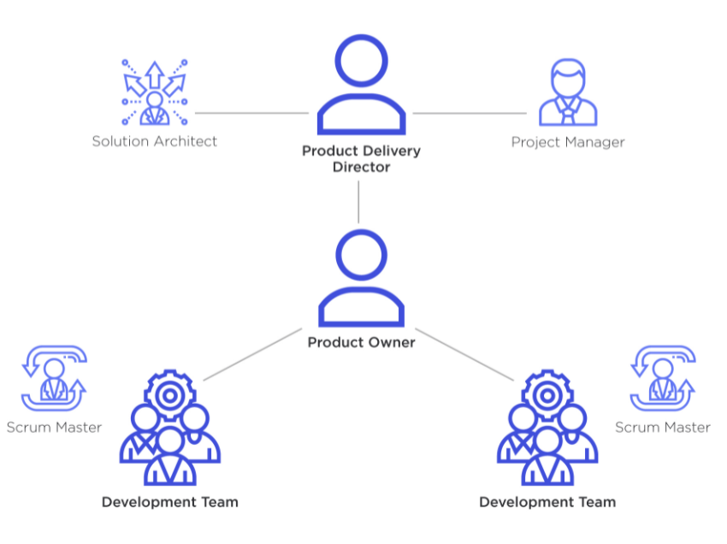

## Project Team

|  |  |  |
| --- | --- | --- |
| **Role** | **Responsibility** | **Name** |
| **Scrum Master** | * Communicate the value of Scrum * Teach the organization on Scrum to maximize business value * Attend all Scrum meetings * Preserve the integrity and spirit of the Scrum framework * Maintain the focus of the Team and facilitate efforts to resolve them * Serve as a coach and mentor to members of the Team * Respectfully hold the Team, Product Owner and Stakeholders accountable for their commitments * Continually work with the Team and business to find and implement improvements * As a timekeeper * Record team meeting   Make the Team aware of impediments | Vinh, Huynh Dac |
| **Product Owner** | - A spokesperson for the customer and needs to represent them | Trung, Tran Quoc |
| **Developer** | - Responsible for quality  - Responsible for delivering the potentially shippable product of the Application each sprint  - Report progress based on the remaining time  - Self-organized  - Owns the Sprint backlog | All  members |
| **Tester** | * Do the Test plan * Creation of test designs, test processes, test cases and test data. * Carry out testing as per the defined procedures. * Graph the results and make sure people know when test results decline. * Prepare all reports related to software testing carried out. * Analysis and evaluate the Test result. * Ensure that all tested related work is carried out as per the defined standards and procedures. | All Members |
| **Mentor** | * Guide on the process. * Monitoring all activities of the Team. * Help with anything. * Reviews project documents   - Reviews product | Viet Hung Dang, Ph.D |

# COMMUNICATION & REPORTING

***Communication Methodology.***

|  |  |  |  |
| --- | --- | --- | --- |
| **Audience/Attendees** | **Topic/ Deliverable** | **Frequency** | **Method** |
| **Mentor and Team member** | | Project Progress Review | Weekly | Zoom Meeting, Face to Face |
| **Team Member** | | Project Progress Review and Daily Meeting | Daily | Email, Facebook, Zoom Meeting, Slack |

**Communication and Report.**

|  |  |  |  |
| --- | --- | --- | --- |
| **Audience / Attendees** | **Topic / Deliverable** | **Frequency** | **Method** |
| Scrum Master, Members | Daily meeting | Daily | Face to Face / Zoom Meeting / Facebook Chat / Slack |
| Scrum Master, Members | Sprint Planning Meeting | When starting a sprint | Face to face / Zoom Meeting |
| Scrum Master, Members, Mentor | Sprint Review Meeting | When finishing a sprint | Face to face / Zoom Meeting |
| Scrum Master, Members | Sprint Retrospective | When the sprint review finish | Face to face/ Zoom Meeting |
| Scrum Master, Members | Individual Meeting | When need | Face to face / Message / |
| Scrum Master, Members, Mentor | Working report, review problems | Once a week | Face to face / Facebook Chat / Slack |

# CONFIGURATION MANAGEMENT

Refer to the CM plan or insert here the contents of the CM plan as appropriated

# SECURITY ASPECTS

* Use authentication to ensure user data integrity
* Encrypting user data to avoid stolen data, decrypting data is also extremely difficult, takes a lot of computational resources and takes a lot of time.
* Do not disclose important documents to the outside

**REFERENCES**

* Provide a complete list of all documents and other sources of information referenced in this Plan.
* Identify each referenced document by title, report number, date, author and publishing organization.
* Identify other referenced sources of information, such as electronic files, using unique identifiers such as path/name, date and version number.

### DEFINITIONS AND ACRONYMS

Define, or provide references to documents or annexes containing the definition of all terms and acronyms required to properly understand this Plan.

|  |  |  |
| --- | --- | --- |
| **Acronym** | **Definition** | **Note** |
| PM | Project Manager |  |
| PTL | Project Technical Leader |  |
| QA | Quality Assurance Officer |  |
| CC | Infrastructure Configuration Controller |  |
| DV | Developer |  |
| URD | User Requirement Document |  |
| SRS | Software Requirement Specification |  |
| ADD | Architecture Design Document |  |
| DDD | Detail Design Document |  |
| TP | Test Plan |  |
| TC | Test Case |  |
| SC | Source Code |  |
| CM | Configuration Management |  |
| CSCI | Computer Software Configuration Items |  |
| CI | Configuration Item |  |
| CCB | Change Control Board |  |
| UI | User Interface |  |
| NE | Node express |  |
| CSV | Comma Separated Values |  |
| Axios | HTTP client |  |
| JWT | JSON Web Token |  |
| Heroku | Cloud Application Platform |  |
| Mongoose | a MongoDB object modeling tool |  |
| WC | Web crawling |  |
| WS | Web Scraping |  |