**International School**

**Capstone Project 2**

CMU-SE 451

**Proposal**

**Version 1.1**

**Date: 22nd May, 2021**

**Food Care**

**Submitted by**

Huynh Dac Vinh  
 Tran Quoc Trung

Ton That Minh Huy

Dang Van Duan

**Approved by**

**Proposal Review Panel Representative:**

NameSignature Date

**Capstone Project 2-Mentor:**

Name Signature Date

**Dang Viet Hung**

**PROJECT INFORMATION**

|  |  |  |  |
| --- | --- | --- | --- |
| **Project acronym** | FC | | |
| **Project Title** | Food Care | | |
| **Start Date** | 01 Mar, 2021 | **End Date** | 25 May, 2021 |
| **Lead Institution** | International School, Duy Tan University | | |
| **Project Mentor** | Ph.D Hung, Dang Viet | | |
| **Scrum master / Project Leader & contact details** | Vinh, Huynh Dac  Email: dacvinh98@gmail.com  Tel: 0347191925 | | |
| **Partner Organization** |  | | |
| **Project Web URL** |  | | |
| **Team members** | Name | Email | Tel |
| 1 | Vinh, Huynh Dac | dacvinh98@gmail.com | 0347191925 |
| 2 | Trung, Tran Quoc | quoctrung.tran210@gmail.com | 0935420530 |
| 3 | Huy, Ton That Minh | tonthatminhh@gmail.com | 0935432561 |
| 4 | Duan, Dang Van | dangvanduan755@gmail.com | 0769710126 |

REVISION HISTORY

|  |  |  |  |  |
| --- | --- | --- | --- | --- |
| **Version** | **Date** | **Comments** | **Author** | **Approval** |
| 1.0 | 02/03/2021 | Initial Release | C2SE.18 team |  |
| 1.1 | 22/05/2021 | Final | Vinh, Huynh Dac |  |
|  |  |  |  |  |

**Document Approval**

The following signatures are required for approval of this document

|  |  |  |
| --- | --- | --- |
| **Mentor** | Dang Viet Hung | Date: |
| **Scrum Master** | Huynh Dac Vinh | Date: |
| **Product Owner** | Tran Quoc Trung | Date: |
| **Team Member** | Ton That Minh Huy | Date: |
| **Team Member** | Dang Van Duan | Date: |

**Contents**

**1. Introduction** 2

**2. Problem Definition** 2

**3. Current Status of Art** 2

**4. Engineering Approach** 3

**4.1. System Context Overview** 3

**4.2. System Context Description** 3

**4.3. Technical Proposal** 4

**4.3.1. Technical to develop the system:** 4

**4.3.2. Supported Environment:** 4

**5. Tasks and Deliverables** 5

**6. Project Management** 6

**6.1. Cost/Budget for Project** 6

**6.2. Tentative Schedule** 7

**7. Project Constraints** 8

**8. Conclusion** 10

**9. References** 10

**10. Attachment:** 10

# **1. Introduction**

Food Care is a system that allows users to build, adjust their own diet plan with the available food while having the nutrition calculated. Users will also receive a warning if the chosen one does not match their body’s needs.

The system will also recommend a diet for users based on their information and target. Users can also adjust the given diet plan with their favorite food and the nutrition will be re-calculated.

Users can provide feedback for the meal, food, or the combination of them, which will help the system give a more precise suggestion next time.

# **2. Problem Definition**

Currently, there are many different diets for different body conditions, and most of them are unofficial, so it is hard to find, and gather the most accurate one.

In some cases, a person needs to avoid specific ingredients, such as food allergy, or religious reasons, so each meal must be broken down apart and have many labels.

The system needs various amounts of food in order to give users different options, so the meal will not be repeated.

The information about each meal needs to be entered and calculated carefully in order to give users the most accurate nutrition they absorb.

# **3. Current Status of Art**

Up till now, there are many websites or app about the auction system online such as:

⦁ **CookPad**: This is an application that allows users to share the dishes users know with others. Others will rate and react to the food you share. Users can save these recipes and practice later.

This application is very good for the community, but it does not indicate the nutritional components of each dish, does not calculate the number of nutrients needed by the body for each person. It's more like a social network sharing recipe than a website that tailors and organizes a suitable diet.

⦁ **MyNetDiary**: This is a great app that allows users to track their weight changes through a diet that you organize yourself or an app that organizes for you. It also shows calories from each meal as well as calculates to balance calorie intake and consumption appropriately.

MyNetDiary has many outstanding features, but unfortunately, those features require a pretty high fee. For those who do not spend a lot of time thinking about what they will eat tonight to have stable health, paying such a large sum is not feasible. Therefore, the range of users using the application will be limited.

With Food Care, users are free to build their own meals or receive a suggested one and adjust them based on their hobbies and habits. In any case, the nutrition will always be calculated and users will be given a warning if the meal does not meet the requirements for nutritional content.

The system will also provide stores to buy the cooked meal in case users are too busy to prepare and cook.

# **4. Engineering Approach**

## **4.1. System Context Overview**

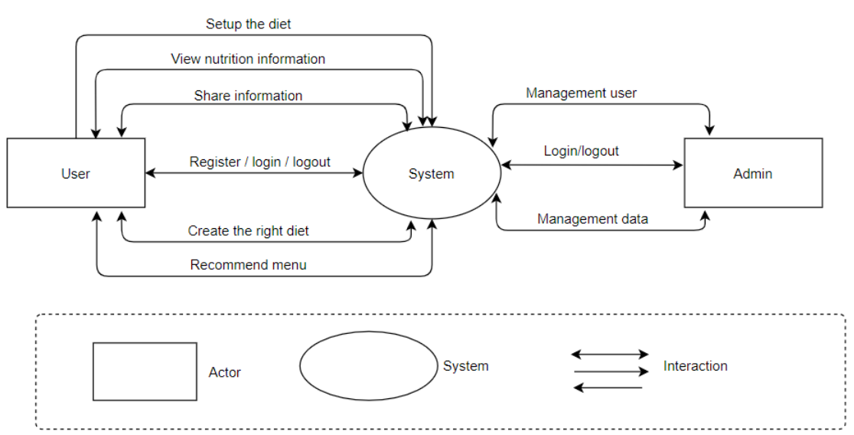

## **4.2. System Context Description**

The User, they can:

- Register an account, log in to the system, and log out of the system.

- Setup their diet by themselves.

- Search for food, view its information

- Build their own menu.

- Get the recommended menu from the system.

- Enter, view, update their information.

- Get recommended stores for the food.

- Provide feedback for menu/ food.

The Admin, they can:

- Log in, log out to the system.

- Manage User (active, deactivate).

- Manage food (add, delete, adjust).

## **4.3. Technical Proposal**

### **4.3.1. Technical to develop the system:**

Operating System: Linux (Ubuntu:1804), Windows 10 Pro

Development Tools: Visual Studio Code, Sublime Text, Git,

Robo3T Version Control System: GitHub

Language: JavaScript (ECMAScript 6), HTML5,

CSS3 Framework: Express JS

Database: MongoDB

Platform: Node Js:8.0 or upper

### **4.3.2. Supported Environment:**

Operating System: Linux, Windows, Android

Web browsers: Chrome, Coc Coc, Microsoft Edge

# **5. Tasks and Deliverables**

|  |  |  |  |  |
| --- | --- | --- | --- | --- |
| **No** | **Phase** | **Task Description** | **Deliverables** | **Responsible** |
| 1 | Product Planning | - Scrum Master to make a new product planning document.    + Environmental Landscape    + Product Requirement    + Specification Requirement    + Value Proposition | - Fundamental document for product.    + Proposal    + Project Plan  - To provide all functions. | Product Owner |
| 2 | Specification & Features | - Scrum Master to share Project planning deck to each function.  - Make a detail specification and features for product | - Project approval deck  - Functional Requirement deck    + User Story    + Architecture Document    + Database Document   + Product Backlog | Product Owner, Scrum Master, Development Team |
| 3 | Design & Development | - Development Team to develop a project following the Scrum Process  - Preparing a backend infrastructure to operate new product  - Making Product | - Development plan    + Sprint Backlog    + Test Plan  - Product | Product Owner,  Development Team |
| 4 | Testing & Deployment | - Development Team testing  - Beta Trials  - Preparing to produce the product | - Development Team test report     + Test Report Document  - Packaging/ Delivery Plan | Product Owner,  Development Team |

# **6. Project Management**

## **6.1. Cost/Budget for Project**

|  |  |  |  |  |
| --- | --- | --- | --- | --- |
| **NO** | **Criteria** | **Price (USD)** | **Amount** | **Total (USD)** |
| 1 | Working hour | $2.5 | 1560 | $3900 |
| 2 | 3rd services | $200 | 1 | $200 |
| **Total cost** | | | | $4100 |

|  |  |  |
| --- | --- | --- |
| Description | Amount | Unit |
| Number of members | 4 | Person |
| Number of working hours per day | 6 | Hour |
| The cost of working per hour per person | 2.5 | Dollar |
| The duration of the project | 3 | Month |
| The number of working days | 65 | Day |
| The cost for 3rd services | 200 | USD |

- Explain:

+ Amount of working hours = 4 members * 4 hours * 65 days.

- Overall:

+ Resource: 4 people

+ Budget: $4100

+ Time: The project must be completed within 3 months

+ Are: Vietnam

**6.2. Tentative Schedule**

**Schedule**

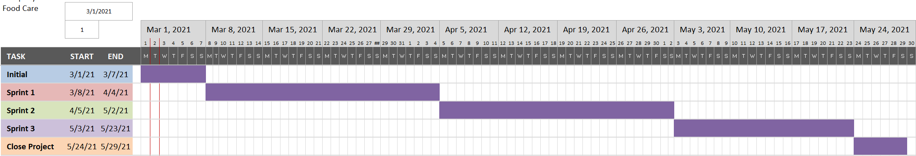

**Scrum Process**

- 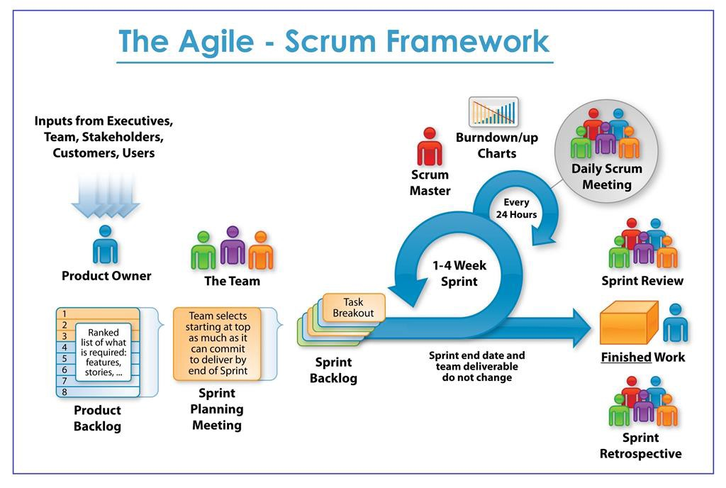Scrum is an iterative and incremental agile software development framework for managing software projects and product or application development.

- Scrum focuses on project management institutions where it is difficult to plan ahead.

- Mechanisms of empirical process control, where feedback loops that constitute the core management technique are used as opposed to traditional command-and-control management.

- Its approach to planning and managing projects is by bringing decision-making authority to the level of operation properties and certainties.

- Benefit of the methodology:

+ Project can respond easily to change.

+ Problems are identified early.

+ Customers get the most beneficial work first.

+ Work done will better meet the customer’s needs.

+ Improved productivity.

+ Ability to maintain a predictable schedule for delivery.

|  |  |
| --- | --- |
| **Full Name** | **Position** |
| Dang Viet Hung | Mentor |
| Huynh Dac Vinh | Scrum master/ Developer |
| Tran Quoc Trung | Product owner/ Developer |
| Ton That Minh Huy | Developer/ Tester |
| Dang Van Duan | Developer/ Tester |

# **7. Project Constraints**

|  |  |  |
| --- | --- | --- |
| **Constraint** | **Constraints Description** | **Guidelines for Acceptance** |
| **Economic** | Developer’s salary, hosting service, tax, cooperation fee, marketing fee.  Later on, we can make money from providing ads from the store or suggest the one sell the food. | Elements for consideration are design costs, production costs, maintenance costs, operating costs, and sales price |
| **Environmental** | -People these days have paid too much attention to working and making money, some really want to have a good diet but they do not have enough time for it. That the reason why we want to create this system, which allows user to have their own diet based on their need.  -This system may change the way people use their meals in certain locations, so the price of specific food may rise. That may lead to goods imbalance. The good side is people will have healthy eating without putting too much time into planning and calculation. -We focus on 3 group of people: people who want a healthy and diversity diet, people who want to build shape, and people who need to follow specific diet (vegetarian, allergy) | Impact of the design on the environment as well as impact of the environment (e.g. temperature range, humidity, vibration, electromagnetic interference immunity, and shock) on the design should be considered. Design for recycling and design to use recycled materials should also be considered |
| **Ethical** | Users’ id will be encrypted, food will be labeled with specific requirements, not with id. | Ethical considerations can be broad. Areas that are typically addressed include intellectual property, reverse- engineering, privacy, security, and the conflict between cost and safety |
| **Public health, safety, and welfare** | The food information might be too large to gather and have to verify its correctness. There are too many diets for each target, and not all of them are official.  Food, and meal in the system must be strictly censored. The one provided by the stores must have quality assurance by the store itself. | Includes safety standards as well as impact of the design on users (for example, electrical or physical hazards) |
| **Social and Global** | Users will receive diets tailored to specific requirements. | Addresses aspects such as benefits, risks, the man-machine interface, the acceptance of products by the intended user or by society at large, global and socially responsible engineering. |
| **Cultural** | In some cultures, people will either refer to cook by themselves or eat out, they also have different eating habits.  We will provide local stores rather than one which too far away. | Which cultural characteristics could influence the approach?  How do the design from different cultures differ? |
| **Sustainability** | With the design, the system can be easily expanded with more food and stores, we can also provide a platform for users to share their diet and give advice to others.  On the other hand, there are many systems with similar ideas on the market, they have various numbers of meals as well as recipes. But our one supports a wide range of users with different needs. | Refers to sustainability of resources, including material, energy, supplies, manufacturing techniques, personnel, operation, and the need for additional infrastructure, as well as sustainability of the design including reliability, lifetime, durability, reusability, maintainability. |

# **8. Conclusion**

- Food Care is a system for anyone who wants a healthy diet, or for a specific purpose, or simply wants to diversify their daily meals. It focuses on convenience, targets each user’s requirement, and evolves by itself.

- We build the system using JavaScript and its framework.

- App support will be available after the web is ready.

# **9. References**

• Software Development Standards for the Guidance and Control Software Project (https://sw-eng.larc.nasa.gov/)

• General Software Coding Standards and Guidelines (https://www.nws.noaa.gov/oh/hrl/developers_docs/General_Software_Standar ds.pdf)

• Scrum and best practices

(https://docs.microsoft.com/en-us/azure/devops/boards/sprints/best-practices-scrum?view=azure-devops)

• The Scrum Guide (https://www.scrum.org/resources/scrum-guide)

o The ISO/IEC & IEEE/EIA Standard 12207, IEEE standards: IEEE-829, IEEE-1008, IEEE-1012

o Requirement

# **10. Attachment:**

DESCRIPTION OF PRODUCT REQUIREMENTS FORM