**International School**

**Capstone Project 2**

CMU-SE 451

**User Interface Design**

**Version 1.2**

**Date: 25nd May, 2021**

**Food Care**

**Submitted by**

Huynh Dac Vinh  
 Tran Quoc Trung

Ton That Minh Huy

Dang Van Duan

**Approved by**

**Proposal Review Panel Representative:**

NameSignature Date

**Capstone Project 2-Mentor:**

Name Signature Date

**Dang Viet Hung**

**PROJECT INFORMATION**

|  |  |  |  |
| --- | --- | --- | --- |
| **Project acronym** | FC | | |
| **Project Title** | Food Care | | |
| **Start Date** | 01 Mar, 2021 | **End Date** | 25 May, 2021 |
| **Lead Institution** | International School, Duy Tan University | | |
| **Project Mentor** | Ph.D Hung, Dang Viet | | |
| **Scrum master / Project Leader & contact details** | Vinh, Huynh Dac  Email: dacvinh98@gmail.com  Tel: 0347191925 | | |
| **Partner Organization** |  | | |
| **Project Web URL** |  | | |
| **Team members** | Name | Email | Tel |
| 1 | Vinh, Huynh Dac | dacvinh98@gmail.com | 0347191925 |
| 2 | Trung, Tran Quoc | quoctrung.tran210@gmail.com | 0935420530 |
| 3 | Huy, Ton That Minh | tonthatminhh@gmail.com | 0935432561 |
| 4 | Duan, Dang Van | dangvanduan755@gmail.com | 0769710126 |

REVISION HISTORY

|  |  |  |  |  |
| --- | --- | --- | --- | --- |
| **Version** | **Date** | **Comments** | **Author** | **Approval** |
| 1.0 | 10/3/2021 | Initial Release | Ton That Minh Huy |  |
| 1.1 | 20/4/2021 | Updated document | Ton That Minh Huy |  |
| 1.2 | 25/5/2021 | Updated document | Ton That Minh Huy |  |
|  |  |  |  |  |

**Document Approval**

The following signatures are required for approval of this document

|  |  |  |
| --- | --- | --- |
| **Mentor** | Dang Viet Hung | Date: |
| **Scrum Master** | Huynh Dac Vinh | Date: |
| **Product Owner** | Tran Quoc Trung | Date: |
| **Team Member** | Ton That Minh Huy | Date: |
| **Team Member** | Dang Van Duan | Date: |

**Contents**

**1. Introduction:** 2

**1.1. Purpose** 2

**1.2. Scope:** 2

**2. List of User Interface for Sprint:** 2

**3. Describe User Interface for All** 4

**3.1. UI-01: Home page** 4

**3.2. UI-02: Login** 5

**3.3. UI-03: Register** 6

**3.4. UI-04: Update profile user** 7

**3.5. UI-05: Change password** 9

**3.6. UI-06: Browse food** 10

**3.7. UI-07: Profile (Edit status profile)** 11

**3.8. UI-08: Preferences (Meal & Layout)** 13

**3.9. UI-9: Preferences (Rate foods)** 14

**3.10. UI-10: Preferences (Diet & Nutrition)** 15

**3.11. UI-11: Preferences (Nutrition Profile Options)** 16

**3.12. UI-12: Preferences (Meal & Layout)** 17

**3.13. UI-13: Preferences (Add meals to the weekly planner)** 18

**3.14. UI-14: Preferences (Meal Settings)** 19

**3.15. UI-15: Collections** 20

**3.16. UI-16: Detail of collection** 21

**3.17. UI-17: Dashboard (Manage users)** 22

**3.18. UI-18: Dashboard (Manage foods)** 23

# **1. Introduction:**

## **1.1. Purpose**

This document describes the user interface of Food Care

## **1.2. Scope:**

Overview of the stages and modules of the software

Create complete interfaces, and describe them clearly

# **2. List of User Interface for Sprint:**

|  |  |  |  |
| --- | --- | --- | --- |
| Roles | User Interface ID | UI Name | Description |
| All | UI-01 | Homepage | The screen is used for showing all information about the system. |
| All | UI-02 | Login | The screen is used for login into the system. |
| User | UI-03 | Register | The screen is used for user register account into the system. |
| User | UI-04 | Edit profile | The screen is used for user edit profile into the system. |
| User | UI-05 | Change password | The screen is used for user change password account into the system. |
| User | UI-06 | Browse food | The screen is used to show list foods |
| User | UI-07 | Edit status profile | The screen is used for user edit status profile into the system. |
| User | UI-08 | Preferences (Meal & Layout) | The screen is used for user edit user’s meal into the system. |
| User | UI-09 | Preferences (Rate foods) | The screen is used for user rate foods into the system. |
| User | UI-010 | Preferences (Diet & Nutrition) | The screen is used for user select Diet type into the system. |
| User | UI-011 | Preferences (Nutrition Profile Options) | The screen is used for user add new Diet into the system. |
| User | UI-012 | Preferences (Meal & Layout) | The screen is used for user edit user’s meal into the system. |
| User | UI-013 | Preferences (Add meals to the weekly planner) | The screen is used for user add new meal into the system. |
| User | UI-014 | Preferences (Meal Settings) | The screen is used for user update meal into the system. |
| User | UI-015 | Collections | The screen is used for user see all collections into the system. |
| User | UI-016 | Detail of collection | The screen is used for user see collection’s detail into the system. |
| Admin | UI-017 | Dashboard (Manage users) | The screen is used for admin manage user into the system. |
| Admin | UI-018 | Dashboard (Manage foods) | The screen is used for admin manage foods into the system. |

# **3. Describe User Interface for All**

## **3.1. UI-01: Home page**

*Figure 1: Homepage*

|  |  |  |  |  |
| --- | --- | --- | --- | --- |
| **From** | **Condition** | **Null** | **Control Type** | **Target** |
| 1 | View |  | Section | Display homepage |

## **3.2. UI-02: Login**

*Figure 2: Login*

5

6

4

3

2

1

|  |  |  |  |  |
| --- | --- | --- | --- | --- |
| **From** | **Condition** | **Null** | **Control Type** | **Target** |
| 1 | Input |  | Textbox | Input user’s email |
| 2 | Input |  | Textbox | Input user’s password |
| 3 | Click |  | Link | Click to go register page |
| 4 | Click |  | Link | Click to go forgot password page |
| 5 | Click |  | Link | Click to agree remember login section |
| 6 | Click |  | Button | Click to login into the homepage |

## **3.3. UI-03: Register**

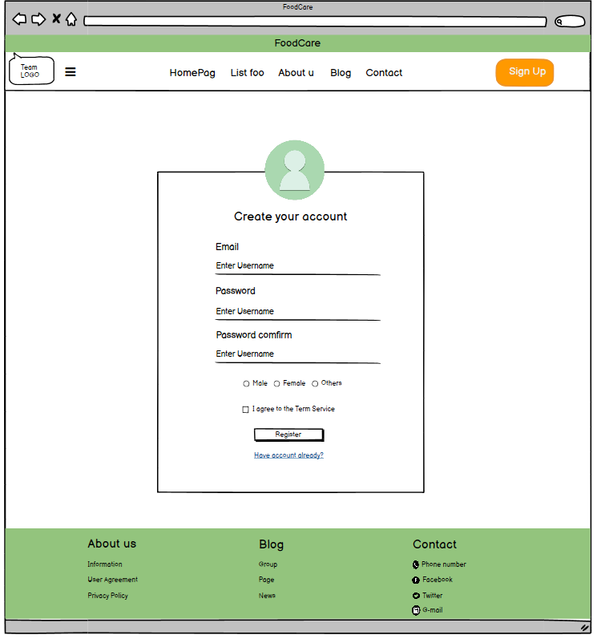

7

6

5

4

3

2

1

*Figure 3: Register*

|  |  |  |  |  |
| --- | --- | --- | --- | --- |
| **From** | **Condition** | **Null** | **Control Type** | **Target** |
| 1 | Input |  | Read only | Input user’s email |
| 2 | Input |  | Textbox | Input user’s password |
| 3 | Input |  | Textbox | Input user’s re-password |
| 4 | Click |  | Button | Click to agree term of service |
| 5 | Click |  | Link | Click to go to login page |
| 6 | Click |  | Button | Click to complete register |
| 7 | Click |  | Radio | Click to select sex |

## **3.4. UI-04: Update profile user**

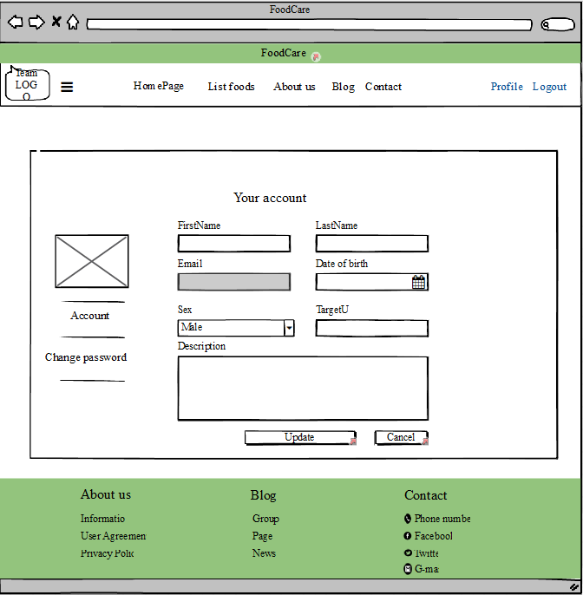

dd/mm/yyyy

12

11

10

2

1

6

3

4

7

9

8

5

*Figure 4: Edit profile user’s*

|  |  |  |  |  |
| --- | --- | --- | --- | --- |
| **From** | **Condition** | **Null** | **Control Type** | **Target** |
| 1 | Input |  | Read only | Input user’s email |
| 2 | Input |  | Textbox | Input user’s first name |
| 3 | Input |  | Textbox | Input user’s last name |
| 4 | Input |  | Select | Click to select date of birth |
| 5 | Input |  | Textbox | Input user’s date of birth |
| 6 | Combo box |  | Textbox | Click to select gender (male/female) |
| 7 | Input |  | Text area | User’s description |
| 8 | Click |  | Button | Click to cancel update profile |
| 9 | Click |  | Button | Click to save update profile |
| 10 | View |  | Section | View picture of user’s |
| 11 | Click |  | Link | Redirect user’s profile |
| 12 | Click |  | Link | Redirect user’s change password |

## **3.5. UI-05: Change password**

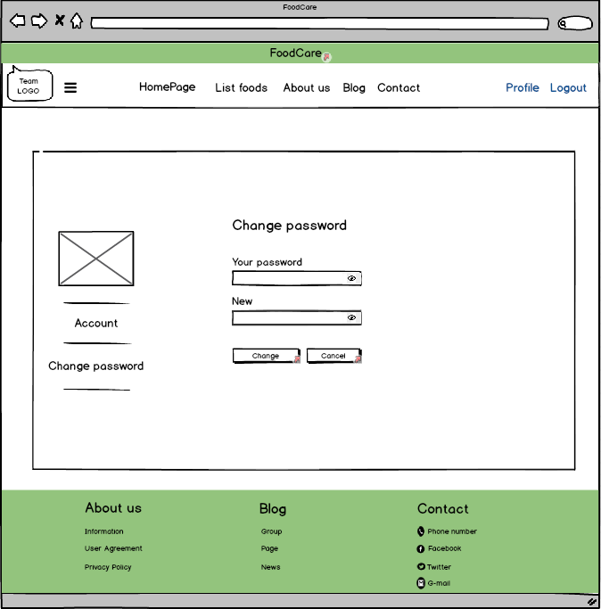

8

7

6

5

4

3

2

1

*Figure 5: Change password*

|  |  |  |  |  |
| --- | --- | --- | --- | --- |
| **From** | **Condition** | **Null** | **Control Type** | **Target** |
| 1 | Input |  | Textbox | Input user’s old password |
| 2 | Input |  | Textbox | Input user’s new password |
| 3 | Click |  | Button | Click to cancel change password |
| 4 | Click |  | Button | Click to save new password |
| 5 | View |  | Section | View picture of user’s |
| 6 | Click |  | Link | Redirect user’s profile |
| 7 | Click |  | Link | Redirect user’s change password |
| 8 | Click |  | Button | View password of user’s |

## **3.6. UI-06: Browse food**

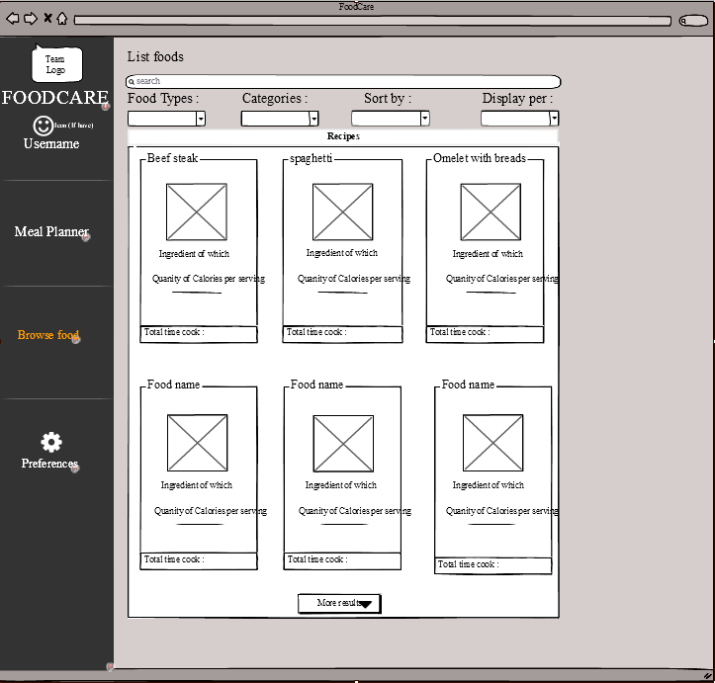

1

5

4

3

2

*Figure 6: Browse food*

|  |  |  |  |  |
| --- | --- | --- | --- | --- |
| **From** | **Condition** | **Null** | **Control Type** | **Target** |
| 1 | Click |  | Link | Click select option |
| 2 | Input |  | Textbox | Input food name |
| 3 | Combo box |  | Textbox | Click to select filter |
| 4 | View |  | Section | View details of food |
| 5 | Button |  | Textbox | Click to show more foods |

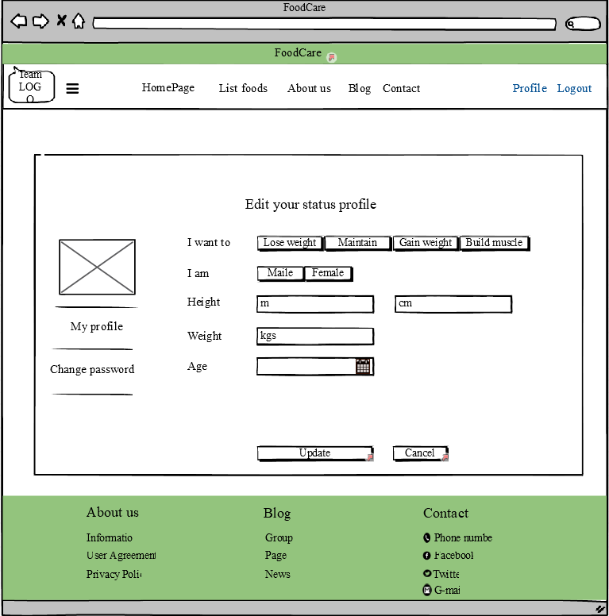

## **3.7. UI-07: Profile (Edit status profile)**

*Figure 7: Meal planner*

3

7

8

6

5

4

2

1

|  |  |  |  |  |
| --- | --- | --- | --- | --- |
| **From** | **Condition** | **Null** | **Control Type** | **Target** |
| 1 | Button |  | Select | Click select option |
| 2 | Button |  | Select | Click to select sex |
| 3 | Input |  | TextBox | Input your height(unit : m) |
| 4 | Input |  | TextBox | Input your height(unit : cm) |
| 5 | Input |  | TextBox | Input your weight(unit : kgs) |
| 6 | Input |  | Select | Click to select date of birth |
| 7 | Button |  | Select | Click to cancel update profile |
| 8 | Button |  | Select | Click to update profile |

## **3.8. UI-08: Preferences (Meal & Layout)**

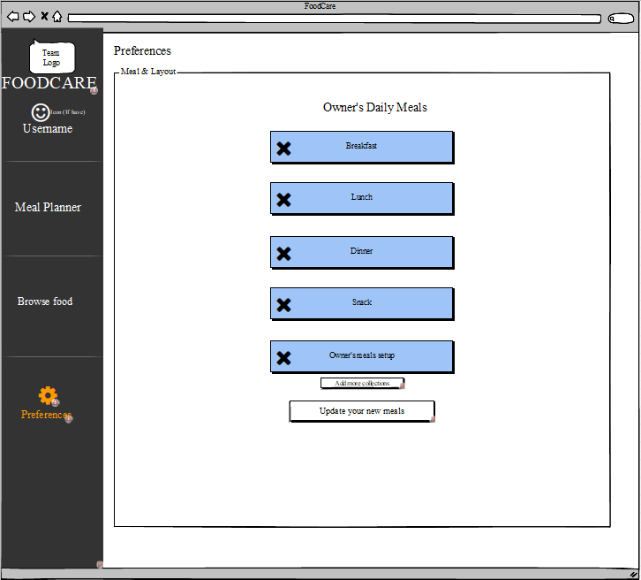

4

3

2

1

*Figure 8: Meal & Layout*

|  |  |  |  |  |
| --- | --- | --- | --- | --- |
| **From** | **Condition** | **Null** | **Control Type** | **Target** |
| 1 | Click |  | Link | Click select option |
| 2 | Click |  | Button | Click to delete your option |
| 3 | Click |  | Button | Click to add more your option |
| 4 | Click |  | Button | Click to update your option |

## **3.9. UI-9: Preferences (Rate foods)**

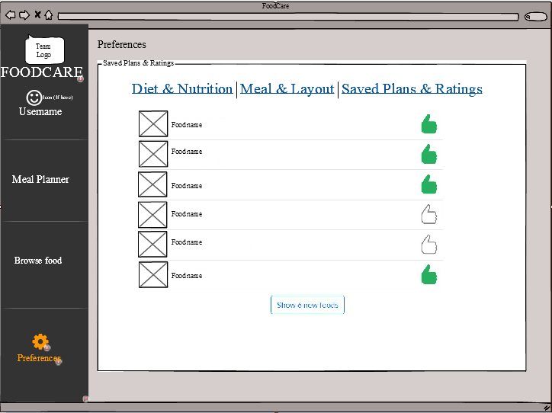

1

2

4

33

*Figure 9: Rate foods*

|  |  |  |  |  |
| --- | --- | --- | --- | --- |
| **From** | **Condition** | **Null** | **Control Type** | **Target** |
| 1 | Click |  | Link | Click select option |
| 2 | Click |  | Select | Click to select your favourite food |
| 3 | Click |  | Button | Click to show more foods |
| 4 | Click |  | TextBox | Click to show foods has been evaluated |
| 5 | View |  | Image | View food’s image |

## **3.10. UI-10: Preferences (Diet & Nutrition)**

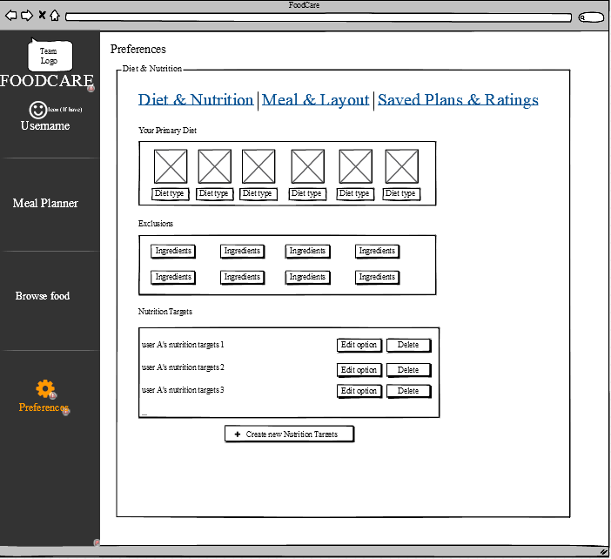

6

4

5

3

2

1

*Figure 10: Diet & Nutrition*

|  |  |  |  |  |
| --- | --- | --- | --- | --- |
| **From** | **Condition** | **Null** | **Control Type** | **Target** |
| 1 | Click |  | Link | Click select option |
| 2 | Click |  | Select | Click to select Diet type |
| 3 | Click |  | Select | Click to select ingredients |
| 4 | Click |  | Button | Click to delete nutrition target |
| 5 | Click |  | Button | Click to edit nutrition target |
| 5 | Click |  | Modal | Click to add new nutrition target |

## **3.11. UI-11: Preferences (Nutrition Profile Options)**

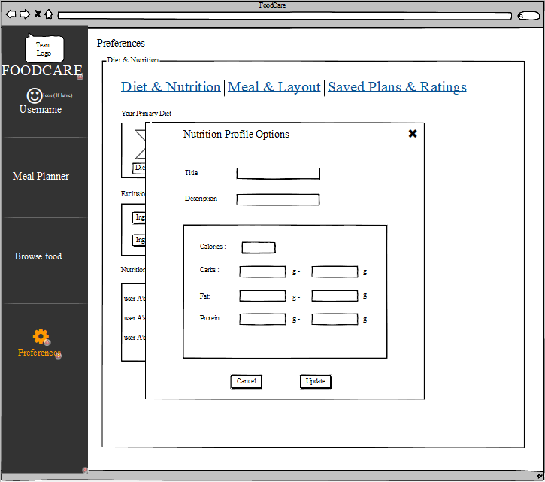

9

7

8

6

5

4

3

2

1

*Figure 11: Nutrition Profile Options*

|  |  |  |  |  |
| --- | --- | --- | --- | --- |
| **From** | **Condition** | **Null** | **Control Type** | **Target** |
| 1 | Input |  | TextBox | Input nutrition title |
| 2 | Input |  | TextBox | Input nutrition description |
| 3 | Input |  | TextBox | Input calories ingredient |
| 4 | Input |  | TextBox | Input cabs ingredient |
| 5 | Input |  | TextBox | Input fats ingredient |
| 6 | Input |  | TextBox | Input protein ingredient |
| 7 | Click |  | Button | Click to update new nutrition target |
| 8,9 | Click |  | Button | Click to close new nutrition target modal |

## **3.12. UI-12: Preferences (Meal & Layout)**

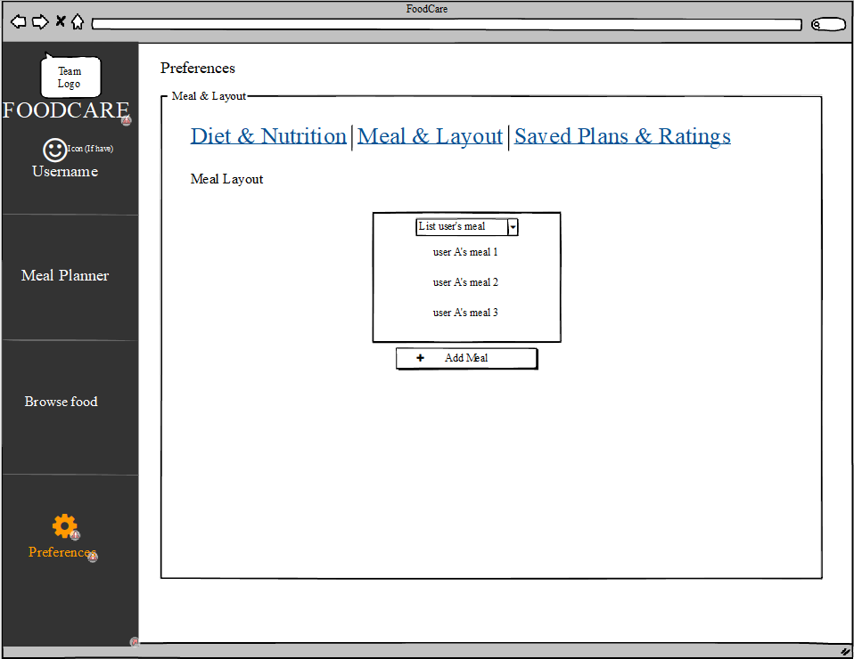

3

22

1

*Figure 12****:*** *Meal & Layout*

|  |  |  |  |  |
| --- | --- | --- | --- | --- |
| **From** | **Condition** | **Null** | **Control Type** | **Target** |
| 1 | Click |  | Link | Click select option |
| 2 | Click |  | Dropdown | Click to show list user’s meal |
| 3 | Click |  | Button | Click to show add new meal modal |

## **3.13. UI-13: Preferences (Add meals to the weekly planner)**

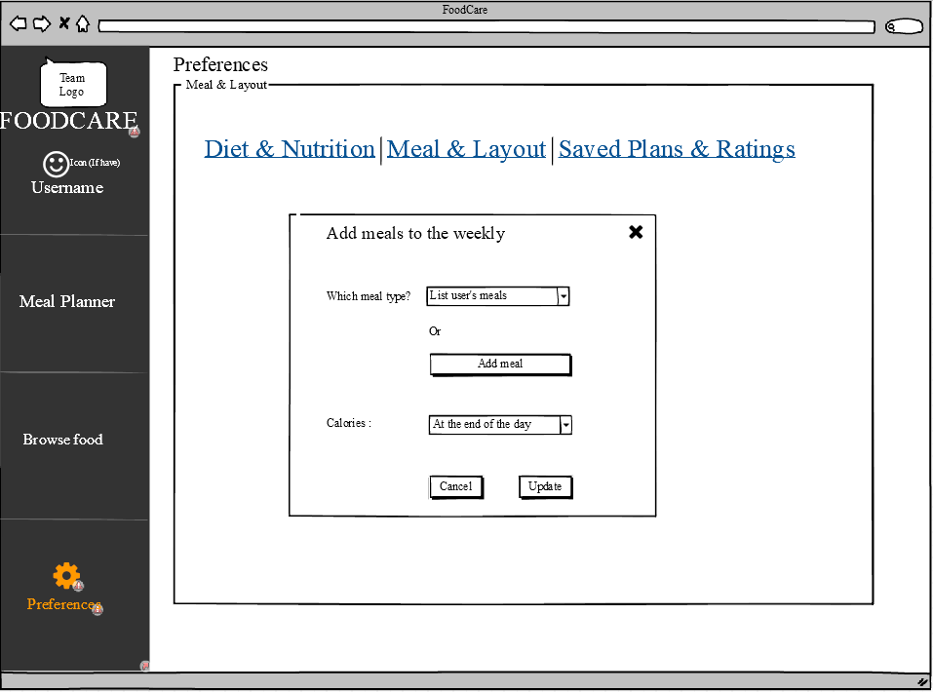

7

6

5

4

3

2

1

*Figure 13: Add meals to the weekly planner*

|  |  |  |  |  |
| --- | --- | --- | --- | --- |
| **From** | **Condition** | **Null** | **Control Type** | **Target** |
| 1 | Click |  | Link | Click select option |
| 2 | Click |  | Dropdown | Click to show list user’s meal |
| 3 | Click |  | Button | Add new user’s meal |
| 4 | Click |  | Dropdown | Click to select the day |
| 5 | Click |  | Button | Click to update new user’s meal |
| 6,7 | Click |  | Button | Click to close add meal modal |

## **3.14. UI-14: Preferences (Meal Settings)**

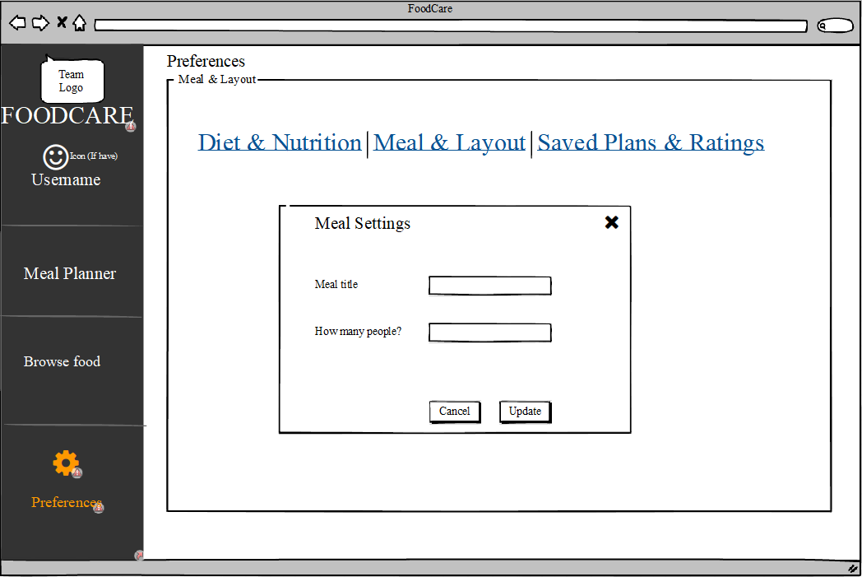

6

55

4

3

2

1

*Figure 14: Meal Settings*

|  |  |  |  |  |
| --- | --- | --- | --- | --- |
| **From** | **Condition** | **Null** | **Control Type** | **Target** |
| 1 | Click |  | Link | Click select option |
| 2 | Input |  | TextBox | Input meal title |
| 3 | Input |  | TextBox | Input quantity person |
| 4 | Click |  | Button | Click to update meal setting |
| 5,6 | Click |  | Button | Click to close meal setting modal |

## **3.15. UI-15: Collections**

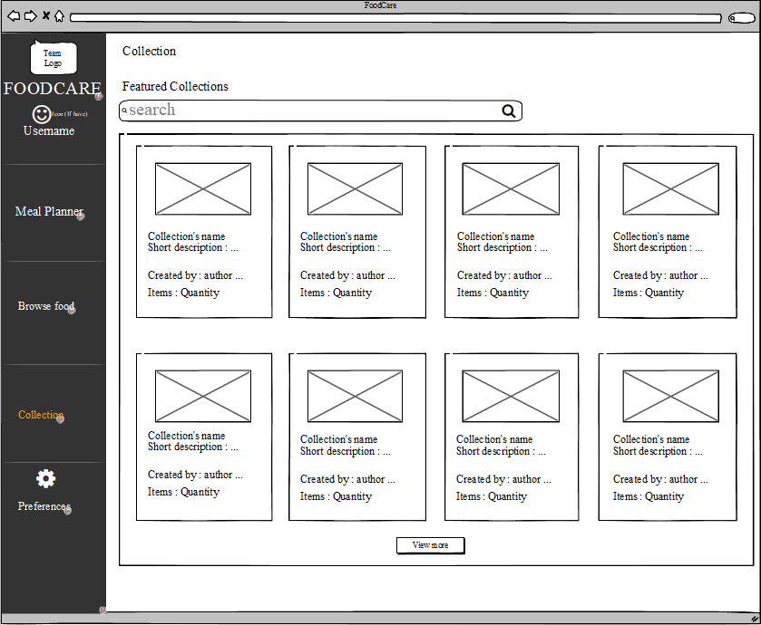

2

3

4

1

*Figure 15: Collections*

|  |  |  |  |  |
| --- | --- | --- | --- | --- |
| **From** | **Condition** | **Null** | **Control Type** | **Target** |
| 1 | Input |  | TextBox | Input collection need to find |
| 2 | Click |  | Button | Click to query collection need to find |
| 3 | View |  | Selection | Show recommended collections |
| 4 | Click |  | Butoon | Click to view more collection |

## **3.16. UI-16: Detail of collection**

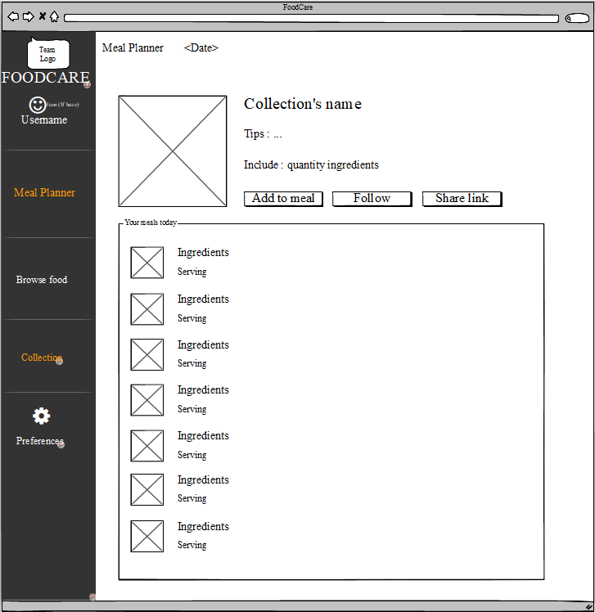

8

7

6

5

4

33

2

1

*Figure 16: Detail of collection*

|  |  |  |  |  |
| --- | --- | --- | --- | --- |
| **From** | **Condition** | **Null** | **Control Type** | **Target** |
| 1 | View |  | Label | Show collection’s thumbnail |
| 2 | View |  | Label | Show collection’s name |
| 3 | View |  | Label | Show collection’s tips |
| 4 | View |  | Label | Show collection’s quantity ingredients |
| 5 | Click |  | Button | Add more meal |
| 6 | Click |  | Button | Follow that collection |
| 7 | Click |  | Button | Share information of collection |
| 8 | View |  | Label | Show all ingredients of collection |

## **3.17. UI-17: Dashboard (Manage users)**

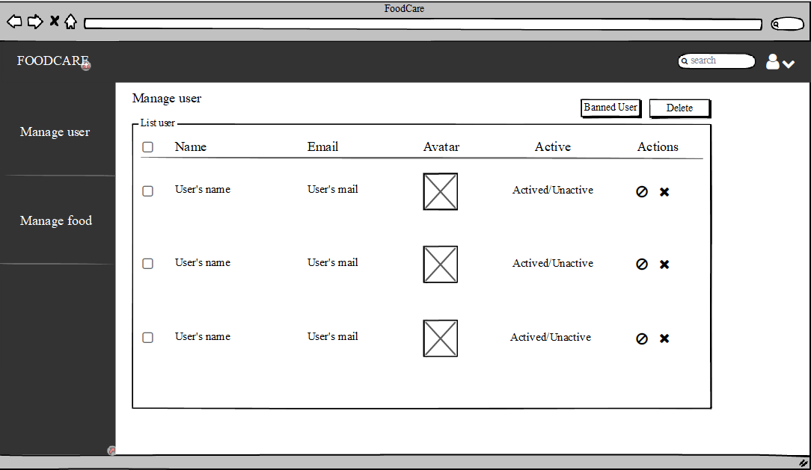

10

9

78

8

6

2

5

4

33

1

*Figure 17: Manage users*

|  |  |  |  |  |
| --- | --- | --- | --- | --- |
| **From** | **Condition** | **Null** | **Control Type** | **Target** |
| 1 | Click |  | Button | Click to ban user accounts |
| 2 | Click |  | Button | Click to delete user accounts |
| 3 | View |  | Column | Show user’s name column |
| 4 | View |  | Column | Show user’s email list |
| 5 | View |  | Column | Show user’s avatar list |
| 6 | View |  | Column | Show user’s status list |
| 7 | Click |  | Button | Click to ban a user list |
| 8 | Click |  | Button | Click to delete a user account |
| 9 | Click |  | Select | Click to select user account |
| 10 | Click |  | Button | Click to show admin profile |

## **3.18. UI-18: Dashboard (Manage foods)**

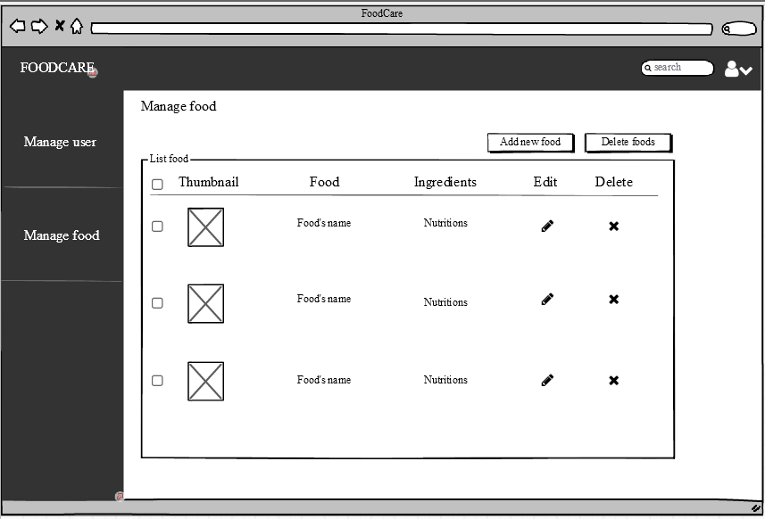

9

3

8

7

6

5

44

2

1

*Figure 18: Manage foods*

|  |  |  |  |  |
| --- | --- | --- | --- | --- |
| **From** | **Condition** | **Null** | **Control Type** | **Target** |
| 1 | Click |  | Button | Click to add new food |
| 2 | Click |  | Button | Click to delete foods |
| 3 | View |  | Column | Show food’s thumbnail list |
| 4 | View |  | Column | Show food’s name list |
| 5 | View |  | Column | Show food’s ingredients list |
| 6 | View |  | Column | Click to edit a food |
| 7 | Click |  | Button | Click to delete a food |
| 8 | Click |  | Button | Click to select foods |
| 9 | Click |  | Select | Click to show admin profile |

3