Software Specification

11th of March 2015
2IO70
Version 0.8

The purpose of this document is to give an as accurately as possible description of the required behaviour of the PP2, without describing how this is achieved, and a UPPAAL model of this behaviour. In order to do this, we translate the system level requirements to a high level specification of what the software controlling the physical machine should do.

Group 16
Rolf Verschuuren
Wigger Boelens
Stefan van den Berg
Dat Phung
Maarten Keet
Tudor Petrescu

Table of Contents
Inputs and Outputs 3
Inputs 3
Outputs 3
Relations 3
Lens lamp of the black white detector 3
Lens lamp of the position sensor 3
Engine of the conveyor belt 3
Engine of the feeder 4
Engine for the sorter 4
Display for counting 4
Validation of the Relations 4
Description of States 5
Validation of the state description 9
State transitions 10
Validation of the state transitions 10
Finite state Automaton 11
Validation of the finite state automaton 11
UPPAAL model 12
Tests done 12
Validation of the UPPAAL model 12

Inputs and Outputs

Inputs
Input | The range/type of the value
Start/Stop button | Boolean value
Abort button | Boolean value
Push button(sensor) | Boolean value
Colour detector | Boolean value
Timer | Values range from seconds to clock ticks

Outputs
Output | The range/type of the value
Lens lamp 1 | Boolean value
Lens lamp 2 | Boolean value
Conveyor engine | Between 6 and 9 V while running  0 V when not running
Feeder engine | Between 3 and 7 V while running  0 V when not running
Sorter engine | Between 6 and 9 V while running  0 V when not running
Display | Integer value, positive

Relations
Lens lamp of the black white detector
The lens lamp of the black white detector will be on when the machine is sorting. Thus the lens lamp will react to the input of the “START/STOP” button and the “ABORT” button. The lens lamp will go on when the machine is in resting state and the “START/STOP” button is pressed and it will go off when the “ABORT” button is pressed while the machine was running.
Lens lamp of the position sensor
The lens lamp of the position sensor reacts only to the “START/STOP” button and the “ABORT” button. The lens lamp will be on after the “START/STOP” button is pressed and the machine is in its resting state. If at any other point in time the “ABORT” button is pressed it will go off. When the “START/STOP” button is pressed and the machine is running then the lens lamp also goes off.
Engine of the conveyor belt
The engine of on the conveyor belt only reacts to the input of the “START/STOP” button and the “ABORT” button. The engine will start when the machine is in its resting state and the “START/STOP” button is pressed. If however the “START/STOP” button is pressed and the machine is not in its resting state then the machine will stop after it completed its current cycle. Whenever the “ABORT” button is pressed the engine stops within 50ms.
Engine of the feeder
The engine for the feeder also only reacts to the input of the “START/STOP” button and the “ABORT” button. This engine also starts when the machine is in its resting state and the “START/STOP” button is pressed. If however the machine is running then the engine will stop. When the “ABORT” button is pressed the engine stops within 50ms.
Engine for the sorter
When the machine is running the engine of the sorter reacts to inputs of the colour detector, the push sensor and the timer. When a signal is received from the colour detector the engine pushes the sorter up, the engine then waits until the timer gives a signal to go down again after it let the disks through, it knows when it is in the correct “up” position from the push sensor . If the “START/STOP” button is pressed when the machine is in its resting state, then the sorter will wait for a signal from the timer that marks the end of the current cycle. If at any time the ““ABORT”” button is pressed, the sorting mechanism is to stop within 50ms.
Display for counting
The display output depends on how many times the colour detector detects a white disc and how many times a disc passes the position sensor without the colour detector detecting it.
In the initial state the counters get reset.

Validation of the Relations
The relations between the inputs and outputs can be validated with the input/output tables. For all inputs, we have outputs. These outputs depend on one or more inputs, which is described in the Relations.

Description of States
Initial_state
Outputs | Value for output
Lens lamp position | 0
Lens lamp sorter | 0
Engine conveyor | 0
Engine feeder | 0
Hbridge0 | 0
Hbridge1 | 0
Display | 0
LED state indicator | 0
Timer start | 0

Calibrate_Sorter
Outputs | Value for output
Lens lamp position | 0
Lens lamp sorter | 0
Engine conveyor | 0
Engine feeder | 0
Hbridge0 | 1
Hbridge1 | 0
Display | 0
LED state indicator | 0
Timer start | 0

Resting_state
Outputs | Value for output
Lens lamp | 0
Lens lamp | 0
Engine conveyor | 0
Engine feeder | 0
Hbridge0 | 0
Hbridge1 | 0
Display | 0
LED state indicator | 1
Timer start | 0

Running_state
Outputs | Value for output
Lens lamp position | 1
Lens lamp sorter | 1
Engine conveyor | 1
Engine feeder | 1
Hbridge0 | 0
Hbridge1 | 0
Display | 0
LED state indicator | 0
Timer start | 2 s + Belt

Running_Wait
Outputs | Value for output
Lens lamp position | 1
Lens lamp sorter | 1
Engine conveyor | 1
Engine feeder | 1
Hbridge0 | 0
Hbridge1 | 0
Display | 0
LED state indicator | 0
Timer start | 2 s + Belt

Running_Timer_Reset
Outputs | Value for output
Lens lamp position | 1
Lens lamp sorter | 1
Engine conveyor | 1
Engine feeder | 1
Hbridge0 | 0
Hbridge1 | 0
Display | 0
LED state indicator | 0
Timer start | 2 s + Belt

Motor_Up
Outputs | Value for output
Lens lamp position | 1
Lens lamp sorter | 1
Engine conveyor | 1
Engine feeder | 1
Hbridge0 | 1
Hbridge1 | 0
Display | 0
LED state indicator | 0
Timer start | Sort

Motor_Up_Stop
Outputs | Value for output
Lens lamp position | 1
Lens lamp sorter | 1
Engine conveyor | 1
Engine feeder | 1
Hbridge0 | 1
Hbridge1 | 0
Display | 0
LED state indicator | 0
Timer start | Sort

Motor_Down
Outputs | Value for output
Lens lamp position | 1
Lens lamp sorter | 1
Engine conveyor | 1
Engine feeder | 1
Hbridge0 | 0
Hbridge1 | 1
Display | 0
LED state indicator | 0
Timer start | 0

Motor_Down_Stop
Outputs | Value for output
Lens lamp position | 1
Lens lamp sorter | 1
Engine conveyor | 1
Engine feeder | 1
Hbridge0 | 0
Hbridge1 | 1
Display | 0
LED state indicator | 0
Timer start | 0

White_Wait
Outputs | Value for output
Lens lamp position | 1
Lens lamp sorter | 1
Engine conveyor | 1
Engine feeder | 1
Hbridge0 | 0
Hbridge1 | 0
Display | 0
LED state indicator | 0
Timer start | Sort

White_Wait_Stop
Outputs | Value for output
Lens lamp position | 1
Lens lamp sorter | 1
Engine conveyor | 1
Engine feeder | 1
Hbridge0 | 0
Hbridge1 | 0
Display | 0
LED state indicator | 0
Timer start | Sort

Runing_Timer
Outputs | Value for output
Lens lamp position | 1
Lens lamp sorter | 1
Engine conveyor | 1
Engine feeder | 0
Hbridge0 | 0
Hbridge1 | 0
Display | 0
LED state indicator | 0
Timer start | Belt

Motor_Up_Timer
Outputs | Value for output
Lens lamp position | 1
Lens lamp sorter | 1
Engine conveyor | 1
Engine feeder | 0
Hbridge0 | 0
Hbridge1 | 0
Display | 0
LED state indicator | 0
Timer start | Belt

White_Wait_Timer
Outputs | Value for output
Lens lamp position | 1
Lens lamp sorter | 1
Engine conveyor | 1
Engine feeder | 0
Hbridge0 | 0
Hbridge1 | 0
Display | 0
LED state indicator | 0
Timer start | Belt

Motor_Down_Timer
Outputs | Value for output
Lens lamp position | 1
Lens lamp sorter | 1
Engine conveyor | 1
Engine feeder | 0
Hbridge0 | 0
Hbridge1 | 0
Display | 0
LED state indicator | 0
Timer start | Belt

Aborted
Outputs | Value for output
Lens lamp position | 0
Lens lamp sorter | 0
Engine conveyor | 0
Engine feeder | 0
Hbridge0 | 0
Hbridge1 | 0
Display | 0
LED state indicator | 0
Timer start | 0

After_tick
Outputs | Value for output
Lens lamp position | 1
Lens lamp sorter | 1
Engine conveyor | 1
Engine feeder | 0
Hbridge0 | 0
Hbridge1 | 0
Engine sorter | 0
Display | 0
LED state indicator | 0
Timer start | Belt

Validation of the state description
The validation for this part is not yet completed and will be added at a later moment in time.

State transitions
Current state | Input | Input value | Next State
Initial | Push | 1 | Calibrate_Sorter
Calibrate_Sorter | Push | 0 | Resting
Resting | StartStop | 1 | Running
Running | Timer | TEnd | Initial
Running | PositionSensor | 0 | Running_Wait
Running | Abort | 1 | Aborted
Running | StartStop | 1 | Running_Timer
Running_Wait | Timer | TEnd | Initial
Running_Wait | PositionSensor | 0 | Running_Timer_Reset
Running_Wait | ColorDetector | 1 | MotorUp
Running_Wait | StartStop | 1 | Running_Timer
Running_Wait | Abort | 1 | Aborted
Running_Timer_Reset | Tick | 1 | Running_Wait
Running_Timer_Reset | Abort | 1 | Aborted
MotorUp | PushButton | 1 | WhiteWait
MotorUp | StartStop | 1 | Motor_Up_Timer
MotorUp | Abort | 1 | Aborted
WhiteWait | StartStop | 1 | White_Wait_Timer
WhiteWait | Abort | 1 | Aborted
WhiteWait | Timer | SORT | MotorDown
MotorDown | StartStop | 1 | Motor_Down_Timer
MotorDown | Abort | 1 | Aborted
MotorDown | Timer | Motor Down | Running_Wait
Running_Timer | Timer | Tic | After_tick
Running_Timer | Abort | 1 | Aborted
Motor_Up_Timer | Timer | Tic | Motor_Up_Stop
Motor_Up_Timer | Abort | 1 | Aborted
White_Wait_Timer | Timer | Tic | White_Wait_Stop
White_Wait_Timer | Abort | 1 | Aborted
Motor_Down_Timer | Timer | Tic | Motor_Down_Stop
Motor_Down_Timer | Abort | 1 | Aborted
Motor_Up_Stop | PushButton | 1 | White_Wait_Stop
Motor_Up_Stop | Abort | 1 | After_tick
Motor_Up_Stop | Timer | Timer Interrupt | Initial
Motor_Up_Stop | Abort | 1 | Aborted
White_Wait_Stop | Timer | SORT | Motor_Down_Stop
White_Wait_Stop | Abort | 1 | Aborted
White_Wait_Stop | Timer | Timer Interrupt | Initial
Motor_Down_Stop | Timer | Motor Down | After_tick
Motor_Down_Stop | Abort | 1 | Aborted
Motor_Down_Stop | Timer | Timer Interrupt | Initial
After_tick | ColorDetector | 1 | Motor_Up_Stop
After_tick | Abort | 1 | Aborted
After_tick | Timer | Timer Interrupt | Initial
Aborted | StartStop | 1 | Initial

Validation of the state transitions
The description of our machine states is validated through its representation in the transition table. No state is excluded from being represented in the state transition table, all transitions will have the initial transition state differ from the end state.

Finite state Automaton
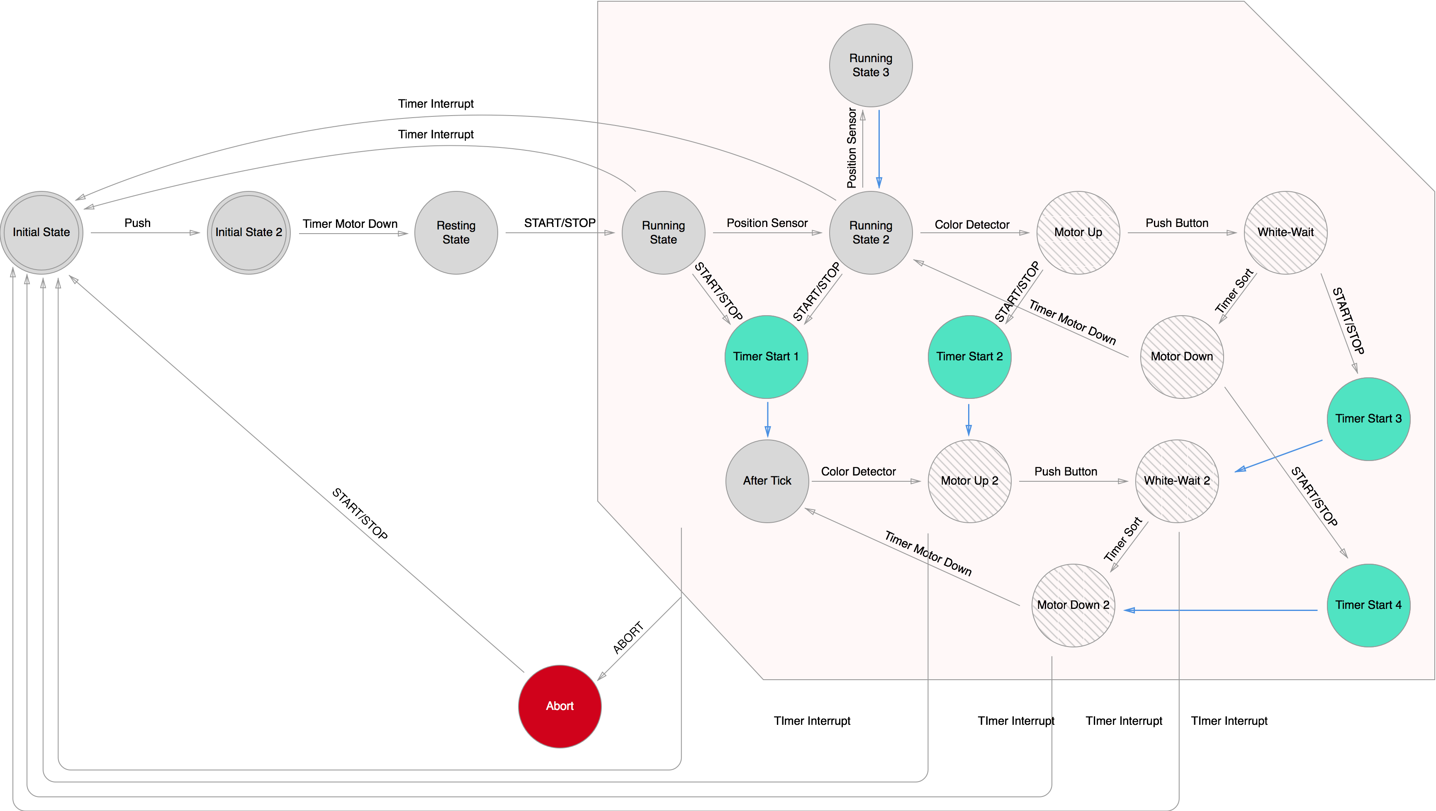

Validation of the finite state automaton
When we were making our finite state automaton we looked at our state description and made sure that all states were represented, then we used our state transition table to make sure all transitions were correctly implemented.

UPPAAL model

Tests done
On the next page is the UPPAAL model. This UPPAAL model has been tested for 2 safety properties. The first one is “ After the start-up of the machine, the assembly program should not stop until the machine is shut down.”. This has been tested using the following property “A[] not deadlock”, and we didn’t have a deadlock. The second safety property which was tested is: “The outputs connected to the h-bridge may never be powered on at the same time.”. This was tested using the following property “A<> !(hbridge0==1 && hbridge1=1)”. This one was also correct.

Validation of the UPPAAL model
All transitions which exist in the UPPAAL model also occur in the Finite State Automaton. And the same action has to be performed to take that transition. Also all states of the Finite State Automaton occur in the UPPAAL model. The states of the UPPAAL model also have the outputs in them. The states of the Finite State Automaton do not have the outputs in them. Thus we validate the values of the outputs, which are in the states, to the description of the states.

