Zhang Boen
CSCE 270
12/5/2016
Lab09 Report
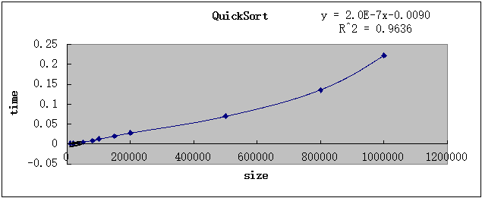
QuickSort:
In theory, the best case, average and worst case performance of quick sort, are O(nlogn), O(nlogn), O(n^2), respectively. For the paragraph above, I generate 10 sets of random-ordered array and use the program to calculate the time needed to sort. In experiment, this graph can be represented y = a *x + b (a and b are constants), and R-square is equal to 0.9636. Because O(n) is quite similar to O(nlogn) and there is no trendline for nlogn, I substitute nlogn by n. This means the time-size graph is very close to y = ax + b, which means that the average performance of quick sort is, in experimental, is also O(nlogn). There is no unexpected result in this case.
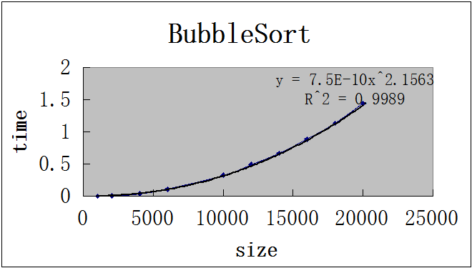
Bubble Sort:
In theory, the best case, average and worst case performance of bubble sort, are O(n), O(n^2), O(n^2), respectively. For the paragraph above, I generate 10 sets of random-ordered array and use the program to calculate the time needed to sort. In experiment, this graph can be represented y = a * x^2.1563 (a is constant), and R-square is equal to 0.9989. This means the time-size graph is very close to y = ax^2, which means that the average performance of bubble sort is, in experimental, is also O(n^2). There is no unexpected result in this case.

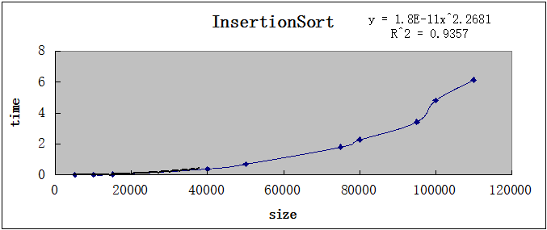
InsertionSort:
In theory, the best case, average and worst case performance of insertion sort, are O(n), O(n^2), O(n^2), respectively. For the paragraph above, I generate 10 sets of random-ordered array and use the program to calculate the time needed to sort. In experiment, this graph can be represented y = a * x^2.2681 (a is constant), and R-square is equal to 0.9357. This means the time-size graph is very close to y = ax^2, which means that the average performance of insertion sort is, in experimental, is also O(n^2). There is no unexpected result in this case.
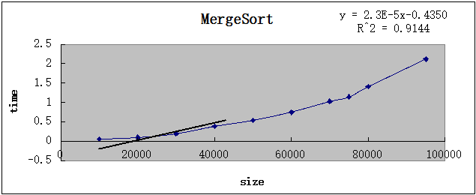
MergeSort:
In theory, the best case, average and worst case performance of merge sort, are all O(nlogn). For the paragraph above, I generate 10 sets of random-ordered array and use the program to calculate the time needed to sort. In experiment, this graph can be represented y = a *x + b (a and b are constants), and R-square is equal to 0.9144 Because O(n) is quite similar to O(nlogn) and there is no trendline for nlogn, I substitute nlogn by n. This means the time-size graph is not very, but still close to y = ax + b, which means that the average performance of merge sort is, in experimental, is also O(nlogn). There is no unexpected result in this case.
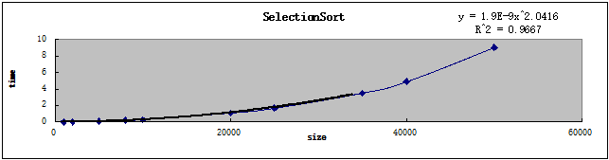
SelectionSort:
In theory, the best case, average and worst case performance of selection sort, are all O(n^2). For the paragraph above, I generate 10 sets of random-ordered array and use the program to calculate the time needed to sort. In experiment, this graph can be represented y = a * x^2.0416 (a is constant), and R-square is equal to 0.9667. This means the time-size graph is very close to y = ax^2, which means that the average performance of selection sort is, in experimental, is also O(n^2). There is no unexpected result in this case.

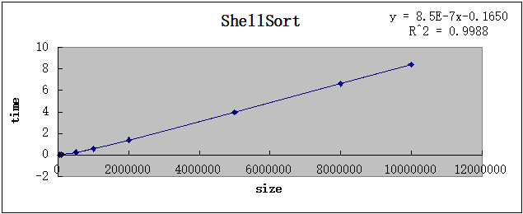
ShellSort:
In theory, the best case, average and worst case performance of shell sort, are O(nlogn), depending on gap sequence, O(n^2). For the paragraph above, I generate 7 sets of random-ordered array and use the program to calculate the time needed to sort. In experiment, this graph can be represented y = a * x + b (a and b are constants), and R-square is equal to 0.9988. This is an unexpected result. Probably in my 7 sets of data, almost all data sets are in the best case of shell sort, so the graph seems like a linear function. The time-size graph is very close to y = ax + b, which means that the best performance of shell sort is, in experimental, is also O(nlogn).

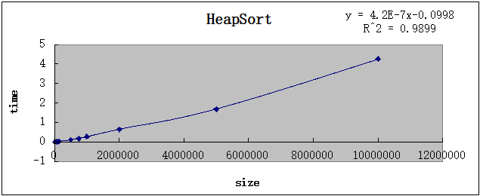
HeapSort:
In theory, the best case, average and worst case performance of heap sort, are all O(nlogn). For the paragraph above, I generate 10 sets of random-ordered array and use the program to calculate the time needed to sort. In experiment, this graph can be represented y = a * x + b (a and b are constants), and R-square is equal to 0.9899. In experiment, this graph can be represented y = a *x + b (a and b are constants), and R-square is equal to 0.9144 Because O(n) is quite similar to O(nlogn) and there is no trendline for nlogn, I substitute nlogn by n. The time-size graph is very close to y = ax + b, which means that the average performance of heap sort is, in experimental, is also O(nlogn). And heap sort is the best O(nlogn) sort because it uses the least time to sort a big-size array.

