Die Weihnachtserzählung rund um die Krippe

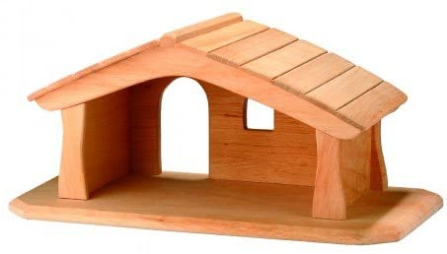Bildquelle: Ostheimer 65600

|  |  |  |
| --- | --- | --- |
| **Was gehört dazu?** |  |  |
|  |  |  |
|  |  |  |
|  |  |  |
|  |  |  |
|  |  |  |
|  |  |  |
|  |  |  |
|  |  |  |
|  |  |  |
|  |  |  |
|  |  |  |
|  |  |  |
|  |  |  |
|  |  |  |
|  |  |  |
|  |  |  |
|  |  |  |
|  |  |  |
|  |  |  |
|  |  |  |
|  |  |  |