SWU College of Computer and Information Science

Experiment Report 2

Course Name | Embedded Systems
Project Name | STM32 UART Interface and Its Application
Grade | 2021 | Major and Class | Automation / Class 01 | Time | 15/11/2023
Student ID | 222021321132005 | Name | 贾博方 | Experiment Type | Verification
I、Experiment Purposes
1. Learn the working principle and configuration method for STM32 UART module.
2. Master the method to implement serial communication in interrupt mode for UART by programming.
Ⅱ、Experiment Contents and Process (Including Experiment Principles, Main Contents and Operation Steps)
Experiment Principles
HAL library UART related function introduction
1) Serial send/receive function
HAL_UART_Transmit(); The timeout management mechanism is used to send data over the serial port
HAL_UART_Receive(); The serial port receives data and uses the timeout management mechanism
HAL_UART_Transmit_IT(); The serial port is sent in interrupt mode
HAL_UART_Receive_IT(); Serial port is received in interrupt mode
HAL_UART_Transmit_DMA(); Serial port is sent in DMA mode
HAL_UART_Transmit_DMA(); Serial port receiving in DMA mode
The parameters of these functions are basically the same, let's choose two to explain.
Serial port sending data:
HAL_UART_Transmit(UART_HandleTypeDef *huart, uint8_t *pData, uint16_t Size,
uint32_t Timeout)
Function: The serial port sends data of a specified length. If the timeout is not complete, the system does not send any more, and a timeout flag is returned
(HAL_TIMEOUT).
Parameters:
UART_HandleTypeDef *huart Another name for UART is UART_HandleTypeDef
huart1; The alias is huart1
*pData Indicates the data to be sent
Size Indicates the number of bytes sent
Timeout Indicates the maximum time for sending data. When the time expires, the system exits sending data
For example, HAL_UART_Transmit(&huart1, (uint8_t *)ZZX, 3, 0xffff); // Serial port sends three bytes
The maximum transfer time is 0xffff
Interrupt receiving data:
HAL_UART_Receive_IT(UART_HandleTypeDef *huart, uint8_t *pData, uint16_t Size)
Function: The serial port is interrupted to receive the specified length data in an interrupted manner. The general process is to set the data store bit
Set, receive data length, and then enable serial port receive interrupt. When data is received, the serial port is interrupted. again
After that, the serial port interrupt function processes until the specified length of data is received, and then closes the interrupt and enters the interrupt to receive back
Call function, no longer trigger receive interrupt. (Trigger interrupt only once)
Parameters:
UART_HandleTypeDef * Alternate name of huart UATR such as UART_HandleTypeDef
huart1; The alias is huart1
*pData Indicates the address of the received data
Size Indicates the number of bytes received
For example, HAL_UART_Receive_IT(&huart1,(uint8_t *)&value,1); // Interrupt receive a character, store
To value
2) Serial port interrupt function
23
HAL_UART_IRQHandler(UART_HandleTypeDef *huart); // Serial interrupt handling function
HAL_UART_TxCpltCallback(UART_HandleTypeDef *huart); // Serial port send interrupt callback function
HAL_UART_TxHalfCpltCallback(UART_HandleTypeDef *huart); // Serial port sends half interrupt callback
Function (less used)
HAL_UART_RxCpltCallback(UART_HandleTypeDef *huart); // Serial port receive interrupt callback function
HAL_UART_RxHalfCpltCallback(UART_HandleTypeDef *huart); // Serial port receives half callback functions
(Used less)
HAL_UART_ErrorCallback(); Serial port receive error function
Serial port receive interrupt callback function:
HAL_UART_RxCpltCallback(UART_HandleTypeDef *huart);
Function: After the interruption of the HAL library is completed, it will not exit directly, but will enter the interrupt callback function, with
The user can set the code in it. After the serial port is interrupted, it will enter the function, which is an empty function.
Users need to modify it.
Parameters:
UART_HandleTypeDef * Alias of huart UATR
Example: HAL_UART_RxCpltCallback(&huart1){// user-specified code}
Serial interrupt handling function
HAL_UART_IRQHandler(UART_HandleTypeDef *huart);
Function: Judge and process the received data to determine whether to send or receive an interrupt, and then perform data
If data is received, the receive interrupt handler function is performed
/* UART in mode Receiver ---------------------------------------------------
* /
if((tmp_flag ! = RESET) && (tmp_it_source ! = RESET))
{
UART_Receive_IT(huart);
}
If data is sent, the send interrupt handler is performed
/* UART in mode Transmitter ------------------------------------------------
* /
if (((isrflags & USART_SR_TXE) ! = RESET) && ((cr1its & USART_CR1_TXEIE) ! = RESET))
{
UART_Transmit_IT(huart);
return;
}
3) Serial port query function
HAL_UART_GetState(); Determine whether the UART is finished receiving, or whether it is busy sending data
Example: while(HAL_UART_GetState(&huart4) == HAL_UART_STATE_BUSY_TX) // Check
The UART is sent. Procedure

Main Contents
In this experiment, STM32F4 can communicate with the host computer through the serial port, and STM32F4 can receive the words sent by the host computer.After the string, the original is returned to the host computer.

Operation Steps
1. STM32CubeMX Configuration serial port
In CubeMX, new project, clock configuration, software debugging mode, system working clock and generation project are commonly selected
The contents of the items are referred to experiment 1.
Directly connect the left key to Connectivity in the figure, select USART1, and set the mode to interstep communication
(Asynchronous), the default value baud rate 115200 bits /s, transmitted data length 8bit, no parity bit, 1
Bit Stop bit, receiving and sending bits are enabled. Enable receiving interrupt in NVIC Settings.
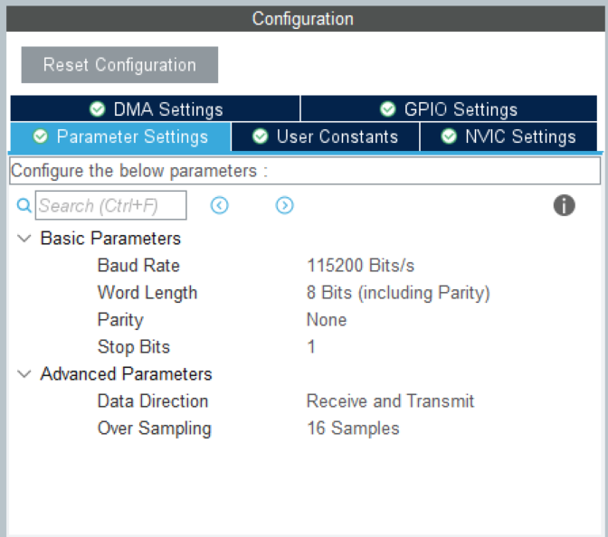
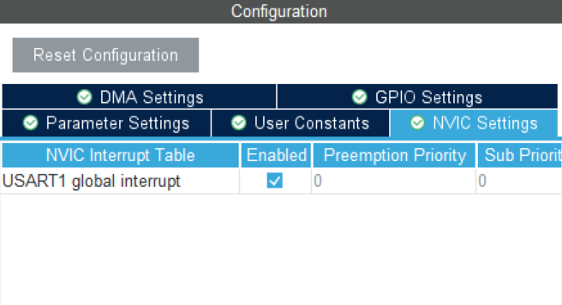
2. Software design
Open the CubeMx generated project code in Keil MDK.
1) Add the following definition in main.c to receive serial port data
#include “string.h”
uint8_t aRxBuffer; //接收中断缓冲
uint8_t Uart1_RxBuff[256]; //接收缓冲
uint8_t Uart1_Rx_Cnt = 0; //接收缓冲计数
uint8_t cAlmStr[] = "数据溢出(大于 256)\r\n"
2) In the int main(void) main function, add the statement to enable the receiving interrupt:
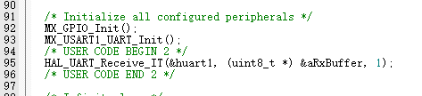
3) Add an interrupt callback function to the lower part of main.c.
The interrupt callback function sends the received data back through the serial port.
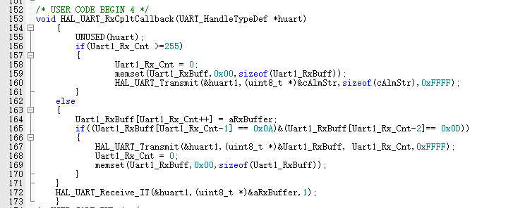

Ⅲ、Experiment Results
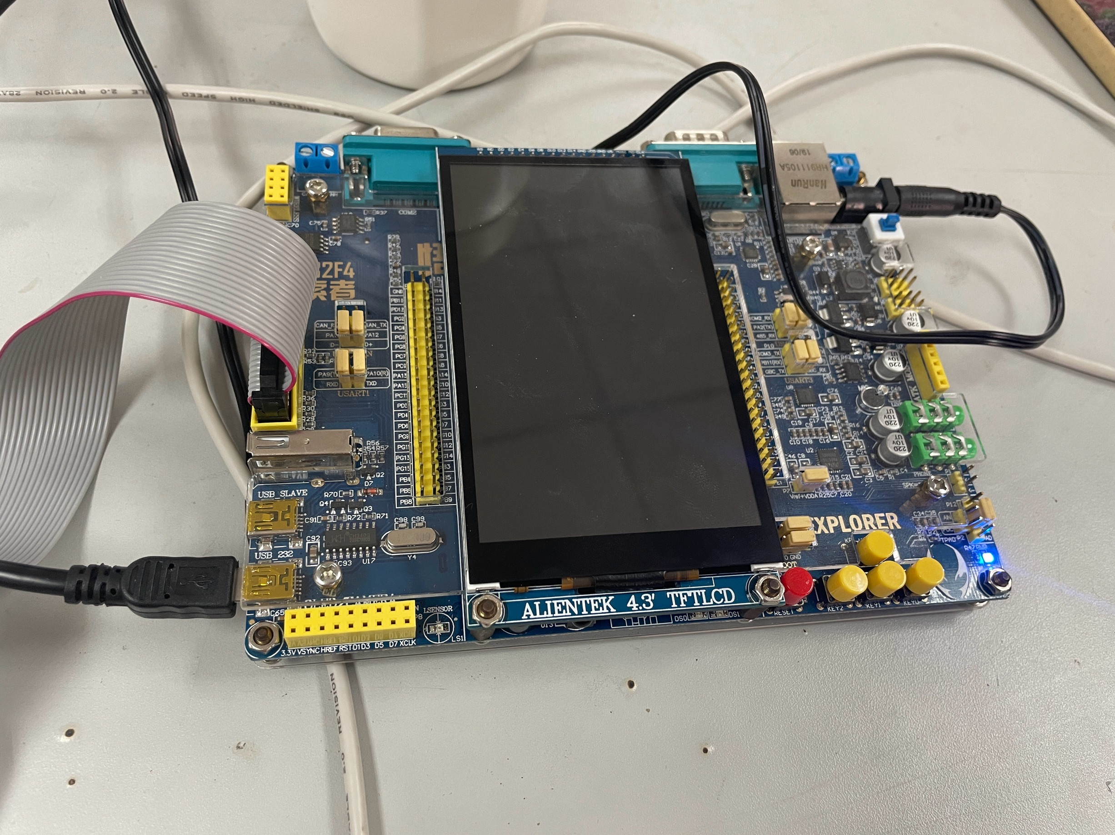

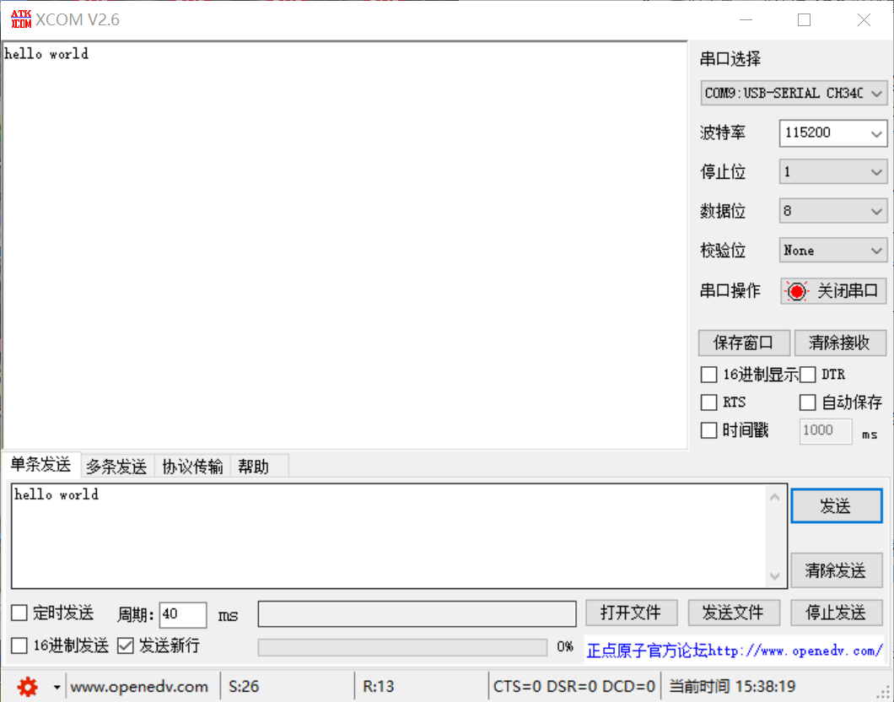

According to the requirements of the experimental instructions, we connect the relevant connection of the integrated version of the single chip microcomputer, enter the text under the serial assistant, and the corresponding result can be obtained in the acceptance area.

Ⅳ、Experiment Analyses and Conclusions
Through this experiment, I learned the relevant knowledge of serial communication of the single chip microcomputer, serial communication refers to the peripheral and the computer, through the data signal line, ground line, control line, etc., a communication method to transmit data by bit, such as SPI communication, USART communication, EEPROM communication. In simple terms, serial communication realizes the information interaction between the upper computer (PC) and the lower computer (such as STM32). The host computer (PC) receives and sends data through serial debugging assistant. The lower machine (STM32) receives and sends characters or strings through functions such as printf() and getchar(). STM32 serial communication interface: UART: universal asynchronous transceiver; USART: Universal synchronous/asynchronous transceiver (both modes can be switched). Among them, RX is data receiving and TX is data sending. Through this experiment, I have learned the knowledge of serial communication in detail, and completed related experiments through STM32F407ZGT6 to carry out serial communication.

Score

