SWU College of Computer and Information Science

Experiment Report 3

Course Name | Embedded Systems
Project Name | STM32 DAC and Its Application
Grade | 2021 | Major and Class | Automation / Class 01 | Time | 22/11/2023
Student ID | 222021321132005 | Name | 贾博方 | Experiment Type | Comprehensive Practice
I、Experiment Purposes
1. Learn the working principle and configuration method for STM32 DAC module;
2. Master the method to achieve adjustable analog output for DAC channel by programming.
Ⅱ、Experiment Contents and Process (Including Experiment Principles, Main Contents and Operation Steps)
Experiment Principles
The STM32F4 DAC module (digital/analog conversion module) is a 12-bit digital input, voltage output type DAC.
The DAC can be configured in 8-bit or 12-bit mode and can also be used with a DMA controller. The DAC works in 12-bit mode
The data can be left justified or right justified. The DAC module has 2 output channels, each of which has its own
The converter. In dual DAC mode, the two channels can be converted independently or simultaneously
Update the output of both channels step by step. The DAC can be obtained by a pin input reference voltage Vref+ (shared with the ADC)
Need to convert results more accurately.
The main features of STM32F4 DAC module are:
2 DAC converters: Each converter corresponds to 1 output channel
② 8-bit or 12-bit monotonic output
(3) Align data left or right in 12-bit mode
④ Synchronous update function
⑤ Noise waveform generation
⑥ Triangular waveform generation
7 Dual DAC channels are converted simultaneously or separately
⑧ Each channel has DMA function

Main Contents
In this experiment, the internal DAC1 of STM32F4 is controlled by keys to output voltage, the output voltage of DAC is collected through channel 5 of ADC1, and the voltage value obtained by ADC and the set output voltage value of DAC are displayed on serial port 1.

Operation Steps
1. Hardware design
The experiment will use the DAC module's channel 1 to output the analog voltage. For DAC channel and pin correspondence, this is listed in the STM32F4 datasheet pin table, as shown below
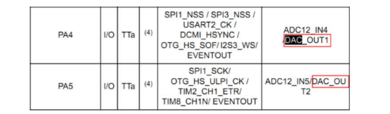
We need to use the ADC to capture the output voltage of the DAC, so we need to short-circuit them on the hardware. The connection schematic diagram of ADC and DAC is shown as follows:
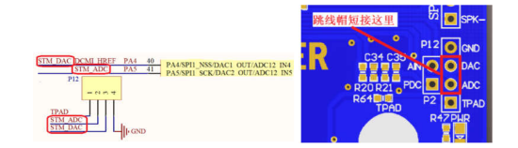
P12 is a multi-function port. We only need to short-circuit ADC and DAC of P14 through jumper cap to start this experiment
2. STM32CubeMX Configures the DAC channel
The contents of new project, clock configuration, software debugging mode and common options of generation engineering in CubeMx are referred to experiment 1.
1) Set ADC channel and DAC channel
ADC1 channel 5 On PA5, select IN5. PA5 is automatically changed to ADC1_IN5.
Select OUT1 Configuration for the DAC channel.
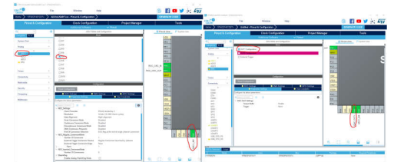
2) Serial port 1, clock configuration, software debugging mode and common options for generation engineering Settings are the same as previous experiments.
3. Software design
Open the CubeMx generated project code in Keil MDK.
1) Modify usart.c to achieve printf() serial port output
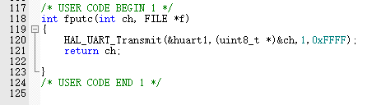
2) Add a header file to maic.c and add two variables to store the values of DAC and ADC
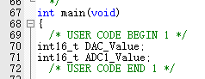
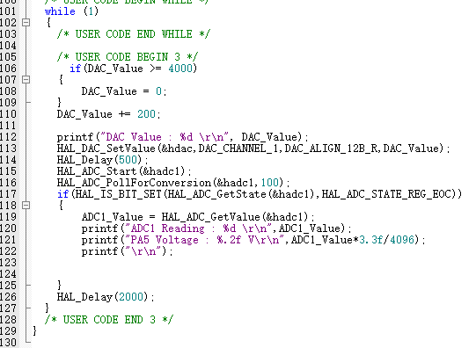

Ⅲ、Experiment Results

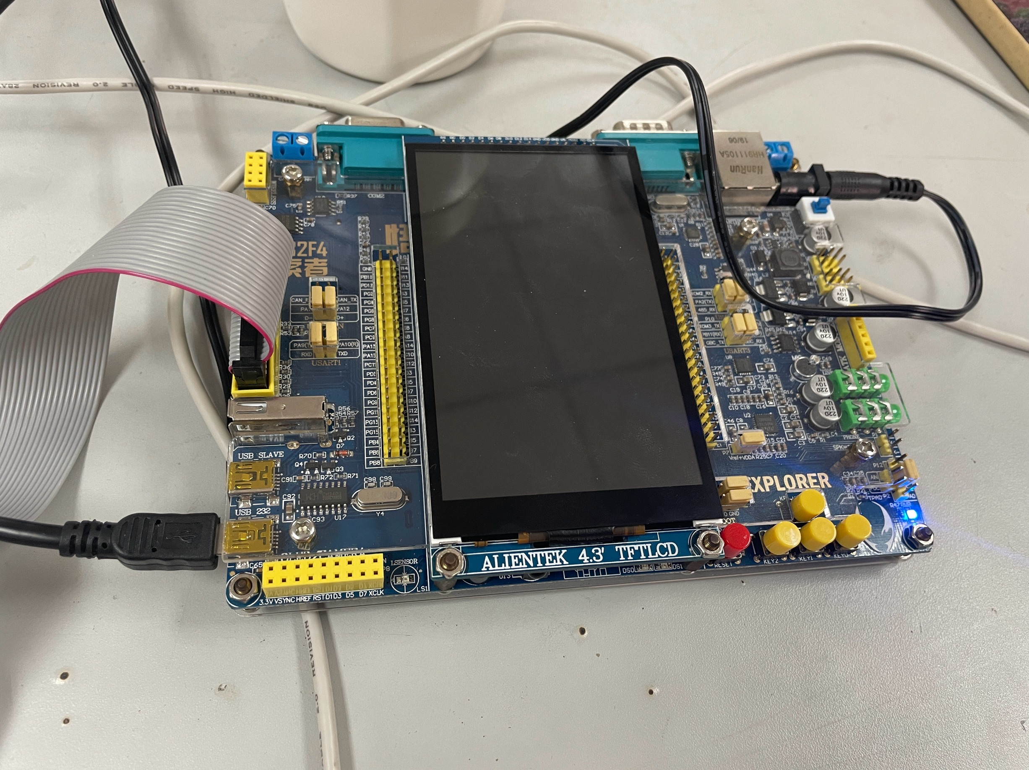
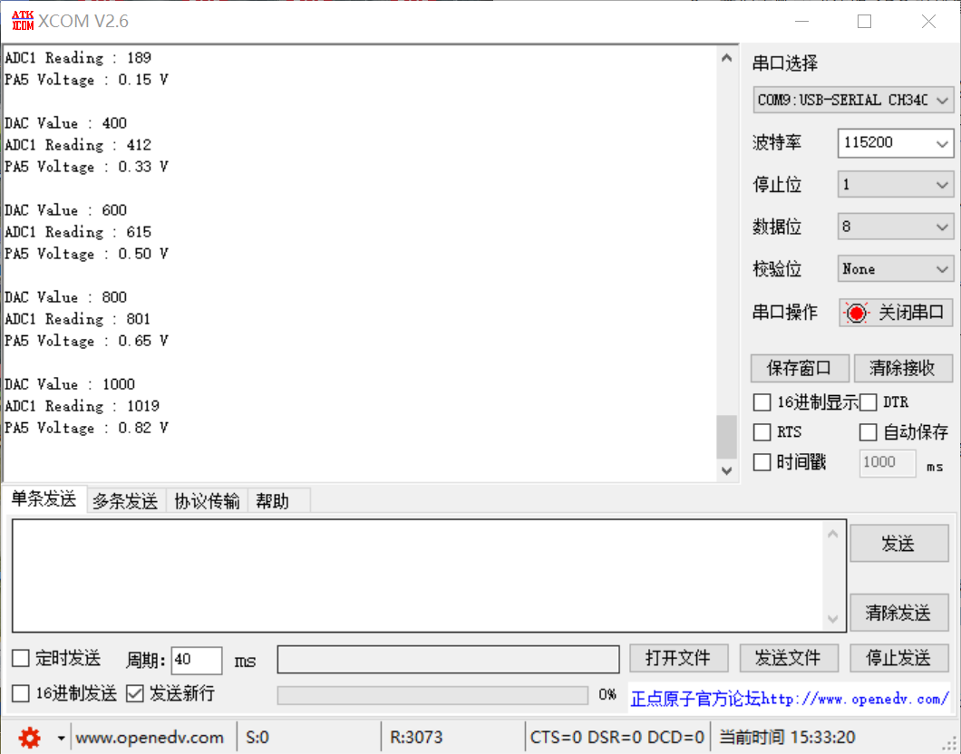

Ⅳ、Experiment Analyses and Conclusions
Through this experiment, I deeply mastered the relevant knowledge of Stm32 SCM ADC DAC, and collected relevant data through SCM and serial assistant. ADC analog-to-digital conversion: converts the input analog signal of the port into a digital signal for easy calculation and display. DAC digital-analog conversion: According to the digital signal, the digital signal is converted to analog signal, and the output from the port is convenient for peripheral control. The STM32F4 DAC module (digital/analog conversion module) is a 12-bit digital input, voltage output DAC. It can be used to measure voltage values, sensor data acquisition and processing. The DAC can be configured in 8-bit or 12-bit mode and can also be used with a DMA controller. When the DAC is operating in 12-bit mode, the data can be set to either left-justified or right-justified. The DAC module has 2 output channels, each with a separate converter. In dual DAC mode, the two channels can be converted independently, or the two channels can be converted simultaneously and the output of both channels can be updated synchronously. The DAC can obtain more accurate conversion results through the pin input reference voltage Vref+ (shared with the ADC). In this experiment, the internal DAC1 of STM32F4 is controlled by keys to output voltage, the output voltage of DAC is collected through channel 5 of ADC1, and the voltage value obtained by ADC and the set output voltage value of DAC are displayed on serial port 1. Through the use of serial assistant, the collected voltage value and other information is output. Through the actual operation of the experiment, I further deepened my understanding of ADC DAC.

Score

