SWU College of Computer and Information Science

Experiment Report 4

Course Name | Embedded Systems
Project Name | FSM design
Grade | 2021 | Major and Class | Automation / Class 01 | Time | 29/11/2023
Student ID | 222021321132005 | Name | 贾博方 | Experiment Type | Comprehensive Practice
I、Experiment Purposes
1. Learn the method to design FSM.
2. Master the basic methods of applying Retro for FSM simulation.
3, master the basic design method of simple CPU;
4. Master the basic methods of using Retro for simple CPU simulation.
Ⅱ、Experiment Contents and Process (Including Experiment Principles, Main Contents and Operation Steps)
Experiment Principles
A finite state machine, also known as a finite automatic state machine, has a finite number of states, each representing a different meaning, and each state can be switched to zero - multiple states. A state machine can be in only one state at any time. A finite state machine can be represented as a directed graph.
In FSM, the output signal at any given moment depends not only on the input signal at that time, but also on the original state of the circuit. The task to be completed in the design of FSM is to solve the simple timing circuit to realize the logic function according to the specific logic problem given, which can be described completely by a set of equation of state, driving equation and output equation. In the use of small-scale ics, the so-called "simplest" is to require the minimum number of triggers and logic gates, and the minimum number of inputs; In the use of large-scale ics, the so-called "simplest" is to require the least number of ics, the least variety, and the least connection between devices.
The design methods and steps for FSM are as follows:
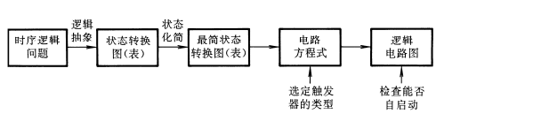
1, logical abstraction, to obtain the circuit state transition diagram or state transition table
● Determines the input/output variables and the number of circuit states.
● Defines the input/output logic states and the meaning of each circuit state and numbers the circuit states sequentially.
● List the state transition table or draw a state transition diagram according to the design requirements.
2. State simplification
● If two states have the same output with the same input and transition to the same secondary state, they are called equal
Valence state; Equivalent states can be merged.
3. State allocation (coding)
● Determines the number of triggers n. If the sequential circuit has M states, then: 2n-1&lt; M ≤ 2n.
● specifies a code for each state.
4, select the trigger type, find the state equation, drive equation, output equation
● Select the type of trigger according to the design requirements.
● According to the state transition table and the selected state code, the type of trigger, write the equation of state of the circuit, driving equation and output equation.
5. Draw a logic diagram
● Draw a logic diagram based on the selected trigger and the resulting equation.
6. Check whether the circuit can start automatically
If the circuit cannot start itself, the logic design needs to be modified.
7.In the Retro software for circuit design
Main Contents
Build a traffic light system in Retro for an intersection of two streets. You only
have to model one traffic light for each of the two streets
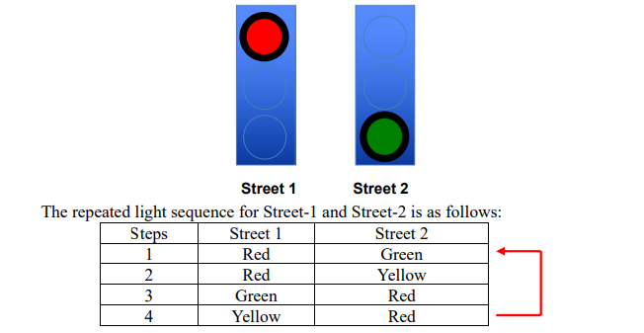
Implement the given task as a state machine using only combinatorial logic elements, flip-flops, and a simple clock to generate the system pulse. Do not worry about actual timing differences between states.
For achieving full marks, minimize the number of gates used.
Get one extra point for using three or less FF and less or equal to 10 gates.
Get one extra point for completing this lab in a new creative way.

Operation Steps
1, logical abstraction, to obtain the circuit state transition diagram or state transition table
● Determines the input/output variables and the number of circuit states. Street one and street two correspond to outputs, so there are 6 outputs and 4 states.
● Defines the input/output logic states and the meaning of each circuit state and numbers the circuit states sequentially.
● List the state transition table or draw a state transition diagram according to the design requirements.
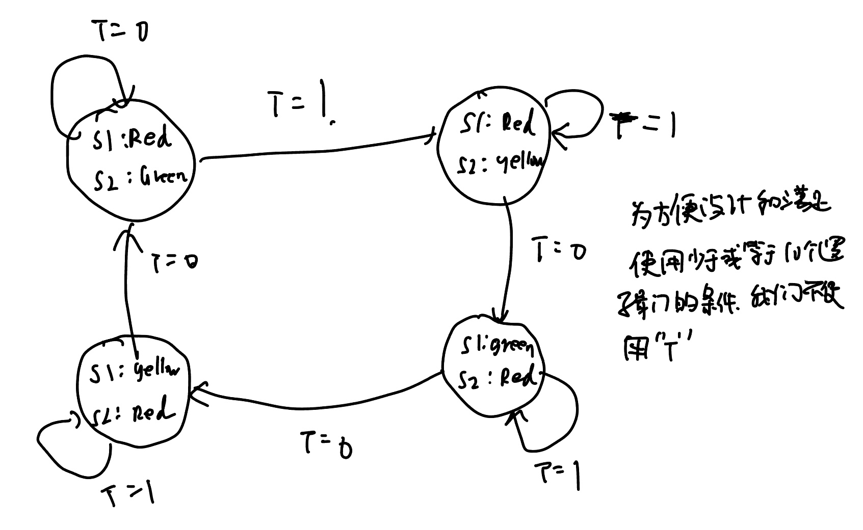
2. State simplification
● If two states have the same output with the same input and transition to the same secondary state, they are called equal
Valence state; Equivalent states can be merged.
3. State allocation (coding)
● Determines the number of triggers n. If the sequential circuit has M states, then: 2n-1&lt; M ≤ 2n.
● specifies a code for each state.
4, select the trigger type, find the state equation, drive equation, output equation
● Select the type of trigger according to the design requirements.
● Write out the state equations, drive equations and output equations of the circuit according to the state transition table and the selected state code and type of trigger. Two D triggers are selected for this experiment
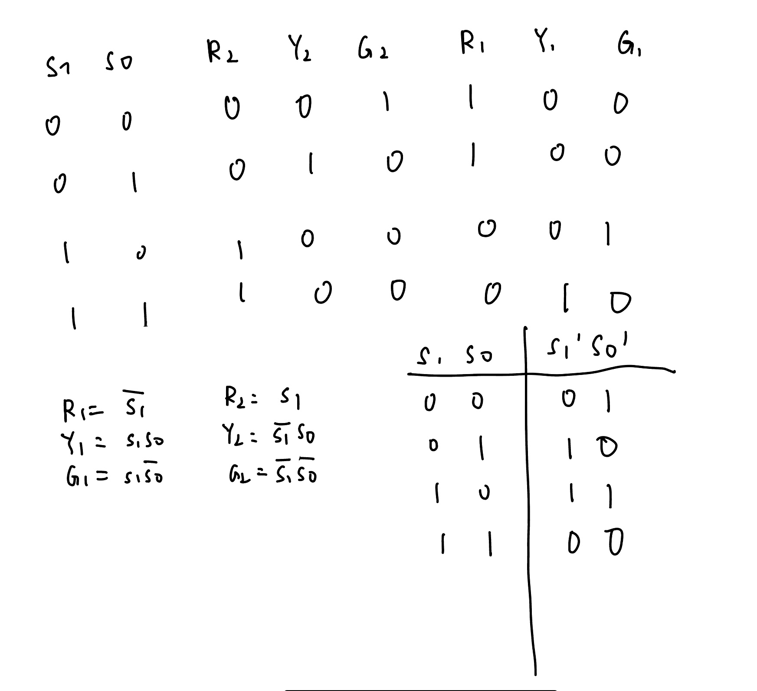
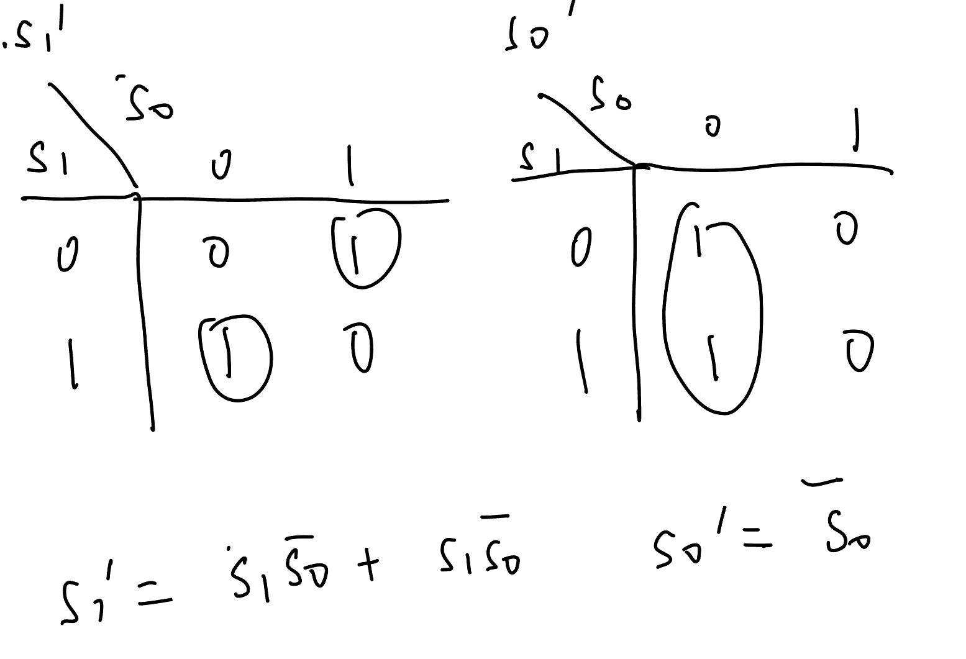
5. Draw a logic diagram
● Draw a logic diagram based on the selected D flip-flop and the resulting equation.
6. Check whether the circuit can start automatically
If the circuit cannot start itself, the logic design needs to be modified.
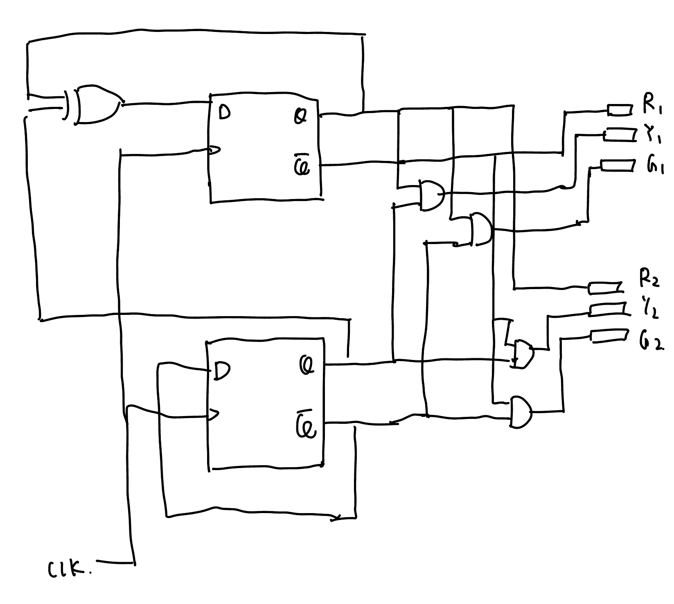
7.In the Retro software for circuit design, at this time we also need to adjust the clock, set the corresponding waveform, to meet the green time is longer than the yellow light
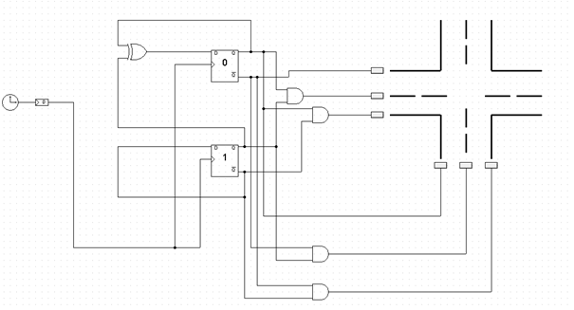

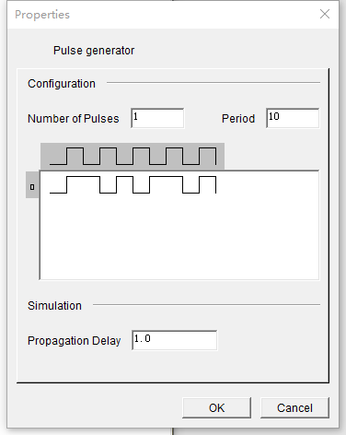

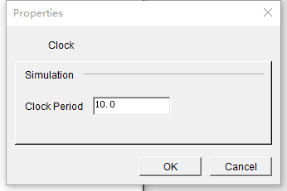

- Build a working CPU
Build a working CPU with 16-bit data bus (8-bit op-codes, and 8-bit operands / 8- bit addresses). Use a 16-bit wide RAM module. Implement the following ALU/CU functions:
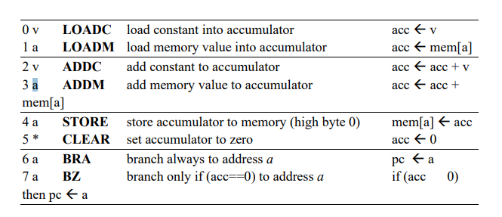
- Write a program
Write a program to calculate 1 + 2 + 3 ... + m, for a given value m with m≥1.
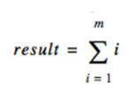
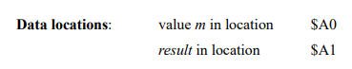
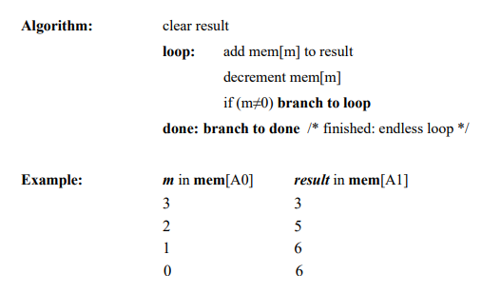
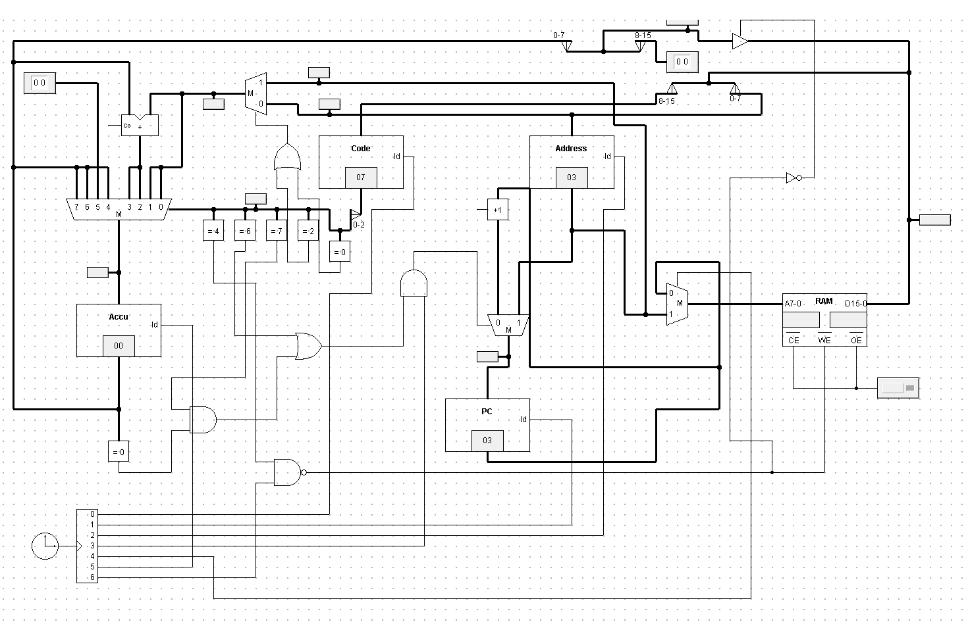
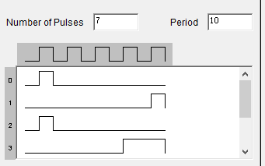
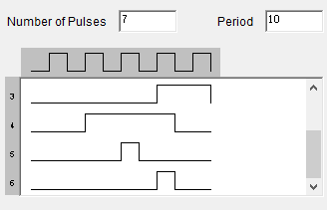

Ⅲ、Experiment Results
Traffic light design
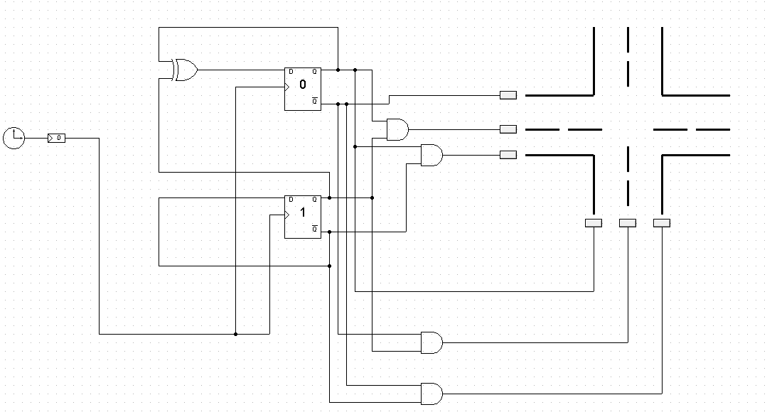
Street 1 ：Red Street 2：Green
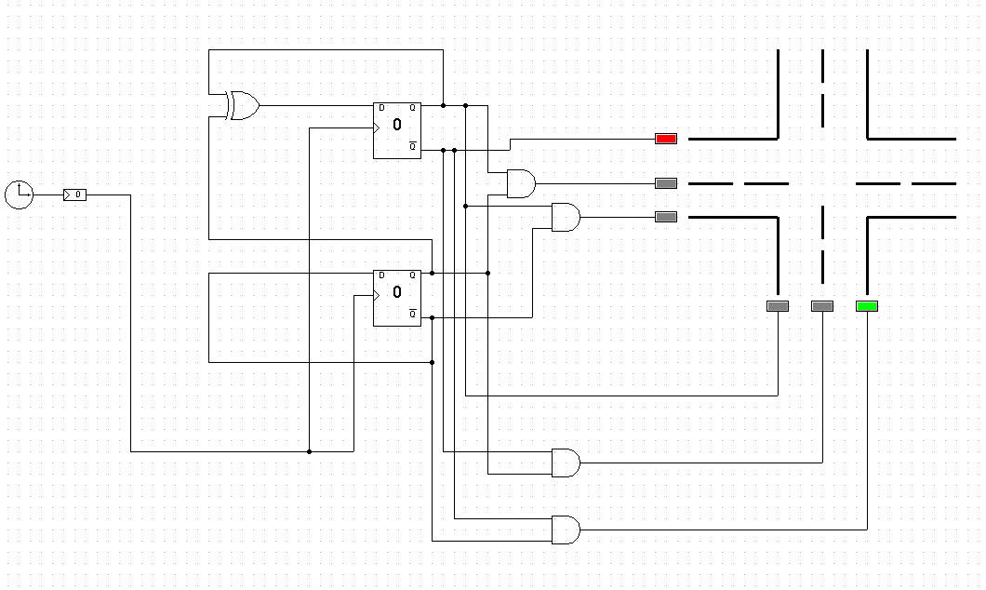
Street 1 ：Red Street 2：Yellow
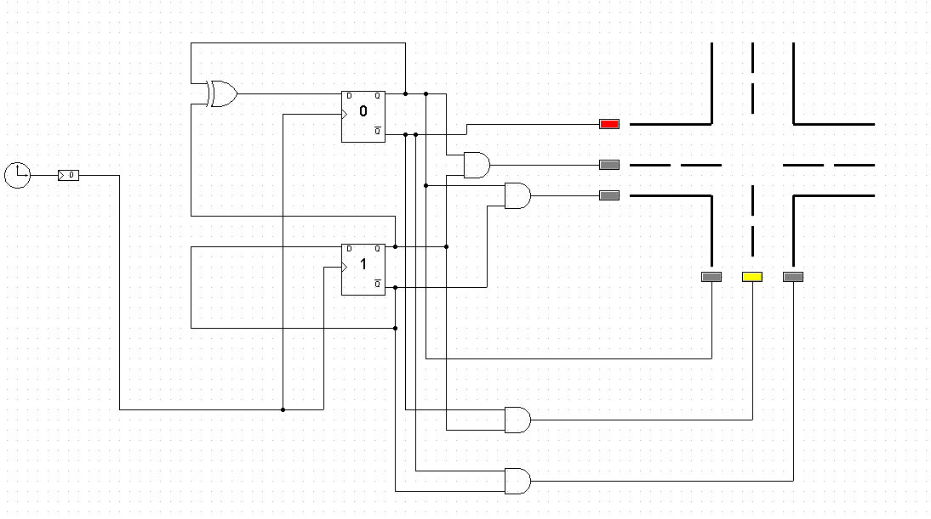
Street 1 ：Green Street 2：Red
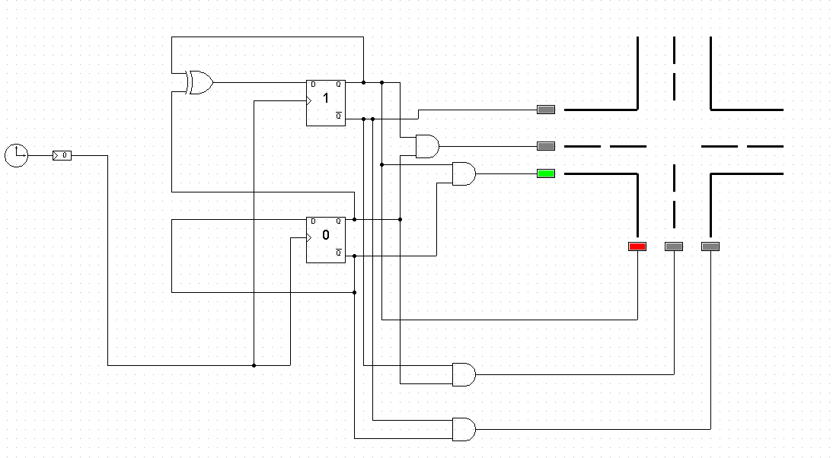
Street 1 ：Yellow Street 2：Red
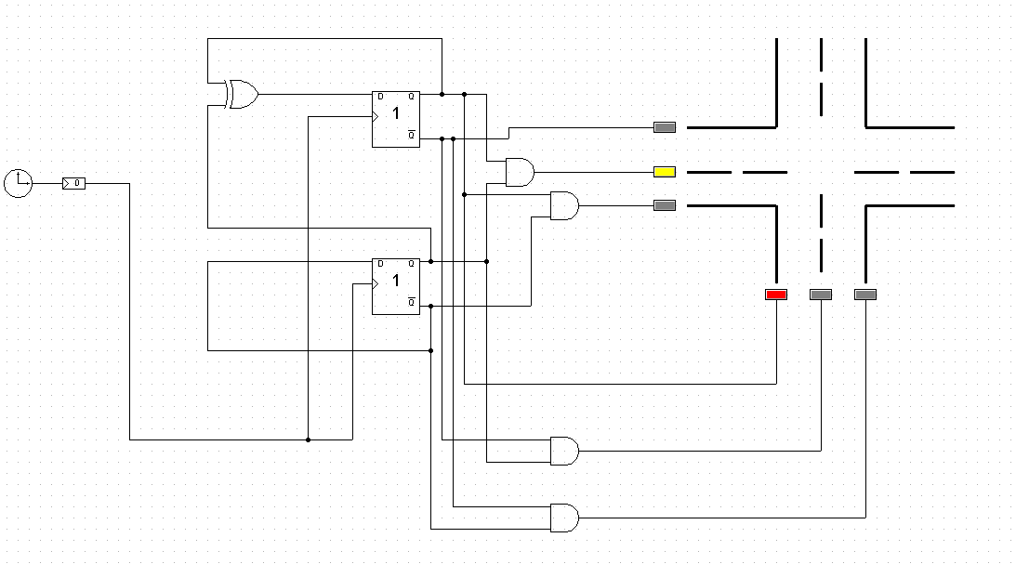
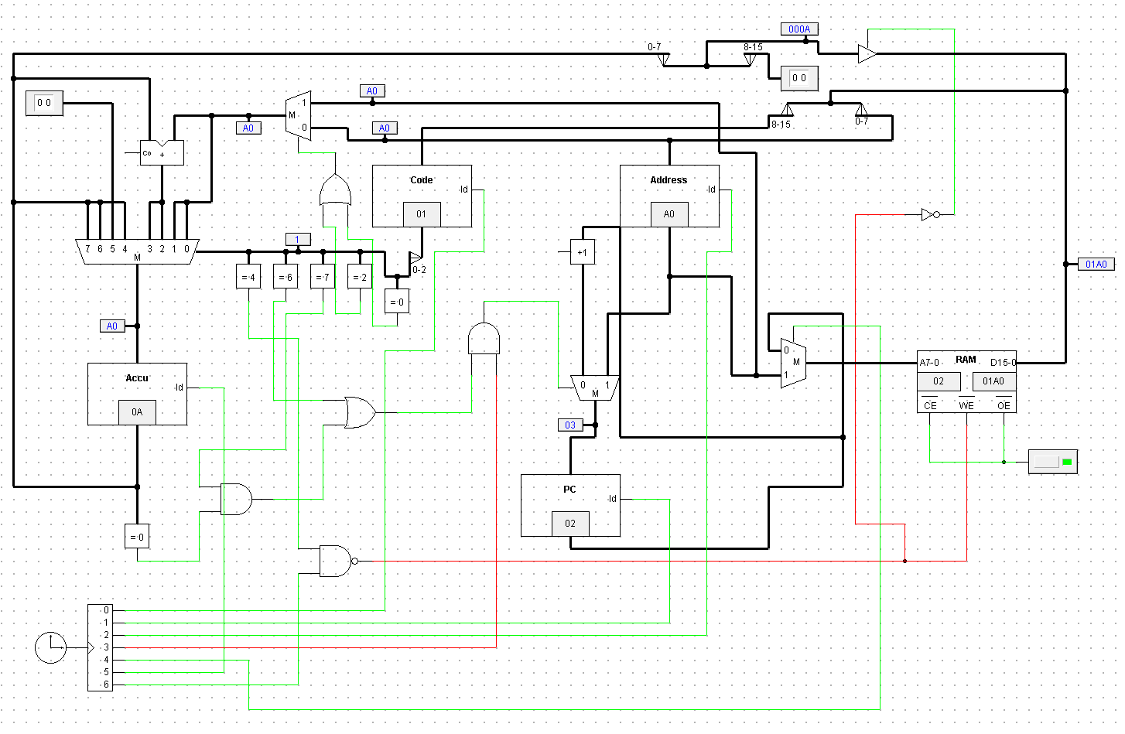
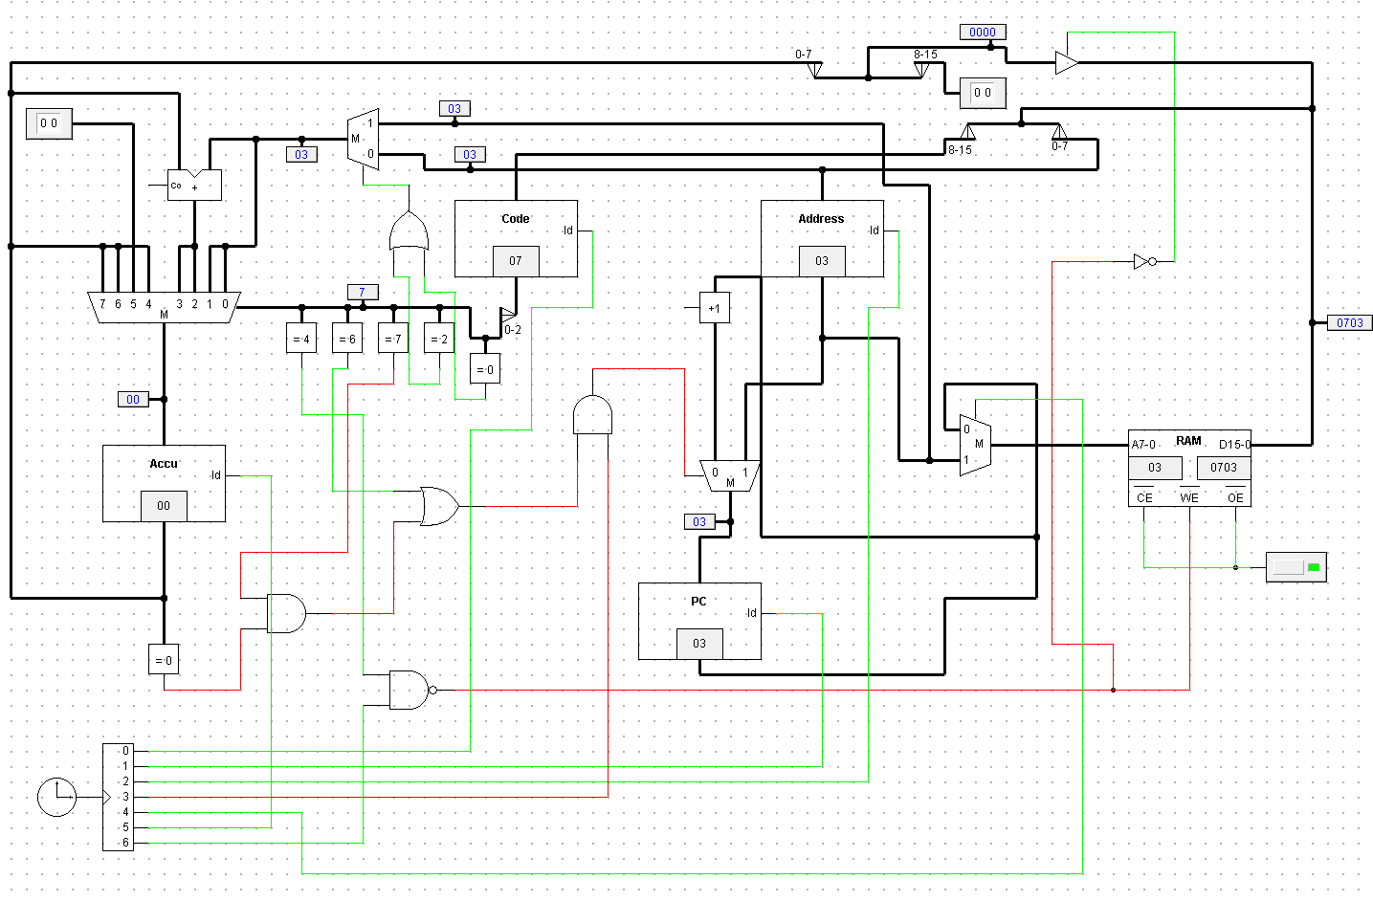
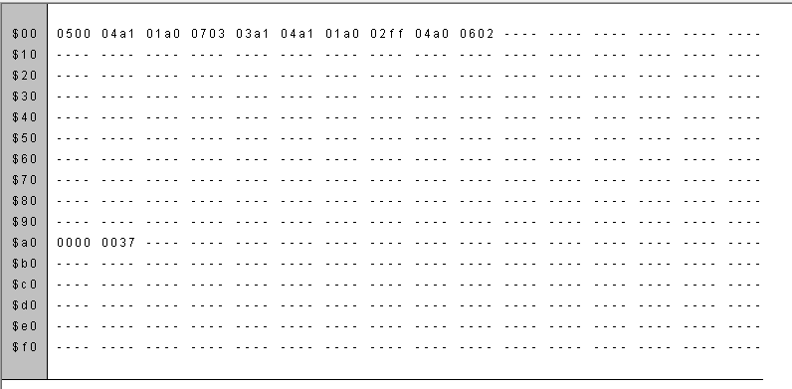
Analyses:
1.Working CPU:
A working CPU with a 16-bit data bus, consisting of 8-bit op-codes and 8-bit operands/addresses, was constructed. Additionally, a 16-bit wide RAM module was utilized. The objective of this experiment was to implement various ALU (Arithmetic Logic Unit) and CU (Control Unit) functions within the CPU.
2.Program Execution:
A program was written to calculate the sum of numbers from 1 to m, where m is a given value greater than or equal to 1. The data locations used in the program were as follows: the value of m was stored in location $A0, and the result of the summation was stored in location $A1.
The algorithm for the program involved clearing the result variable initially. Then, in a loop, the memory location [m] was added to the result variable, and the value of m was decremented. If m was not equal to 0, the program branched back to the loop. Once m became 0, the program branched to the "done" section, which constituted an endless loop.
For example, if the value of m was stored in mem[A0] as 3, the result would be stored in mem[A1] as follows:
Iteration 1: m = 3, result = 3
Iteration 2: m = 2, result = 5
Iteration 3: m = 1, result = 6
Iteration 4: m = 0, result = 6

First, the value in the PC register is 00, at which point all the clocks are 0. So the address bit in RAM is 00, and the corresponding 16-bit data bit is 0500.
The first clock cycle
With the clock lines 0 and 2 being high, the high octet 05 is read by the code register and the low octet 00 is read by the address register. Then the clock signal 4 is high, the binary multiplexer is high, end 1 is read, still 00. Then the clock signal 5 is high, the accumulator value 00 is read. Then the clock signal line 3 and 6 are high, the binary multiplexer input 1 end of the data, the RAM address end is still 00, with the clock signal line 1 is high, the PC register 01 is read, the RAM address end is 01. The corresponding data end is 04A1, and a clock period ends.
Second clock cycle
At this time 04A1 is sent to the data bus via RAM, with clock lines 0 and 2 being high, the high octet 04 is read by the code register, and the low octet A1 is read by the address register. Then the clock signal 4 is high, the binary multiplexer is high, end 1 is read, and the address end of RAM is A1. A1 corresponds to 0000, so the data side of RAM is updated to 0000. The clock signal 5 is then high and the accumulator's value 00 is read. Clock signal 4 is still high, the binary multiplexer is changed to a 1-terminal input, and 00 on the data line is changed to A1. Then the clock signal line 3 and 6 are high, the binary multiplexer input 1 end of the data, the RAM address end is still A1, the PC register 01 is read, the RAM address end is 01. The corresponding data end is 04A1, and as the clock signal line 1 is high, the binary multiplexer is read as 03, and the original 02 is sent to the address end of the RAM by the PC register, and the corresponding data end of the RAM is 01A0, at which time a clock cycle ends.
The third clock cycle
At this time, 01A0 is sent to the data bus through RAM, and with clock lines 0 and 2 being high, the high octet 01 is read by the code register, and the low octet A0 is read by the address register. Then the clock signal 4 is high, the binary multiplexer is high, end 1 is read, and the address end of RAM is A0. The data corresponding to A0 is 000A, so the data end of RAM is updated to 000A, and the high eight bits on the corresponding data line are 00 and the low eight bits are 0A. Then the clock signal 5 is high, the corresponding opcode on the code side is 01, and the corresponding operation is to read the value on the corresponding binary multiplexer, that is, 0A, which is read into the accumulator, and then output. Then the clock signal line 3 and 6 are high, the binary multiplexer input 1 end of the data, the RAM address end is still A0, the PC register 02 is read, the RAM address end is 02. The corresponding data end is 01A0. As the clock signal line 1 becomes high, the binary multiplexer is read as 04, and the original 03 is sent by the PC register to the address side of RAM, and the corresponding data side of RAM is 0703, at which time a clock cycle ends.
Fourth clock cycle
At this time 0703 is sent to the data bus via RAM, with clock lines 0 and 2 being high, the high octet 07 is read by the code register, and the low octet 03 is read by the address register. Then the clock signal 4 is high, the binary multiplexer is high, end 1 is read, and 03 is sent to the data line. Then the clock signal 5 is high, the corresponding opcode on the code side is 07, and the corresponding operation is to read the value on the corresponding binary multiplexer, that is, 0A, which is read into the accumulator, and then output. Then the clock signal line 3 and 6 are high, the binary multiplexer input 1 end of the data, the RAM address end is still 03, the PC register 04 is read, the RAM address end is 03 corresponding to the data end 0703. As the clock signal line 1 becomes high, the binary multiplexer is read as 05, and the original 04 is sent by the PC register to the address end of the RAM, and the corresponding data end of the RAM is 03A1, at which time a clock cycle ends.
Fifth clock cycle
At this time 03A1 is sent to the data bus via RAM, with clock lines 0 and 2 being high, the high octet 03 is read by the code register, and the low octet A1 is read by the address register. Then the clock signal 4 is high, the binary multiplexer is high, end 1 is read, and A1 is sent to the data line. A1 is read into the address end of RAM, and the corresponding data end is 000A. Then the clock signal 5 is high, the corresponding opcode on the code side is 03, and the corresponding operation is to read the value on the corresponding binary multiplexer, that is, A1, which is read into the accumulator, and 0A and A1 are added to get AB. At this time, the clock signal 4 is still high, the data of the RAM data segment is sent to the data bus, the corresponding opcode on the code side is 03, the corresponding operation is to read the value on the corresponding binary multiplexer, that is, 00, is read into the accumulator, 0A and 00 are added to get 0A. Then the clock signal line 3 and 6 are high, the binary multiplexer input 1 end of the data, the RAM address end is still 04, the PC register 05 is read, the RAM address end 04 corresponding to the data end 03A1. As the clock line 1 becomes high, the binary multiplexer is read as 06, and the original 05 is sent by the PC register to the address end of RAM, and the corresponding data end of RAM is 04A1, at which time a clock cycle ends.
The sixth clock cycle
At this time 04A1 is sent to the data bus via RAM, with clock lines 0 and 2 being high, the high octet 04 is read by the code register, and the low octet A1 is read by the address register. Then the clock signal 4 is high, the binary multiplexer is high, end 1 is read, and A1 is sent to the data line. A1 is read into the address end of RAM, and the corresponding data end is 000A. Then the clock signal 5 is high, the corresponding opcode on the code side is 04, and the corresponding operation is to read the value on the corresponding binary multiplexer, that is, 0A, which is read into the accumulator. At this time, the clock signal 4 is still high, the data of the RAM data segment is sent to the data bus, the corresponding opcode on the code side is 04, and the corresponding operation is to read the corresponding value on the binary multiplexer, that is, 0A is read into the accumulator. Then the clock signal line 3 and 6 are high, the binary multiplexer inputs 1 end data, the RAM address end is A1, the data end is 000A, the binary multiplexer inputs 1 end data, the RAM address end is still 05, the PC register 06 is read, the RAM address end is 05 corresponding to the data end 04A1. As the clock signal line 1 becomes high, the binary multiplexer is read as 07, and the original 06 is sent by the PC register to the address end of the RAM, and the corresponding data end of the RAM is 01A0, at which time a clock cycle ends.
The seventh clock cycle
At this time, 01A0 is sent to the data bus through RAM, and with clock lines 0 and 2 being high, the high octet 01 is read by the code register, and the low octet A0 is read by the address register. Then the clock signal 4 is high, the binary multiplexer is high, end 1 is read, and A0 is sent to the data line. A0 is read into the address end of RAM, and the corresponding data end is 0000. Then the clock signal 5 is high, the corresponding opcode on the code side is 01, and the corresponding operation is to read the value on the corresponding binary multiplexer, that is, 0A, which is read into the accumulator. At this time, the clock signal 4 is still high, the data of the RAM data segment is sent to the data bus, the corresponding opcode on the code side is 04, and the corresponding operation is to read the corresponding value on the binary multiplexer, that is, 0A is read into the accumulator. End 1 of the binary multiplexer is read, and A0 enters the address end of RAM. Then the clock signal line 3 and 6 are high, the binary multiplexer inputs 1 end data, the RAM address end is A0, the data end is 000A, the binary multiplexer inputs 1 end data, the RAM address end is still 06, the PC register 07 is read, the RAM address end is 06 corresponding to the data end 01A0. As the clock signal line 1 is high, the binary multiplexer is read as 08, and the original 07 is sent by the PC register to the address end of RAM, and the corresponding data end of RAM is 02FF, at which time a clock cycle ends.
The eighth clock cycle
At this time 02FF is sent to the data bus via RAM, with clock lines 0 and 2 being high, the high octet 02 is read by the code register, and the low octet FF is read by the address register. Then the clock signal 4 is high, the binary multiplexer is high, end 1 is read, and FF is sent to the data line. FF is read into the address side of RAM. Then the clock signal 5 is high, the corresponding opcode on the code side is 02, and the corresponding operation is to read the value on the corresponding binary multiplexer, that is, the sum of 09 and FF (-1), and the result is 08, which is read into the accumulator. At this time, the clock signal 4 is still high, the data of the RAM data segment is sent to the data bus, the corresponding opcode on the code side is 04, and the corresponding operation is to read the corresponding value on the binary multiplexer, that is, 0A is read into the accumulator. End 1 of the binary multiplexer is read, and 07 enters the address end of RAM. Then the clock signal line 3 and 6 are high, the binary multiplexer inputs 1 end of data, the RAM address end is 07, the data end is 02FF, the binary multiplexer inputs 1 end of data, the RAM address end is still 07, the PC register is read in 08, the RAM address end is 07 corresponding to the data end is 02FF. As the clock signal line 1 is high, the binary multiplexer is read as 09, and the original 08 is sent to the address end of the RAM by the PC register, and the corresponding RAM data end is 04A0, at which time a clock cycle ends.
The ninth clock cycle
At this time 04A0 is sent to the data bus through RAM, with clock lines 0 and 2 being high, the high octet 04 is read by the code register, and the low octet A0 is read by the address register. Then the clock signal 4 is high, the binary multiplexer is high, end 1 is read, and A0 is sent to the data line. A0 is read into the address end of RAM. A0 is read into the address end of RAM. Then the clock signal 5 is high, the corresponding opcode on the code side is 04, and the corresponding operation is to read the value on the corresponding binary multiplexer, that is, 09 read into the accumulator. At this time, the clock signal 4 is still high, the data of the RAM data segment is sent to the data bus, the corresponding opcode on the code side is 04, and the corresponding operation is to read the corresponding value on the binary multiplexer, that is, 0A is read into the accumulator. End 1 of the binary multiplexer is read, and A0 enters the address end of RAM. Then the clock signal line 3 and 6 are high, the binary multiplexer inputs 1 end data, the RAM address end is A0, the data end is 000A, the binary multiplexer inputs 1 end data, the RAM address end is still 08, the PC register is read in 09, the RAM address end is 08 corresponding to the data end is 04A0. As the clock line 1 becomes high, the binary multiplexer is read as 10, and the original 09 is sent by the PC register to the address side of RAM, where the corresponding RAM data side is 0602, at which time a clock cycle ends.
The tenth clock cycle
At this time 0602 is sent to the data bus via RAM, with clock lines 0 and 2 being high, the high octet 06 is read by the code register, and the low octet 02 is read by the address register. Then the clock signal 4 is high, the binary multiplexer is high, end 1 is read, and 02 is sent to the data line. 02 is read into the address end of the RAM, and the data end of the RAM is 01A0. Then the clock signal 5 is high, the corresponding opcode on the code side is 06, and the corresponding operation is to read the value on the corresponding binary multiplexer, that is, 09 read into the accumulator. At this time, the clock signal 4 is still high, the data of the RAM data segment is sent to the data bus, the corresponding opcode on the code side is 06, and the corresponding operation is to read the corresponding value on the binary multiplexer, that is, 09 is read into the accumulator. End 1 of the binary multiplexer is read and 09 enters the address end of RAM. Then the clock signal line 3 and 6 are high, the binary multiplexer input 1 end of data, the RAM address end of 09, the data end of 0602, the binary multiplexer input 1 end of data, the RAM address end of 09 is still 09, the PC register 10 is read, the RAM address end of 09 corresponding to the data end of 0602.

Ⅳ、Experiment Analyses and Conclusions
Traffic light design
Through this experiment, I reviewed and deepened the knowledge of FSM, and realized the self-starting of traffic lights through practical application. In this experiment, we need to design the state diagram and state table, determine the corresponding state, and determine the requirements to ensure that the use of logic gates is less than or equal to 10, if the time condition is added as input, at least 12 logic gates need to be set, so the time condition input cannot be included. In addition, we also need to select the type of trigger. In this experiment, we chose D-trigger, wrote out the output equation according to the state table and Carnaugh diagram, and then drew the corresponding sketch. Finally, simulation is carried out on Retro to realize the corresponding functions. We also need to set the corresponding clock, while considering the actual situation of the red and green time is longer than the yellow light, so we should adhere to this principle when setting the clock. Finally, through this experiment, the relevant knowledge of FSM has been deepened and applied in practice.

CPU design
First, the value in the PC register is 00, at which point all the clocks are 0. So the address bit in RAM is 00, and the corresponding 16-bit data bit is 0500.
The first clock cycle
With the clock lines 0 and 2 being high, the high octet 05 is read by the code register and the low octet 00 is read by the address register. Then the clock signal 4 is high, the binary multiplexer is high, end 1 is read, still 00. Then the clock signal 5 is high, the accumulator value 00 is read. Then the clock signal line 3 and 6 are high, the binary multiplexer input 1 end of the data, the RAM address end is still 00, with the clock signal line 1 is high, the PC register 01 is read, the RAM address end is 01. The corresponding data end is 04A1, and a clock period ends.
Second clock cycle
At this time 04A1 is sent to the data bus via RAM, with clock lines 0 and 2 being high, the high octet 04 is read by the code register, and the low octet A1 is read by the address register. Then the clock signal 4 is high, the binary multiplexer is high, end 1 is read, and the address end of RAM is A1. A1 corresponds to 0000, so the data side of RAM is updated to 0000. The clock signal 5 is then high and the accumulator's value 00 is read. Clock signal 4 is still high, the binary multiplexer is changed to a 1-terminal input, and 00 on the data line is changed to A1. Then the clock signal line 3 and 6 are high, the binary multiplexer input 1 end of the data, the RAM address end is still A1, the PC register 01 is read, the RAM address end is 01. The corresponding data end is 04A1, and as the clock signal line 1 is high, the binary multiplexer is read as 03, and the original 02 is sent to the address end of the RAM by the PC register, and the corresponding data end of the RAM is 01A0, at which time a clock cycle ends.
The third clock cycle
At this time, 01A0 is sent to the data bus through RAM, and with clock lines 0 and 2 being high, the high octet 01 is read by the code register, and the low octet A0 is read by the address register. Then the clock signal 4 is high, the binary multiplexer is high, end 1 is read, and the address end of RAM is A0. The data corresponding to A0 is 000A, so the data end of RAM is updated to 000A, and the high eight bits on the corresponding data line are 00 and the low eight bits are 0A. Then the clock signal 5 is high, the corresponding opcode on the code side is 01, and the corresponding operation is to read the value on the corresponding binary multiplexer, that is, 0A, which is read into the accumulator, and then output. Then the clock signal line 3 and 6 are high, the binary multiplexer input 1 end of the data, the RAM address end is still A0, the PC register 02 is read, the RAM address end is 02. The corresponding data end is 01A0. As the clock signal line 1 becomes high, the binary multiplexer is read as 04, and the original 03 is sent by the PC register to the address side of RAM, and the corresponding data side of RAM is 0703, at which time a clock cycle ends.
Fourth clock cycle
At this time 0703 is sent to the data bus via RAM, with clock lines 0 and 2 being high, the high octet 07 is read by the code register, and the low octet 03 is read by the address register. Then the clock signal 4 is high, the binary multiplexer is high, end 1 is read, and 03 is sent to the data line. Then the clock signal 5 is high, the corresponding opcode on the code side is 07, and the corresponding operation is to read the value on the corresponding binary multiplexer, that is, 0A, which is read into the accumulator, and then output. Then the clock signal line 3 and 6 are high, the binary multiplexer input 1 end of the data, the RAM address end is still 03, the PC register 04 is read, the RAM address end is 03 corresponding to the data end 0703. As the clock signal line 1 becomes high, the binary multiplexer is read as 05, and the original 04 is sent by the PC register to the address end of the RAM, and the corresponding data end of the RAM is 03A1, at which time a clock cycle ends.
Fifth clock cycle
At this time 03A1 is sent to the data bus via RAM, with clock lines 0 and 2 being high, the high octet 03 is read by the code register, and the low octet A1 is read by the address register. Then the clock signal 4 is high, the binary multiplexer is high, end 1 is read, and A1 is sent to the data line. A1 is read into the address end of RAM, and the corresponding data end is 000A. Then the clock signal 5 is high, the corresponding opcode on the code side is 03, and the corresponding operation is to read the value on the corresponding binary multiplexer, that is, A1, which is read into the accumulator, and 0A and A1 are added to get AB. At this time, the clock signal 4 is still high, the data of the RAM data segment is sent to the data bus, the corresponding opcode on the code side is 03, the corresponding operation is to read the value on the corresponding binary multiplexer, that is, 00, is read into the accumulator, 0A and 00 are added to get 0A. Then the clock signal line 3 and 6 are high, the binary multiplexer input 1 end of the data, the RAM address end is still 04, the PC register 05 is read, the RAM address end 04 corresponding to the data end 03A1. As the clock line 1 becomes high, the binary multiplexer is read as 06, and the original 05 is sent by the PC register to the address end of RAM, and the corresponding data end of RAM is 04A1, at which time a clock cycle ends.
The sixth clock cycle
At this time 04A1 is sent to the data bus via RAM, with clock lines 0 and 2 being high, the high octet 04 is read by the code register, and the low octet A1 is read by the address register. Then the clock signal 4 is high, the binary multiplexer is high, end 1 is read, and A1 is sent to the data line. A1 is read into the address end of RAM, and the corresponding data end is 000A. Then the clock signal 5 is high, the corresponding opcode on the code side is 04, and the corresponding operation is to read the value on the corresponding binary multiplexer, that is, 0A, which is read into the accumulator. At this time, the clock signal 4 is still high, the data of the RAM data segment is sent to the data bus, the corresponding opcode on the code side is 04, and the corresponding operation is to read the corresponding value on the binary multiplexer, that is, 0A is read into the accumulator. Then the clock signal line 3 and 6 are high, the binary multiplexer inputs 1 end data, the RAM address end is A1, the data end is 000A, the binary multiplexer inputs 1 end data, the RAM address end is still 05, the PC register 06 is read, the RAM address end is 05 corresponding to the data end 04A1. As the clock signal line 1 becomes high, the binary multiplexer is read as 07, and the original 06 is sent by the PC register to the address end of the RAM, and the corresponding data end of the RAM is 01A0, at which time a clock cycle ends.
The seventh clock cycle
At this time, 01A0 is sent to the data bus through RAM, and with clock lines 0 and 2 being high, the high octet 01 is read by the code register, and the low octet A0 is read by the address register. Then the clock signal 4 is high, the binary multiplexer is high, end 1 is read, and A0 is sent to the data line. A0 is read into the address end of RAM, and the corresponding data end is 0000. Then the clock signal 5 is high, the corresponding opcode on the code side is 01, and the corresponding operation is to read the value on the corresponding binary multiplexer, that is, 0A, which is read into the accumulator. At this time, the clock signal 4 is still high, the data of the RAM data segment is sent to the data bus, the corresponding opcode on the code side is 04, and the corresponding operation is to read the corresponding value on the binary multiplexer, that is, 0A is read into the accumulator. End 1 of the binary multiplexer is read, and A0 enters the address end of RAM. Then the clock signal line 3 and 6 are high, the binary multiplexer inputs 1 end data, the RAM address end is A0, the data end is 000A, the binary multiplexer inputs 1 end data, the RAM address end is still 06, the PC register 07 is read, the RAM address end is 06 corresponding to the data end 01A0. As the clock signal line 1 is high, the binary multiplexer is read as 08, and the original 07 is sent by the PC register to the address end of RAM, and the corresponding data end of RAM is 02FF, at which time a clock cycle ends.
The eighth clock cycle
At this time 02FF is sent to the data bus via RAM, with clock lines 0 and 2 being high, the high octet 02 is read by the code register, and the low octet FF is read by the address register. Then the clock signal 4 is high, the binary multiplexer is high, end 1 is read, and FF is sent to the data line. FF is read into the address side of RAM. Then the clock signal 5 is high, the corresponding opcode on the code side is 02, and the corresponding operation is to read the value on the corresponding binary multiplexer, that is, the sum of 09 and FF (-1), and the result is 08, which is read into the accumulator. At this time, the clock signal 4 is still high, the data of the RAM data segment is sent to the data bus, the corresponding opcode on the code side is 04, and the corresponding operation is to read the corresponding value on the binary multiplexer, that is, 0A is read into the accumulator. End 1 of the binary multiplexer is read, and 07 enters the address end of RAM. Then the clock signal line 3 and 6 are high, the binary multiplexer inputs 1 end of data, the RAM address end is 07, the data end is 02FF, the binary multiplexer inputs 1 end of data, the RAM address end is still 07, the PC register is read in 08, the RAM address end is 07 corresponding to the data end is 02FF. As the clock signal line 1 is high, the binary multiplexer is read as 09, and the original 08 is sent to the address end of the RAM by the PC register, and the corresponding RAM data end is 04A0, at which time a clock cycle ends.
The ninth clock cycle
At this time 04A0 is sent to the data bus through RAM, with clock lines 0 and 2 being high, the high octet 04 is read by the code register, and the low octet A0 is read by the address register. Then the clock signal 4 is high, the binary multiplexer is high, end 1 is read, and A0 is sent to the data line. A0 is read into the address end of RAM. A0 is read into the address end of RAM. Then the clock signal 5 is high, the corresponding opcode on the code side is 04, and the corresponding operation is to read the value on the corresponding binary multiplexer, that is, 09 read into the accumulator. At this time, the clock signal 4 is still high, the data of the RAM data segment is sent to the data bus, the corresponding opcode on the code side is 04, and the corresponding operation is to read the corresponding value on the binary multiplexer, that is, 0A is read into the accumulator. End 1 of the binary multiplexer is read, and A0 enters the address end of RAM. Then the clock signal line 3 and 6 are high, the binary multiplexer inputs 1 end data, the RAM address end is A0, the data end is 000A, the binary multiplexer inputs 1 end data, the RAM address end is still 08, the PC register is read in 09, the RAM address end is 08 corresponding to the data end is 04A0. As the clock line 1 becomes high, the binary multiplexer is read as 10, and the original 09 is sent by the PC register to the address side of RAM, where the corresponding RAM data side is 0602, at which time a clock cycle ends.
The tenth clock cycle
At this time 0602 is sent to the data bus via RAM, with clock lines 0 and 2 being high, the high octet 06 is read by the code register, and the low octet 02 is read by the address register. Then the clock signal 4 is high, the binary multiplexer is high, end 1 is read, and 02 is sent to the data line. 02 is read into the address end of the RAM, and the data end of the RAM is 01A0. Then the clock signal 5 is high, the corresponding opcode on the code side is 06, and the corresponding operation is to read the value on the corresponding binary multiplexer, that is, 09 read into the accumulator. At this time, the clock signal 4 is still high, the data of the RAM data segment is sent to the data bus, the corresponding opcode on the code side is 06, and the corresponding operation is to read the corresponding value on the binary multiplexer, that is, 09 is read into the accumulator. End 1 of the binary multiplexer is read and 09 enters the address end of RAM. Then the clock signal line 3 and 6 are high, the binary multiplexer input 1 end of data, the RAM address end of 09, the data end of 0602, the binary multiplexer input 1 end of data, the RAM address end of 09 is still 09, the PC register 10 is read, the RAM address end of 09 corresponding to the data end of 0602.

Score

