SWU College of Computer and Information Science

Experiment Report 5

Course Name | Embedded Systems
Project Name | STM32 Timer and Its Application
Grade | 2021 | Major and Class | Automation / Class 01 | Time | 13/12/2023
Student ID | 222021321132005 | Name | 贾博方 | Experiment Type | Comprehensive Practice
I、Experiment Purposes
1. Learn the working principle and configuration method for STM32 general-purpose timers;
2. Master the method to achieve timer interrupt and PWM output based on general-purpose timers by programming.
Ⅱ、Experiment Contents and Process (Including Experiment Principles, Main Contents and Operation Steps)
Experiment Principles

1. Learn the basic principle and configuration of STM32 timer;
2.master the use of TIM interrupt open function;
3.master the use of timer interrupt callback function
4.Familiar with the programming method of PWM output (LED brightness adjustment) using STM32 universal timer.

Main Contents
The STM32F4 timing function is very strong, there are TIME1 and TIME8 and other high-level timing devices, there are also
TIME2~TIME5, TIM9~TIM14 and other general timers, as well as TIME6 and TIME7 and other basic timers, total up to
As many as 14 timers.
The STM32F4 universal timer can be used to measure the pulse length of the input signal (input capture) or to generate output
Waveform (output comparison and PWM), etc. Use timer pre-divider and RCC clock controller pre-divider, pulse length
And waveform periods can be adjusted from a few microseconds to a few milliseconds. Each of the STM32F4's universal timers is completely self-contained
No resources are shared with each other.
The STM32's universal TIMx (TIM2 to TIM5 and TIM9 to TIM14) timer features include:
1) 16 bit /32 bit (TIM2 and TIM5 only) up, down, up/down automatic loading counter (TIMx_CNT),
Note: TIM9~TIM14 only supports upward (increasing) counting.
2) 16-bit programmable (can be modified in real time) pre-divider (TIMx_PSC), the frequency dividing coefficient of the counter clock frequency is
It is a value ranging from 1 to 65535.
3) 4 independent channels (TIMx_CH1~4, TIM9~TIM14 up to 2 channels), these channels can be used for
The for:
A. Input capture
B. Output comparison
C.P generation (edge or middle alignment mode), note: TIM9~TIM14 does not support middle alignment mode
D. Monopulse mode output
4) The external signal (TIMx_ETR) can be used to control the timer and the timer interconnection (can be controlled with 1 timer
Another timer) synchronization circuit.
5) Interrupt /DMA occurs when the following events occur (TIM9~TIM14 do not support DMA) :
A. Update: Counter overflow up/down, counter initialization (triggered by software or internal/external)
B. Trigger events (counters start, stop, initialize, or count by internal/external trigger)
C. Input capture
D. Output comparison
E. Support for incremental (orthogonal) encoders and Hall sensor circuits for positioning (TIM9~TIM14 not supported)
F. Trigger input as external clock or periodic current management (TIM9~TIM14 not supported)

Pulse Width Modulation (PWM), short for "Pulse width modulation", is a very effective technique for controlling analog circuits using the digital output of microprocessors, widely used in many fields from measurement and communication to power control and conversion.
SMT32F4 series has a total of 15 timers: advanced timers (TIM1, TIM8); Universal timers (TIM2, TIM3, TIM4, TIM5, TIM9~TIM14); Basic timers (TIM6, TIM7). Each universal timer of STM32 has four independent channels that can be used as: input capture, output comparison, PWM output, monopulse mode output, etc. STM32 timers except TIM6 and TIM7 (basic timers), other timers can produce PWM output. Among them, the advanced timers TIM1 and TIM8 can generate 7 PWM outputs at the same time.
The following is an example of upward counting, a brief description of the working principle of PWM:
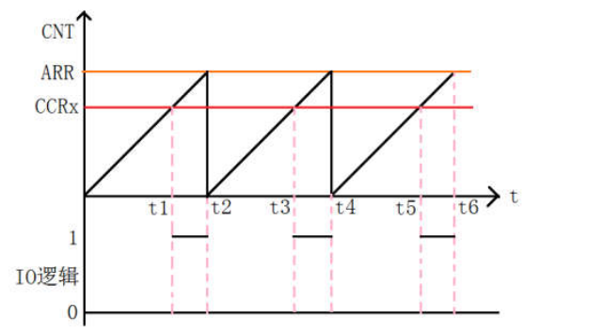
● In PWM output mode, in addition to CNT (current counter value), ARR (automatic reload value), there is an additional value CCRx (capture/compare register value).
● When the CNT is less than CCRx, the output level of the TIMx_CHx channel is low.
● When CNT is equal to or greater than CCRx, the TIMx_CHx channel outputs a high level.
One cycle of PWM:
1. The timer starts from 0 and counts upward
2. In the 0-t1 range, the TIMx_CNT value of the timer counter is less than the CCRx value, and the output level is low
3. In the t1-t2 segment, the TIMx_CNT value of the timer counter is greater than the CCRx value, and the output level is high
4. When the value of TIMx_CNT reaches ARR, the timer overflows and counts up again. Loop this process
5. At this point, a PWM cycle is complete
Each timer has four channels, each channel has a capture compare register,
The pulse width modulation mode (PWM signal) can be realized by comparing the register value with the counter value and by comparing the high and low levels. The TIMx_ARR register determines the PWM frequency and the TIMx_CCRx register determines the duty cycle. If the pulse counter TIMx_CNT is configured to count up, and the overloaded register TIMx_ARR is configured to N, that is, the current count value X of TIMx_CNT is continuously added up under the drive of the TIMxCLK clock source. When the value X of TIMx_CNT is greater than N, The value of TIMx_CNT will be reset to 0. At the same time of TIMxCNT counting, the count value X of TIMxCNT will be compared with the value A pre-stored in the comparison register TIMx_CCR. When the value X of the pulse counter TIMx_CNT is less than the value A of the comparison register TIMx_CCR, Outputs A high (or low) level and, conversely, a low (or high) level when the value X of the pulse counter is greater than or equal to the value A of the comparison register.
In such A cycle, the output pulse period obtained is the value (N+1) stored in the overloaded register TIMx_ARR multiplied by the clock period of the trigger pulse, and the pulse width is the value of the comparison register TIMx_CCR multiplied by the clock period of the trigger pulse, that is, the duty cycle of the output PWM is A/(N+1).
PWM working mode:
PWM mode 1(count up) : The counter counts from 0 to the automatic reload value (TIMx_ARR), and then counts from 0 again, and generates a counter overflow event PWM mode 2(count down) : The counter is reduced from the automatic reload value (TIMx_ARR) to 0, Then decrement from the reload value (TIMx_ARR) is redone and a counter overflow event is generated to set the OC1M[2:0] bit of the TIMx_CCMR1 register to determine the PWM output mode:
PWM mode 1: When counting up, once TIMx_CNT; When TIMx_CCR1 is used, channel 1 is an effective level; otherwise, channel 1 is an invalid level. On a downward count, once When TIMx_CCR1, channel 1 is an invalid level (OC1REF=0); otherwise, channel 1 is an effective level (OC1REF=1).
PWM Mode 2: When counting up, once TIMx_CNT When TIMx_CCR1 is used, channel 1 is an invalid level; otherwise, channel 1 is an effective level. On a downward count, once When TIMx_CCR1 is used, channel 1 is an effective level; otherwise, channel 1 is an invalid level.
In both modes TIMx_CNT(the current value of the counter) and TIMx_CCR1(the capture/comparison value) only determine whether the active level or the invalid level The active level can be high or low, which needs to be combined with the CC1P bit value of the CCER register to determine. It also needs to be explained here that for the pin relationship of the timer channel, you can check the corresponding data manual of STM32F4. For example, in our PWM experiment, we used channel 1 of timer 14, and the corresponding pin PF9 can be viewed from the data manual table:
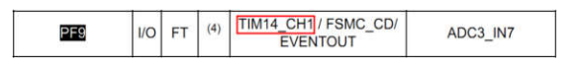

Operation Steps
Hardware design
The hardware resources used in this experiment are: indicator DS0 and DS1, timer TIM3. DS0 is connected to PF9,
DS1 is connected to PF10. TIM3 is an internal resource of STM32F4 and only requires software setup to work properly.
The STM32CubeMX is configured with timer TIM3
In CubeMX, the contents of new project, clock configuration, software debugging mode and common options of generation engineering are referred to experiments
one.
Refer to "STM32F4xx Chinese Reference Manual.pdf" to see that TIM3 is connected to APB1.
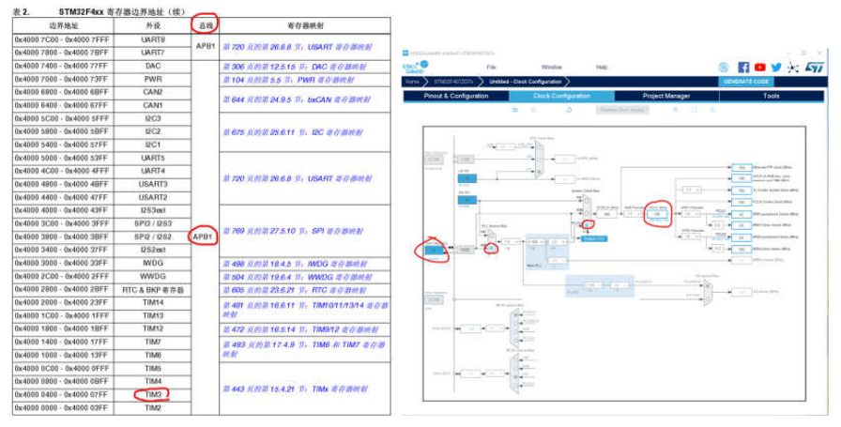
1) Click Clock Configuration to set APB1's clock to 84M
2) Set TIM3
Since TIM3 is hung on the APB1 bus, looking at the clock tree we know that the current frequency of APB1 is 84MHz, we
Expect one interrupt per second.
Settings:
Clock Source Select Internal Clock
Pre-division select 35000-1, which is 34999 (note that the 16-bit maximum can only represent 65535)
The automatic reload value is set to 2400-1, which is 2399
Description: Timer update interrupt frequency = clock frequency /(pre-division +1)/(automatic reload value +1)
That is, 84000000/35000/2400=1(HZ), that is, one interrupt per second
3) Check TIM3 global interrupt in the NVIC Setting
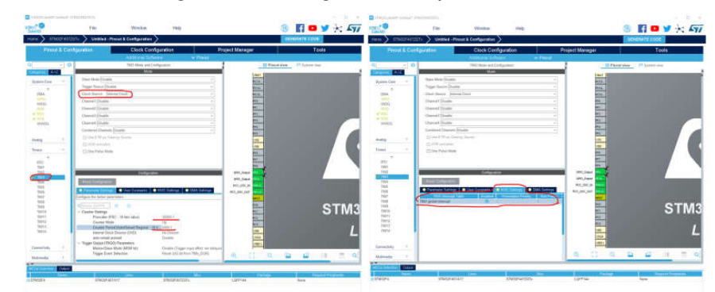
Software design
Open the CubeMx generated project code in Keil MDK.
1) Flip LED0 in the while(1) loop in the main.c file at a 500ms cycle to indicate the program running status.
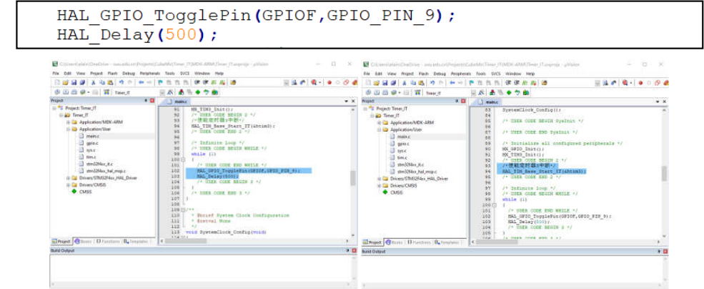
2) In the int main(void) main function, add the statement to enable the receiving interrupt:
/* Enables the timer 3 interrupt */
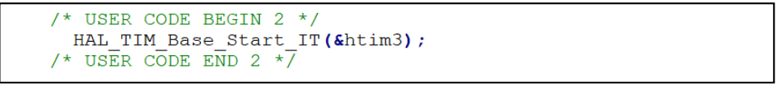
3) Add an interrupt callback function to the lower part of main.c.
The level of LED1 is flipped once in the timer interrupt handler.
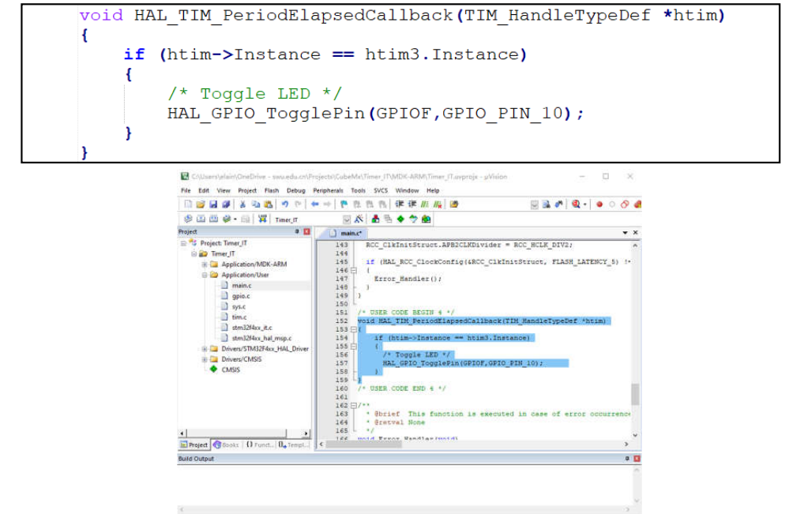
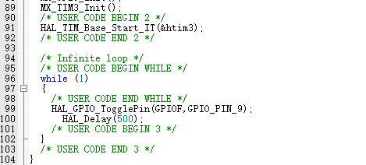
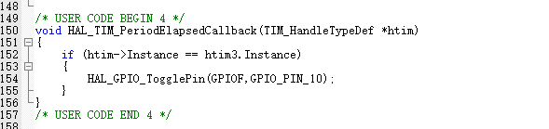
Hardware design
The hardware resources used in this experiment are: indicator DS0 and timer TIM14. DS0 is connected to PF9, TIM14 is an internal resource of STM32F4 and only requires software setup to work properly.
The new project, clock configuration, software debugging mode and common options of generation engineering in STM32CubeMX configuration timer TIM14CubeMX are reference experiments
two.
1) Click Clock Configuration to set APB1's clock to 84M
2) Set TIM14
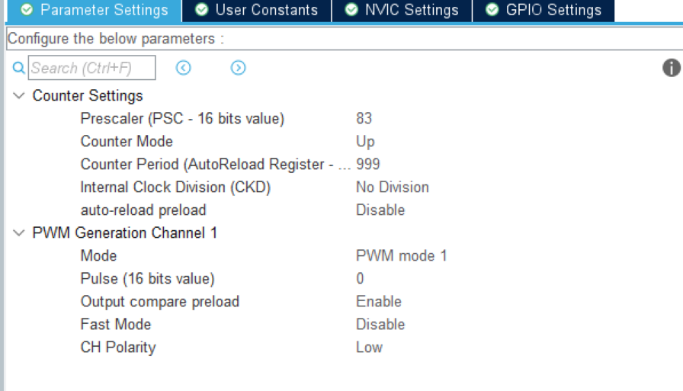
The PWM frequency is 84MHz/84/1000=1kHz
PWM frequency: Fpwm =Tclk/((arr+1)*(psc+1))(Unit: Hz)
arr is the counter value
psc is the pre-division value
Software design
Open the CubeMx generated project code in Keil MDK.
1) Define variables
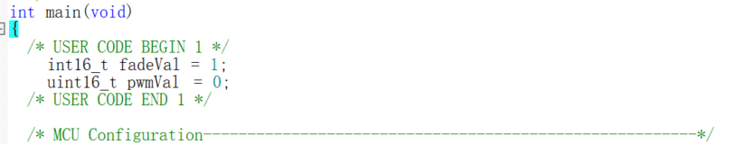
2) Enable PWM Channel1 output of TIM14:
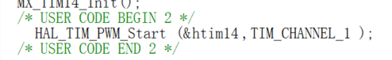
3) Add code in the while loop:
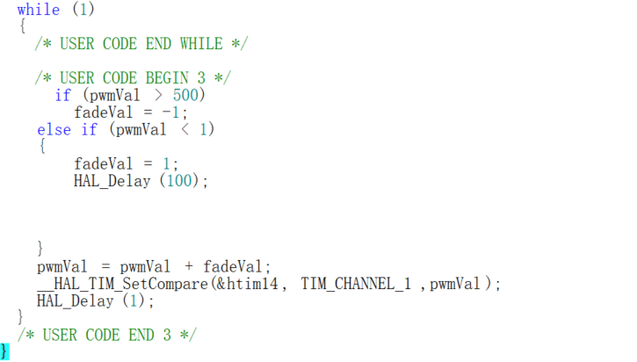

Ⅲ、Experiment Results

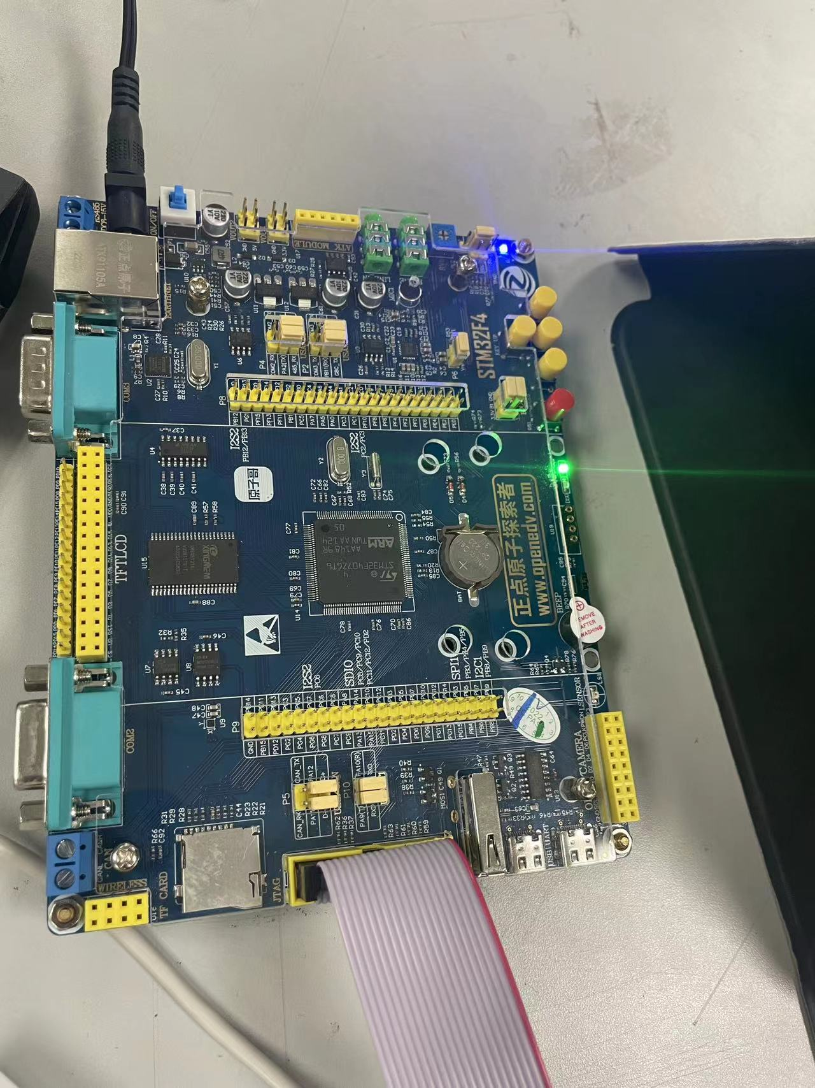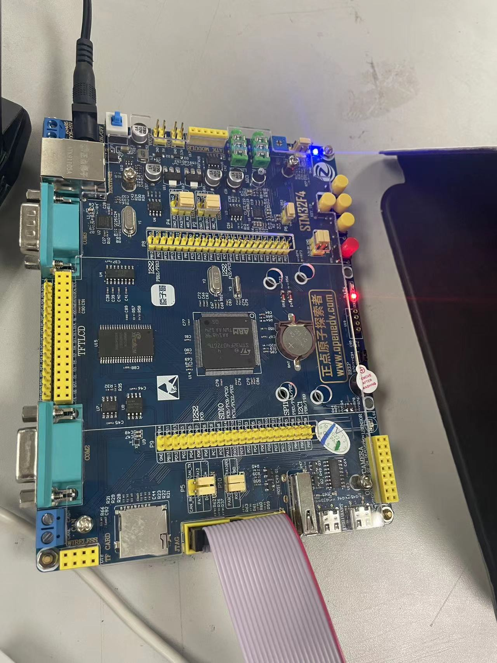
Phenomenon：Red LED lights and green LED lights flashing, red flashing will be slower, there is a delay
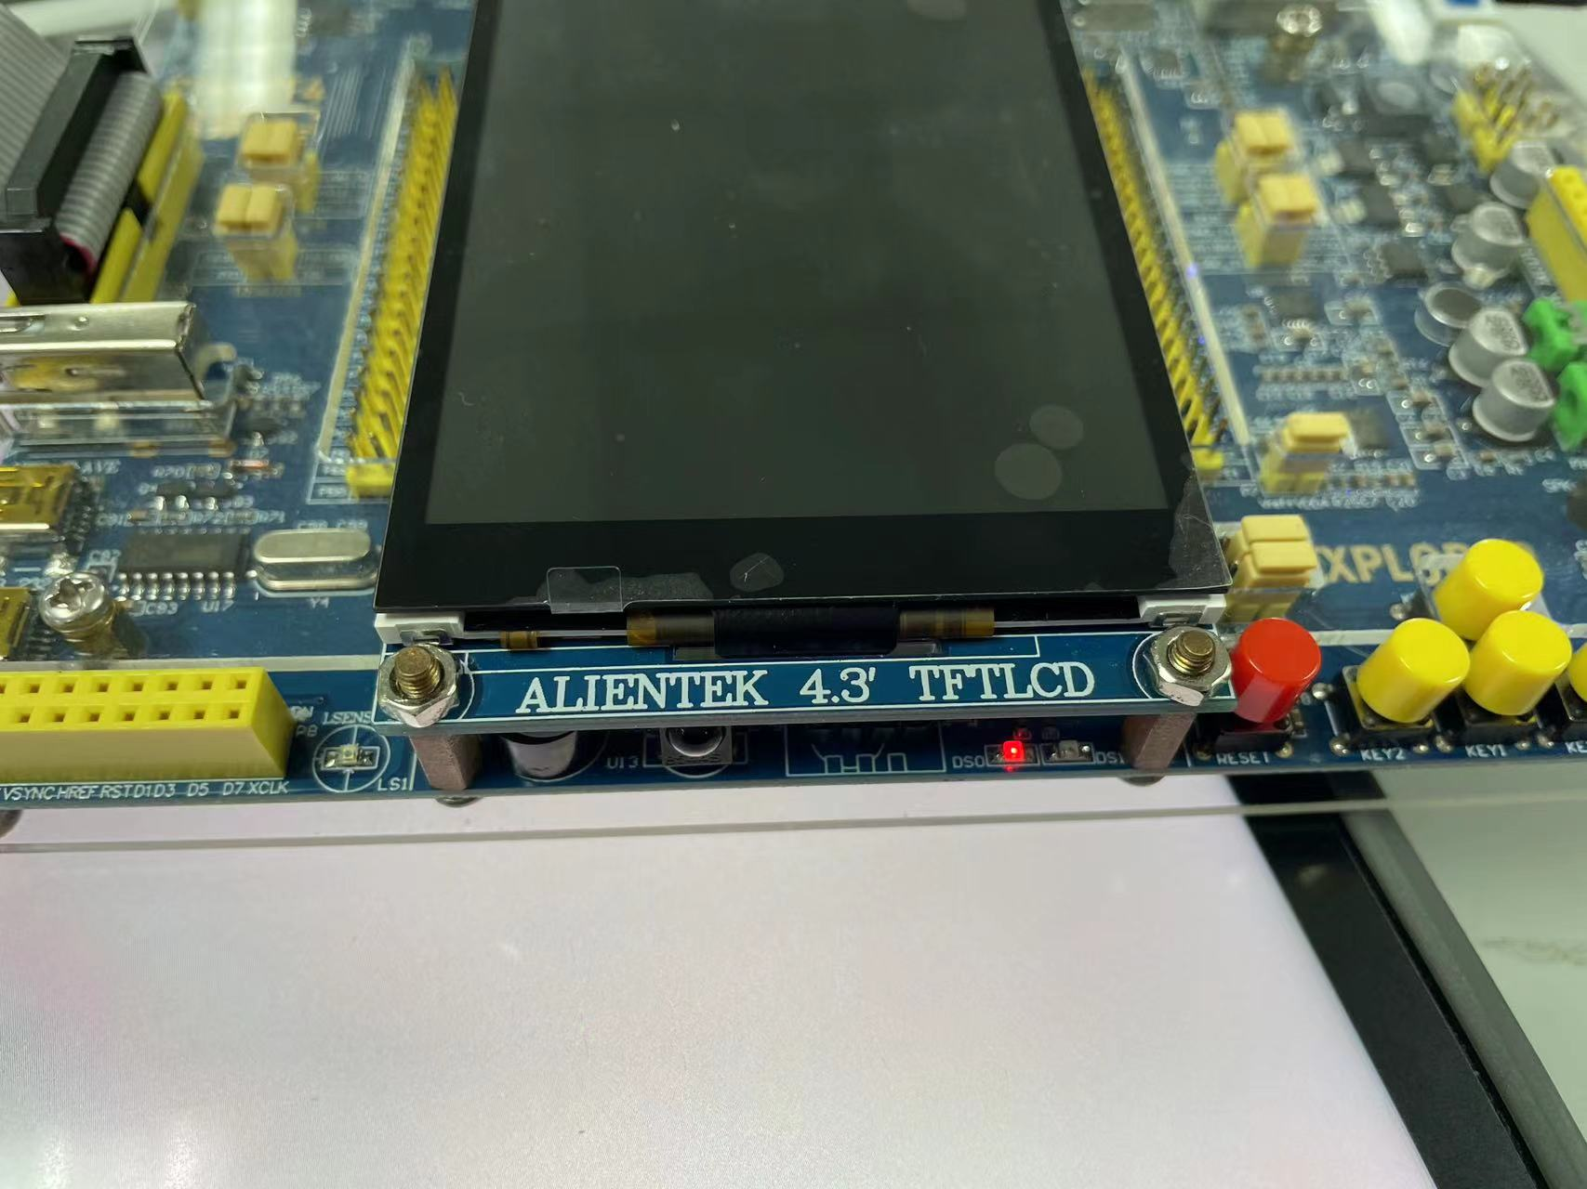

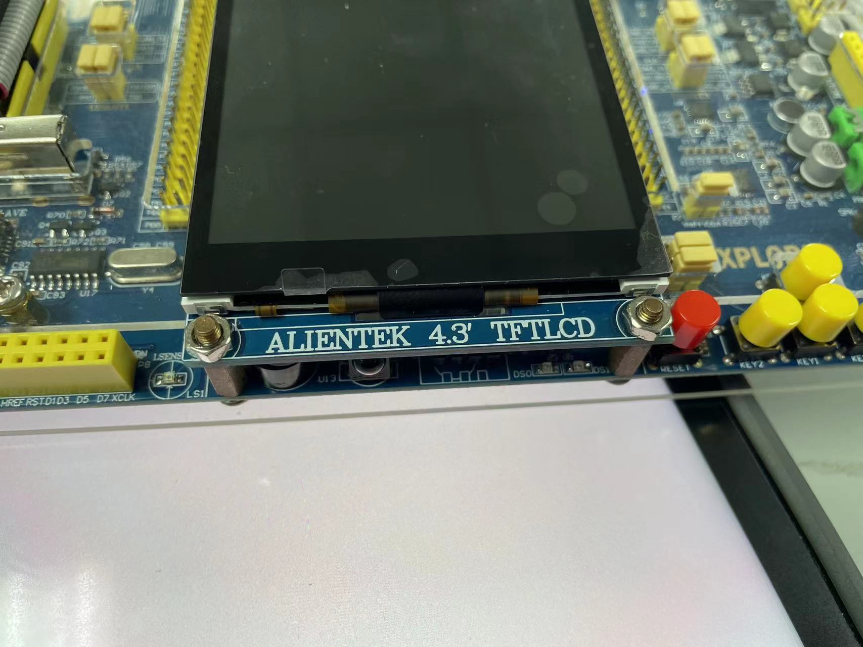
Phenomenon: The phenomenon of breathing lamp appears. The brightness of the LED lamp can be smoothly transitioned with the adjustment of the PWM signal

Ⅳ、Experiment Analyses and Conclusions
Through this experiment we have learned about the clock: STM32F4 timer function is very strong, there are high level TIME1 and TIME8, TIME2~TIME5, TIM9~TIM14 and other general timers, as well as TIME6 and TIME7 and other basic timers. A total of 14 timers. The STM32F4 universal timer can be used to measure the pulse length of the input signal (input capture) or generate the output waveform (output comparison and PWM). With timer pre-dividers and RCC clock controller pre-dividers, the pulse length and waveform period can be adjusted from a few microseconds to a few milliseconds. Each of the STM32F4's universal timers is completely independent and does not share any resources with each other.
In addition, by configuring the relevant clock and pin state in Cubemx, we can realize the switching on and off of the LED lights connected to the PF10 and PF9 pin feet, and with the delay function, we can realize the dislocation flashing

The experimental results show that the brightness of LED lamp can be smoothly transitioned with the adjustment of PWM signal, which is in line with the expected effect. By adjusting the duty cycle of the PWM signal, we can precisely control the brightness level of the LED, and the change of the PWM value in the experiment has an obvious fading phenomenon. Through this experiment, we deeply understand the configuration of timer, including the setting of pre-divider, the meaning of automatic overload register (ARR), and the function of capture/comparison register (CCR). The configuration of these registers directly affects the frequency and duty cycle of the PWM signal, which in turn affects the brightness of the LED lamp. We also learned how to use HAL library functions such as HAL_TIM_PWM_Start() and HAL_TIM_SetCompare() to control PWM signals.

Score

