

**计算机与信息科学学院 软件学院**

**实**

**验**

**报**

**告**

**学 院：** 计算机与信息科学学院

**专 业：** 自动化

**课程名称：** 计算机控制系统

**实 验：** Lab 1 Development

Environment establishment

**学 号：** 222021321132005

**姓 名：** 贾博方

**学年学期：** 2023-2024-1

**指导老师：** 张渝

**完成日期：** 2023-09-13

**1. The purpose and requirements of the experiment**

Learn about Python's features

Download and install Anaconda

Learn the basic syntax of the Python language

Methods for executing Python commands and script files

**2. Experiment content and results**

Practice downloading Python

Practice installing Python

Practice executing Python commands and script files

Practice text editing in Python

(1) Find the appropriate location on the anaconda website to download

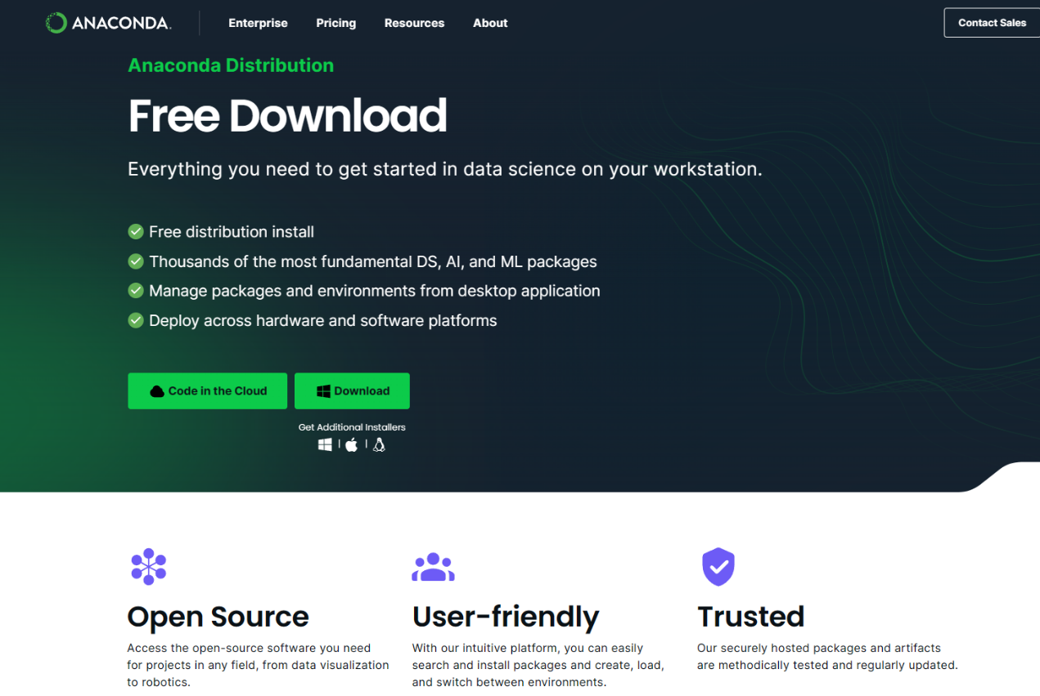

(2) Select the corresponding version to download according to your computer model

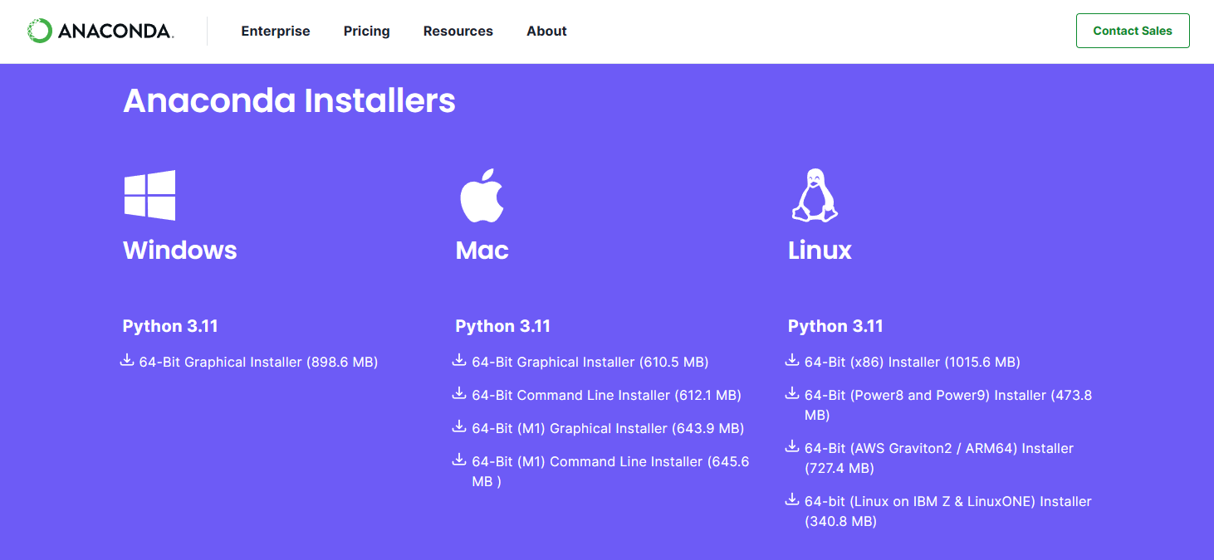

(3) You can view the download after it is complete

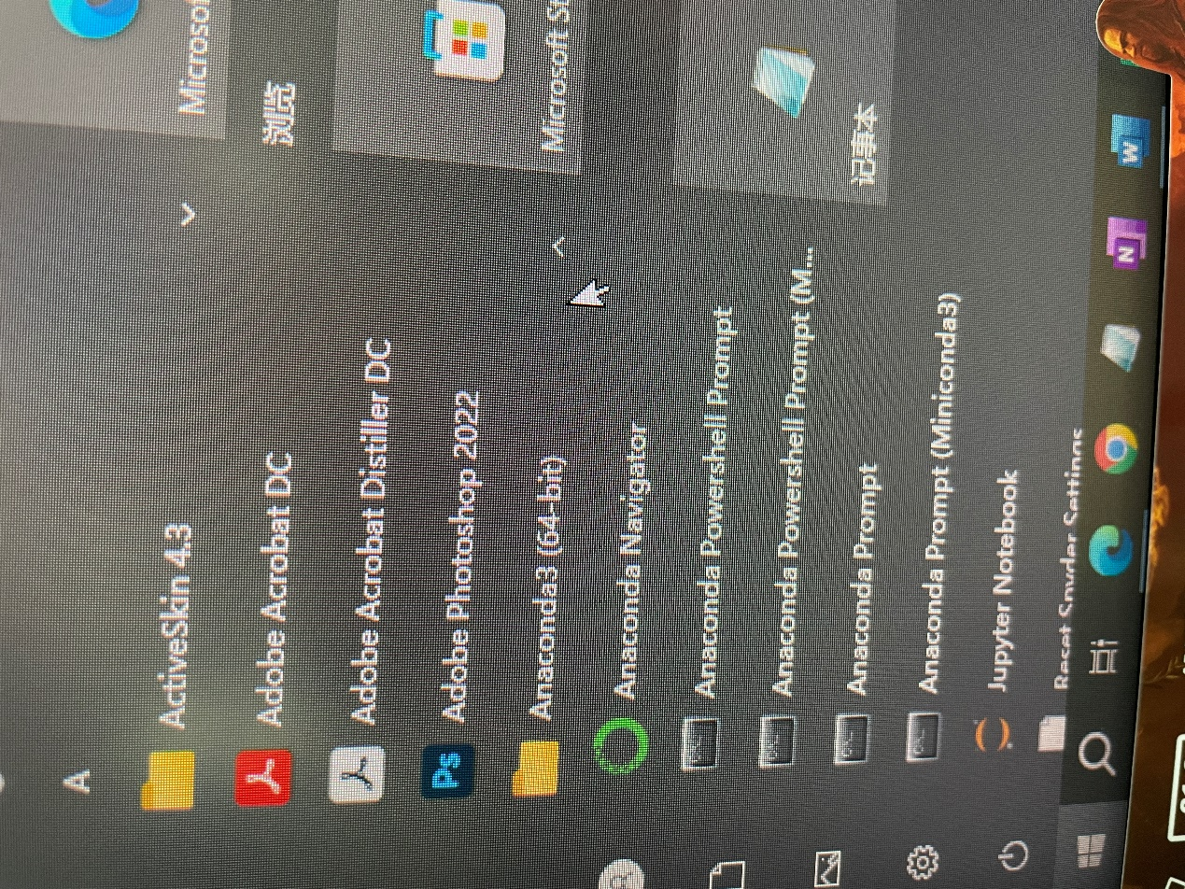

(4)text

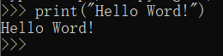

(5)download pycharm

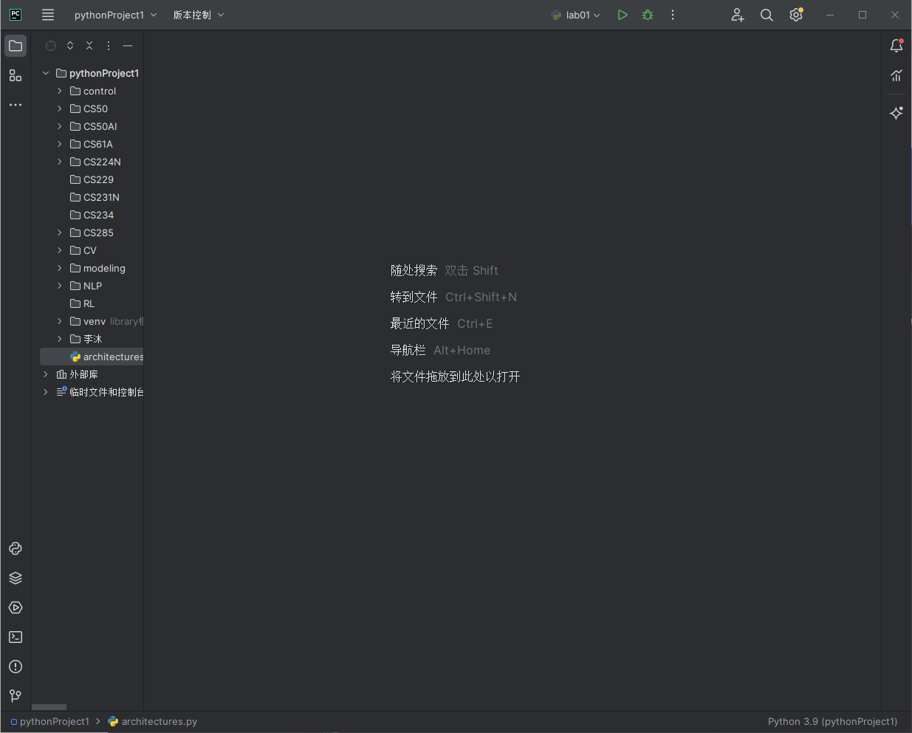

**3. Analysis and discussion**

In this experiment, I mainly configured the environment, downloaded anaconda and pycahrm, configured the relevant environment, and got familiar with the operation of python

The speed of downloading anaconda requires the use of Tsinghua University image and may be slow

**4. Teachers' comments and score**