

**计算机与信息科学学院 软件学院**

**实**

**验**

**报**

**告**

**学 院：** 计算机与信息科学学院

**专 业：** 自动化

**课程名称：** 计算机控制系统

**实 验：** Lab 3 Function, module and   
 I/O experiment

**学 号：** 222021321132005

**姓 名：** 贾博方

**学年学期：** 2023-2024-1

**指导老师：** 张渝

**完成日期：** 2023-10-10

**1. The purpose and requirements of the experiment**

Understand the concept of functions

Learn how to declare and call functions

Learn to use function arguments and return values

What is a module

Learn to use the modules in the standard library

Understand the basic meaning of I/O programming

Learn basic ways to enter and display data

**2. Experiment content and results**

tuple

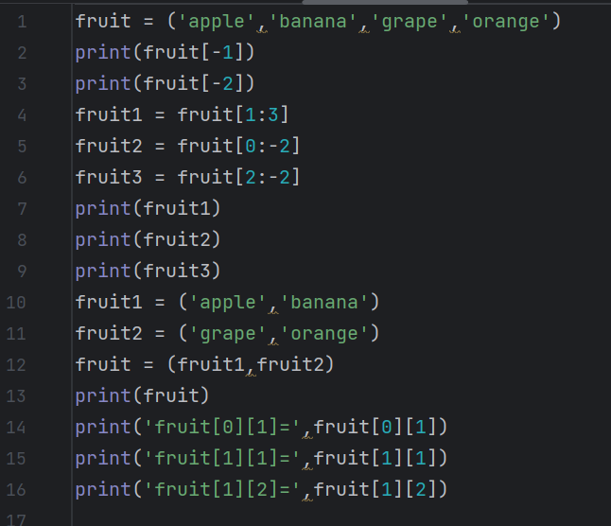

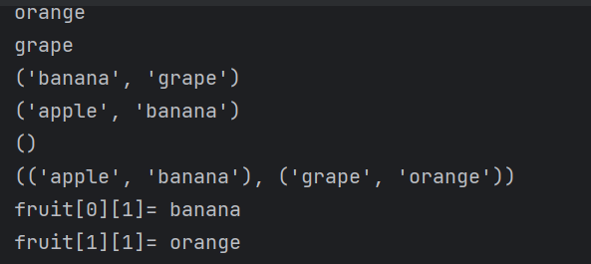

list

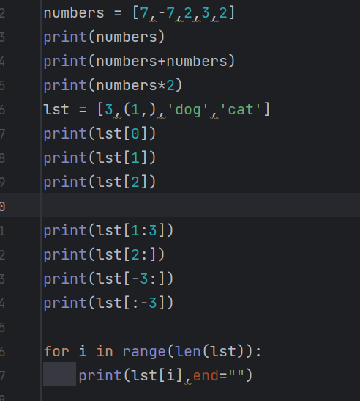

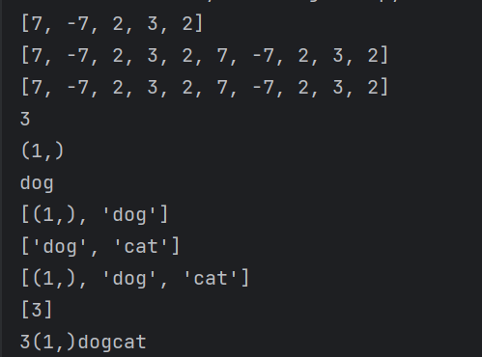

Dictionary

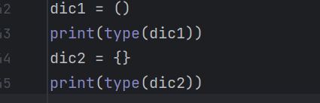

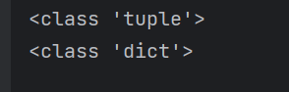

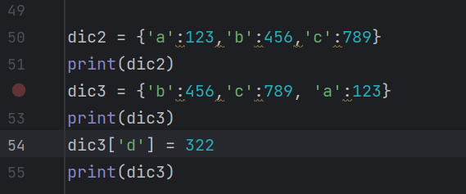

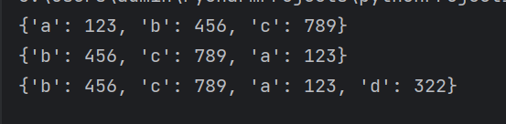

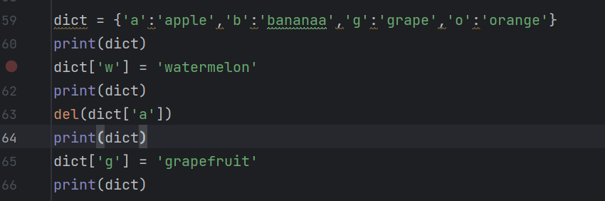

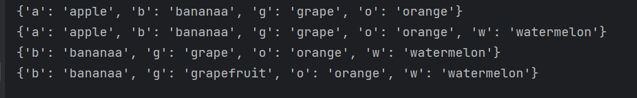

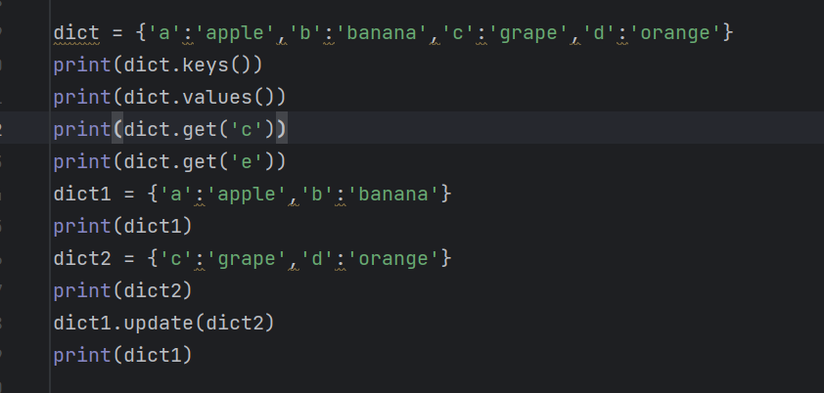

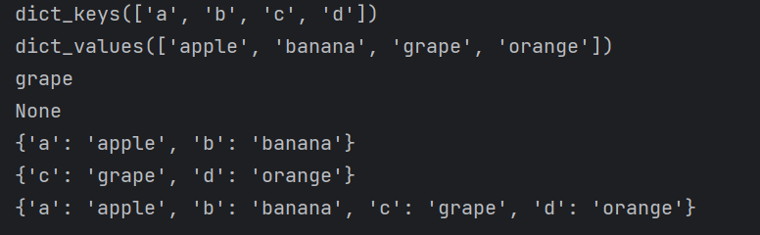

String

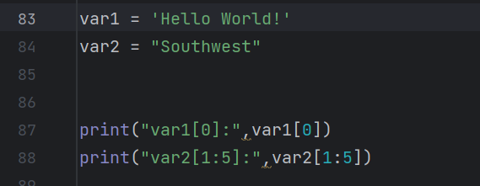

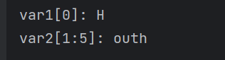

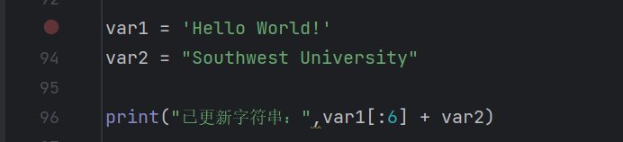



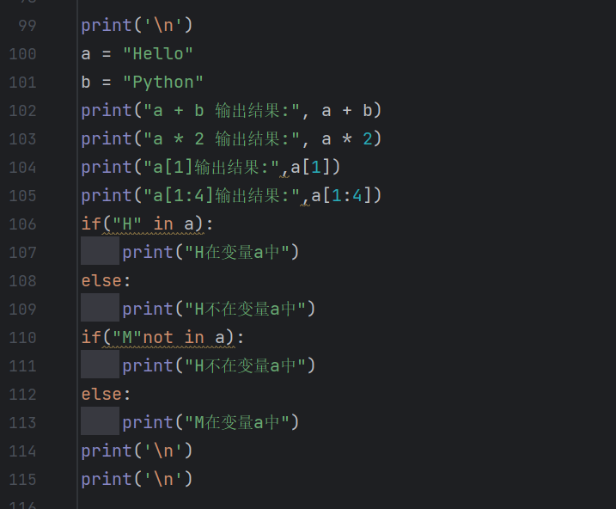

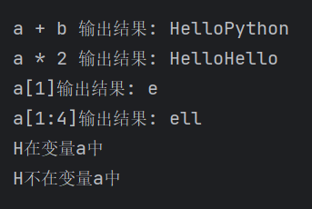

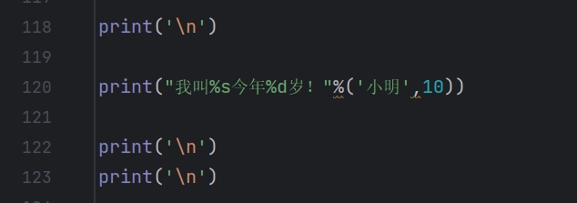

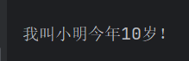

Escape character

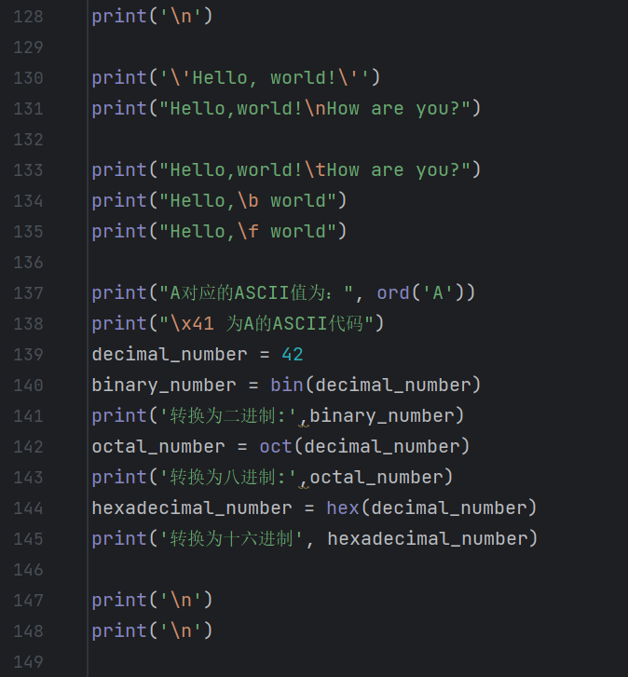

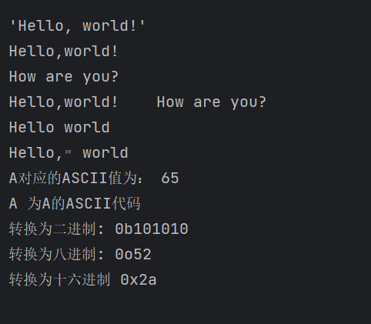

String fragmentation

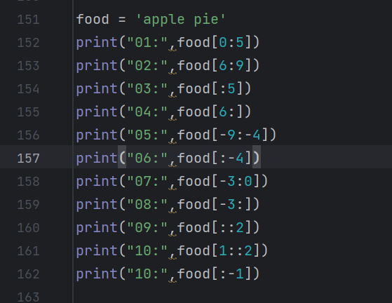

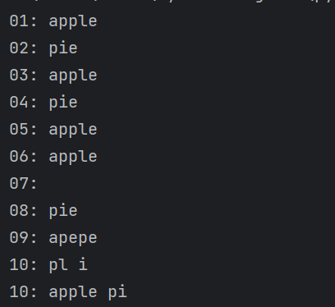

String substitution

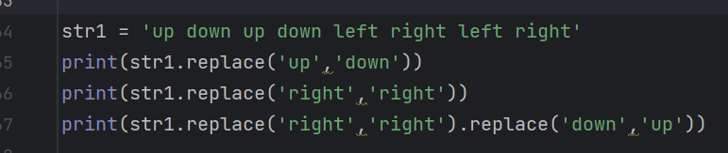

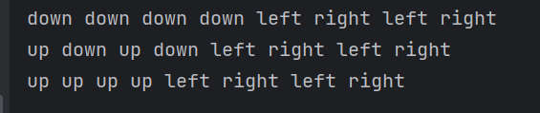

Function

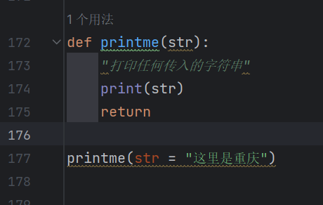



Keyword parameter

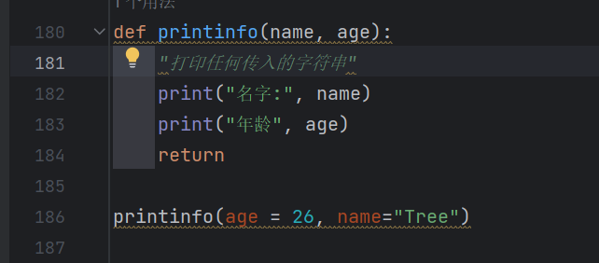

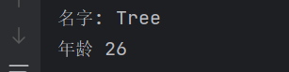

A function with default values for arguments

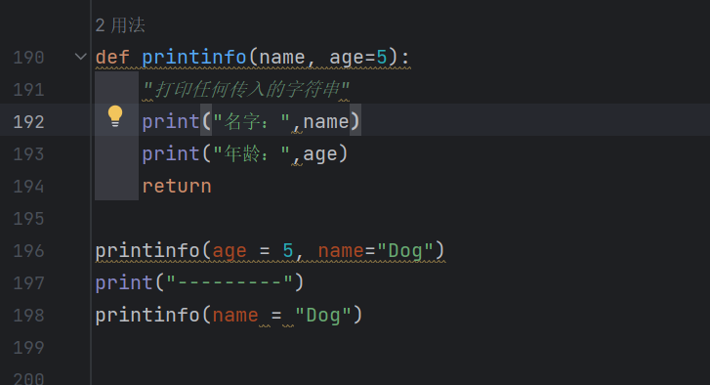

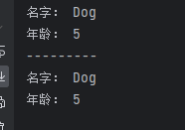

Multiple inputs as tuples

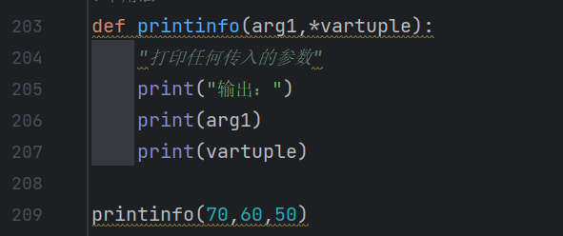

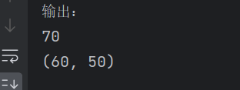

Indeterminate length parameter

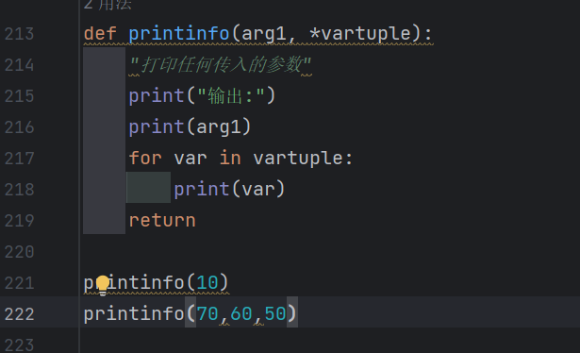

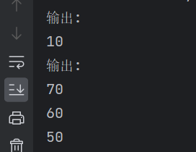

Indeterminate length parameter

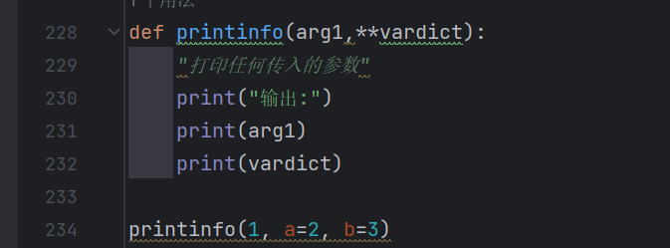

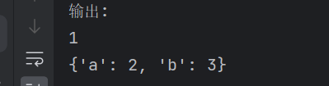

Anonymous function

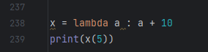



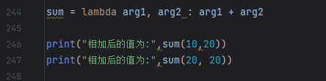



Encapsulate anonymous functions within a function

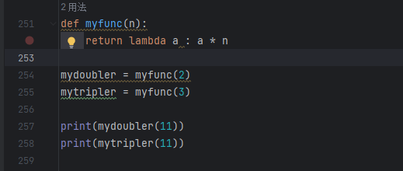



Return

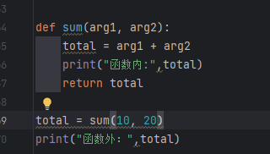



application

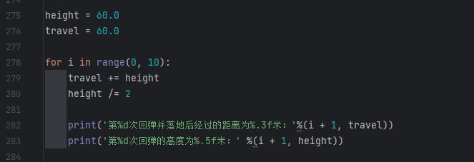

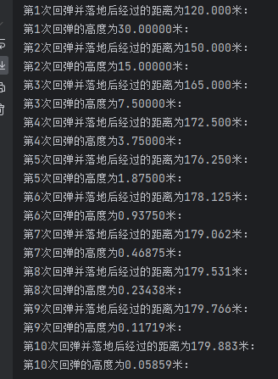

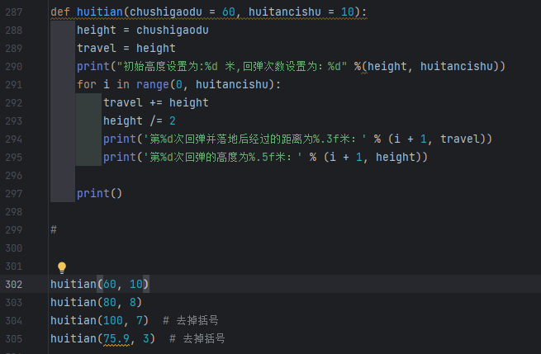

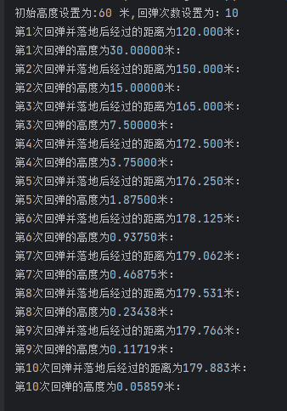

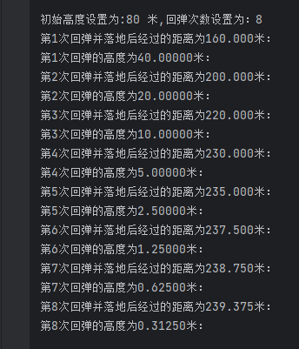

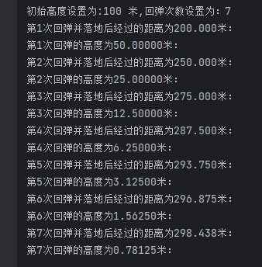

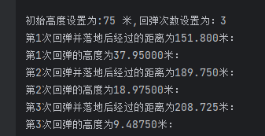

Output a random integer between 100 [10-90]

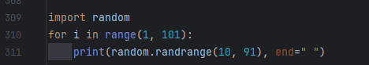



Output the current date (format: 23/09/2022) and time (format: 2022-09-23 14:48:46) in the specified format

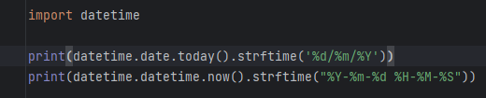



Input a string of characters and output the string in reverse

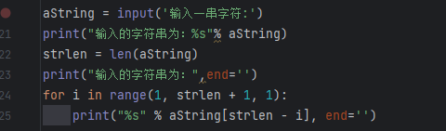

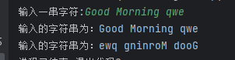

Find the factorial recursively

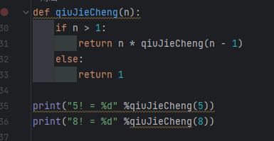



I/O sampling

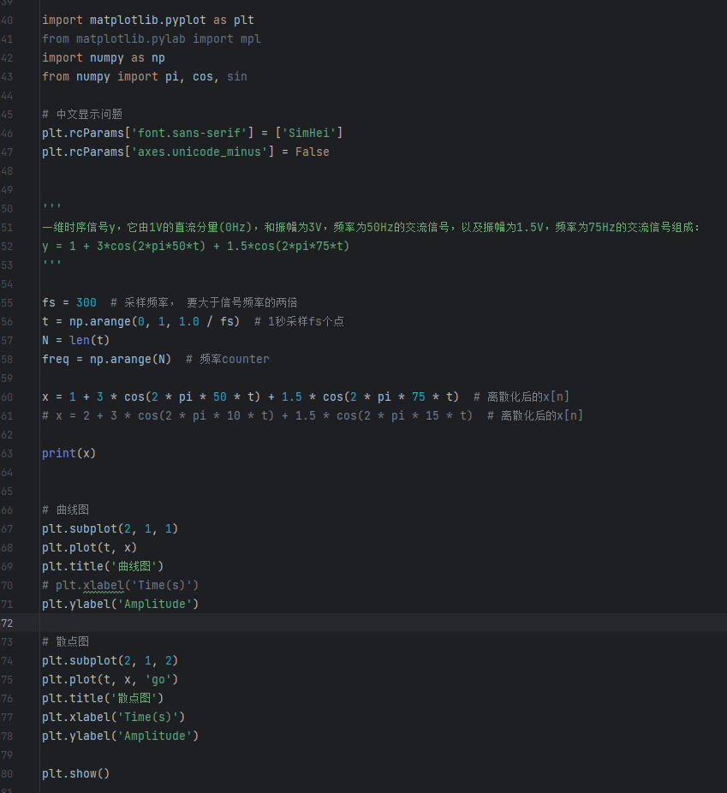

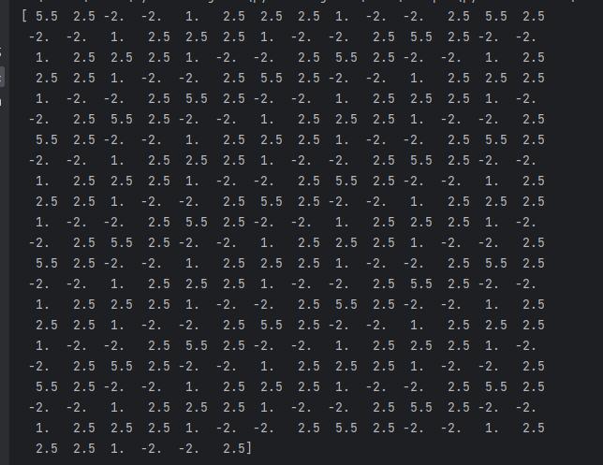

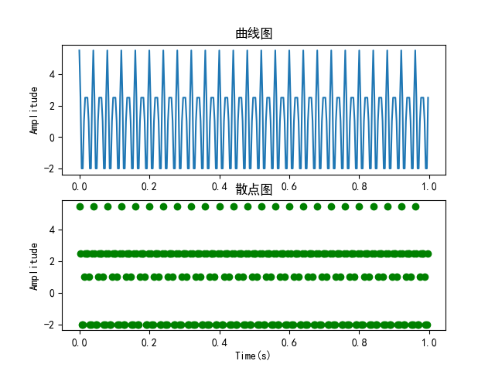

Calculate the solution of the equation

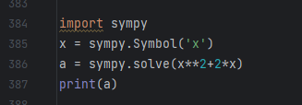



Solve the equations

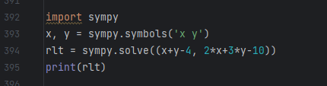



Enter a year a month a day, judge this day is the number of days of this year?

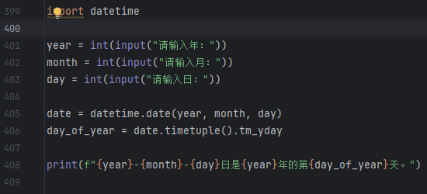

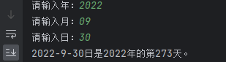

A number that is exactly equal to the sum of its factors is called a "perfect number". For example 6=1+2+3. Program to find all perfect numbers up to 10000

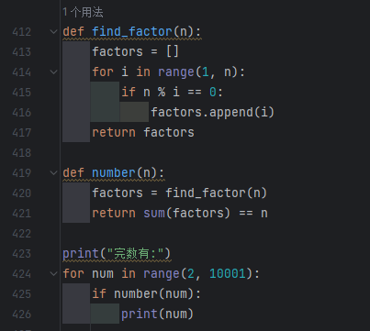

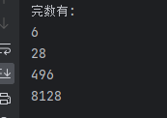

Use a recursive program to print out the following pattern:

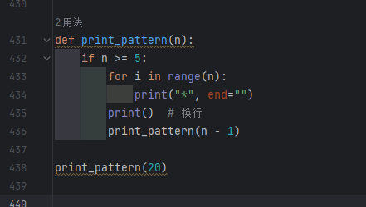

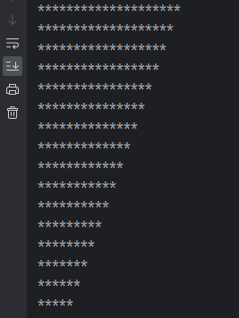

Write a program to input the personal information of 5 students and the grades of 3 courses, and print out.

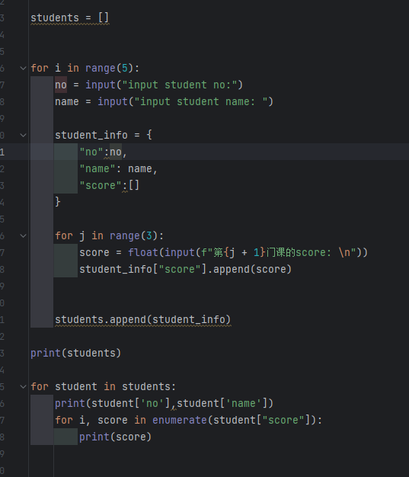

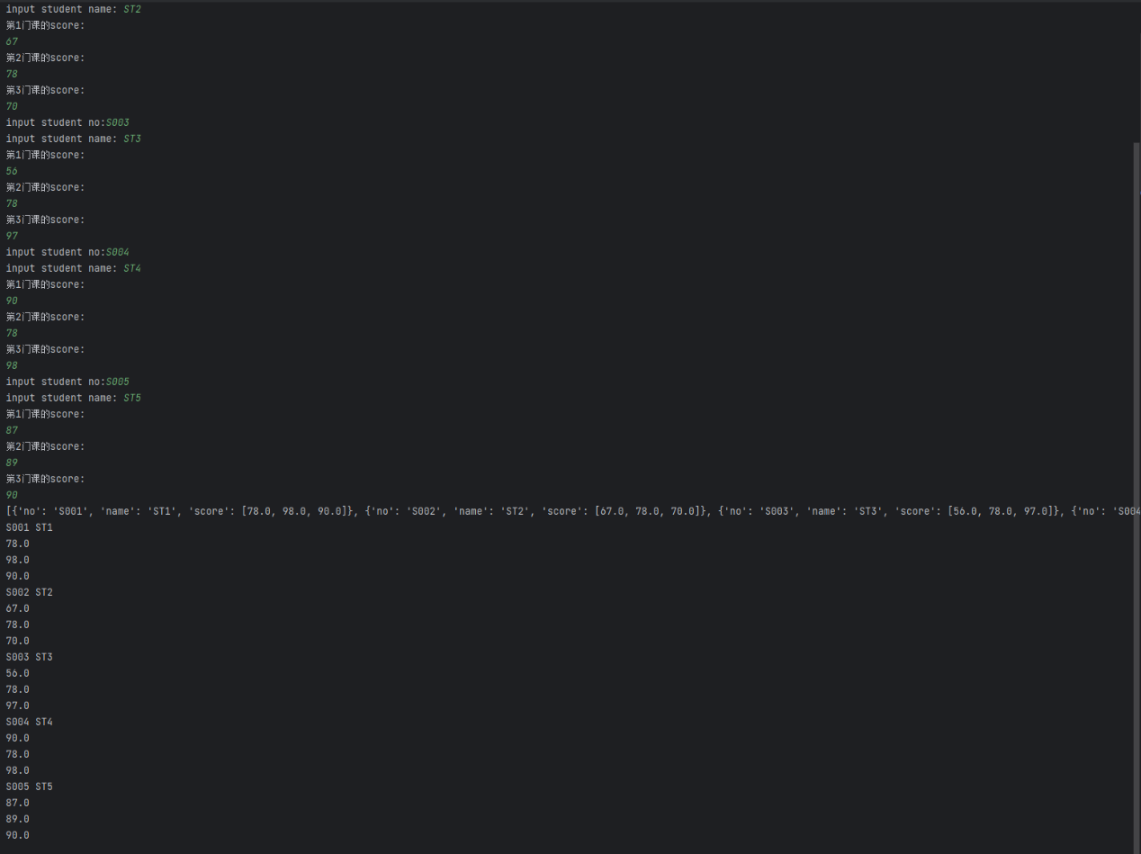

Solve the equations

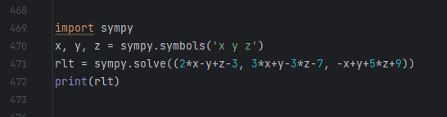



I/O sampling

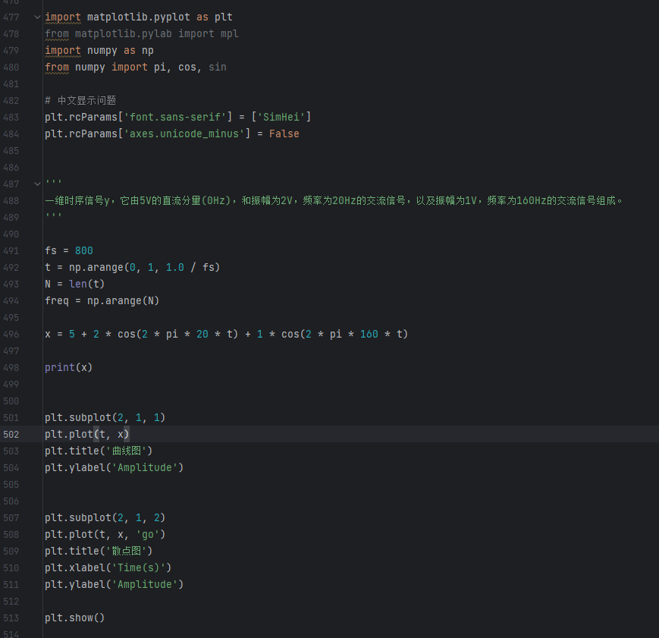

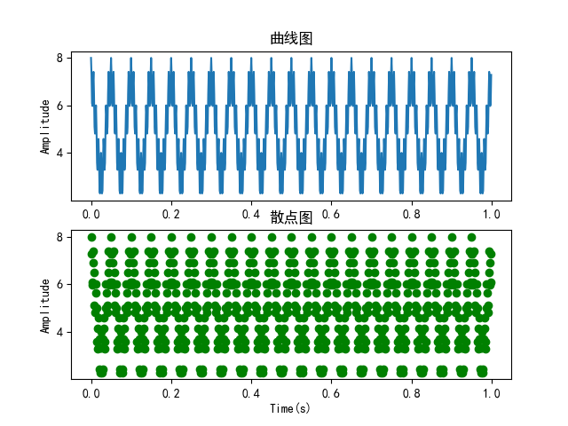

Discrete Fourier transform

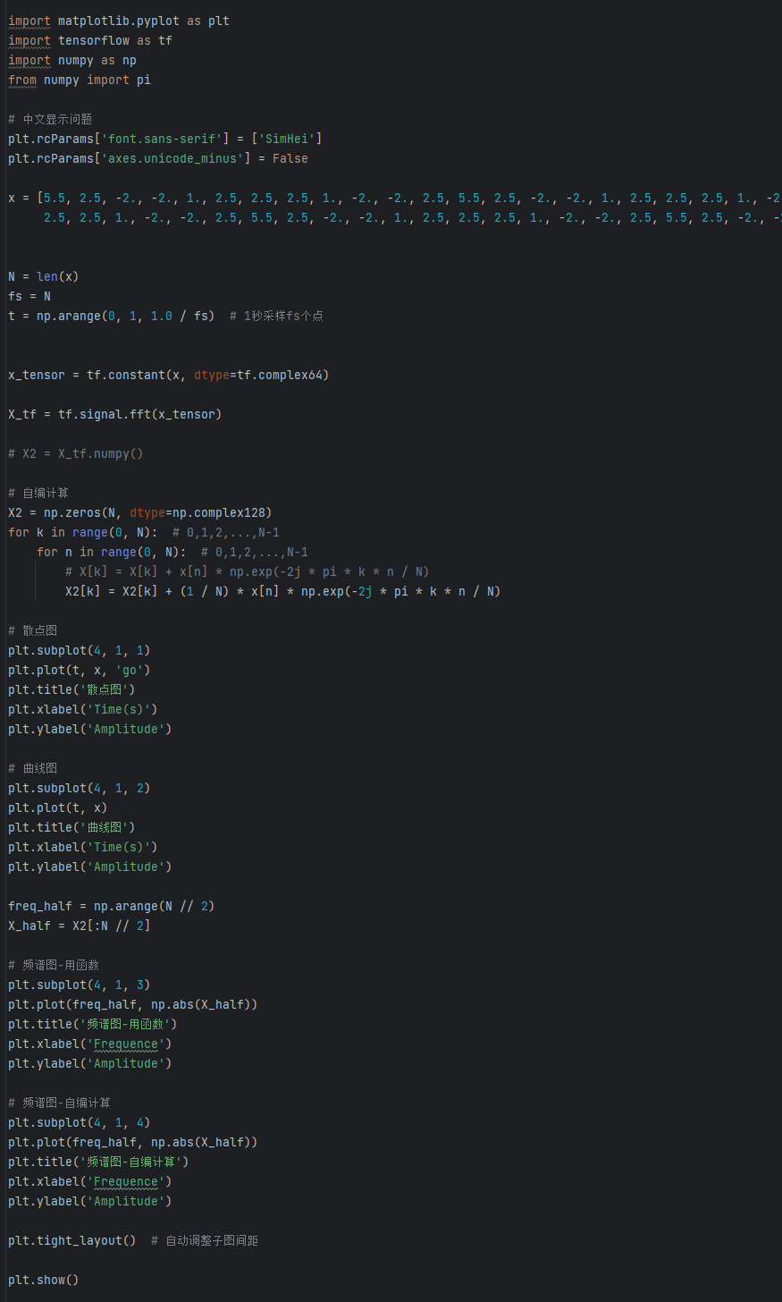

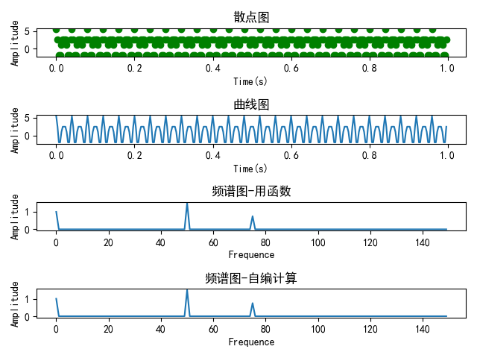

**3. Analysis and discussion**

Through the experiment we master the tuple, a list, dictionary, string, escape character, string fragmentation, string substitution, function declaration and return values, keyword arguments, parameters with default value function, multiple input as a tuple, variable length argument, lambda functions, As well as encapsulating the lambda function in an ordinary function and the output of the period, it is necessary to use the datatime library, recursive factorial, and I/O sampling, among which the more important is to use the Chinese adaptation and matplotlib and numpy packages, and to draw two-dimensional images and draw multiple images into one image. At the same time, I also learned to use sympy package to calculate the solution of equations, calculate the solution of equations, and also learned to use python to achieve Fourier transform.

**4. Teachers' comments and score**