

**计算机与信息科学学院 软件学院**

**实**

**验**

**报**

**告**

**学 院：** 计算机与信息科学学院

**专 业：** 自动化

**课程名称：** 计算机控制系统

**实 验：** Lab 4 Serial communication-232

**学 号：** 222021321132005

**姓 名：** 贾博方

**学年学期：** 2023-2024-1

**指导老师：** 张渝

**完成日期：** 2023-10-24

**1. The purpose and requirements of the experiment**

(1)Understanding 232 Communication

(2)Creating a virtual serial port

(3)Develop communication applications

**2. Experiment content and results**

Serial communication refers to a communication method that transmits data bit by bit between peripherals and computers through data signal lines, ground lines, control lines, etc. This communication method uses fewer data lines, which can save communication costs in long-distance communication, but its transmission speed is lower than parallel transmission. Serial port is a very common device communication protocol on computers.

**Obtain the list of available serial ports**

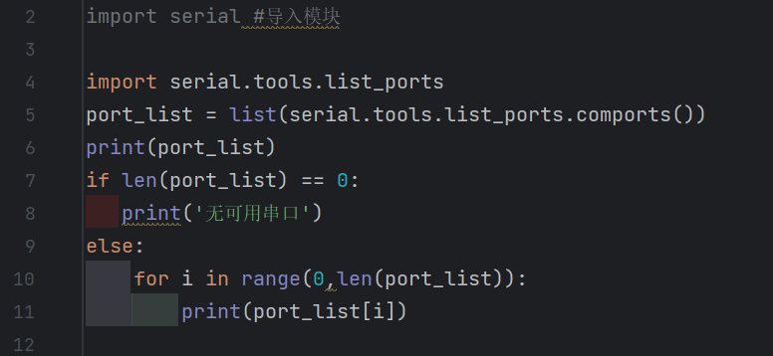

**Debugging and running**

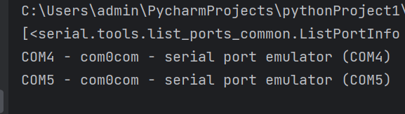

**Prefix of data in different bases**

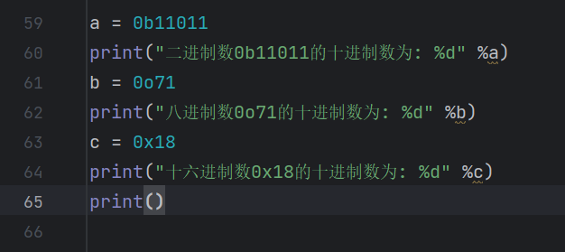

**Debugging and running**

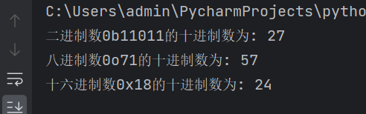

**Decimal conversion between integers**

**Binary related conversions**

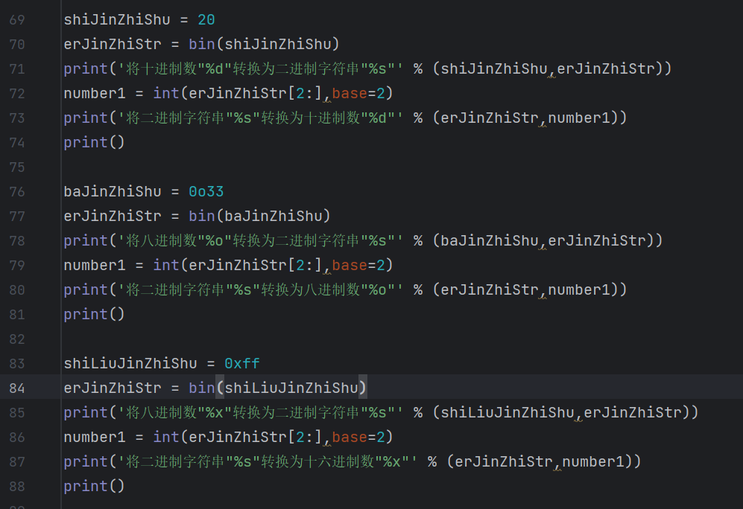

**Debugging and running**

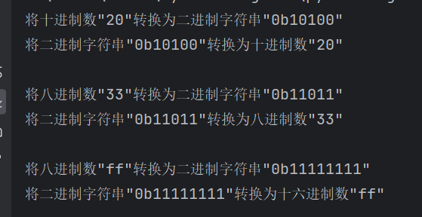

**Hexadecimal related conversions**

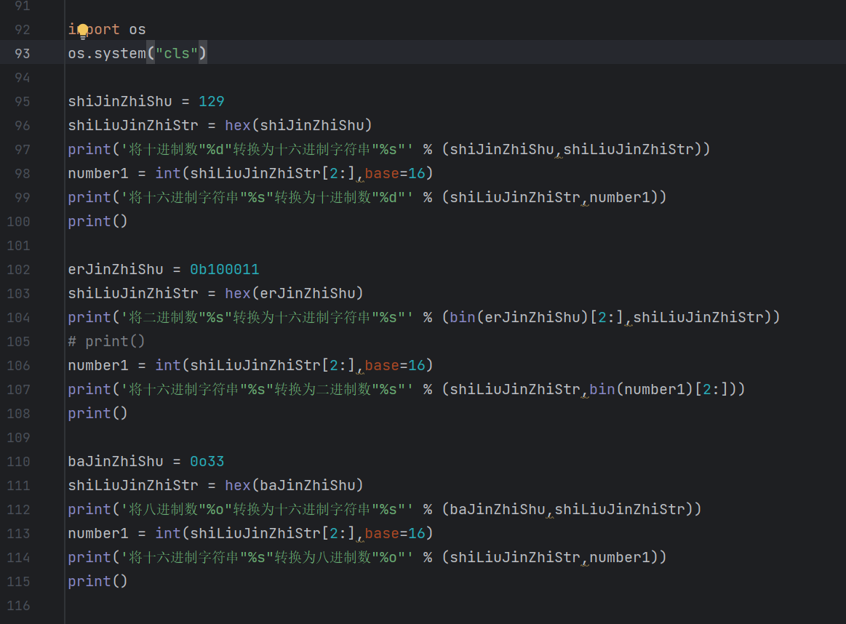

**Debugging and running**

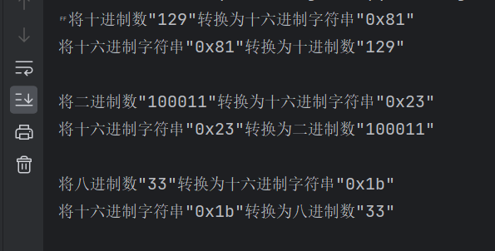

**Strings are converted to bytes, and bytes are converted to hexadecimal strings**

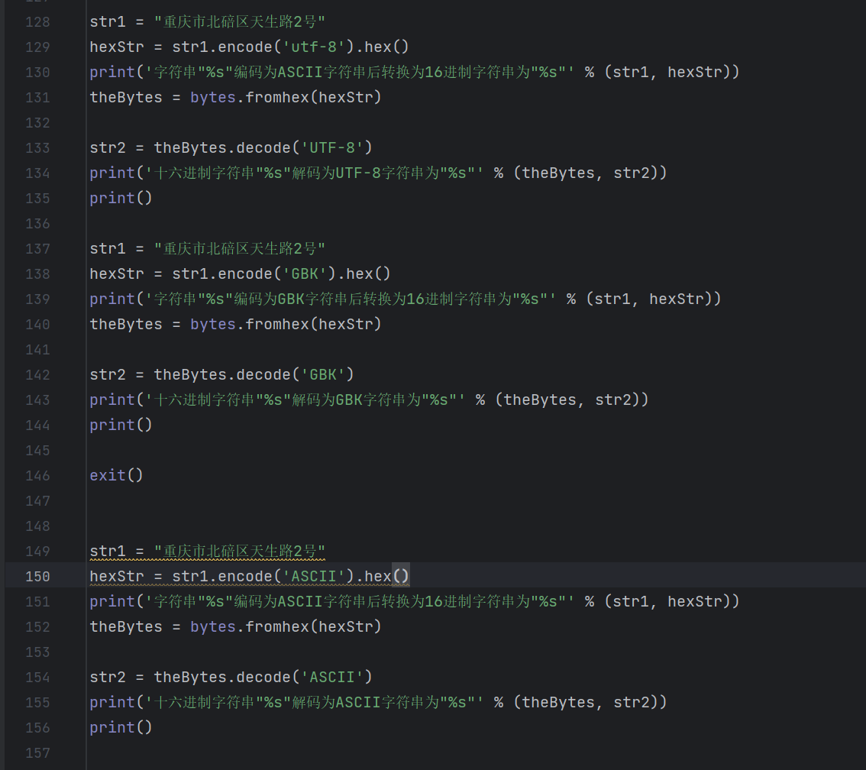

**Debugging and running**

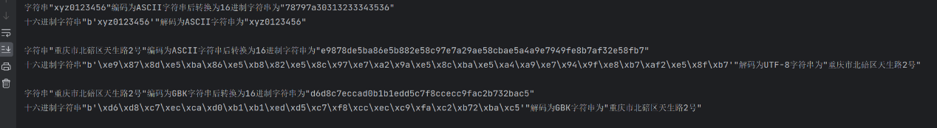

**Send a string**

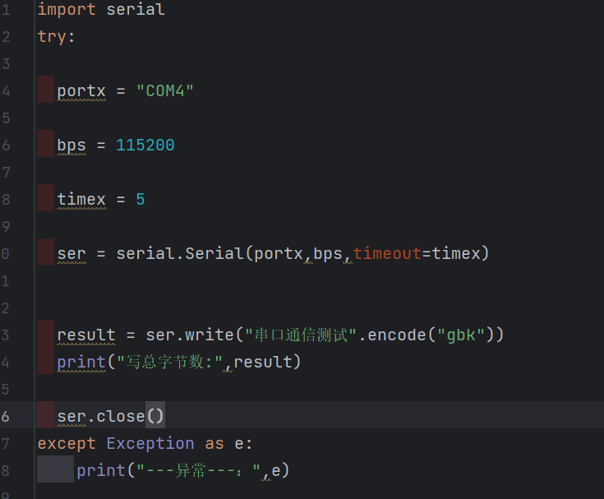

**Debugging and running**



**Virtual serial port**

(Use the CH340 for actual connection)

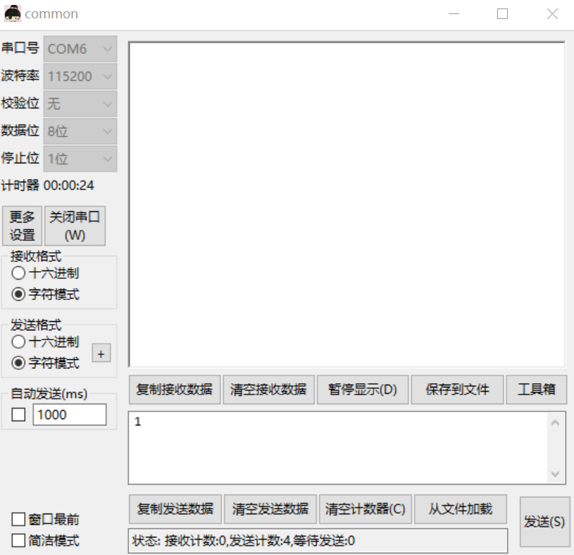

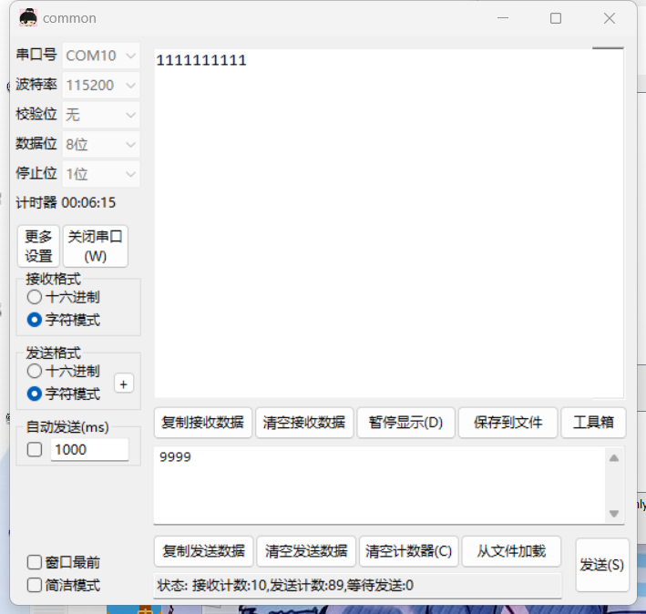

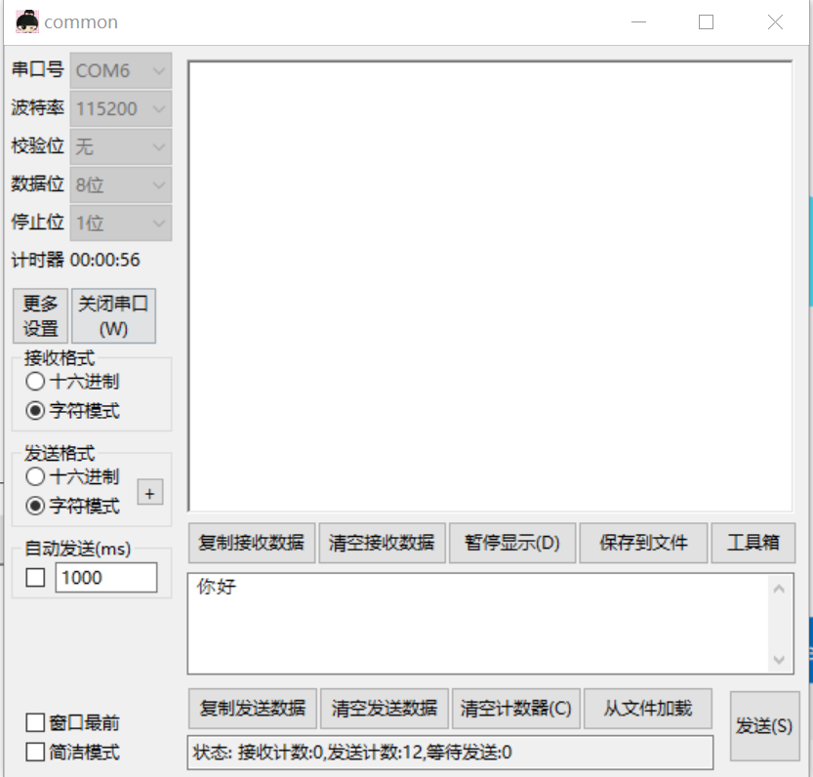

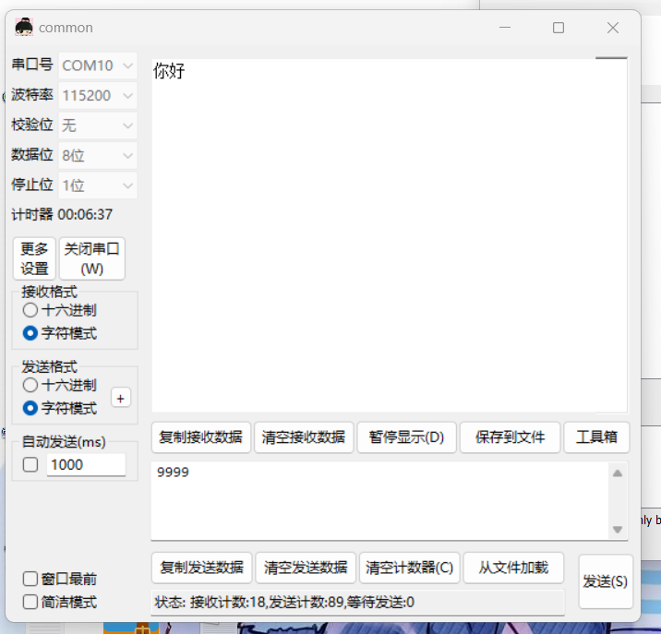

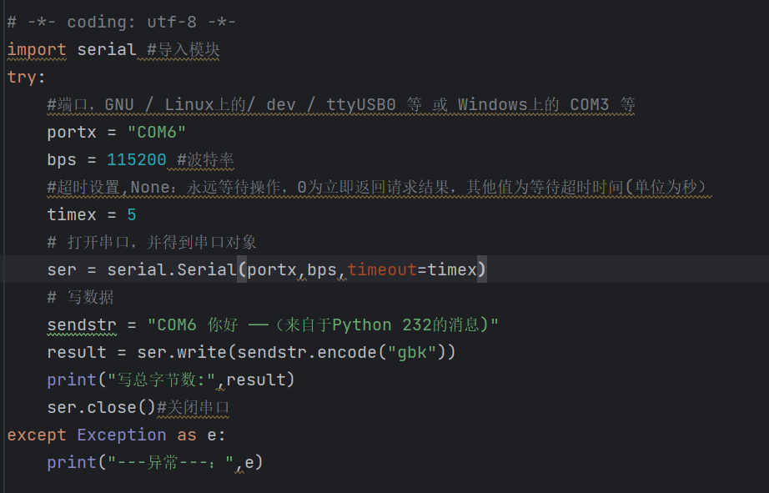

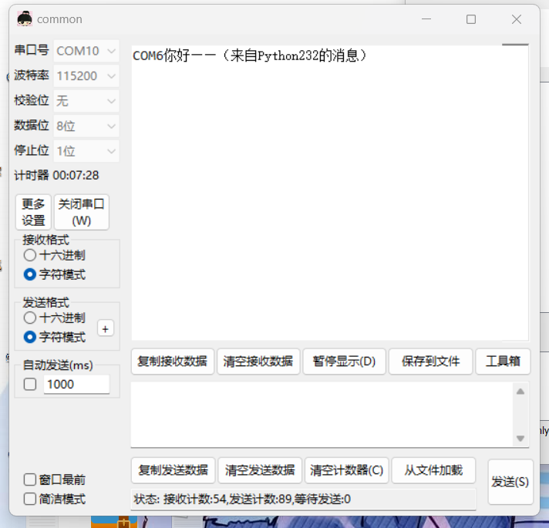

**3. Analysis and discussion**

**Through this experiment, we understand 232 Communication and learn to create virtual serial port.And developing communication applications. We can use python programs to see if a serial port exists and what serial ports are available to ensure that we have a serial port connected. In addition, the virtual serial port can be created by using software to simulate the actual serial port application, and the data can be sent and received. Similarly, when using the actual serial port, we can also communicate between computers and computers in order to send and receive data, which is the application of python control hardware in communication. Through this experiment, we have learned a lot of professional knowledge, which can make us lay a solid foundation in the future development and application.**

**4. Teachers' comments and score**