

**计算机与信息科学学院 软件学院**

**实**

**验**

**报**

**告**

**学 院：** 计算机与信息科学学院

**专 业：** 自动化

**课程名称：** 计算机控制系统

**实 验：** Lab5 Field device data acquisition

**学 号：** 222021321132005

**姓 名：** 贾博方

**学年学期：** 2023-2024-1

**指导老师：** 张渝

**完成日期：** 2023-10-30

**1. The purpose and requirements of the experiment**

(1)Serial communication 232/485 network

(2)Understand the onsite device communication protocols

(3)Establish a communication environment for onsite devices

(4)Develop data acquisition applications

(5)thread

**2. Experiment content and results**

Master program

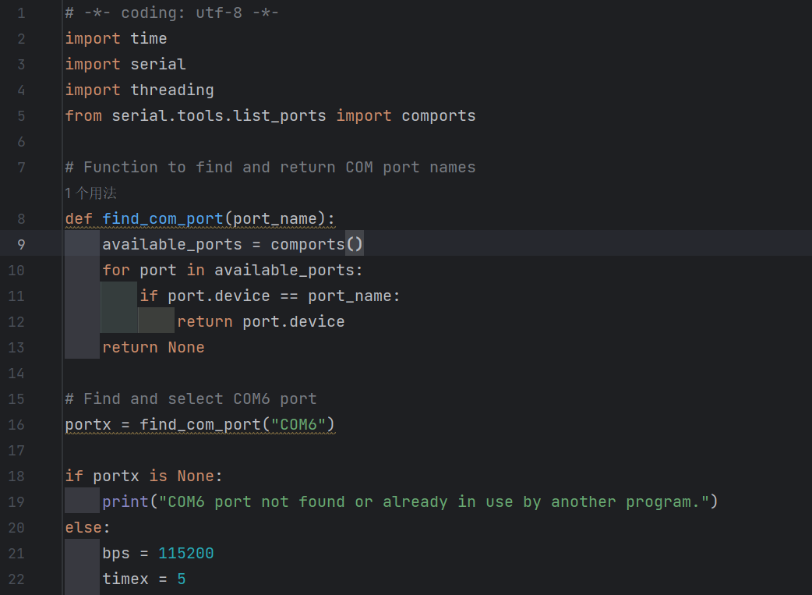

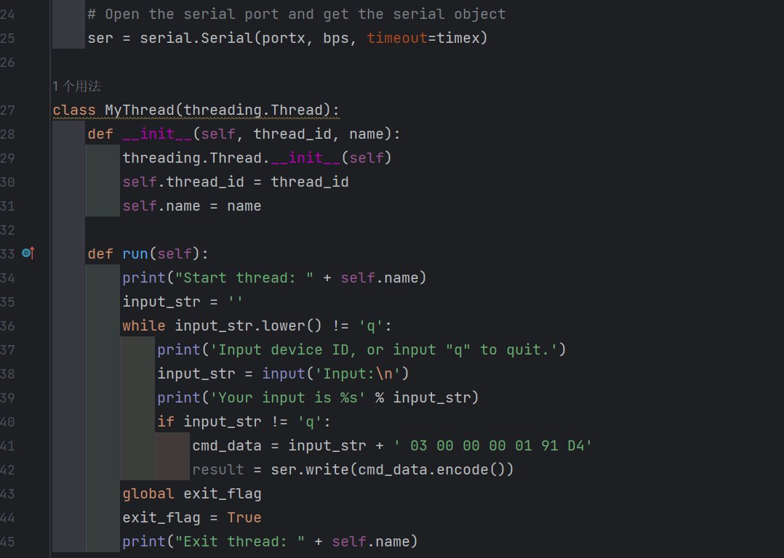

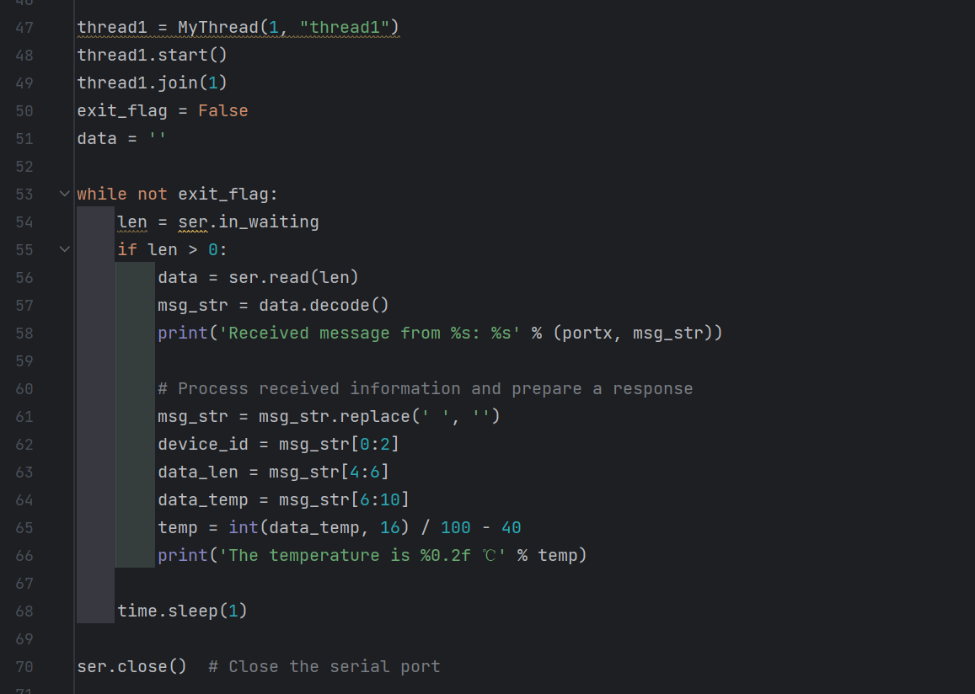

Slave program

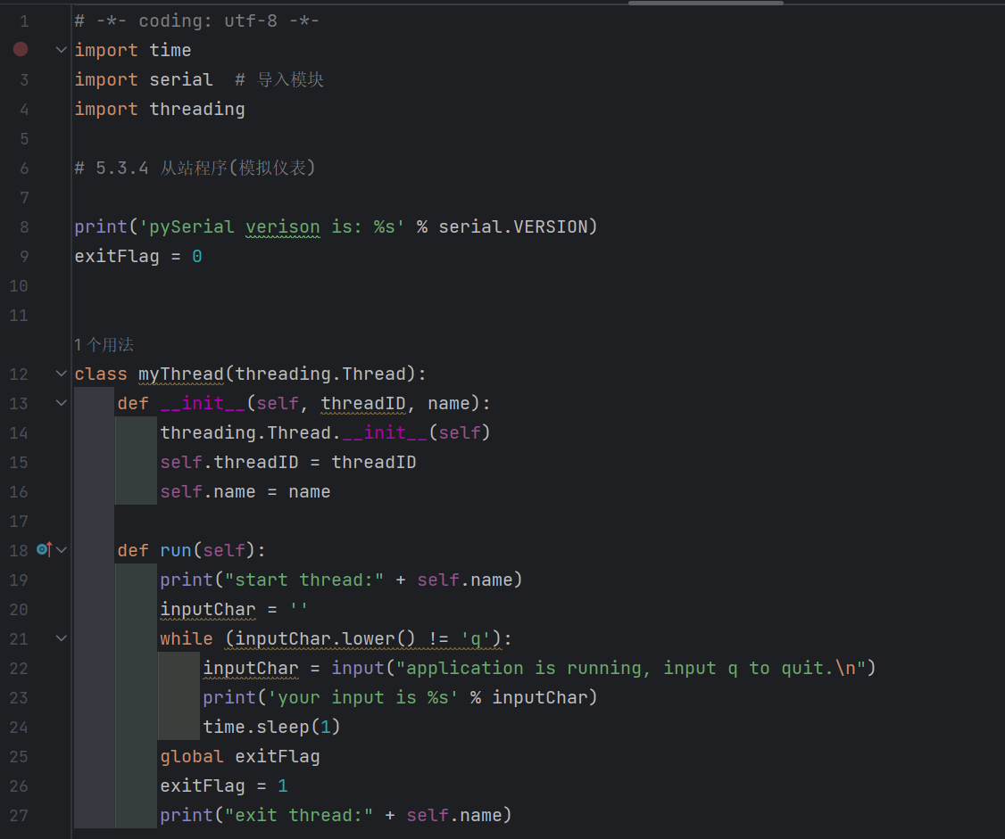

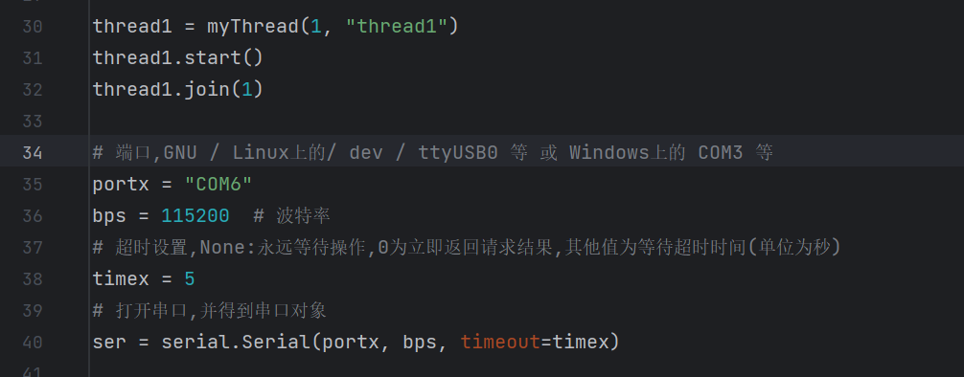

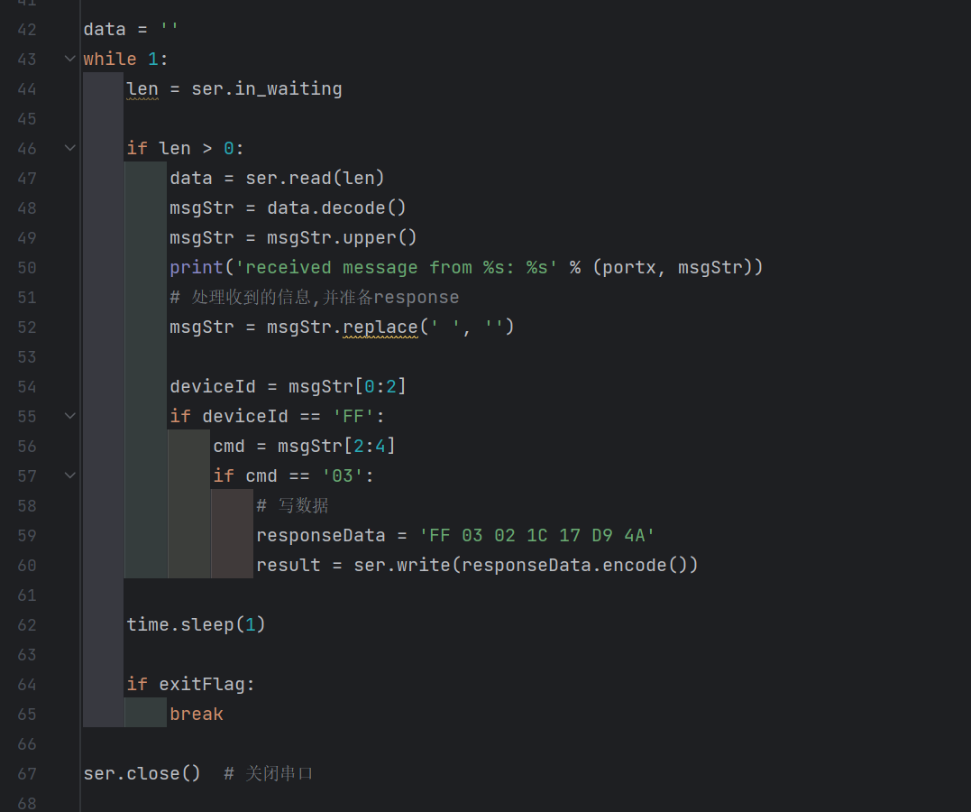

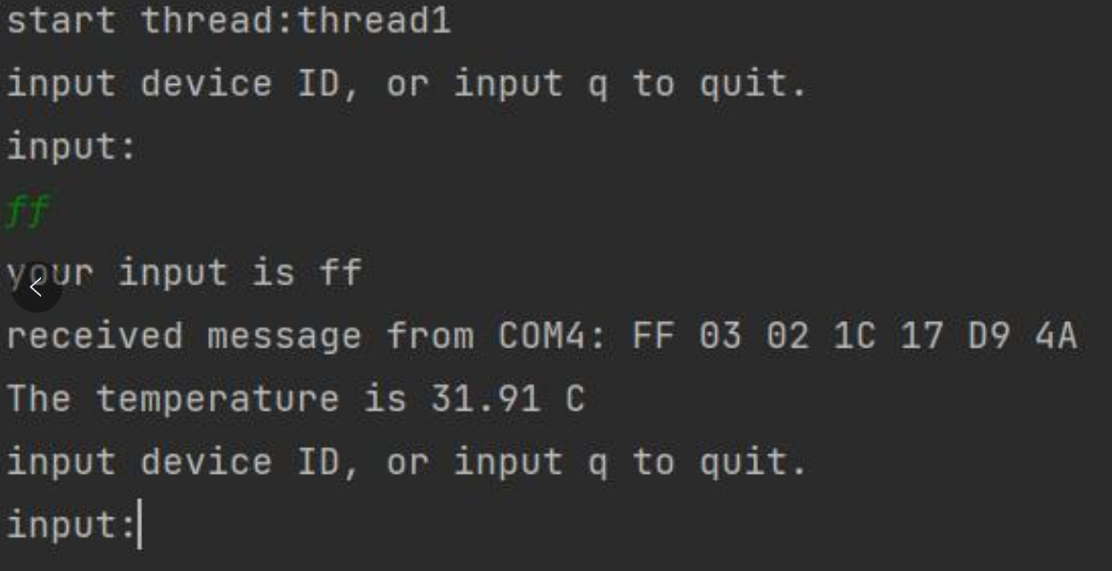

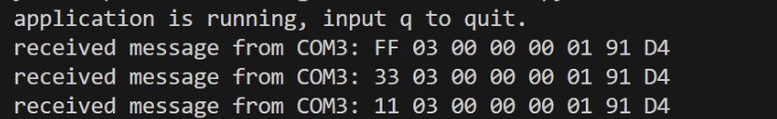

**3. Analysis and discussion**

Through this test, we have a better understanding of the sending and receiving of information, the two computers are divided into the host and the slave, and then the data is sent and received through the serial port. Importantly, there may be difficulties, such as python programs that may require administrator privileges, and threads that may not be closed, which is more obvious with jupyter. In addition, we also notice that during the sending process, we will encounter the problems of "access denied" and "handle invalid". The possible cause of the problem is that the port is occupied and the process is open too much.

**4. Teachers' comments and score**