

**计算机与信息科学学院 软件学院**

**实**

**验**

**报**

**告**

**学 院：** 计算机与信息科学学院

**专 业：** 自动化

**课程名称：** 计算机控制系统

**实 验：** Lab6 Process data storage

**学 号：** 222021321132005

**姓 名：** 贾博方

**学年学期：** 2023-2024-1

**指导老师：** 张渝

**完成日期：** 2023-11-7

**1. The purpose and requirements of the experiment**

Understand process device communication protocols

Sample the process data

Save the sampled data to the database

**2. Experiment content and results**

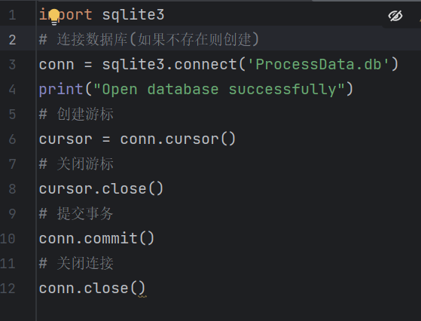

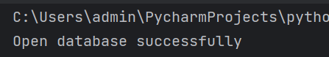

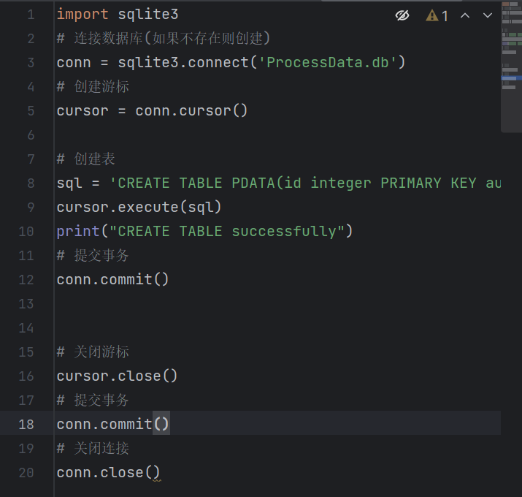

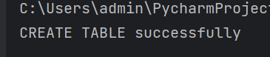

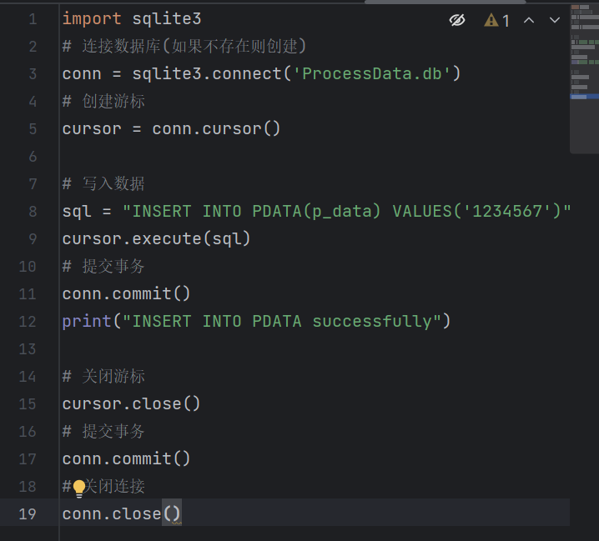

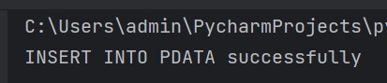

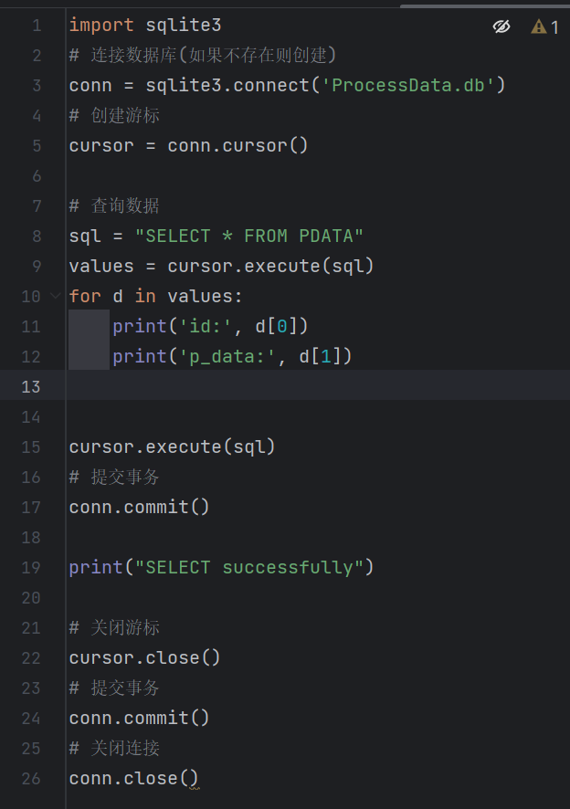

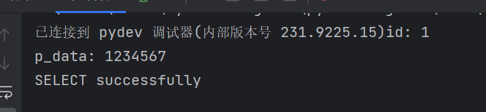

Master program

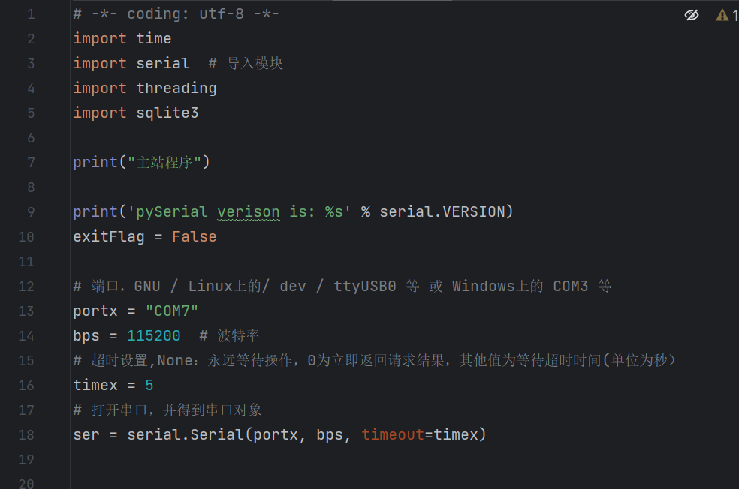

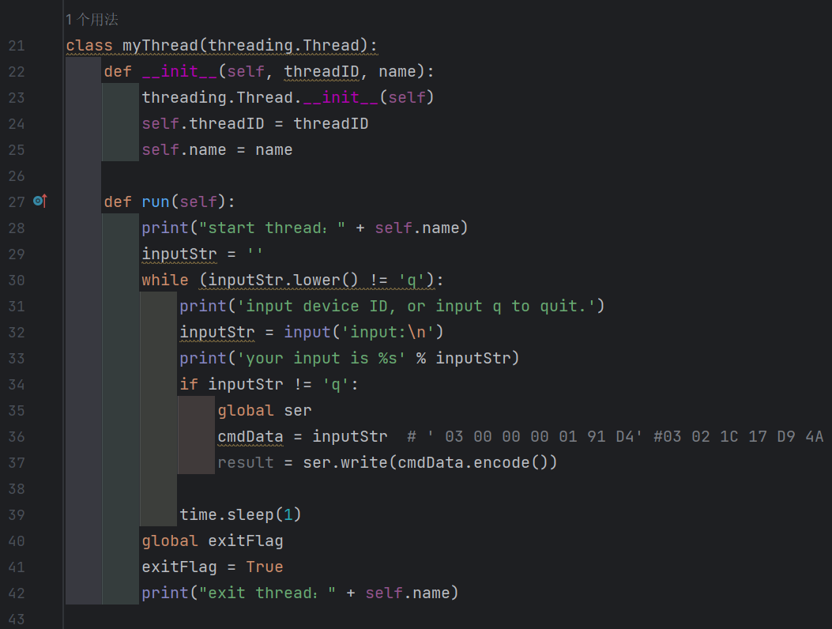

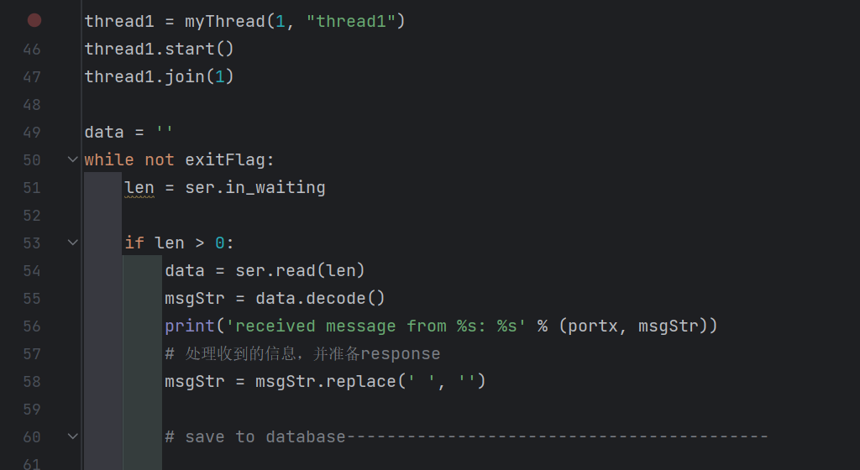

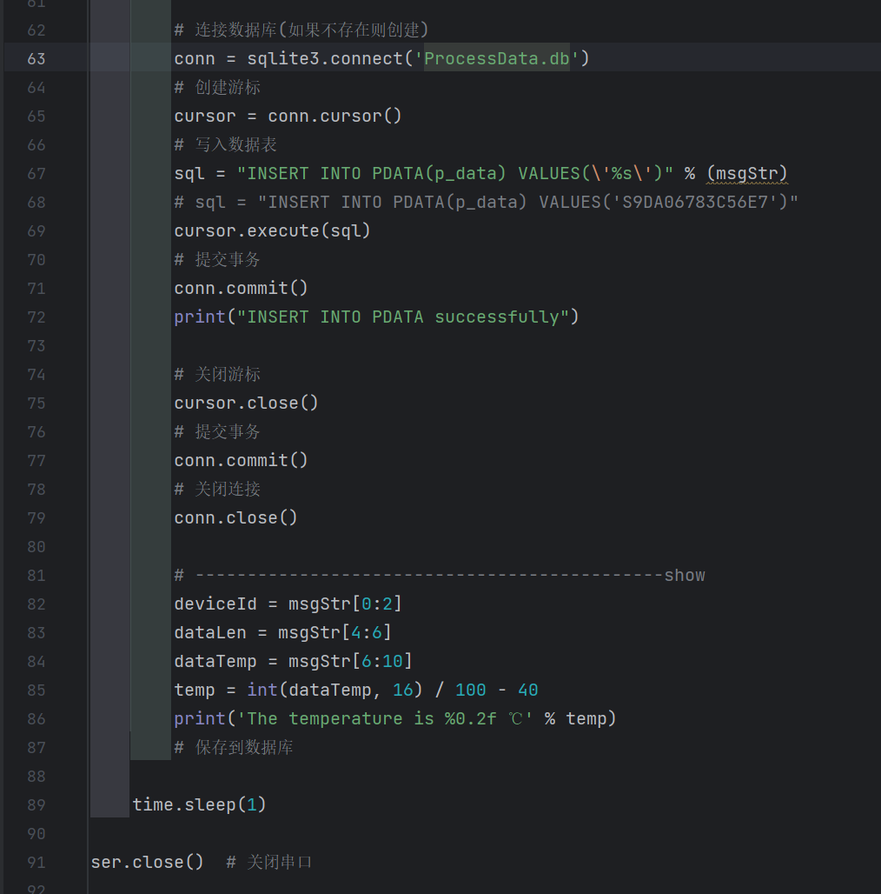

Slave program

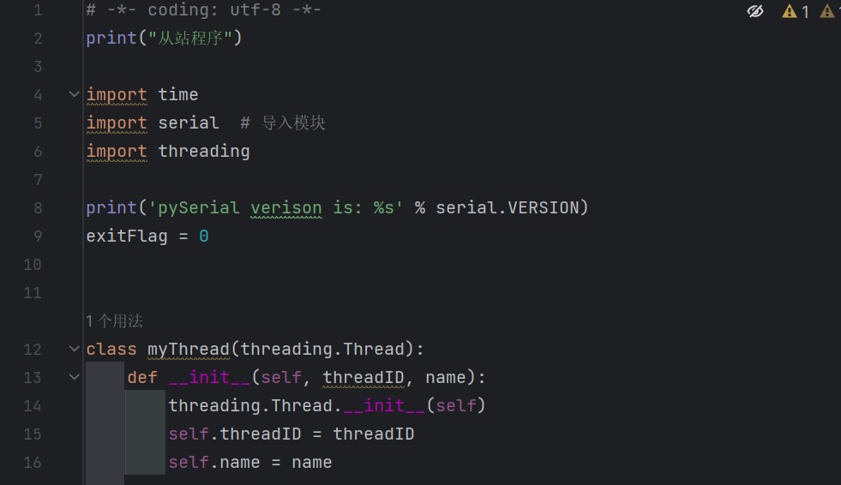

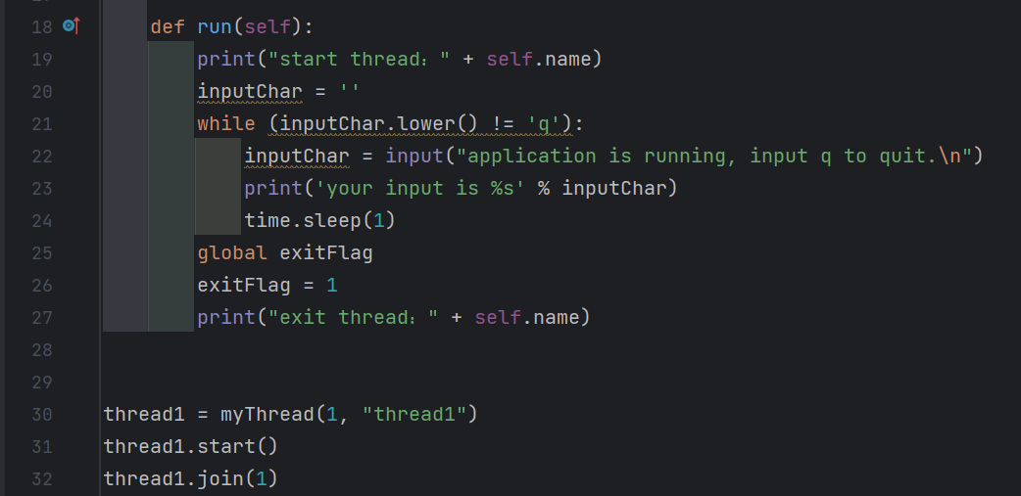

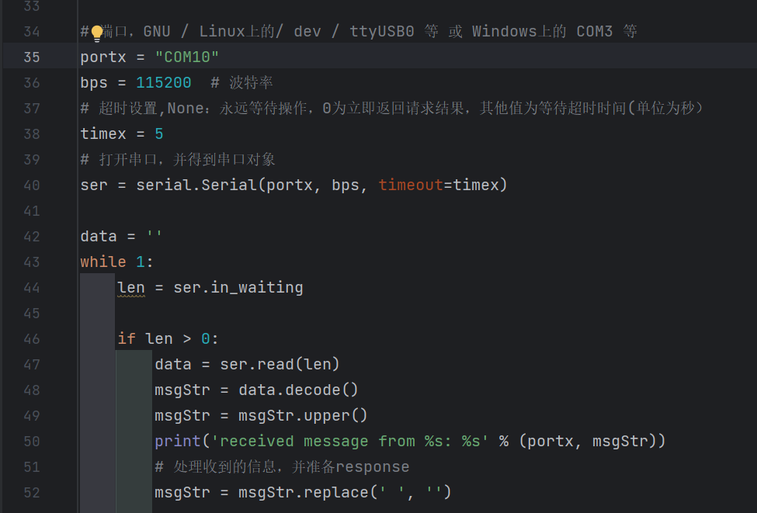

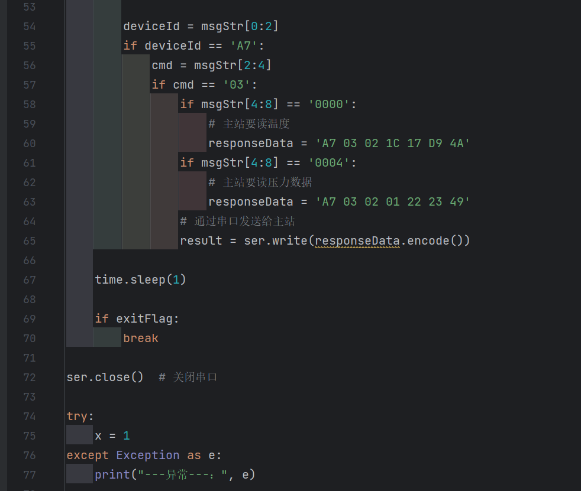

result

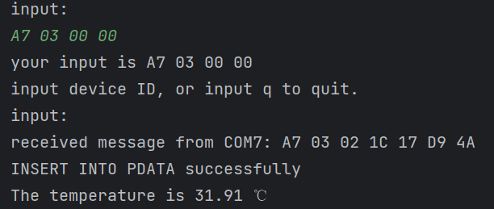

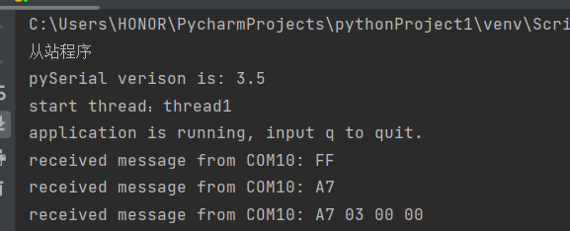

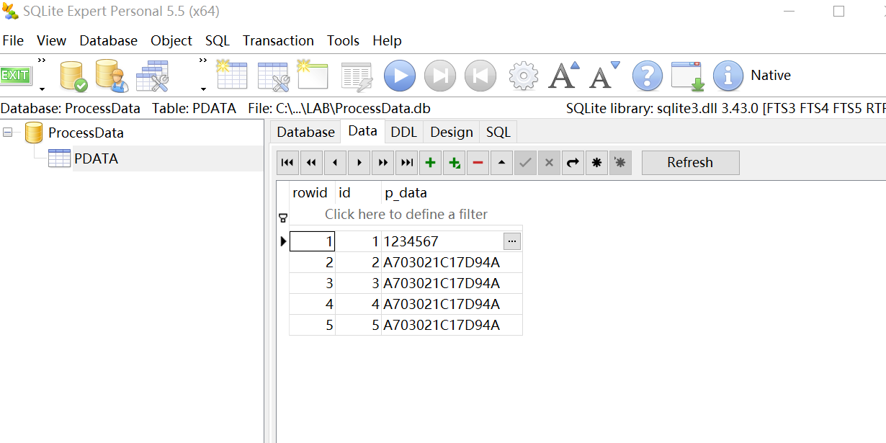

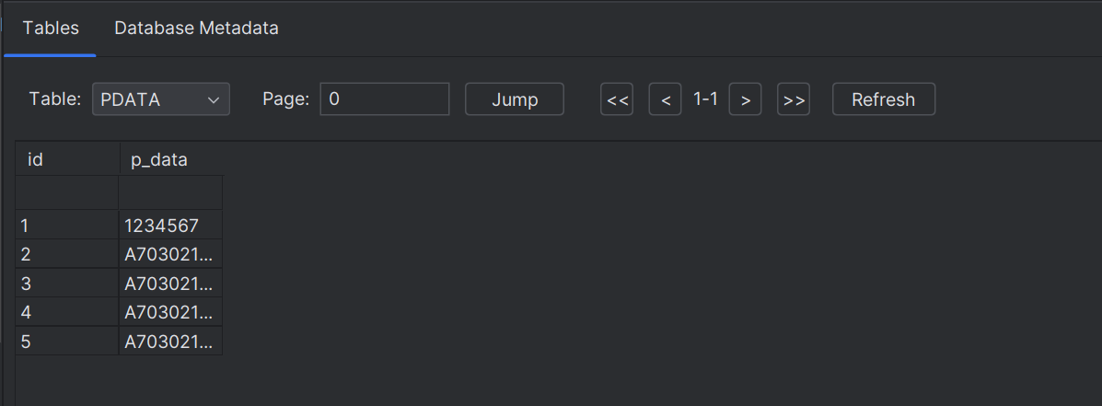

**3. Analysis and discussion**

Through this experiment, we have mastered the relevant contents of the database. SQLite is an embedded database, its database is a file, and it is embedded in python. Through a series of example programs, we have mastered some basic operations of the database. Then we modified on the basis of experiment 5, and added the operation about database to the relevant program, so that the data transmission can be saved in the database, so that we can check in time. We have linked to a database called 'ProcessData, which sends data from the master to the slave, and from the slave to the master. We will introduce the data coming from the slave, and the related sent data will be written to the database. We can use SQLite Expert Personal to view, and the data is updated in time. In addition, we can also view the db file in pycharm. To sum up, this experiment mainly investigated our ability to send and receive data through serial port and view data through database, which enriched relevant knowledge and deepened our understanding and mastery.

**4. Teachers' comments and score**