

**计算机与信息科学学院 软件学院**

**实**

**验**

**报**

**告**

**学 院：** 计算机与信息科学学院

**专 业：** 自动化

**课程名称：** 计算机控制系统

**实 验：** Lab 8 System configuration for open

process connections

**学 号：** 222021321132005

**姓 名：** 贾博方

**学年学期：** 2023-2024-1

**指导老师：** 张渝

**完成日期：** 2023-11-14

**1. The purpose and requirements of the experiment**

(1)Understanding OPC

(2)Establish a communication environment for onsite devices

(3)configuration

**2. Experiment content and results**

**OPC Server simulation 1 installation**

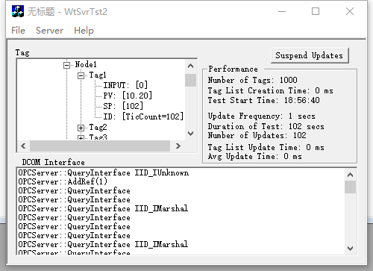

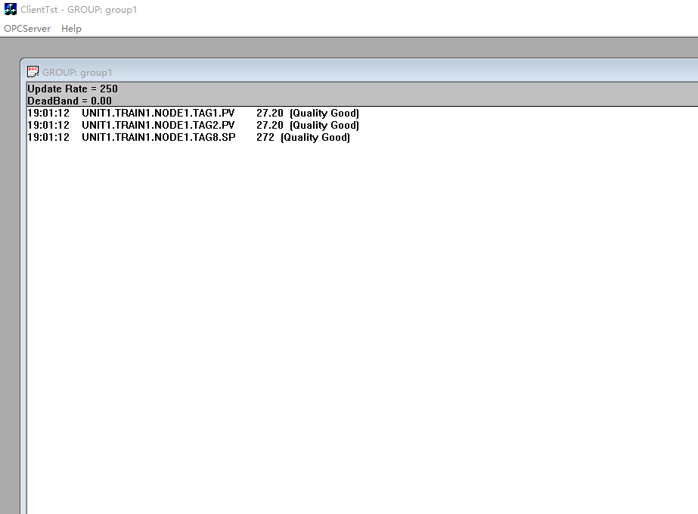

The software sometimes has some problems and often automatically exits, so we use another software

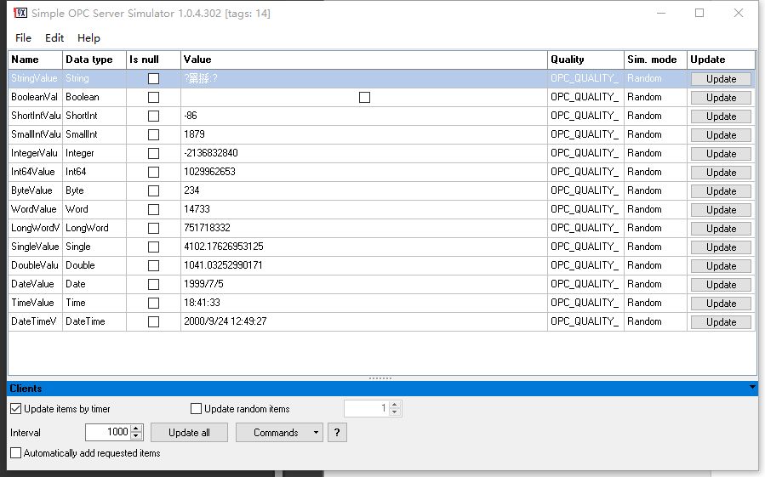

**Use KingView to do this**

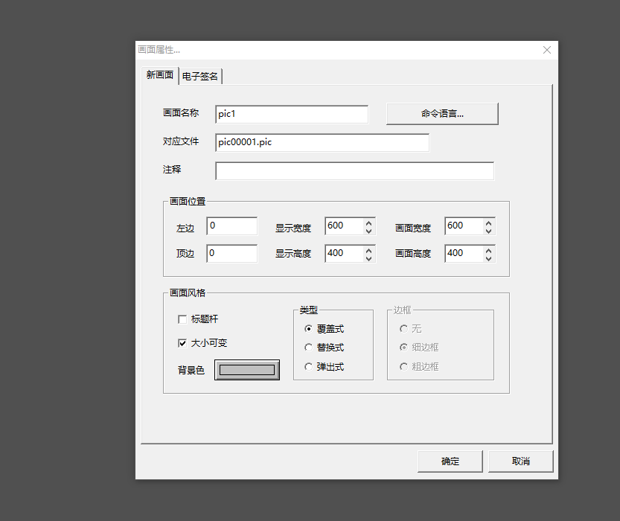



Add text for screen display

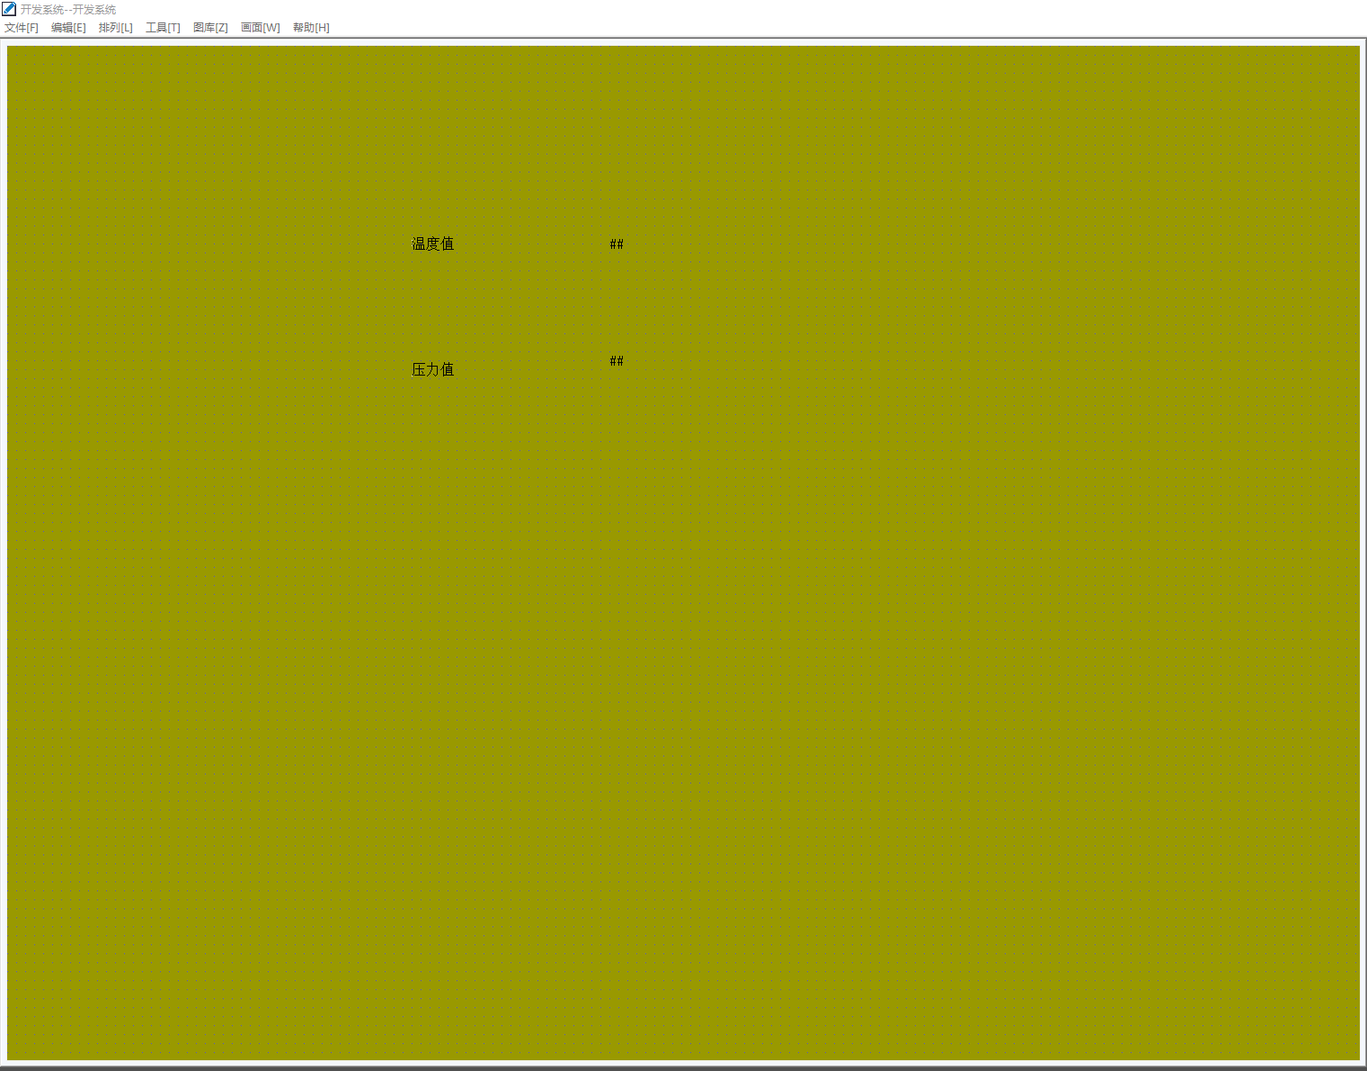

**Create a second screen and insert the real-time trend curve**

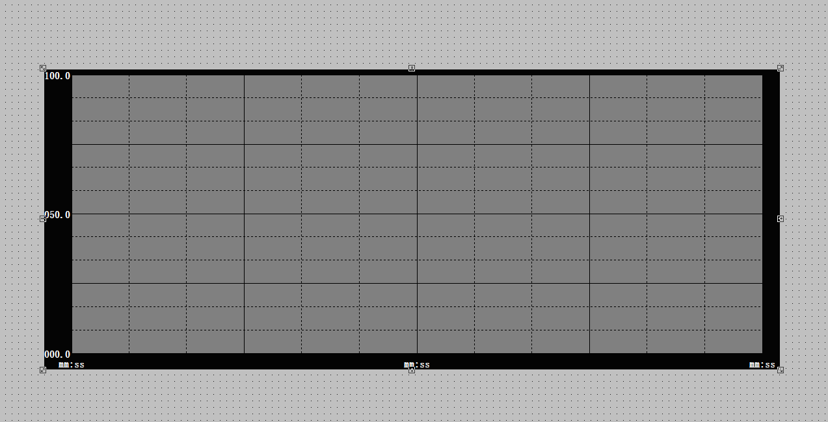

**Insert two buttons to switch between the two screens**

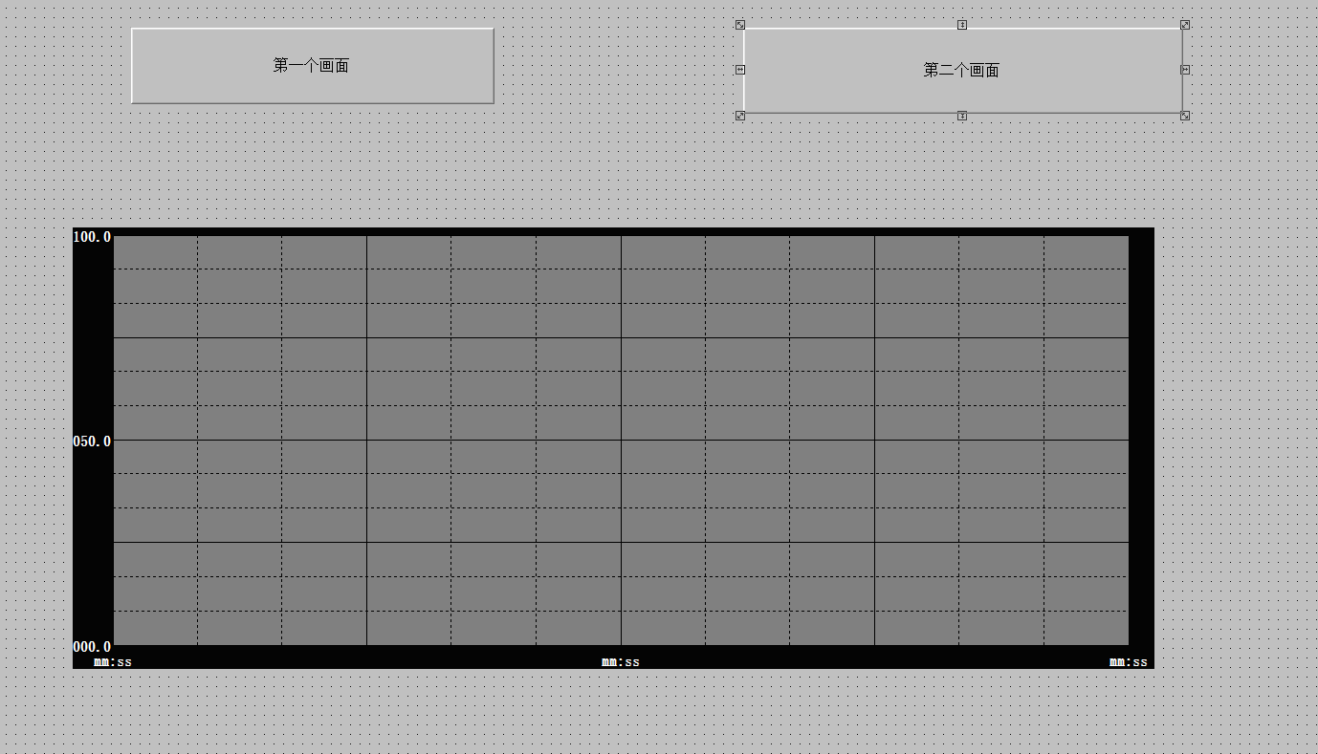

**Select the function and set the parameters**

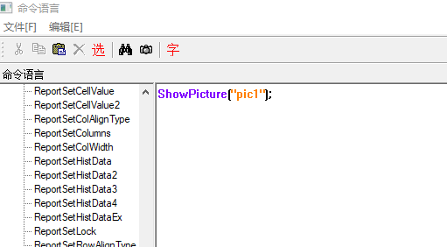

**Click OK and then click OK again**

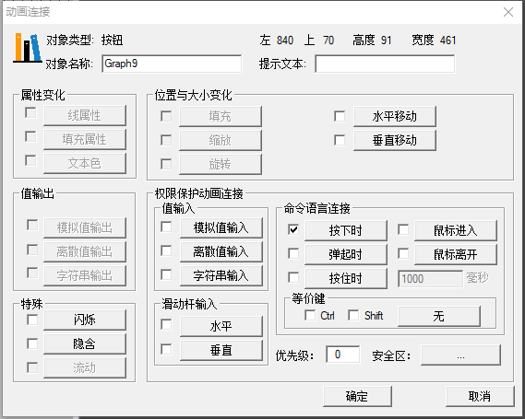

**Copy the buttons from the second screen to the first screen**

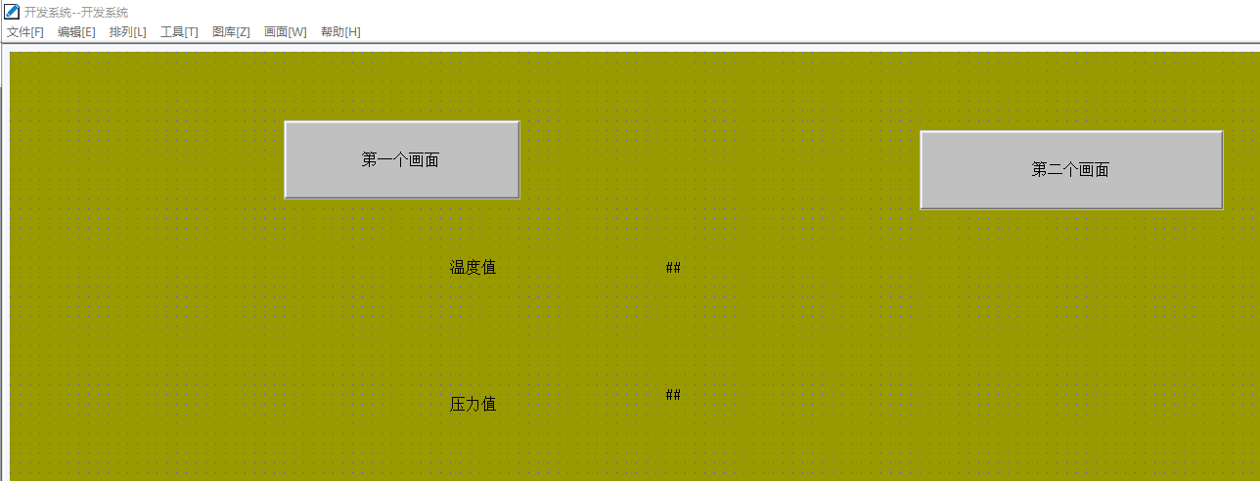

**Click to enter the view to enter the running system, you can click the corresponding button to achieve switching**

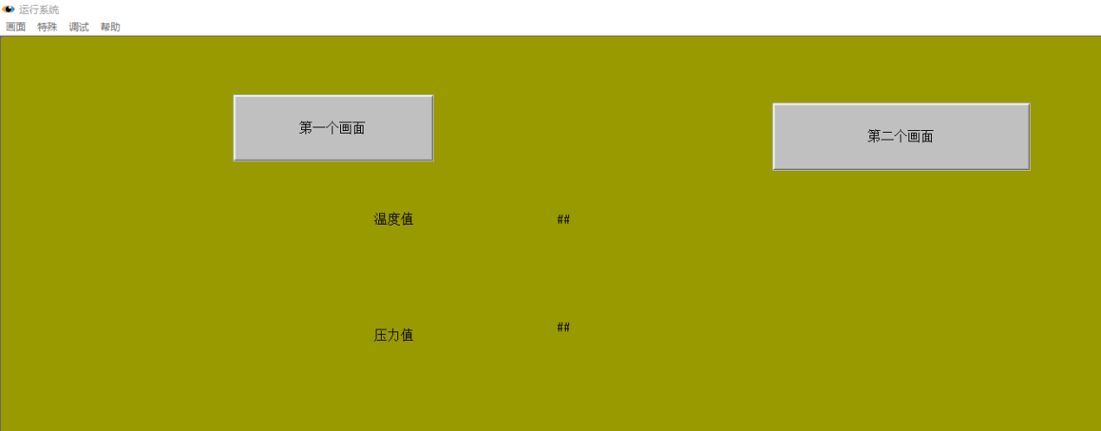

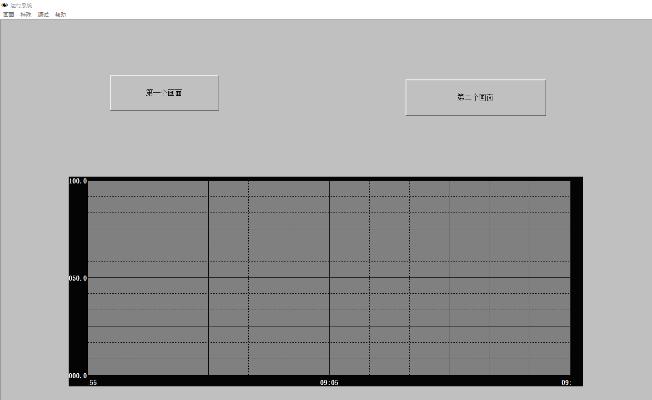

**Link an OPC and choose our new one**

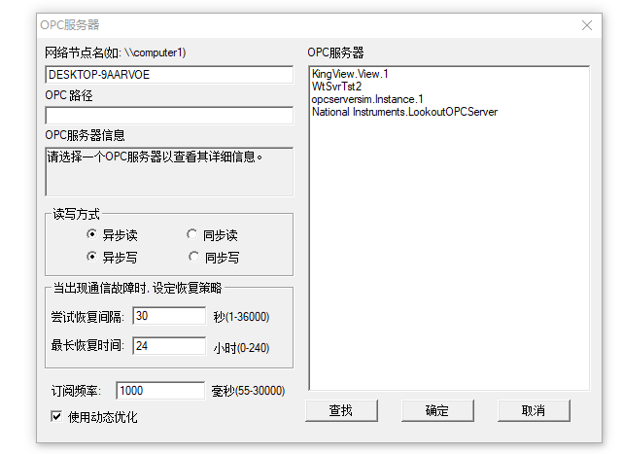

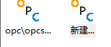

**Create a new variable in the database**

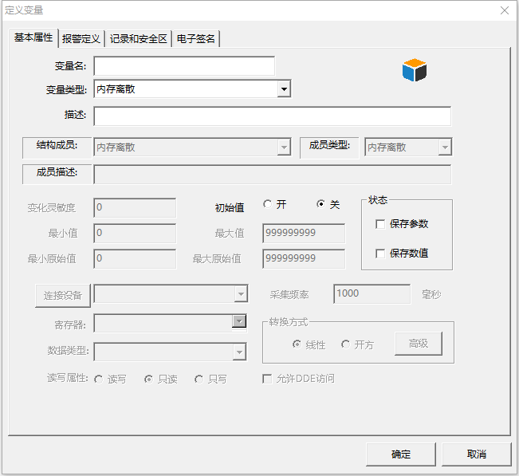

**Fill in the corresponding data**

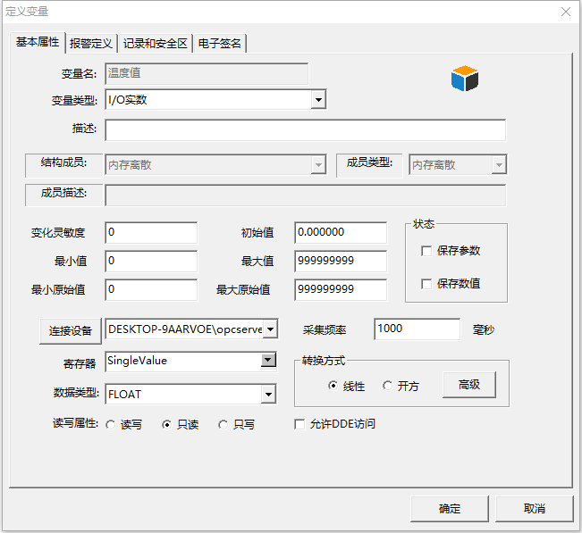

**Click the ## section to enter the data setting, we select the analog value output and select the appropriate output format**

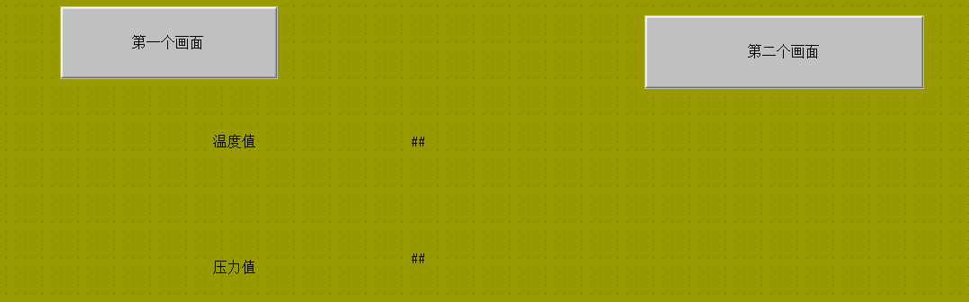

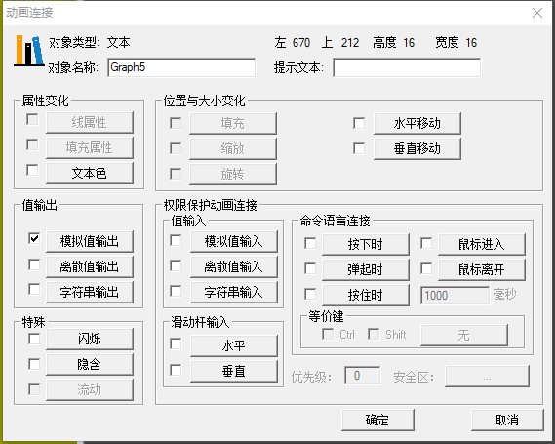

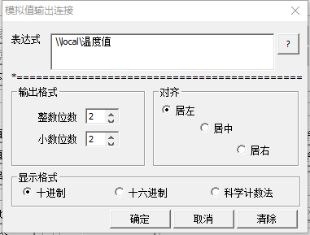

**Click to enter the view, you can view the data**

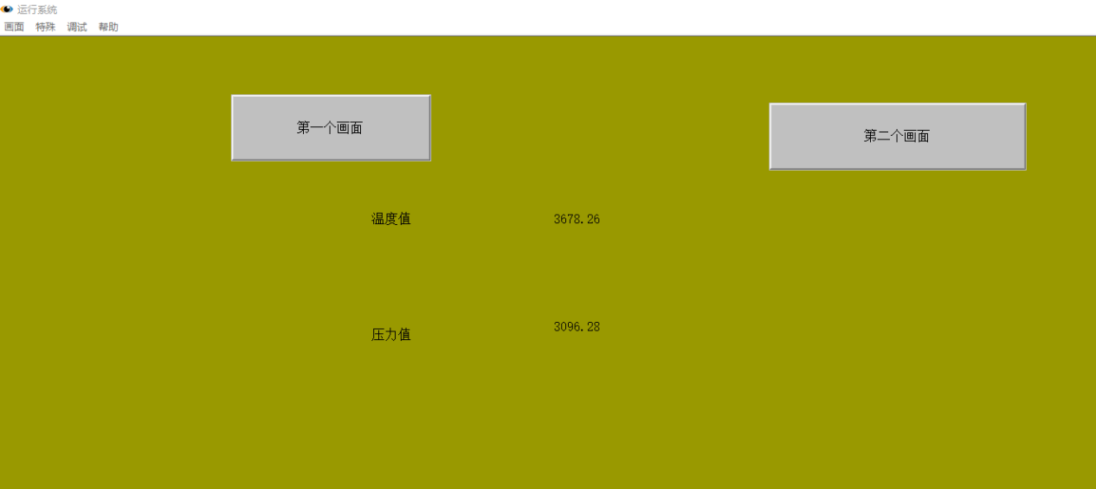

**Click to enter the second screen to set the real-time trend curve**

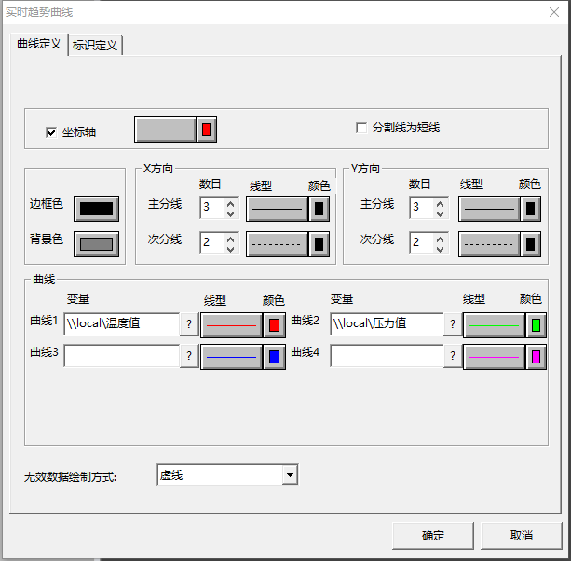

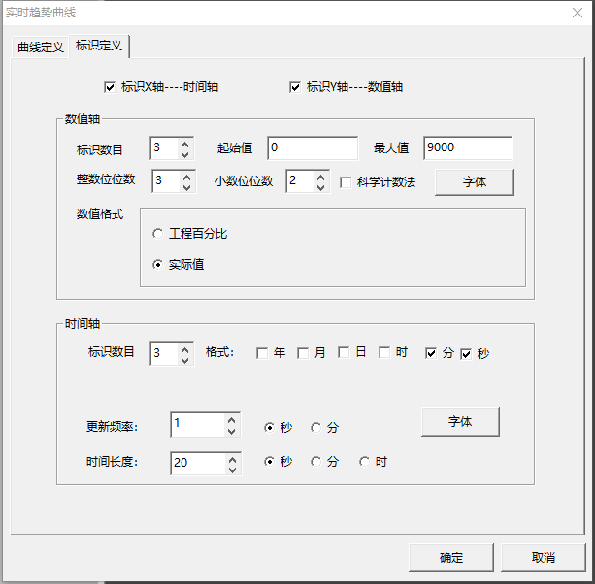

Click view to view the curve

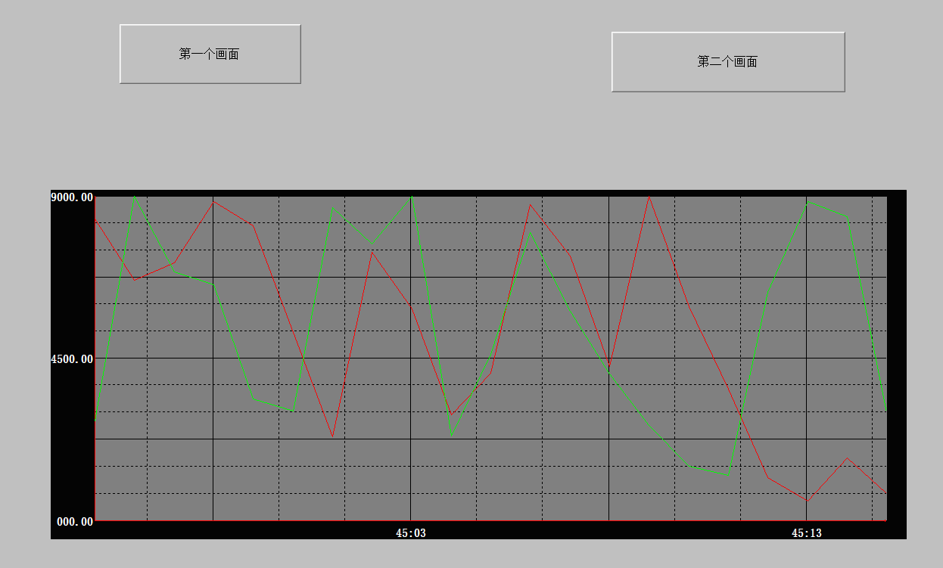

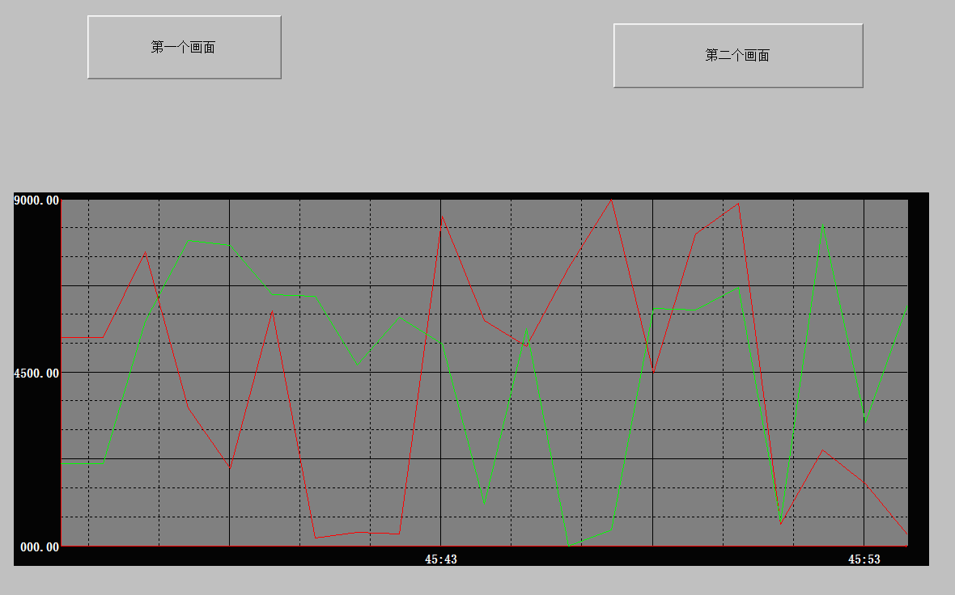

**The screen after adjusting the threshold**

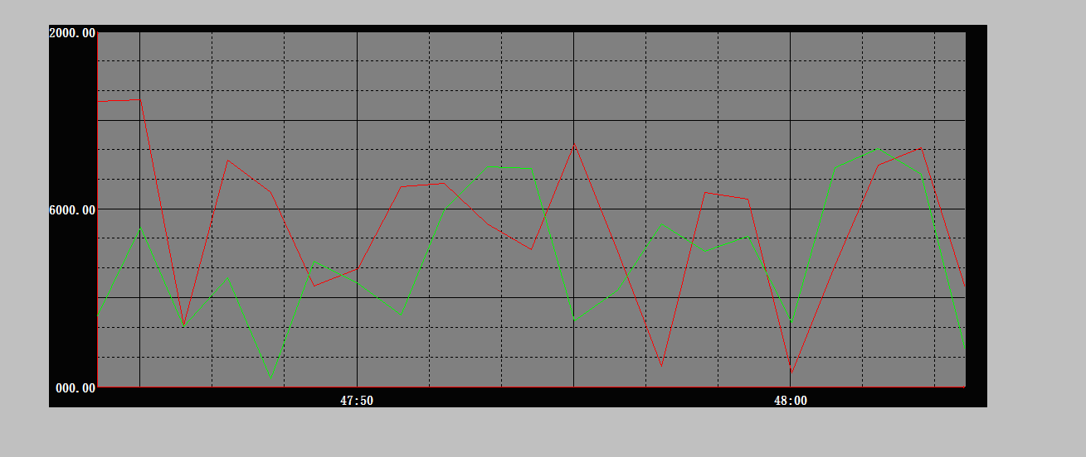

After the experiment, a liquid level alarm operating system was created, and three screens were set up: liquid level screen, real-time alarm window and historical alarm window. At this time, we made use of relevant opc data to link, and set alarm and record when the liquid level exceeded 200.

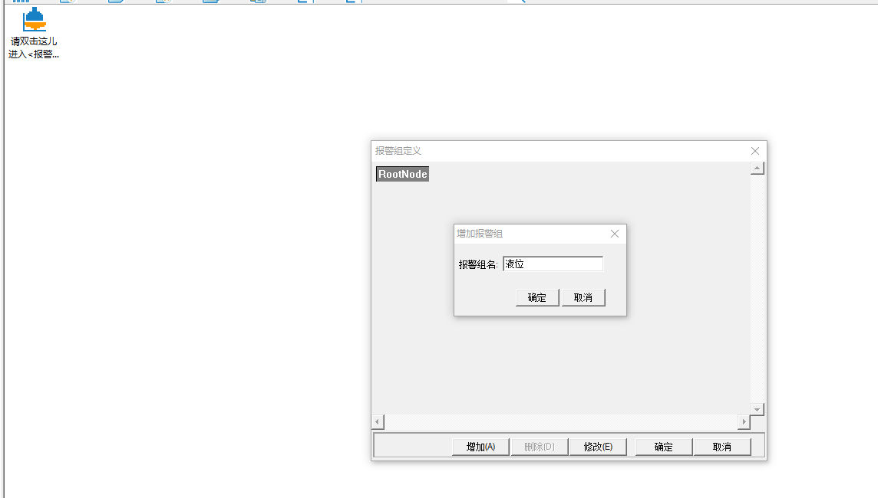

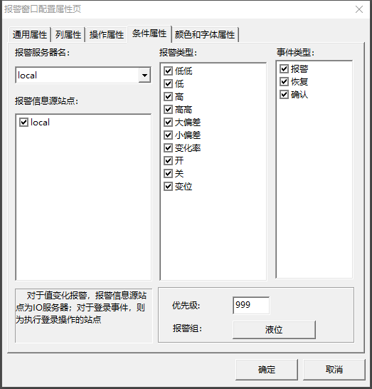

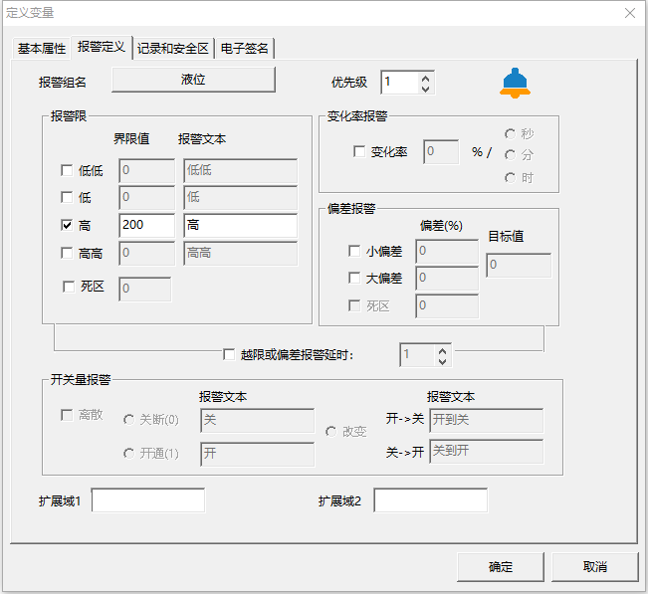

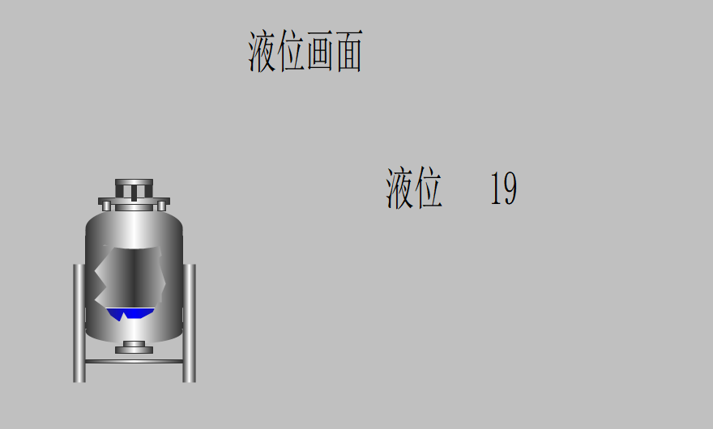

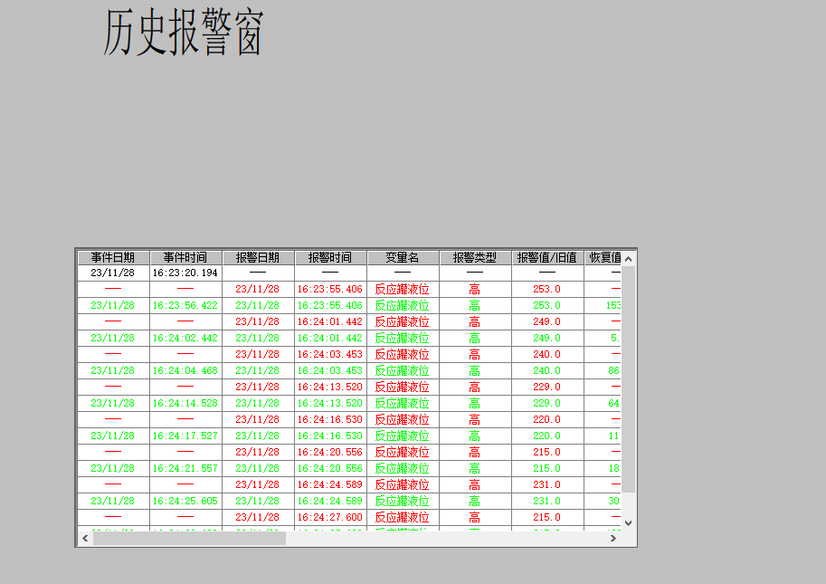

**Link to database**

**Using the access database, first create a database file in mdb format, and then add the created database on ODBC, and then add the database in the alarm Settings of Kingview, at this time we can also click the button to detect whether the database connection is successful. Finally, repeat the alarm Settings above, turn off the configuration queen, and you can view the historical alarm data in the mdb file**

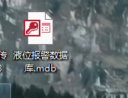

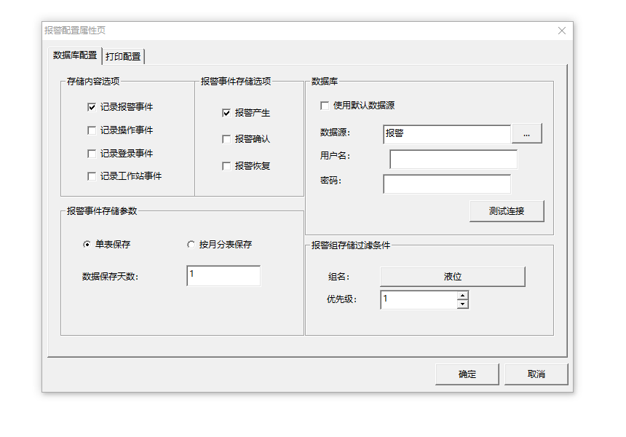

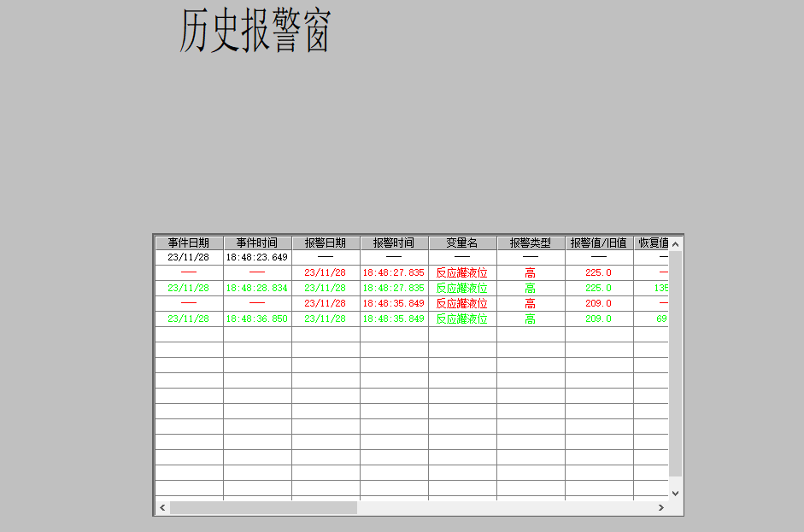

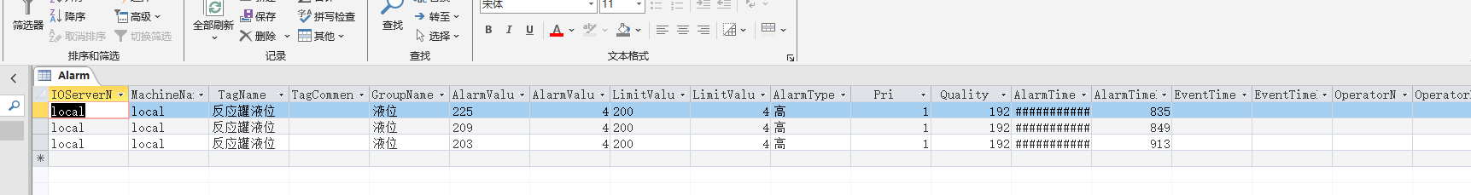

**3. Analysis and discussion**

Through this experiment, I mainly mastered the use of Kingview software. For example, we can set OPC, set different screens, add trend charts, moments, straight lines and other different shapes to the screen, and also import complete CAD files and open source components, which greatly facilitate our operation. In addition, I also mastered the import and other contents. I can display data in real time and switch between different screens to get real-time data curves. Through this experiment, I have greatly enriched my ability and learned more content in the direction of computer control.

In the future to learn more about King Configuration knowledge, we also need to know more about the corresponding function content, and do a good job of combing and training the call and logical direction.

After the experiment, a liquid level alarm operating system was created, and three screens were set up: liquid level screen, real-time alarm window and historical alarm window. At this time, we made use of relevant opc data to link, and set alarm and record when the liquid level exceeded 200. Through this operation, I enriched my understanding of Kingview and database, and further deepened my grasp of relevant knowledge

Using the access database, first create a database file in mdb format, and then add the created database on ODBC, and then add the database in the alarm Settings of Kingview, at this time we can also click the button to detect whether the database connection is successful. Finally, repeat the alarm Settings above, turn off the configuration queen, and you can view the historical alarm data in the mdb file

**4. Teachers' comments and score**