SWE 574 Software Development As A Team
Instructor: Suzan Üsküdarlı

BUCOMP Software Product Manual

Revision 1.0

By: Group-1

İlyas Alper Karatepe
Emre Gürer
Serkan Karaçay
Emre Demirel
Hasancan Akgündüz

Revision History

Revision | Date | Explanation
1.0 | 02.01.2016 | Initial software product manual

Table of Contents

Revision History 1
Table of Contents 2
1. Introduction 3
2. Implementation 3
2.1. Source Code and Executable Organization 3
2.2. Software Tools 4
2.3. Platform 4
3. Testing 4
4. Application Installation, Configuration and Operation 5
4.1. Installation & Configuration 5
4.2. User Interfaces 6
4.2.1. Home Page 6
4.2.2. Registration Form 7
4.2.3. User Profile Page 8
4.2.4. Communities Page 8
4.2.5. Create Community Page 10
4.2.6. Community Details Page 10
4.2.7. Create Topic Form 12
4.2.8. Create Meeting Form 12
4.2.9. Meeting Details Page 14
5. References 14
6. Source Code and Executable Delivery 14

Introduction

The purpose of this software product manual is to document the implementation, testing, installation and operation of BUCOMP web application as a software product.

BUCOMP application is implemented and tested as it is described in BUCOMP Application Design Specification Document, satisfying the requirements in BUCOMP Application Requirements Specification Document. Implementation, testing and operational details are given in the following sections of this document.

Implementation

Github Locations:
Web Application: https://github.com/BogaziciUniversitySWEG1/web-app-repo
Android Application: https://github.com/BogaziciUniversitySWEG1/android-app-repo
Documentations: https://github.com/BogaziciUniversitySWEG1/docs-repo
APK File: https://github.com/BogaziciUniversitySWEG1/docs-repo/tree/master/APK
Wiki: https://github.com/BogaziciUniversitySWEG1/docs-repo/wiki

Github access:
username: swe574g1
password: swe574g1

Source Code and Executable Organization

- Structure and organization of source code, including related source code filenames
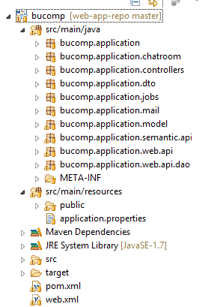
- Structure and organization of executables:
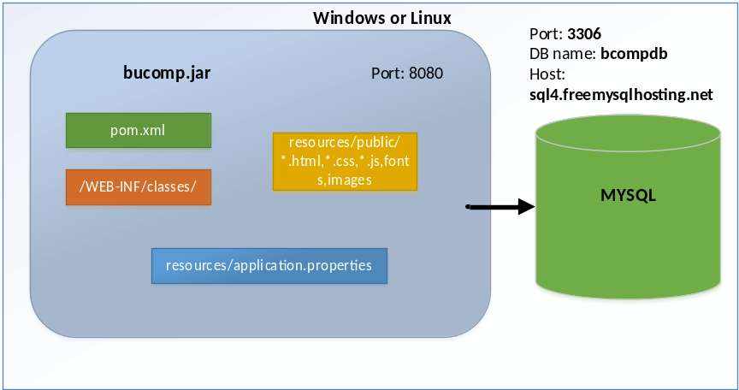
- Database script:

bucompdb.sql: Includes database and database objects create scripts. It can be installed as below:

shell> mysql bucompdb.sql

See Section 6 regarding source code delivery.

Software Tools

On the server side;
- The application executes on Windows and Linux systems on which Java SE Runtime Environment 7 (Java Runtime Environment 1.7.0.51) is installed.
- Deployment file (bucomp.jar) can be run as a standalone java application.
- As a build automation tool, Apache Maven, which describes how software is built, and its dependencies, is used in the project. The version of maven is “Maven 3.2.3”.
- Eclipse IDE for Java EE Developers (Juno) is used as the development environment and in order to use maven commands inside the IDE, Apache Maven plugin is installed on eclipse.
- The frameworks and libraries used are listed below:
  - Spring boot framework 1.2.7.RELEASE,
  - Apache Commons File Upload 1.2.2, for implementing file upload functionality
  - spring-boot-starter-mail for sending emails,
  - org.eclipse.persistence 2.5.0 for database connection management and ORM.
  - Log4j 2.0.2, for implementing logging requirements

On the client side;
- HTML 5 and CSS-based design templates for typography, forms, buttons, navigation and other interface components
- Ajax, Javascript and JQuery for implementing required functionalities in client side and communicating with the server side.

Platform

The platform information on which BUCOMP application is implemented and tested and also is expected to operate is as below:

- System software : Windows / Linux
- Java Version : 1.7
- Database:
RDBMS : MySQL 5.6
Driver : com.mysql.jdbc.Driver
Url : jdbc:mysql://sql4.freemysqlhosting.net:3306/
DB Name : bucompdb
User : sql498926
Password : qZi6wKzSta

Additionally, it is expected from this application to run on a Linux platform.

Testing

Details of module/object-method test cases and system integration test cases:
- Access the application at the address http://<server_host>:8080 and the home page should be seen.
- Register a user
- Log-in to the application
- Create a community
- Create a meeting
- Create a topic
- Join a community
- Modify account information
- Search a community

All parts/functions of the software has been implemented according to the most recent RSD and DSD and has been tested sufficiently and operating correctly.

Application Installation, Configuration and Operation

This section includes following items:
- All information and instructions regarding the installation, configuration and the operation of BUCOMP application.
- A snapshot of user interfaces

Installation & Configuration

Please follow the instructions given below to install and configure BUCOMP application.

- Download JDK or JRE 7 binary distribution for your environment and install it.
- Put bucomp application deployment file “bucomp.jar” into $home/bucomp folder.
- Download and install MySQL 5.6 to the same server.
- Start installed MySQL server.
- Execute bucompdb.sql script in mysql server to create database in the server.
- Create database user needed for application to connect to database as below:
CREATE USER 'sql498926'@'localhost' IDENTIFIED BY 'qZi6wKzSta';
GRANT ALL PRIVILEGES ON * . * TO 'sql498926'@'localhost';
- Go to folder “$home/bucomp” and run bucomp application with the following command:
Shell> nohup java –jar bucomp.jar &
(You need to give execute right to bucomp.jar file before running this command)

The application log file can be found under $home/nohup.out file.

In order to start mysql server at boot time automatically, start scripts may be created under /etc/init.d directory.

Installation and configuration details may be found in MySQL references given in References section.

User Interfaces

Home Page
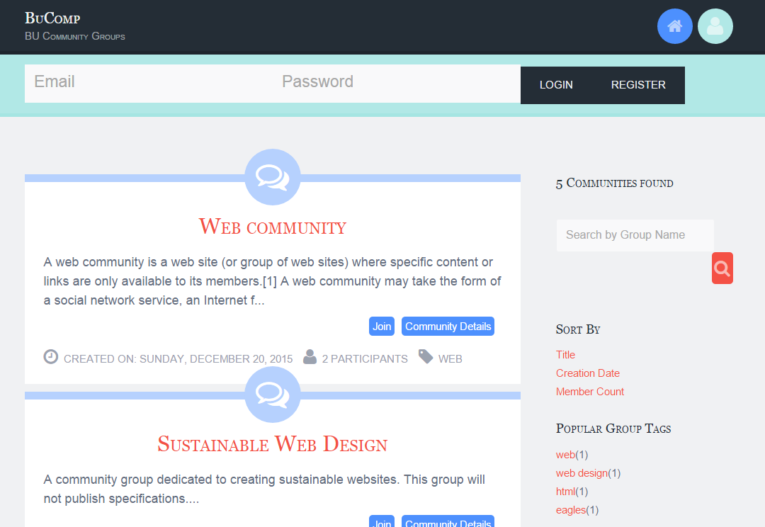

Registration Form
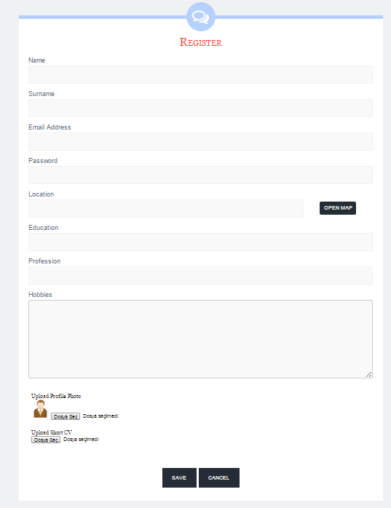

User Profile Page

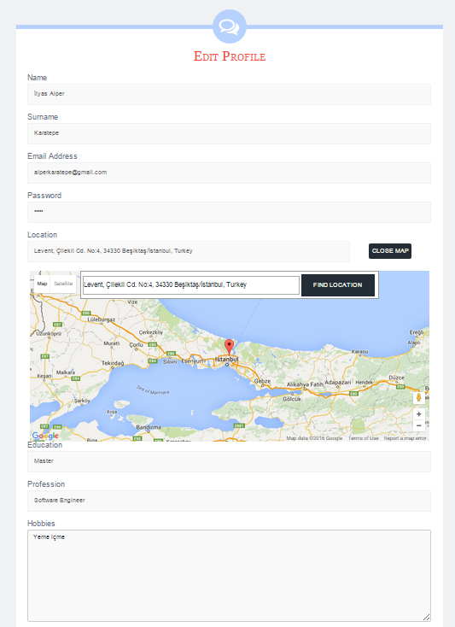

Communities Page

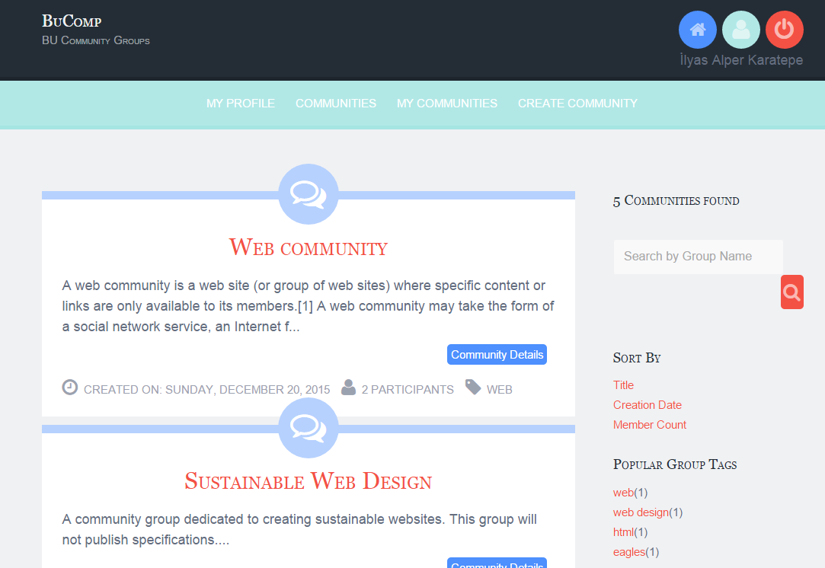

Create Community Page

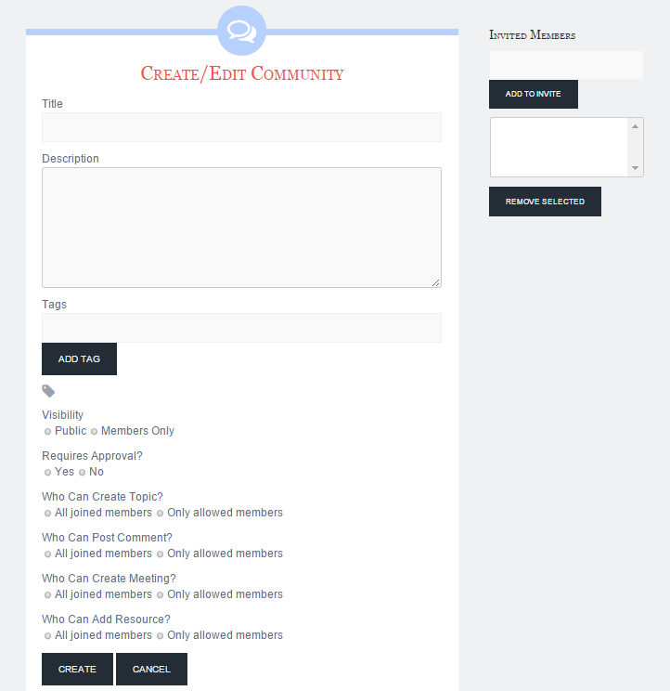

Community Details Page

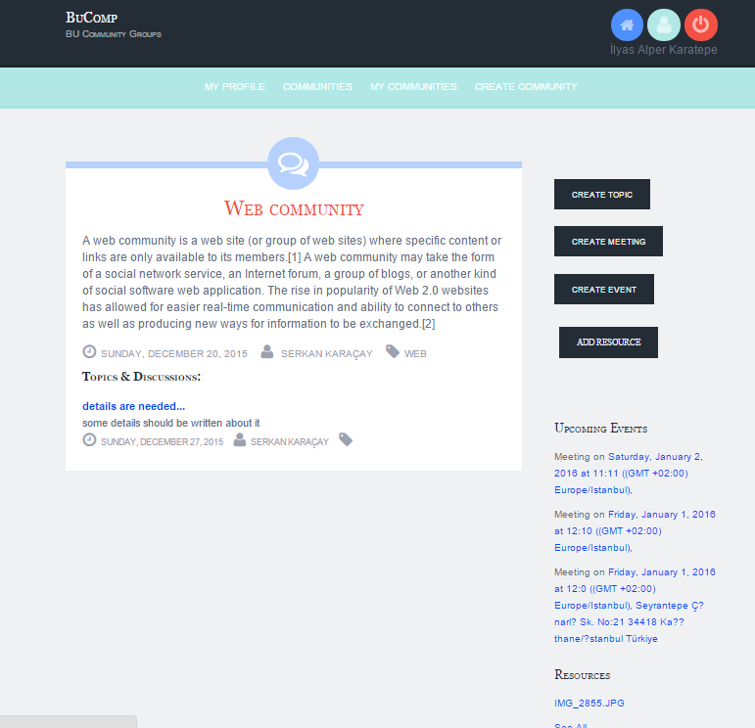

Create Topic Form

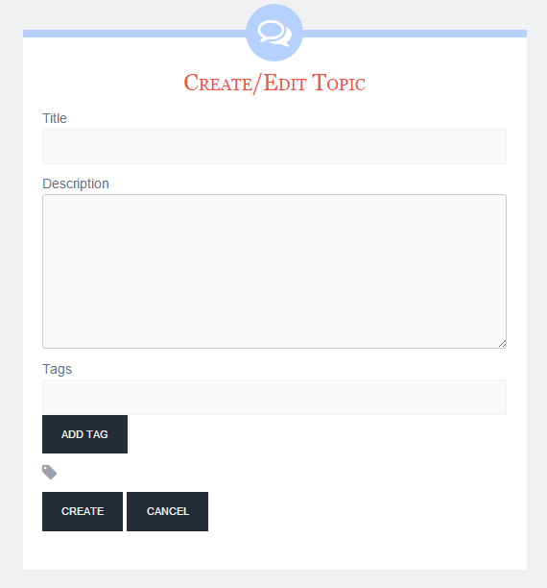

Create Meeting Form

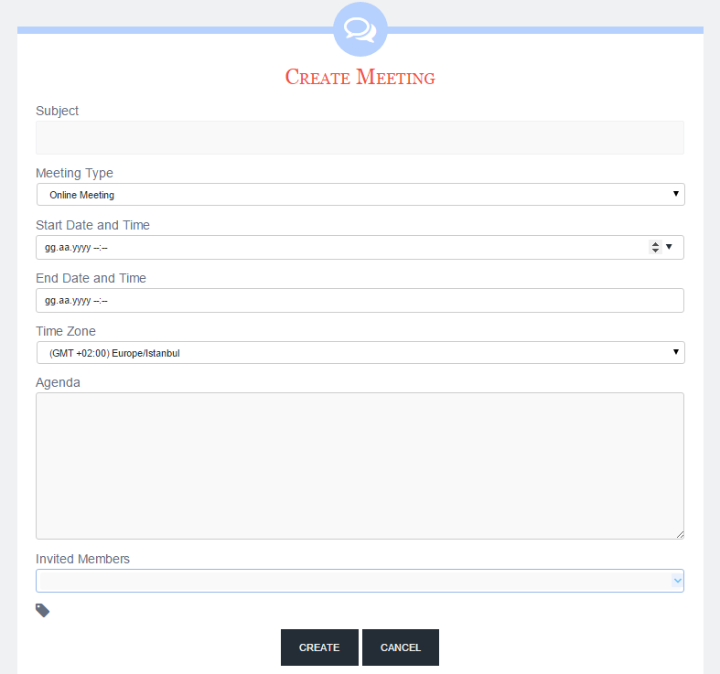

Meeting Details Page

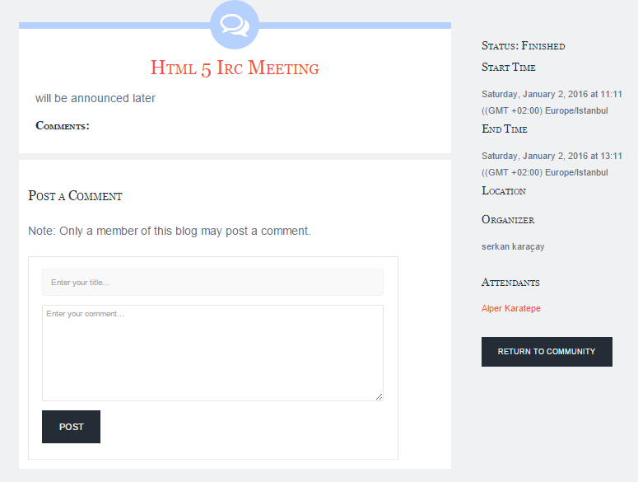

References

- Requirement Specification Document, SWE574Group1RSDv1.1
- Design Specification Document, SWE574Group1DSDv1.1
- MySQL Documentation, http://dev.mysql.com/doc/refman/5.6/en/index.html

Source Code and Executable Delivery
Source code, database script (bucompdb.sql), executable file (bucomp.jar) and other project related documents are given in CD format.

