# Section

## Subsection

### Subsubsection

#### Not a subsubsubsection but a paragraph.

##### Not a subsubsubsubsection but a subparagraph.

Body Text

Default Paragraph

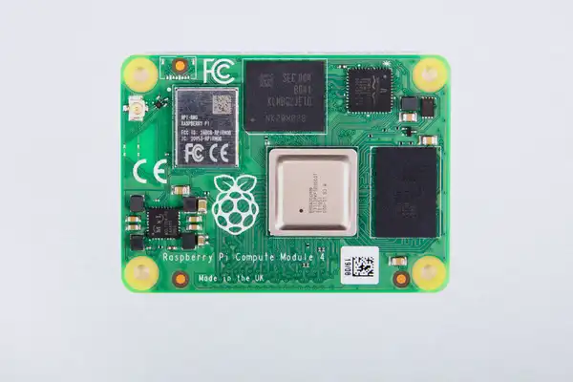

Image Caption

Table Caption