FACULTY OF ENGINEERING AND INFORMATION SCIENCES

CSCI218 Assignment Coversheet

Attach this Cover Sheet as the front page of the assignment. Assignments are to be submitted to the relevant academic. Submit only one copy of the assignment per group to the relevant online site.
PLAGIARISM
Deliberate plagiarism may lead to failure in the subject. Plagiarism is cheating by using the written ideas or submitted work of someone else. The University of Wollongong has a strong policy against plagiarism. A plagiarized assignment will receive a zero mark and be penalized according to the university rules. Plagiarism detection software might be used for this assignment.
See Acknowledgement Practice/Plagiarism Prevention Policy at http://www.uow.edu.au/about/policy/UOW058648.html

Any use of generative AI tools must be clearly stated in the report. Failure to do so may result in penalties for misuse. For example, directly copying and pasting AI-generated content is not permitted.

STUDENT NAME / UOW ID: Bowei Chen / 9106169

STUDENT NAME / UOW ID: Cheng jialin / 8749929

STUDENT NAME / UOW ID: Tang zhouquan / 8877981

STUDENT NAME / UOW ID: Chen zhu / 8750786

STUDENT NAME / UOW ID: Yang yuhao / 8932219

STUDENT NAME / UOW ID: Lee Mingxuan / 9097016

Subject Code & Name: CSCI218 Foundations of AI

Tutor’s Name: Ms Cher Lim

Assignment Due Date: 22nd Feb 2026 (SGT 11:55pm)

DECLARATION
We certify that this is entirely our own work, except where we have given fully documented references to the work of others, and that the material contained in this assignment has not previously been submitted for assessment in any formal course of study. We understand the definition and consequences of plagiarism.

ACKNOWLEDGEMENT
The marker of this assignment may, for the purpose of assessing this assignment, reproduce this assignment and provide a copy to another member of academic staff. If required to do so, we will provide an electronic copy of this assignment to the marker and acknowledge that the assessor of this assignment may, for the purpose of assessing this assignment:
a) Reproduce this assignment and provide a copy to another member of academic staff; and/or
b) Communicate a copy of this assignment to a plagiarism checking service such as Turnitin (which may then retain a copy of this assignment on its database for the purpose of future plagiarism checking).

Student Signature: Date: 14/2

Student Signature: Date: 14/2

Student Signature: Date: 14/2

Student Signature: Date: 14/2

Student Signature: Date: 14/2

Student Signature: Date: 14/2

[Insert e-signatures or type names]

CSCI218 Technical Summary

Project Title: Morphological Feature Dataset for Rice Variety Classification

GitHub link:

YouTube link:

Attribution Table (Required):
Section | Student Name(s) | Roles | Percentage
- Problem Definition & Dataset Description | Tang zhouquan  Bowei Chen | Tang zhouquan: A  Bowei Chen: R, D | 70/30
- Methodology & Design Rationale | Yang YuHao  Cheng jialin  Chen zhu  Lee Mingxuan  Tang zhouquan  Bowei Chen | Yang yuhao: A, E, V  Cheng jialin: A, E, V  Chen zhu: A, E, V  Lee Mingxuan: A, E, V  Tang zhouquan:R, D  Bowei Chen: R, E, D | 24/24/24/22/4/2
- Experimental Setup & Training configuration | Yang YuHao  Cheng jialin  Chen zhu  Lee Mingxuan  Tang zhouquan  Bowei Chen | Yang yuhao: A, E, V  Cheng jialin: A, E, V  Chen zhu: A, E, V  Lee Mingxuan: A, E, V  Tang zhouquan:R, D  Bowei Chen: R, E, D | 20/20/20/20/15/5
- Evaluation Metrics & Analysis Methods | Yang YuHao  Cheng jialin  Chen zhu  Lee Mingxuan  Tang zhouquan  Bowei Chen | Yang yuhao: A, E, V  Cheng jialin: A, E, V  Chen zhu: A, E, V  Lee Mingxuan: A, E, V  Tang zhouquan:R, D  Bowei Chen: R, E, D | 20/20/20/20/10/10
- Results & Error Analysis | Yang YuHao  Cheng jialin  Chen zhu  Lee Mingxuan  Tang zhouquan  Bowei Chen | Yang yuhao: A, E, V  Cheng jialin: A, E, V  Chen zhu: A, E, V  Lee Mingxuan: A, E, V  Tang zhouquan:A, R, D  Bowei Chen: R, E, D | 20/20/20/20/10/10
- Limitations & Proposed Improvements | Tang zhouquan  Bowei Chen | Tang zhouquan: R  Bowei Chen: A, R, D | 40/60

- Problem Definition & Dataset Description
1.1 Problem Description:
This project addresses a supervised binary classification problem involving the automatic identification of two rice varieties: Cammeo and Osmancik. Rice variety classification is important in agricultural quality control, pricing, storage management, and food industry automation. Traditionally, rice classification may rely on manual inspection, which is time-consuming, subjective, and prone to human error.
The objective of this project is to develop and compare multiple machine learning models that can accurately classify rice grains based on measurable physical characteristics extracted from digital images. Specifically, the model is expected to: learn distinguishing patterns between Cammeo and Osmancik rice varieties, generalize well to unseen data, achieve high classification accuracy and balanced performance across both classes. And achieve high classification accuracy and balanced performance across both classes, allowing comparison between different algorithmic approaches.
1.2 Data description:
The dataset used in this project is the Rice (Cammeo and Osmancik) dataset, obtained from the UCI Machine Learning Repository. It is a real-world dataset commonly used for classification research. The dataset was created by extracting morphological features from high-resolution images of rice grains. Image processing techniques were applied to measure geometric and shape-based properties of each grain.
Dataset Characteristics:
- Total instances: 3810 rice samples
- Number of features: 7 numerical attributes
- Number of classes: 2 (Cammeo and Osmancik)
- Feature type: Continuous numerical values
- Target variable: Rice variety label (Cammeo or Osmancik)
- Class distribution: Approximately balanced, reducing class imbalance bias
Feature Description
Each instance represents one rice grain and includes the following attributes:
- Area – The number of pixels inside the grain boundary.
- Perimeter – The length of the grain boundary.
- Major Axis Length – The length of the longest axis of the fitted ellipse.
- Minor Axis Length – The length of the shortest axis of the fitted ellipse.
- Eccentricity – A measure of how elongated the grain is.
- Convex Area – The number of pixels in the convex hull of the grain.
- Extent – The ratio of the grain area to the bounding box area.
These features capture geometric shape differences between Cammeo and Osmancik rice, making the dataset suitable for pattern recognition and classification.
  - Methods Used:
Four classification algorithms were implemented and compared:
1.3.1 K-Nearest Neighbors (KNN)
- A distance-based algorithm.
- Classifies a sample according to the majority class among its k nearest neighbors.
- Sensitive to feature scaling.
1.3.2 Logistic Regression
- A linear probabilistic classifier.
- Models the probability of class membership using the logistic (sigmoid) function.
- Works well when classes are linearly separable.
1.3.3 Random Forest
- An ensemble learning method.
- Builds multiple decision trees and combines their predictions.
- Reduces overfitting and improves generalization.
- Handles nonlinear relationships effectively.
1.3.4 Multilayer Perceptron (MLP)
- A feedforward artificial neural network.
- Consists of input, hidden, and output layers.
- Capable of learning complex nonlinear decision boundaries.

- Methodology & Design Rationale
2.1 KNN
In this experiment, a k-Nearest Neighbors (KNN) classifier is selected as the first classification model due to its simplicity and effectiveness on numerical datasets. KNN is a non-parametric, instance-based learning algorithm that does not assume a predefined functional form for the decision boundary. For the Rice dataset, morphological features may exhibit non-linear relationships, making distance-based classification a suitable choice.
In the implementation, KNN classifies a test sample by computing its distance to all training samples and assigning the class label based on the majority vote among its k nearest neighbors. Since KNN relies on distance calculations, feature standardization is applied to ensure that all features contribute equally. The Euclidean distance metric is used, which is defined as:
$d(x,x_{i})=\sqrt{\sum_{j=1}^{n}{}(x_{j}−x_{ij})^{2}}$
where $x$denotes the test sample, $x_{i}$represents a training sample, and $n$is the number of input features. The predicted class label $\hat{y}$is determined by majority voting:
$\hat{y}=arg⁡{max⁡}_{c}\sum_{i∈N_{k}(x)}{}I(y_{i}=c)$
where $N_{k}(x)$denotes the set of k nearest neighbors. The value of k is selected using a validation set to balance model bias and variance.
2.2 Logistic Regression
Logistic Regression (LR) is a supervised linear classification algorithm used for predicting the probability that a sample belongs to a particular class.
In this project, the task is binary classification (Cammeo vs. Osmancik), which makes Logistic Regression particularly suitable. The main idea of LR is:
Computer a linear combination of the input features:

Pass this value through a sigmoid (logistic) function:

The sigmoid function converts the linear output into a probability between 0 and 1.
Apply a threshold (usually 0.5):
- If probability ≥ 0.5 → Class 1 (e.g., Cammeo)
- If probability < 0.5 → Class 0 (e.g., Osmancik)
Thus, Logistic Regression finds a linear decision boundary that separates the two rice varieties in feature space.
The dataset contains only two classes, which perfectly matches the design of Logistic Regression. Unlike more complex models, LR is naturally built for binary classification problems. One of the key advantages of Logistic Regression is that it is interpretable:
- Each feature has a corresponding weight.
- The sign of the weight indicates whether the feature increases or decreases the probability of belonging to a class.
- The magnitude of the weight indicates the importance of that feature.
  - Random Forest
Random Forest is an ensemble learning method that builds multiple decision trees and combines their predictions to improve classification performance. Why chosen Random Forest: First it can handle nonlinear relationships, the rice dataset features (area, perimeter, axis lengths, etc.) may not be linearly separable. Random Forest can capture complex nonlinear decision boundaries. Secondly, robust to Noise and overfitting, compared to a single decision tree, Random Forest reduces variance by averaging multiple trees. Thirdly, it works well with numerical features, the dataset contains continuous numerical features, which are well suited for tree-based methods. For design choices we can make:
Number of Trees (n_estimators): A moderate number of trees balances performance and computational cost.
Default max_features: Ensures randomness at each split to reduce correlation between trees.
No Need for Feature Scaling: Tree-based models are not sensitive to feature scale.
2.4 MLP
In this experiment, a Multi-Layer Perceptron (MLP) is selected as the classification model because of its ability to effectively learn nonlinear relationships between input features and output classes. For the Rice dataset, morphological features do not exhibit simple linear relationships; therefore, linear models may struggle to produce an optimal decision boundary.
In the implementation, the MLP architecture consists of two hidden layers with 32 and 16 neurons respectively. ReLU activation functions are applied to the hidden layers. The Adam optimizer is used with a learning rate of10^3 , and L2 regularization (α=10^-4 ) is introduced to mitigate overfitting.
The forward propagation of each layer in the MLP can be expressed as:

$z^{l}=W^{l−1}+b^{l}, a^{l}=f(z^{l})$
where f(⋅) denotes the activation function. In this experiment, the ReLU activation function is defined as:
$ReLU(x)=max(0,x)$
Through multiple layers of nonlinear transformations, the model is able to learn more complex decision boundaries, thereby improving its ability to distinguish between Cammeo and Osmancik samples.
- Experimental Setup & Training Configuration
It is important to note that different data splitting strategies were employed based on the model characteristics. For hyperparameter-sensitive models like KNN and MLP, a distinct validation set (20%) was reserved, resulting in a 60/20/20 split. For Logistic Regression and Random Forest, which are more robust, we utilized an 80/20 split combined with 5-fold cross-validation to maximize training data usage. All final evaluations were conducted on the isolated 20% test set to ensure fair comparison.
3.1 KNN
The experiment was implemented in Python using the scikit-learn library. After preprocessing and feature standardization, a baseline KNN model with k = 5 was first trained on the training set to establish an initial performance reference.
To determine the optimal number of neighbors, a set of odd values of k was evaluated using the validation set. For each candidate value of k, the model was trained on the training set and its classification accuracy was measured on the validation set. The value of k that achieved the highest validation accuracy was selected as the final model configuration.
Using the selected value of k, the KNN model was retrained on the training set and evaluated once on the test set to obtain an unbiased estimate of generalization performance. The dataset was split into 60% training, 20% validation, and 20% test sets using stratified sampling, and a fixed random seed was applied to ensure reproducibility. All experiments were conducted on a standard personal computing environment.
3.2 Logistic Regression
This experiment was conducted to ensure transparency and reproducibility. The primary libraries used include NumPy and Pandas for data manipulation, Matplotlib (and optionally Seaborn) for visualization, and Scikit-learn for model development and evaluation. These libraries can be installed locally using standard package management tools such as pip, although they are pre-installed in Google Colab.
The dataset was loaded using pandas.read_csv() and then preprocessed by separating input features (X) and target labels (y). If required, categorical variables were encoded and features were normalized or standardized to ensure stable model convergence. The dataset was split into training and testing subsets using train_test_split() from Scikit-learn to allow unbiased evaluation of performance.
The Logistic Regression model was implemented using sklearn.linear_model.LogisticRegression. The model was trained on the training set using the .fit() method and evaluated on the test set using .predict(). Performance metrics such as accuracy, precision, recall, F1-score, and confusion matrix were computed using Scikit-learn’s evaluation functions. Model execution was performed on the default CPU provided by Google Colab. No GPU acceleration was required since Logistic Regression is computationally efficient.
By specifying the software versions, dataset preprocessing steps, train-test split configuration, and evaluation metrics, the experiment can be reliably reproduced in any standard Python environment supporting Scikit-learn.
  - Random Forest
The Random Forest model was implemented and executed in Python using the scikit-learn library within the Google Colab environment. The dataset was first preprocessed by separating features and labels, followed by splitting the data into training and testing sets using train_test_split with a fixed random seed to ensure reproducibility (e.g., random_state=42). No feature scaling was required, as Random Forest is a tree-based model and is not sensitive to feature magnitude.
The model was created using RandomForestClassifier with explicitly defined hyperparameters, such as the number of trees (n_estimators), maximum tree depth (max_depth, if specified), and random_state to guarantee consistent results across runs. During training, the algorithm constructed multiple decision trees using bootstrapped samples of the training data and random feature selection at each split to increase diversity among trees. The final prediction was obtained through majority voting across all trees.
The model was trained on the training dataset using the .fit() function and evaluated on the test dataset using .predict(). Performance metrics such as accuracy, precision, recall, F1-score, and confusion matrix were calculated using scikit-learn’s evaluation functions.
  - MLP
This experiment is implemented using the MLPClassifier provided by the scikit-learn framework. The model is trained for 80 epochs, and warm_start=True is enabled so that model weights from the previous epoch are retained and updated iteratively.
In each epoch, the model computes the loss and accuracy on the training, validation, and test sets to monitor learning progress. The loss function used is binary cross-entropy (log loss), defined as:
$ℒ=−\frac{1}{N}\sum_{i=1}^{N}{}[y_{i}log(p_{i})+(1−y_{i})log(1−p_{i})]$
where pidenotes the predicted probability that the i-th sample belongs to the positive class.
By comparing the training and validation loss curves, it is possible to identify potential overfitting or underfitting. After training is completed, only the test set is used for final performance evaluation to ensure objectivity.

- Evaluation Metrics & Analysis Methods
To comprehensively evaluate the classification performance of these models, several common metrics are used, including Accuracy, Precision, Recall, and F1-score. For a single class, these metrics are defined as follows:

Accuracy was used to measure the overall proportion of correctly classified samples. Since the task involves classifying two rice varieties (Cammeo and Osmancik), accuracy provides a clear indication of the model’s general correctness. However, accuracy alone may not fully reflect performance if there is any class imbalance.
Precision: measures the reliability of predictions made for a given class
$Precision=\frac{TP}{TP−FP}$
Recall: measures the model’s ability to correctly identify samples of a given class
$Recall=\frac{TP}{TP+FN}$
F1-score: a harmonic mean of Precision and Recall
$F1=\frac{2×Precision×Recall}{Precision+Recall}$
Precision and recall were therefore also calculated. Precision measures how many samples predicted as a given class are actually correct, which is important to evaluate the reliability of positive predictions. Recall measures how many actual samples of a class were correctly identified, reflecting the model’s ability to capture all instances of that variety. The F1-score, which is the harmonic mean of precision and recall, provides a balanced evaluation when both false positives and false negatives are important.
In the implementation, metrics are computed using macro averaging, where metrics are first calculated separately for each class and then averaged. This approach avoids bias caused by class imbalance.
In addition, a confusion matrix is used to analyze prediction results. The confusion matrix provides a clear visualization of correct and incorrect classifications for each class, serving as the basis for further error analysis.
- Results & Error Analysis
Main results of each:
  - KNN
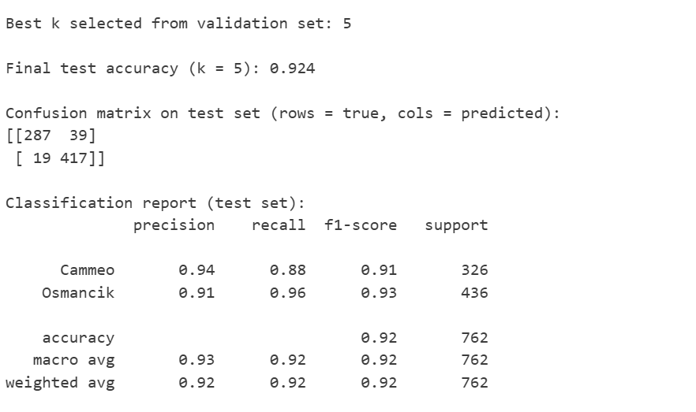
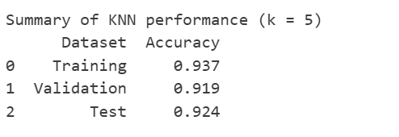
The KNN model achieved high accuracy across all datasets, with a training accuracy of 0.937, a validation accuracy of 0.919, and a test accuracy of 0.924. The training accuracy is slightly higher than the validation and test accuracy, indicating that the model learned the training data well without serious overfitting. The value of k selected using the validation set also performed well on the test set, showing good generalization.
5.2 Logistic Regression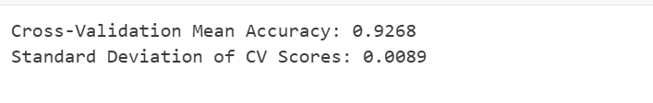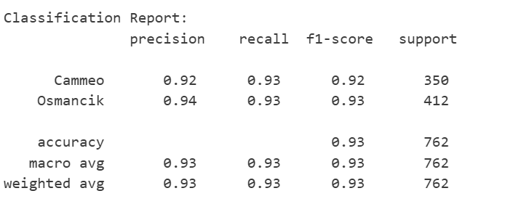
The results show that the Logistic Regression (LR) model performs very well on this dataset. It achieves a cross-validation mean accuracy of 92.68% with a very small standard deviation of 0.0089, indicating that the model is stable and generalizes consistently across different folds. From the classification report, both classes (Cammeo and Osmancik) have high precision, recall, and F1-scores around 0.92–0.94, showing balanced performance without strong bias toward either class. The overall accuracy on the test set is 93%, and both macro and weighted averages are also 0.93, confirming that the model handles class distribution effectively and provides reliable classification results.
  - Random Forest
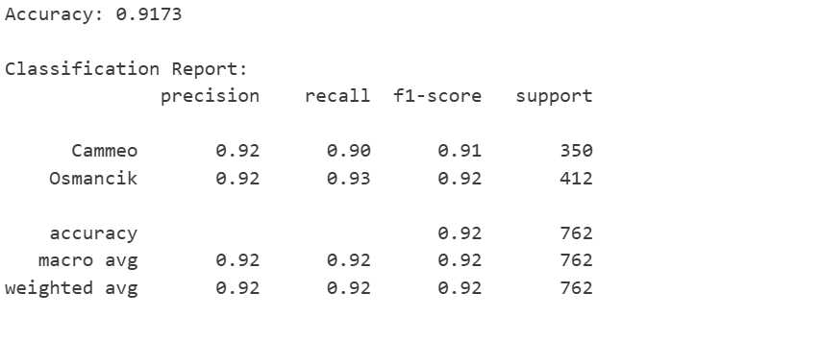
This output shows the performance of the Random Forest model on the test set. The overall accuracy is 0.9173, meaning the model correctly classified around 92% of the samples. From the classification report, both classes (Cammeo and Osmancik) have strong and balanced performance. Cammeo has precision 0.92, recall 0.90, and F1-score 0.91, indicating the model is slightly weaker in recalling all Cammeo samples. Osmancik has precision 0.92, recall 0.93, and F1-score 0.92, showing slightly better detection for this class. The macro and weighted averages are both 0.92, which means the model performs consistently across both classes without significant bias.
  - MLP
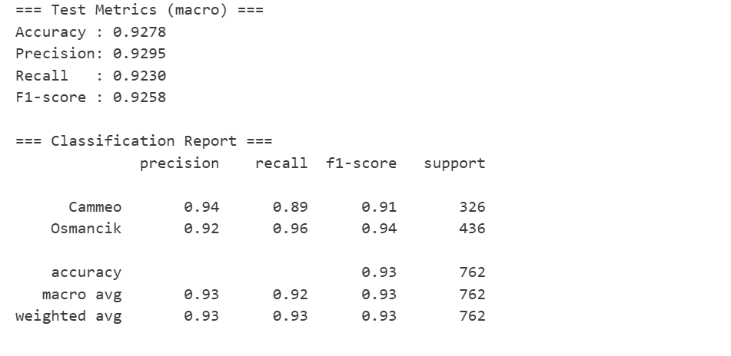
According to the evaluation metric table (Accuracy, Precision, Recall, and F1-score) on the test set, the trained MLP model achieves strong overall classification performance on the Rice dataset. The test accuracy is relatively high, indicating that the model can correctly distinguish most Cammeo and Osmancik samples.
Furthermore, the macro-averaged Precision, Recall, and F1-score values are relatively close, suggesting that the model performs in a balanced manner across both classes, without favoring one class over the other. This indicates that the model is not only accurate but also consistent in recognizing both rice varieties.
Based on the results shown in the table, it can be concluded that:
The MLP model demonstrates good overall performance and class balance, with stable generalization capability.
Conclusion:
The MLP gets the highest accuracy of all. MLP achieved higher accuracy because it can model complex nonlinear relationships through hidden layers and nonlinear activation functions. Logistic Regression is limited to linear decision boundaries, KNN suffers from the curse of dimensionality, and Random Forest uses axis-aligned splits that may not capture smooth feature interactions as effectively as MLP.
Error Analysis：
While the accuracy scores presented above are solid, looking at where the models failed tells a more interesting story than the raw numbers alone.
Across all four models—KNN, Random Forest, MLP, and Logistic Regression—we noticed a consistent pattern: the errors weren't random. The models struggled with the exact same subset of "borderline" rice grains. Looking at the confusion matrices, the Logistic Regression (LR) and MLP models were actually the most stable, misclassifying only about 54 to 55 instances in total. In contrast, Random Forest and KNN (k=5) had slightly higher error rates, missing roughly 60 to 65 samples.
The core issue seems to be physical ambiguity. Since our dataset relies strictly on morphological features like Area and Major Axis Length, there is a natural overlap where a small Cammeo grain is mathematically almost identical to a large Osmancik grain.
What really stood out to us was the performance of Logistic Regression. We honestly expected the more complex Random Forest or MLP to dominate, yet the simple linear model achieved a test accuracy (~93%) that matched the neural network. This suggests that the decision boundary between these two rice varieties is largely linear; adding model complexity didn't necessarily solve the problem of physical overlap.
On the other hand, Random Forest produced slightly more false positives than we anticipated (accuracy ~91.7%). This might be because tree-based models split data using axis-aligned cuts, which can be a bit "blocky" when trying to capture the smooth, diagonal boundary that separates these rice types. KNN also faced challenges with precision, likely because Euclidean distance is very sensitive to outliers—a single oddly shaped grain can easily "pull" the prediction of its neighbors to the wrong class.
In short, the errors here aren't really a failure of the algorithms, but rather a reflection of the "gray zone" in the data where the two species simply look too similar.
6. Limitations & Proposed Improvements
Limitations
Reflecting on our approach, we identified a few key limitations that constrain how well this system would work in the real world.
First, we are limited by the features themselves. We relied solely on 7 geometrical attributes (like Area, Perimeter, Eccentricity). While effective, this discards a lot of information. We don't have data on texture, color, or chalkiness. If a Cammeo grain is broken or discolored but keeps its shape, our models will classify it as "healthy," which limits the system's use for actual quality control.
Secondly, there is the issue of data scale. Although 3,810 samples sounded like a lot initially, it is actually quite small for a neural network. This likely explains why our MLP model didn't significantly outperform the simpler Logistic Regression—there simply wasn't enough data for the deep learning model to find complex non-linear patterns that would justify its computational cost.
We also noticed a trade-off with efficiency. While KNN was fast to train, it is computationally "lazy" and slow during inference because it has to calculate the distance to every training point. In a factory processing tons of rice per hour, this latency would be a bottleneck compared to the instant calculation of the Logistic Regression formula.
Proposed Improvements
To address these issues, we propose the following realistic improvements:
- Enriching the Feature Space:
If we could access the raw images instead of just the extracted CSV data, we could use Convolutional Neural Networks (CNNs). This would allow the model to learn surface textures and visual patterns, potentially distinguishing those "borderline" cases that simple shape-based features missed.
- Synthetic Data Augmentation:
To help the MLP and Random Forest models generalize better, we could use techniques like SMOTE (Synthetic Minority Over-sampling Technique). By generating synthetic samples in the overlapping "gray zone" of the feature space, we could force the models to learn more robust decision boundaries.
- Model Ensembling:
Since Logistic Regression provides a stable linear baseline and Random Forest offers non-linear structural insights, combining them could be powerful. A "Voting Classifier" (Stacking) that averages the probabilities from the LR, RF, and MLP models would likely smooth out individual errors, potentially pushing accuracy reliably above the 95% mark.
- Explainability for Users:
In a real agricultural setting, farmers need to trust the system. We suggest integrating SHAP (SHapley Additive exPlanations) values. This would generate a report for each specific grain explaining why it was classified as Osmancik (e.g., "Classified as Osmancik because Eccentricity is low"), making the "black box" transparent.
Generative AI Declaration
Generative artificial intelligence tools were used to assist in organizing the report structure and refining language expression. All model implementations, experimental procedures, and result analyses are based on the student’s own experiments and understanding of the Rice dataset and comply with the requirements of the course assignment.
Reference：
1. I. Cinar and M. Koklu, "Identification of Rice Varieties Using Machine Learning Algorithms," Journal of Agricultural Engineering, vol. 50, no. 4, pp. 306–314, 2019. Available:
https://www.semanticscholar.org/paper/Classification-of-rice-grain-varieties-using-two-Pazoki-Farokhi/9c7908f327b76b1818d4f9123d4d27d98fe2424b
2. H. Pazoki-Farokhi, "Classification of rice grain varieties using two artificial intelligence techniques," Semantic Scholar, 2023. [Online]. Available: https://www.semanticscholar.org/paper/Classification-of-rice-grain-varieties-using-two-Pazoki-Farokhi/9c7908f327b76b1818d4f9123d4d27d98fe2424b
3. UCI Machine Learning Repository, "Rice (Cammeo and Osmancik) Data Set," [Online]. Available: https://archive.ics.uci.edu/ml/datasets/Rice+(Cammeo+and+Osmancik)

