Maximum Clique Problem – Lab 10

* Test your algorithms on large instances
  + We conducted experiments on large sets of DIMACS intances, representing the standard test-bed for evaluating the performance of coloring algorithms. The results that we obtained are present in the reports for the previous laboratories, so we will not mention them here.
* Automatic algorithm configuration:
  + We have two parameters that can be configurable:
    - Iterations: the number of iterations our algorithm will run until will stop
    - Tolerance: the number of iterations until we will randomly restart the algorithm if we don’t find an improved solution.

In order to detect the best configuration for these parameters we chose a set of values for these values and run all possible combinations on 5 different data sets and tried to find the best configuration that finds a clique of a size close to the best known clique for that dataset.

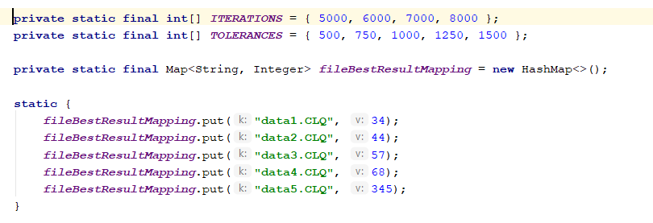

Each combination was run 10 times on each dataset and we took into consideration the average value.

In the end we ended up with the following values for our parameters:



* Predict the performance of your algorithm on individual instances:
  + To predict the performance of our algorithm on individual instances we tried using a regression approach.
  + We created a dataset by running our algorithm multiple times on different datasets. The dataset consists of the following features:
    - Nodes – the number of nodes in the graph
    - Edges – the number of edges in the graph
    - Best_Known – the size of the maximal clique for the graph
    - Result – the result of our algorithm on the instance

By using regression we predict the „Result” of our algorithm by giving to the model the Nodes, Edges and the Best_Known features.

We tested this on the DSJC500_5.clq instance from the DIMACS dataset. This intance has 500 nodes, 125248 edges and the maximal clique has a size of 13. The prediction was that our algorithm will find a clique ~ 9.71.



Our algorithm found a 12 size clique on this test instance.

