

Robotic Process Automation

Food data collecter

Process Definition Document (PDD)

Teodor Grumeza



Document History

|  |  |  |  |  |  |  |
| --- | --- | --- | --- | --- | --- | --- |
| Date | Version | Role | Name | Organization | Function | Comments |
| dd.mm.yyyy | 1.0 | Author | *Name Surname* | *Client org* | *AP-SME* | Created document v 1.0 |
|  |  |  |  |  |  |  |
|  |  |  |  |  |  |  |

Contents

1. Introduction 5

1.1 Purpose of the document 5

1.2 Objectives 5

1.3 Process key contacts 5

1.4 Minimum Pre-requisites for automation 6

2. As IS process description 6

2.1 Process Overview 6

2.2 Applications used in the process 7

2.3 As IS Detailed Process map 7

2.4 Additional sources of process documentation 8

3. To BE Process Description 9

3.1 TO BE Detailed Process Map 9

3.1.1 Change/Improvement details 9

3.1.2 Areas already automated 10

3.2 In Scope for RPA 10

3.3 Out of Scope for RPA 10

3.4 Business Exceptions Handling 10

3.4.1 Known Exceptions 10

3.4.2 Unknown Exceptions 11

3.5 Application Error and Exception Handling 11

3.5.1 Know Errors or Exceptions 12

3.5.2 Unknow Errors and Exceptions 12

4. Other Requirements and Observations 13

5. Document Approval 13

## Introduction

### Purpose of the document

The Process Definition Document outlines the business process chosen for automation using UiPath Robotic Process Automation (RPA) technology.

The document describes the sequence of steps performed as part of the business process, the conditions and rules of the process prior to automation and how they are envisioned to work after automating it, partly or entirely. This specifications document serves as a base for developers, providing them the details required for applying robotic automation to the selected business process.

### Objectives

The process that has been selected for RPA is part of Open Food Extractor conducted within the Teodor Grumeza .

The business objectives and benefits expected by the Business Process Owner after automation of the selected business process are:

* *Allow the collection of food product information*
* *Allow the collection of images with barcode and expiration dates*
* *Reduce the manual effort required to gather food product information*
* *Allow continuous data collection*

### Process key contacts

The specifications document includes concise and complete requirements of the business process and it is built based on the inputs provided by the **processSubject Matter Expert (SME)/ Process Owner.**

The **Process Owner** is expected **to review it and provide signoff for accuracy** and completion of the steps, context, impact and complete set of process exceptions.

The names have to be included in the table below.

|  |  |  |  |
| --- | --- | --- | --- |
| *Role* | *Name* | *Contact details*  *(email, phone number)* | *Notes* |
| ***Process SME*** | *Name, Surname* | [Name.surname@domain.com](mailto:Name.surname@domain.com)  *Mobile: 44 0735 325 209* | *Point of contact for questions related to business exceptions and passwords* |
| ***Process Reviewer /*** | *Name, Surname* | [Name.surname@domain.com](mailto:Name.surname@domain.com)  *Mobile: 44 0735 325 209* | *Point of Contact for process exceptions* |
| ***Process Owner/ Approver for production*** | *Name, Surname* | [Name.surname@domain.com](mailto:Name.surname@domain.com)  *Mobile: 44 0735 325 209* | *Escalations, Delays,* |

### Minimum Pre-requisites for automation

1. Filled in Process DefinitionDocument
2. Chrome Browser
3. Python Script

## As IS process description

### Process Overview

General information about the process selected for RPA prior to automation.

|  |  |  |
| --- | --- | --- |
| # | Item | Description |
| 1 | **Process full name** | *OpenFood data scraping* |
| 2 | **Process Area** | *Data Colection* |
| 3 | **Department** | *IT* |
| 4 | **Process short description**  (operation, activity, outcome) | *PDF invoices sent by email are posted in SAP for later payment.* |
| 5 | **Role(s) required for performing the process** | *Any* |
| 6 | **Process schedule and frequency** | *24/7* |
| 7 | **# of items processes** | *13.834 produse / for the ro domain*  *3,185,441 products / for the word domain* |
| 8 | **Average handling time per item** | *~25 seconds* |
| 9 | **Peak period (s)** | *As needed* |
| 10 | **Total # of FTEs supporting this activity** | *0* |
| 11 | **Level of exception rate** | *~40% exceptions (incomplete product information)* |
| 12 | **Input data** | *CSV with the urls (If the second part is run alone)* |
| 13 | **Output data** | *CSV with product information (name, description, allergens)*  *CSV with nutritional values* |
| 14 | **Dependencies** | *EN.ImageDownloader.Activities package*  *UIPath.Excel.Activities*  *UiPath.System.Activities* |

*\*Add more table rows if necessary to include relevant data for the automation process. No fields should be left empty. Use “n/a” for the items that don`t apply to the selected business process.*

### Applications used in the process

The table includes a comprehensive list all the applications that are used as part of the process automated, at various steps in the flow.

|  |  |  |  |  |  |  |
| --- | --- | --- | --- | --- | --- | --- |
| # | Application name & version | System  Language | Login Module | Interface | Environment/  Access method | Comments  (Include URLs) |
| *1* | *UiPath* | *EN* | *UiPath login portal* | *Client* | *Local desktop* | *Collecting Data* |
| *2* | *Python* | *EN* | *n/a* | *Client* | *Local desktop* | *Advance filtering/Reprocessing* |

*\*Add more table rows to include the complete list of applications.*

### As IS Detailed Process map

This chapter depicts the AS IS business process in detail to enable the developer to build the automated process.

*{Detailed process map to be added here, with input/output flow at each stage. Divide the process into stages if required (for better readability)}.*

*Add the AVG TAT(Average Turn Around Time) for each key transaction/ activity. Use the “Short description of key process steps” . More detailed information can be documented in a separate table and/or documented and embedded in this document/ Section.*

*Stage 1: UrlCollection.*

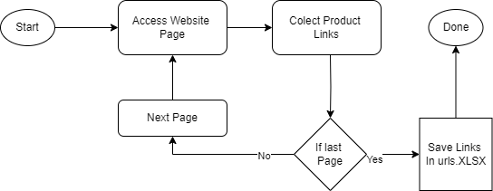

*Stage 2: InfoColection.*

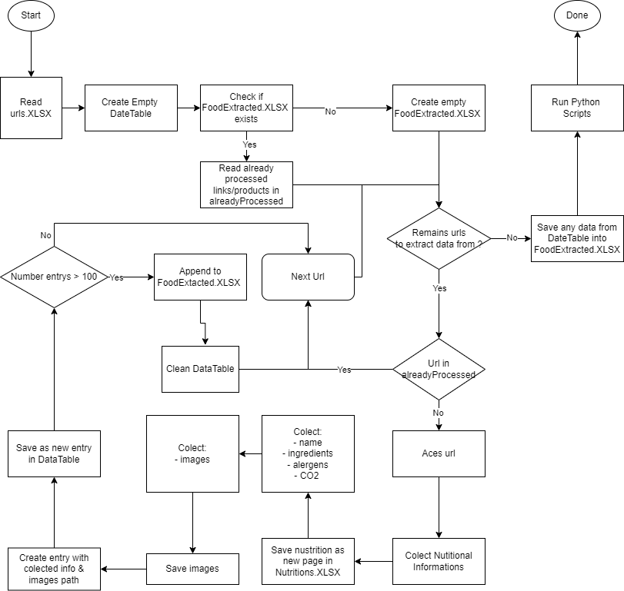

|  |  |  |
| --- | --- | --- |
| Step | **Short Description of Key Process Steps** | **AVG**  **TAT\*** |
| ***1*** | *Acess the ro.openfoodfacts.org or world.openfoodfacts.org* | *1 s* |
| ***2*** | *Collect UrlFrom each page until last one* | *5 s/page* |
| ***3*** | *For each link collect the General Informatioin/Nutrition/Images* | *25s/link* |
| ***4*** | *Save inforamtions* | *3 s* |
| ***5*** | *Clean the Obtained data* | *10 s* |

### Additional sources of process documentation

If there is additional material created to support the process automation please mention it here, along with the supported documentation provided.

|  |  |  |
| --- | --- | --- |
| Additional Process Documentation | | |
| **Video Recording of the process [Mandatory]** | *Insert link to the video recording and provide access to the video.* | *Date and time of the recording.*  *Insert additional relevant comments* |
| **List of supporting documents** | *Embed documents* | *List here all the templates, mapping tables, list of URLS that are provided as supporting info for automation.* |

### Change/Improvement details

|  |  |  |  |  |  |
| --- | --- | --- | --- | --- | --- |
| # | Initiative name and Expected Outcome/Benefits | Process Step(s) where it is identified | Does it impact the current automation request? How? | Expected completion date | Contact person for more details |
| 1. | Reducing the timeouts and time need for each link | - research make improvement | No | 05 July | Bogdan Bozga |

### In Scope for RPA

The activities **in scope of RPA**, are listed here:

1. *Collecting information*
2. *Verifying missing fields*
3. *Save data*
4. *Filter collected data*

### Out of Scope for RPA

The activities **OUT of scope of RPA**, are listed here. Mention of the changes/ improvement opportunities identified for automation are out of scope for this automation iteration.

1. Using the data to fine tune the bar-code detector and LLAMA for smart glasses

### Application Error and Exception Handling

A comprehensive list of all errors, warnings or notifications should be consolidated here with the description and action to be taken, for each, by the Robot.

Errors identified in the automation process can be classified as:

#### Know Errors or Exceptions

|  |  |  |  |  |
| --- | --- | --- | --- | --- |
| **AE #** | **Error name** | **Step** | **Parameters** | **Action to be taken** |
| ***1*** | *Website stops responding* | *Any step when working with chrome. Most frequent when opening new urls.* | *This Site Can’t Be Reached* | *Wait for site to respond.* |
| ***2*** | *Missing information* | *Collecting any of the information* | *UIPath Wizard* | *Exception treated for each case* |

#### Unknow Errors and Exceptions

For all the other **unanticipated or unknown application exceptions/errors**, the robot should:

*Openfoodfacts site in maintenance: The robot should wait/become dormant until the site back online.*