ACL Seminar 3 – Zipf's Law Experimental Results Table
Student: Todoran Ciprian Bogdan | Date: November 2026 | Languages: English, Italian, Romanian
# | Student | Corpus source /  Corpus dimension | Zipf graph  (top 200 words) | The most freq. 7 words  (in order) | Percent of tokens covered by top 7 words | Percent of words appearing once  (- as types, - as tokens)
1 | Todoran Ciprian Bogdan | EN: Frankenstein:  75,201 tokens, 7,013 types;  IT: Pinocchio:  41,525 tokens, 6,215 types;  RO: Bachelor Thesis:  8,301 tokens, 2,056 types. | Top 200 Comparison (EN, IT, RO):  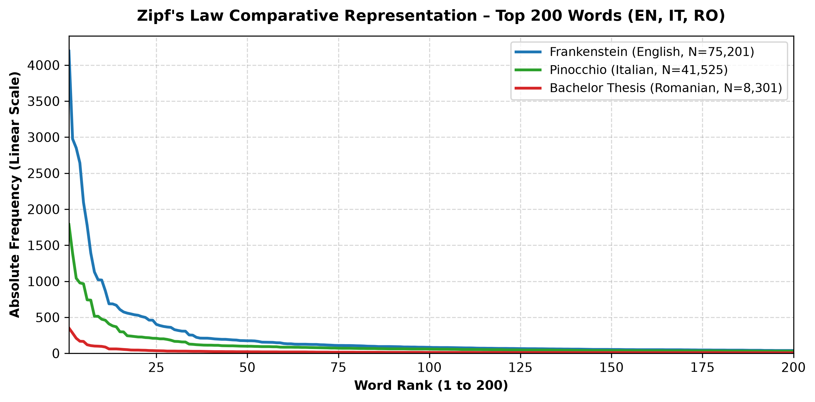 | EN: ("the":4195), ("and":2976), ("i":2850), ("of":2642), ("to":2094), ("my":1776), ("a":1391)  IT: ("e":1788), ("di":1390), ("che":1042), ("a":977), ("il":965), ("la":742), ("un":738)  RO: ("de":351), ("în":281), ("a":209), ("și":168), ("m":165), ("pentru":119), ("un":107) | EN: 23.83%  IT: 18.40%  RO: 16.87% | EN: 3,015, 4.01% of the tokens, 42.99% of the types  IT: 3,302, 7.95% of the tokens, 53.13% of the types  RO: 1,138, 13.71% of the tokens, 55.35% of the types

