Internship in Sight

Analysis and Design Document

Student: Cârcu Bogdan

**Group: 30431**

Revision History

|  |  |  |  |
| --- | --- | --- | --- |
| **Date** | **Version** | **Description** | **Author** |
| 24/04/2018 | 1.0 | Project Deliverable (2) | Cârcu Bogdan |
|  |  |  |  |
|  |  |  |  |
|  |  |  |  |

Table of Contents

I. Project Specification 4

II. Elaboration – Iteration 1.1 4

1. Domain Model 4

2. Architectural Design 4

2.1 Conceptual Architecture 4

2.2 Package Design 4

2.3 Component and Deployment Diagrams 4

III. Elaboration – Iteration 1.2 4

1. Design Model 4

1.1 Dynamic Behavior 4

1.2 Class Design 4

2. Data Model 4

3. Unit Testing 4

IV. Elaboration – Iteration 2 4

1. Architectural Design Refinement 4

2. Design Model Refinement 4

V. Construction and Transition 5

1. System Testing 5

2. Future improvements 5

VI. Bibliography 5

# Project Specification

**Internship in Sight** is a Java-based application that targets the students and their need to find internships, training camps or other general work offers from companies. Also, companies will able to advertise their internship opportunities and interact in a transparent manner with the possible applicants. The application will support two main types of users: students and companies. Only one account per user and per company is permitted. Moreover, a third type of user will have total access to the overall information (the administrator).

The **administrator** can perform the following operations:

* CRUD on users
* CRUD on internships

The basic **user** can:

* Login
* Register
* Log out

The **student** can:

* View internship offers
* Apply for an internship
* Rate internship experience if participated in one
* Comment the internship experience

The **company** can:

* Accept a candidate
* Deny a candidate
* Advertise internships
* Tag students as their internship graduates, thus granting them access to the rating system

# Elaboration – Iteration 1.1

# Domain Model

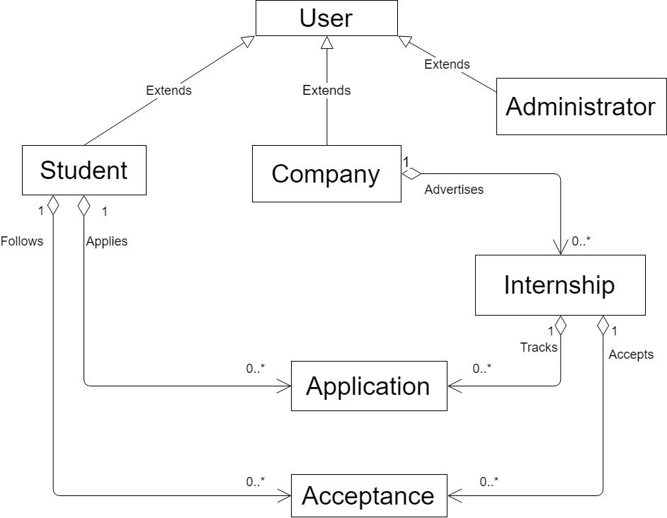

# Architectural Design

## Conceptual Architecture

Architectural style: **Layered Architecture**

* This architecture is a client-server architecture in which presentation, application processing, and data management functions are separated.
* Every layer can use the functionalities of the layer below but not vice-versa

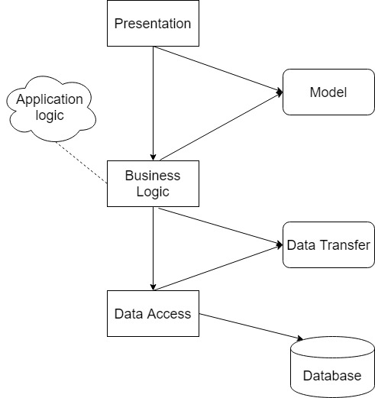

**Motivation:**

* Coherent structure
* Ability to separate key enterprise functions into different logical locations where they can be executed, managed and changed with relative independence
* The platform trying to be built can be enhanced in a various number of ways, so we need support for frequent and unavoidable changes

Architectural Pattern: **Model-View-Controller**

**MVC** is an [architectural pattern](https://en.wikipedia.org/wiki/Architectural_pattern) commonly used for developing [user interfaces](https://en.wikipedia.org/wiki/User_interface) that divides an application into three interconnected parts. This is done to separate internal representations of information from the ways information is presented to and accepted from the user. The MVC design pattern decouples these major components allowing for efficient [code reuse](https://en.wikipedia.org/wiki/Code_reuse) and parallel development.

**Components**

* The *model* is the central component of the pattern. It expresses the application's behavior in terms of the [problem domain](https://en.wikipedia.org/wiki/Problem_domain), independent of the user interface. It directly manages the data, logic and rules of the application.
* A *view* can be any output representation of information, such as a chart or a diagram. Multiple views of the same information are possible.
* The third part or section, the *controller*, accepts input and converts it to commands for the model or view.

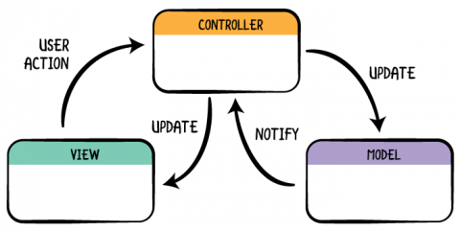

**Motivation:**

* Known to be one of the best choices when it comes to web-applications
* Flexible
* Adds bonuses to the separation of concerns
* Many platforms and frameworks provide clean and suggestive ways to implement a MVC system (e.g.: Spring Boot for Java)

## Package Design

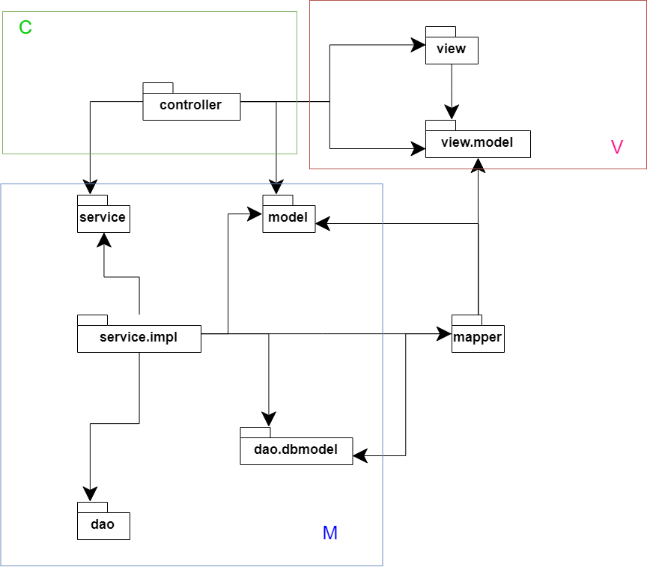

## Component and Deployment Diagrams

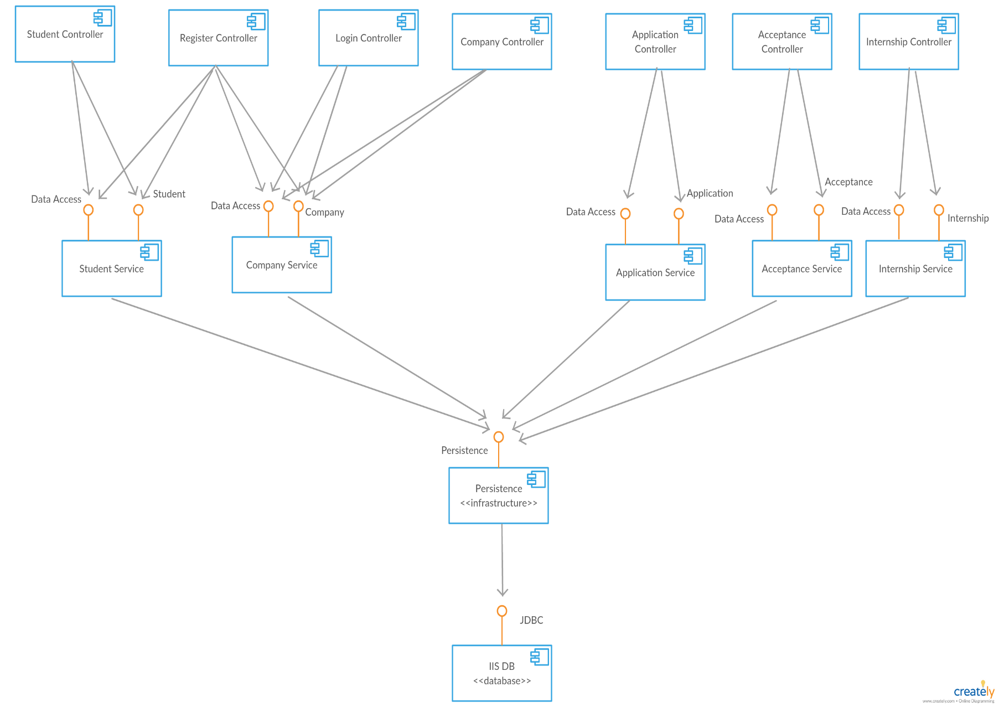

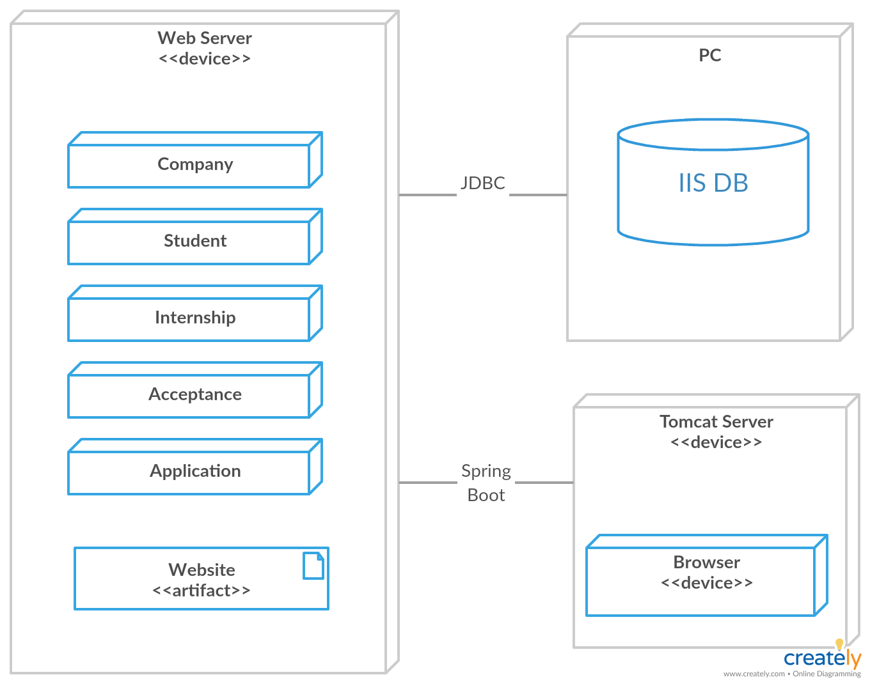

# Elaboration – Iteration 1.2

# Design Model

## Dynamic Behavior

*[Create the interaction diagrams (1 sequence, 1 communication diagrams) for 2 relevant scenarios]*

## Class Design

*[Create the UML class diagram; apply GoF patterns and motivate your choice]*

# Data Model

*[Create the data model for the system.]*

# Unit Testing

*[Present the used testing methods and the associated test case scenarios.]*

# Elaboration – Iteration 2

# Architectural Design Refinement

*[Refine the architectural design: conceptual architecture, package design (consider package design principles), component and deployment diagrams. Motivate the changes that have been made.]*

# Design Model Refinement

## *[Refine the UML class diagram by applying class design principles and GRASP; motivate your choices. Deliver the updated class diagrams.]*

# Construction and Transition

# System Testing

*[Describe how you applied integration testing and present the associated test case scenarios.]*

# Future improvements

*[Present future improvements for the system]*

# Bibliography