**Nume proiect:** Sistem de control al accesului cu parola

**Autor:** George-Alexandru Bogdan

**Scop:**

Acest proiect isi poate fi uitilizat ca alternativa la clasicul lacat cu cheie sau cifru. Poate fi implementat atat pe usi de casa cat si pe mici cutii de valori.

Avantajele unui astfel de sistem sunt:

* Oricine cunoaste parola are acces (nu mai este necesara clonarea cheii, ca in cazul unei incuietori clasice)
* Dificil de compromis datorita parolei de tip PIN
* Posibilitate de extindere a sistemului (adaugare de module de recunoastere de cartele RFID sau de amprenta, actionarea mai multor incuietori in acelasi moment)

**Componente necesare:**

* 1 Arduino UNO (or compatible)
* 1 Passive buzzer
* 1 10K Potentiometer
* 1 Servo Motor
* 1 4x4 Membrane Switch
* 1 Liquid Crystal display (LCD)
* 1 Breadboard
* 1 9V 1A Adapter
* 1 330Ω resistors
* 2 220Ω resistors
* 2 LEDs
* Jumper wires

**Cost:** 35 RON **Pret sistem asemanator:** minim 99 RON

**Link prezentare youtube:** https://youtu.be/Aa6w33WC57g

**Planul proiectului:**

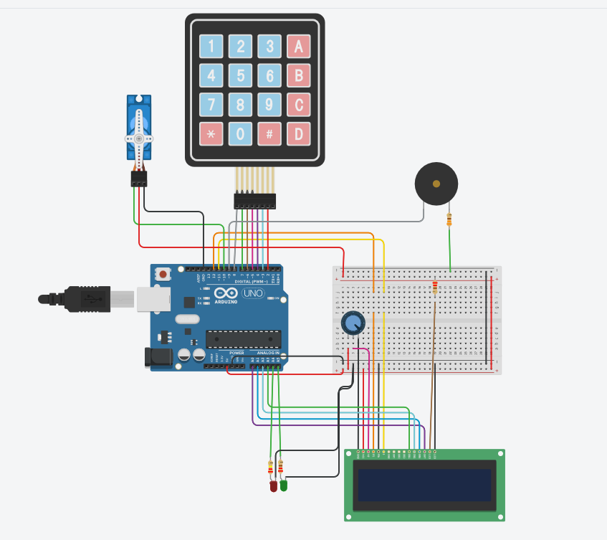

**Fotografii cu proiectul:**

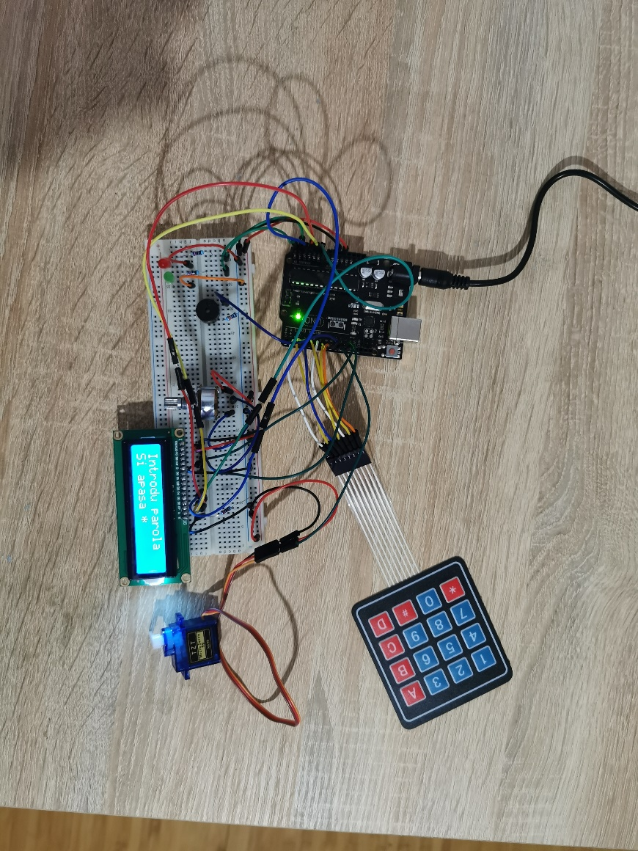

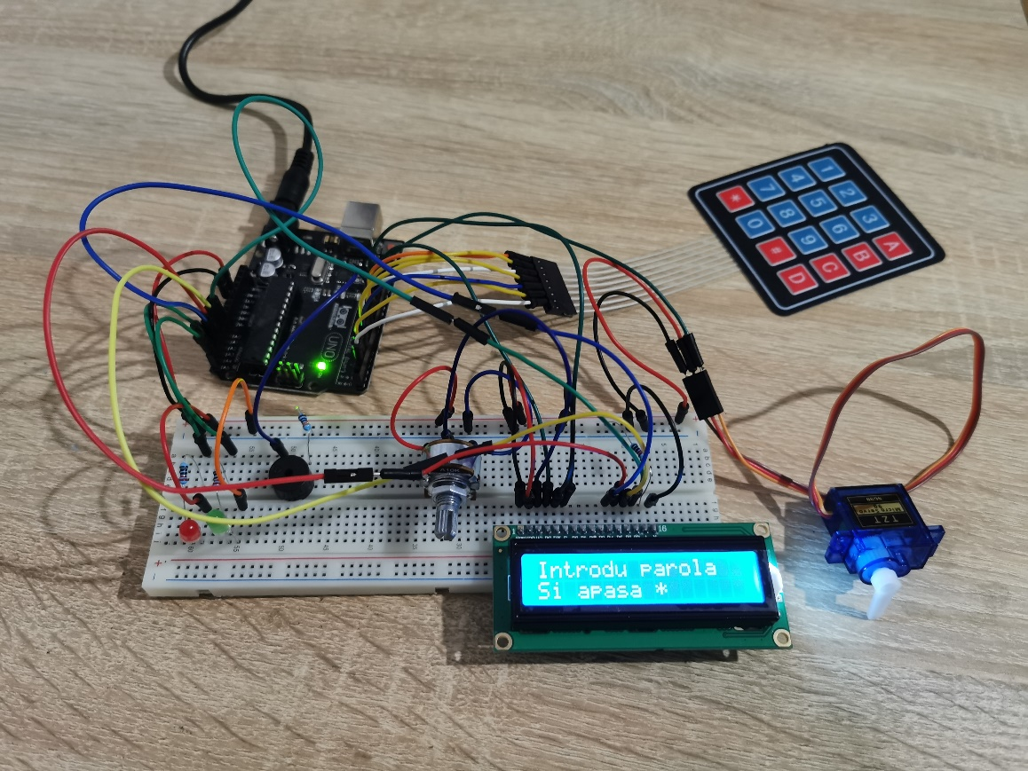

**Cod sursa:**

#include <Keypad.h>

#include <LiquidCrystal.h>

#include <Servo.h>

Servo sm;

int led_pin = 13;

int buzzer_pin = 9;

struct MusicStruct {

int A = 550;

int As = 582;

int B = 617;

int C = 654;

int Cs = 693;

int D = 734;

int Ds = 777;

int E = 824;

int F = 873;

int Fs = 925;

int G = 980;

int Gs = 1003;

int A2 = 1100;

int A2s = 1165;

int B2 = 1234;

int C3 = 1308;

int C3s = 1385;

int D3 = 1555;

}Music;

struct LengthStruct {

float half = 0.5;

float one = 1.0;

float one_half = 1.5;

float two = 2.0;

float two_half = 2.5;

}Length;

const byte ROWS = 4; //four rows

const byte COLS = 3; //four columns

char keys[ROWS][COLS] = {

{'1','2','3'},

{'4','5','6'},

{'7','8','9'},

{'*','0','#'}

};

byte rowPins[ROWS] = {8, 7, 6, 5}; // row pinouts of the keypad R1 = D8, R2 = D7, R3 = D6, R4 = D5

byte colPins[COLS] = {4, 3, 2}; //connect to the column pinouts of the keypad

Keypad keypad = Keypad( makeKeymap(keys), rowPins, colPins, ROWS, COLS );

LiquidCrystal lcd(12, 11, 17, 16, 15, 14);

int tempo = 400;

int redLed = 18;

int greenLed = 19;

void setup() {

pinMode(led_pin, OUTPUT);

pinMode(buzzer_pin, OUTPUT);

Serial.begin(9600);

lcd.begin(16, 2);

lcd.setCursor(0, 0);

lcd.print("Introdu parola");

lcd.setCursor(0, 1);

lcd.print("Si apasa *");

sm.write(180);

sm.attach(10);

pinMode(redLed, OUTPUT);

pinMode(greenLed, OUTPUT);

}

void setTone(int pin, int note, int duration) {

tone(pin, note, duration);

delay(duration);

noTone(pin);

}

void play_yes()

{

setTone(buzzer_pin, Music.B, tempo * Length.one);

setTone(buzzer_pin, Music.E, tempo * Length.one_half);

}

void play_no()

{

setTone(buzzer_pin, Music.F, tempo * Length.one);

setTone(buzzer_pin, Music.B, tempo * Length.two_half);

}

String pass = "147258";

String inputPass = "";

bool isOpen = false;

int noWrongPass = 0;

void alarm()

{

lcd.clear();

lcd.setCursor(0, 0);

lcd.print("Alarma!");

digitalWrite(redLed, HIGH);

for(int i=0;i<=5;++i)

{

play_no();

}

noWrongPass = 0;

digitalWrite(redLed, LOW);

}

void wrongPass()

{

digitalWrite(redLed, HIGH);

noWrongPass++;

lcd.clear();

lcd.setCursor(0, 0);

lcd.print("Parola gresita");

lcd.setCursor(0, 1);

lcd.print(String("de " + String(noWrongPass) + " ori!"));

play_no();

inputPass = "";

digitalWrite(redLed, LOW);

if(noWrongPass > 3)

{

alarm();

}

delay(10);

lcd.clear();

lcd.setCursor(0, 0);

lcd.print("Introdu parola");

lcd.setCursor(0, 1);

lcd.print("Si apasa *");

}

void correctPass()

{

digitalWrite(greenLed, HIGH);

inputPass = "";

lcd.clear();

lcd.setCursor(0, 0);

lcd.print("Parola corecta!");

play_yes();

noWrongPass = 0;

if(!isOpen)

{

lcd.setCursor(0, 1);

lcd.print("Usa deschisa!");

sm.write(0);

isOpen = true;

}

else

{

lcd.setCursor(0, 1);

lcd.print("Usa inchisa!");

sm.write(180);

isOpen = false;

}

digitalWrite(greenLed, LOW);

delay(10);

lcd.clear();

lcd.setCursor(0, 0);

lcd.print("Introdu parola");

lcd.setCursor(0, 1);

lcd.print("Si apasa *");

}

void loop() {

char key = keypad.getKey();

if(key)

{

if(key == '*')

{

setTone(buzzer_pin, Music.B, tempo * Length.half);

Serial.println(inputPass);

if(pass == inputPass)

correctPass();

else

wrongPass();

}

else

{

setTone(buzzer_pin, Music.E, tempo * Length.half);

inputPass.concat(key);

}

}

}