**Project Status Report**

**R.A.D.U - REQUIREMENTS AND DESIGN UTILITY**

**NTT Data Romania S.A.**

**19-21, Constanta Street,**

**400158 Cluj Napoca**

**2019**

**Table of Contents**

1 Project Status: 3

1.1 Statistics #1 3

# Project Status:

## Statistics #1

Date: 1st August 2019

1. Insights:

* The application is still unstable and needs improvement due to high number of functional bugs.

1. Requirements:

* 80% of the requirements are implemented.

1. Contributors

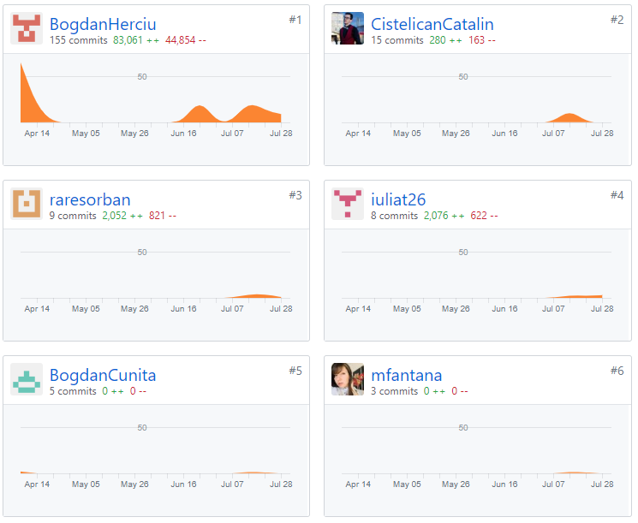

1. Code Frequency:

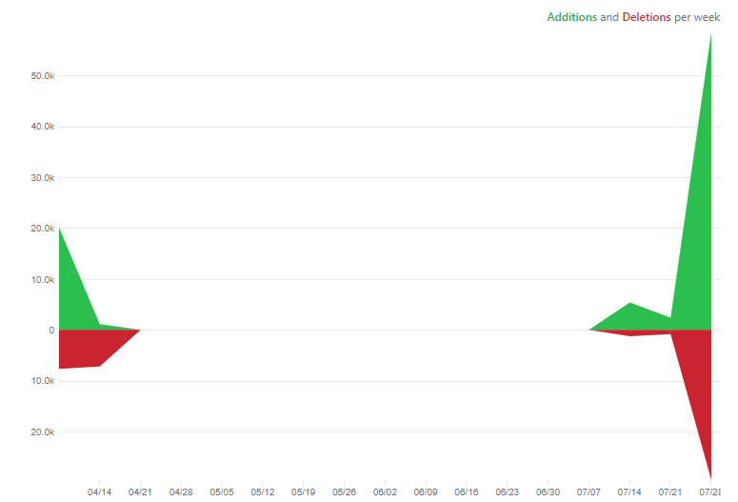

1. Commits:

