**My First Day**

**R.A.D.U. - Requirements And Design Utility**

**NTT Data Romania S.A.**

**19-21, Constanta Street,**

**400158 Cluj Napoca**

**2019**

**Table of Contents**

1 Introduction 3

2 First Steps 4

# Introduction

This document is intended to describe the first steps that a student must follow in the first day of work for the R.A.D.U Project.

# First Steps:

1. Create a GitHub account.

Link: <https://github.com/>

1. Install GitHub Desktop.

Link: <https://desktop.github.com/>

1. Follow the Git tutorial on YouTube:

Link: <https://www.youtube.com/watch?v=77W2JSL7-r8>

1. Download project from Git, to the following path: “C:\RequirementsTool”
2. Open Git.
3. Select “Clone Repository”.

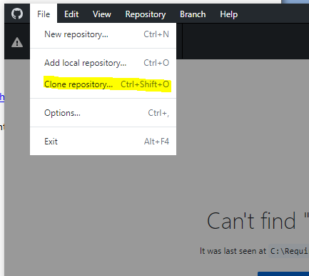

1. Select the “*Repository URL or GitHub username and repository*” and the “*Local path*”:

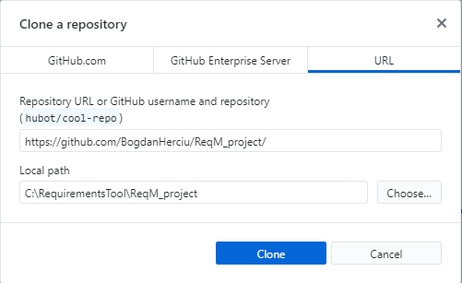

“<https://github.com/BogdanHerciu/ReqM_project/>”

1. Install Visual Studio Community.

Link: <https://visualstudio.microsoft.com/downloads/>

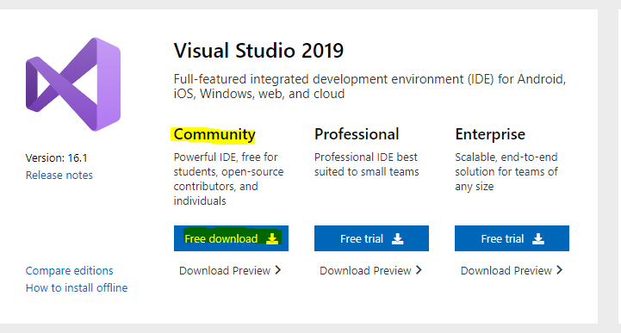

1. Open the project in Visual Studio:

Path: C:\RequirementsTool\ReqM_project\ReqM_Tool\ReqMTool

1. Study the following document: “ReqM_project\ProjectDocuments\02_Executing\05_Project_Requirements”.
2. Try to understand the application that is already developed.
3. Try to understand the code that is already implemented.

- note down your improvement ideas.

- note down your code change proposals

1. Make a schematic architecture about how the code you think it will look at the end of the project.
2. You’re free to make modifications over the code without commiting something on the GitHub.
3. Don’t foget to have fun!

