**R Markdown** Reference Guide

### Learn more about R Markdown at rmarkdown.rstudio.com

Learn more about Interactive Docs at shiny.rstudio.com/articles

Contents:

## Markdown Syntax

1. Knitr chunk options
2. Pandoc options

# Syntax Becomes

Plain text

End a line with two spaces to start a new paragraph.

*italics* and _italics_

**bold** and bold superscript^2^

~~strikethrough~~ [link](www.rstudio.com) # Header 1

## Header 2

### Header 3

#### Header 4

##### Header 5

###### Header 6 endash: --

emdash: ---

ellipsis: ...

inline equation: $A = \pi*r^{2}$ image: ![](path/to/smallorb.png) horizontal rule (or slide break):

***

> block quote

* unordered list
* item 2

+ sub-item 1

+ sub-item 2

1. ordered list
2. item 2

+ sub-item 1

+ sub-item 2

Table Header | Second Header

| Table Cell | Cell 2

Cell 3 | Cell 4

Updated 10/30/2014

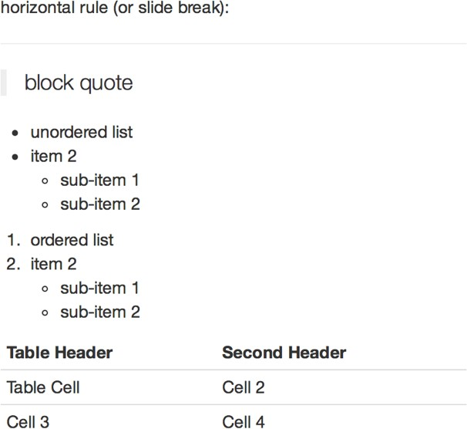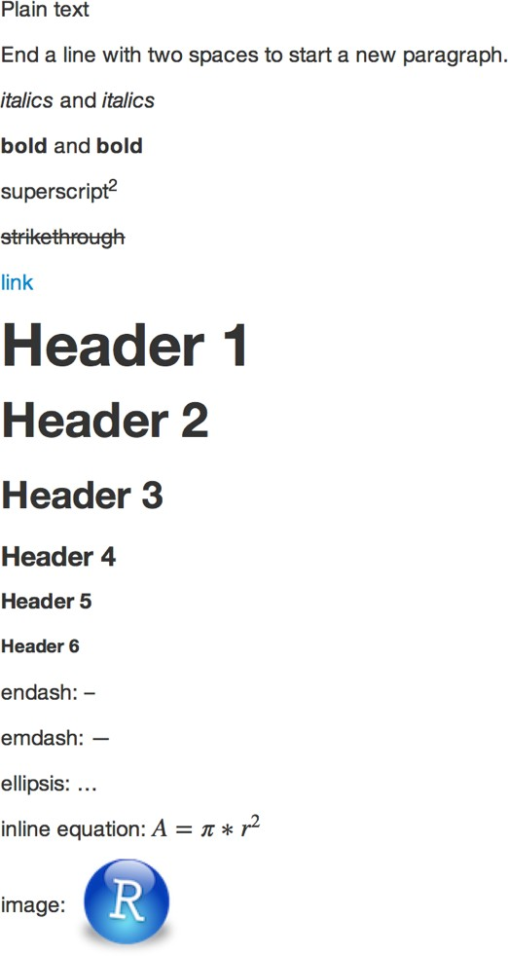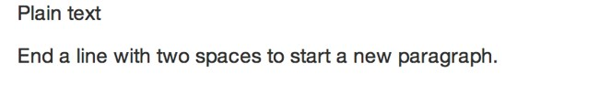

© 2014 RStudio, Inc. CC BY RStudio.

**R Markdown** Reference Guide

Learn more about R Markdown at rmarkdown.rstudio.com

Learn more about Interactive Docs at shiny.rstudio.com/articles

Contents:

1. Markdown Syntax
2. **Knitr chunk options**
3. Pandoc options

**Becomes**

**Syntax**

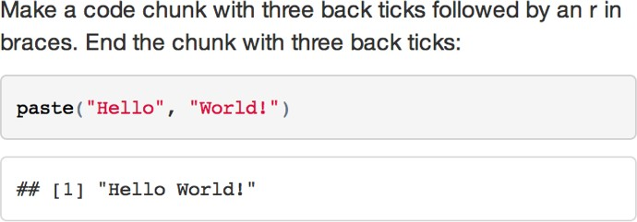Make a code chunk with three back ticks followed by an r in braces. End the chunk with three back ticks:

```{r}

paste("Hello", "World!")

```

Place code inline with a single back ticks. The first back tick must be followed by an R, like this `r paste("Hello", "World!")`.

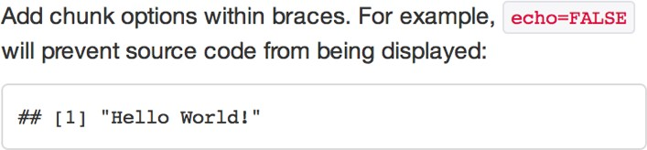Add chunk options within braces. For example,

`echo=FALSE` will prevent source code from being displayed:

```{r eval=TRUE, echo=FALSE} paste("Hello", "World!")

```

Learn more about chunk options at <http://yihui.name/knitr/options>

|  |  |  |
| --- | --- | --- |
| **Chunk options** | | |
| **option** | **default value** | **description** |
| **Code evaluation** | | |
| **child** | NULL | A character vector of filenames. Knitr will knit the files and place them into the main document. |
| **code** | NULL | Set to R code. Knitr will replace the code in the chunk with the code in the code option. |
| **engine** | 'R' | Knitr will evaluate the chunk in the named language, e.g. **engine = 'python'.** Run **names(knitr::knit_engines$get())** to see supported languages. |
| **eval** | TRUE | If **FALSE**, knitr will not run the code in the code chunk. |
| **include** | TRUE | If **FALSE**, knitr will run the chunk but not include the chunk in the final document. |
| **purl** | TRUE | If **FALSE**, knitr will not include the chunk when running **purl()** to extract the source code. |
| **Results** | | |
| **collapse** | FALSE | If **TRUE**, knitr will collapse all the source and output blocks created by the chunk into a single block. |
| **echo** | TRUE | If **FALSE**, knitr will not display the code in the code chunk above it’s results in the final document. |
| **results** | 'markup' | If **'hide'**, knitr will not display the code’s results in the final document. If **'hold'**, knitr will delay displaying all output pieces until the end of the chunk. If **'asis'**, knitr will pass through results without reformatting them (useful if results return raw HTML, etc.) |
| **error** | TRUE | If **FALSE**, knitr will not display any error messages generated by the code. |
| **message** | TRUE | If **FALSE**, knitr will not display any messages generated by the code. |
| **warning** | TRUE | If **FALSE**, knitr will not display any warning messages generated by the code. |
| **Code Decoration** | | |
| **comment** | '##' | A character string. Knitr will append the string to the start of each line of results in the final document. |
| **highlight** | TRUE | If **TRUE**, knitr will highlight the source code in the final output. |
| **prompt** | FALSE | If **TRUE**, knitr will add > to the start of each line of code displayed in the final document. |
| **strip.white** | TRUE | If **TRUE**, knitr will remove white spaces that appear at the beginning or end of a code chunk. |
| **tidy** | FALSE | If **TRUE**, knitr will tidy code chunks for display with the **tidy_source()** function in the **formatR** package. |

Updated 10/30/2014 © 2014 RStudio, Inc. CC BY RStudio.

**R Markdown** Reference Guide

### Learn more about R Markdown at rmarkdown.rstudio.com

Learn more about Interactive Docs at shiny.rstudio.com/articles

Contents:

1. Markdown Syntax

## Knitr chunk options

1. Pandoc options

|  |  |  |
| --- | --- | --- |
| **Chunk options (Continued)** | | |
| **option** | **default value** | **description** |
| **Chunks** | | |
| **opts.label** | NULL | The label of options set in **knitr:: opts_template()** to use with the chunk. |
| **R.options** | NULL | Local R options to use with the chunk. Options are set with **options()** at start of chunk. Defaults are restored at end. |
| **ref.label** | NULL | A character vector of labels of the chunks from which the code of the current chunk is inherited. |
| **Cache** | | |
| **autodep** | FALSE | If **TRUE**, knitr will attempt to figure out dependencies between chunks automatically by analyzing object names. |
| **cache** | FALSE | If **TRUE**, knitr will cache the results to reuse in future knits. Knitr will reuse the results until the code chunk is altered. |
| **cache.comments** | NULL | If **FALSE**, knitr will not rerun the chunk if only a code comment has changed. |
| **cache.lazy** | TRUE | If **TRUE**, knitr will use **lazyload()** to load objects in chunk. If **FALSE**, knitr will use **load()** to load objects in chunk. |
| **cache.path** | 'cache/' | A file path to the directory to store cached results in. Path should begin in the directory that the .Rmd file is saved in. |
| **cache.vars** | NULL | A character vector of object names to cache if you do not wish to cache each object in the chunk. |
| **dependson** | NULL | A character vector of chunk labels to specify which other chunks a chunk depends on. Knitr will update a cached chunk if its dependencies change. |
| **Animation** | | |
| **anipots** | 'controls,loop' | Extra options for animations (see the **animate** package). |
| **interval** | 1 | The number of seconds to pause between animation frames. |
| **Plots** | | |
| **dev** | 'png' | The R function name that will be used as a graphical device to record plots, e.g. **dev='CairoPDF'**. |
| **dev.args** | NULL | Arguments to be passed to the device, e.g. **dev.args=list(bg='yellow', pointsize=10)**. |
| **dpi** | 72 | A number for knitr to use as the dots per inch (dpi) in graphics (when applicable). |
| **external** | TRUE | If **TRUE**, knitr will externalize tikz graphics to save LaTex compilation time (only for the **tikzDevice::tikz()** device). |
| **fig.align** | 'default' | How to align graphics in the final document. One of 'left', 'right', or 'center'. |
| **fig.cap** | NULL | A character string to be used as a figure caption in LaTex. |
| **fig.env** | 'figure' | The Latex environment for figures. |
| **fig.ext** | NULL | The file extension for figure output, e.g. **fig.ext='png'**. |
| **fig.height, fig.width** | 7 | The width and height to use in R for plots created by the chunk (in inches). |
| **fig.keep** | 'high' | If **'high'**, knitr will merge low-level changes into high level plots. If **'all'**, knitr will keep all plots (low-level changes may produce new plots). If **'first'**, knitr will keep the first plot only. If **'last'**, knitr will keep the last plot only. If **'none'**, knitr will discard all plots. |
| **fig.lp** | 'fig:' | A prefix to be used for figure labels in latex. |
| **fig.path** | 'figure/' | A file path to the directory where knitr should store the graphics files created by the chunk. |
| **fig.pos** | '' | A character string to be used as the figure position arrangement in LaTex. |
| **fig.process** | NULL | A function to post-process a figure file. Should take a filename and return a filename of a new figure source. |
| **fig.retina** | 1 | Dpi multiplier for displaying HTML output on retina screens. |
| **fig.scap** | NULL | A character string to be used as a short figure caption. |
| **fig.subcap** | NULL | A character string to be used as captions in sub-figures in LaTex. |
| **fig.show** | 'asis' | If **'hide'**, knitr will generate the plots created in the chunk, but not include them in the final document. If **'hold'**, knitr will delay displaying the plots created by the chunk until the end of the chunk. If **'animate'**, knitr will combine all of the plots created by the chunk into an animation. |
| **fig.showtext** | NULL | If **TRUE**, knitr will call **showtext::showtext.begin()** before drawing plots. |
| **out.extra** | NULL | A character string of extra options for figures to be passed to LaTex or HTML. |
| **out.height, out.width** | NULL | The width and height to scale plots to in the final output. Can be in units recognized by output, e.g. **8\\linewidth, 50px** |
| **resize.height, resize.width** | NULL | The width and height to resize tike graphics in LaTex, passed to **\resizebox{}{}.** |
| **sanitize** | FALSE | If **TRUE**, knitr will sanitize tike graphics for LaTex. |

Updated 10/30/2014 © 2014 RStudio, Inc. CC BY RStudio.

**R Markdown** Reference Guide

### Learn more about R Markdown at rmarkdown.rstudio.com

Learn more about Interactive Docs at shiny.rstudio.com/articles

Contents:

* 1. Markdown Syntax
  2. Knitr chunk options
  3. **Pandoc options**

# Templates

html_document pdf_document word_document md_document ioslides_presentation slidy_presentation beamer_presentation

# Basic YAML

---

title: "A Web Doc" author: "John Doe" date: "May 1, 2015" **output: md_document**

---

# Template options

---

title: "Chapters" output:

**html_document: toc: true toc_depth: 2**

---

# Latex options

---

title: "My PDF" output: pdf_document **fontsize: 11pt geometry: margin=1in**

---

# Interactive Docs

---

title: "Slides" output:

slidy_presentation: incremental: true

**runtime: shiny**

---

# Syntax for slide formats (ioslides, slidy, beamer)

# Dividing slides 1

Pandoc will start a new slide at each first level header ## Header 2

… as well as each second level header

***

**becomes**

You can start a new slide with a horizontal rule`***` if you do not want a header.

## Bullets

Render bullets with

* a dash
* another dash

## Incremental bullets

>- Use this format

>- to have bullets appear

>- one at a time (incrementally)

# Slide display modes

*Press a key below during presentation to enter display mode. Press* ***esc*** *to exit display mode.*

**ioslides**

**f** - enable fullscreen mode

**w** - toggle widescreen mode

**o** - enable overview mode

**h** - enable code highlight mode

**p** - show presenter notes

**slidy**

**C** - show table of contents

**F** - toggle display of the footer

**A** - toggle display of current vs all slides

**S** - make fonts smaller

**B** - make fonts bigger

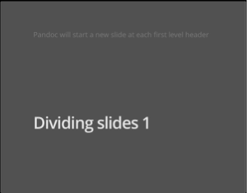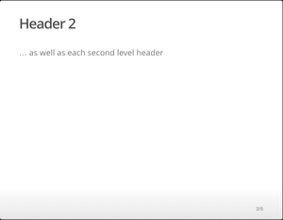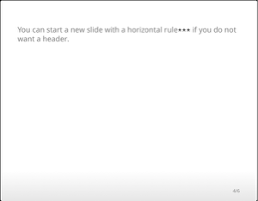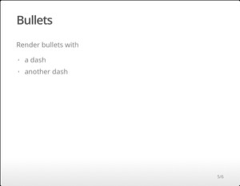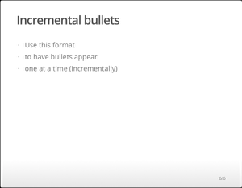

|  |  |
| --- | --- |
| **Top level options to customize LaTex (pdf) output** | |
| **option** | **description** |
| **lang** | Document language code |
| **fontsize** | Font size (e.g. 10pt, 11pt, 12 pt) |
| **documentclass** | Latex document class (e.g. article) |
| **classoption** | Option for document class (e.g. oneside); may be repeated |
| **geometry** | Options for geometry class (e.g. margin=1in); may be repeated |
| **mainfont, sansfont, monofont, mathfont** | Document fonts (works only with xelatex and lualatex, see the latex_engine option) |
| **linkcolor, urlcolor, citecolor** | Color for internal, external, and citation links (red, green, magenta, cyan, blue, black) |

Updated 10/30/2014 © 2014 RStudio, Inc. CC BY RStudio.

**R Markdown** Reference Guide

### Learn more about R Markdown at rmarkdown.rstudio.com

Learn more about Interactive Docs at shiny.rstudio.com/articles

Contents:

1. Markdown Syntax
2. Knitr chunk options
3. **Pandoc options**

|  |  |  |  |  |  |  |  |  |
| --- | --- | --- | --- | --- | --- | --- | --- | --- |
| **option** | **html** | **pdf** | **word** | **md** | **ioslides** | **slidy** | **beamer** | **description** |
| **colortheme** |  |  |  |  |  |  | X | Beamer color theme to use (e.g., colortheme: "dolphin"). |
| **css** | X |  |  |  | X | X |  | Filepath to CSS style to use to style document (e.g., css: styles.css). |
| **duration** |  |  |  |  |  | X |  | Add a countdown timer (in minutes) to footer of slides (e.g., duration: 45). |
| **fig_caption** | X | X | X |  | X | X | X | Should figures be rendered with captions? |
| **fig_crop** |  | X |  |  |  |  | X | Should pdfcrop utility be automatically applied to figures (when available)? |
| **fig_height** | X | X | X | X | X | X | X | Default figure height (in inches) for document. |
| **fig_retina** | X |  |  | X | X | X |  | Scaling to perform for retina displays (e.g., fig_retina: 2). |
| **fig_width** | X | X | X | X | X | X | X | Default figure width (in inches) for document. |
| **font_adjustmen** |  |  |  |  |  | X |  | Increase or decrease font size for entire presentation (e.g., font_adjustment: -1). |
| **fonttheme** |  |  |  |  |  |  | X | Beamer font theme to use (e.g., fonttheme: "structurebold"). |
| **footer** |  |  |  |  |  | X |  | Text to add to footer of each slide (e.g., footer: "Copyright (c) 2014 RStudio"). |
| **highlight** | X | X |  |  |  | X | X | Syntax highlighting style (e.g. "tango", "pygments", "kate", "zenburn", and |
| **includes** | X | X |  | X | X | X | X | See below |
| **-in_header** | X | X |  |  | X | X | X | File of content to place in document header (e.g., in_header: header.html). |
| **-before_body** | X | X |  |  | X | X | X | File of content to place before document body (e.g., before_body: |
| **-after_body** | X | X |  |  | X | X | X | File of content to place after document body (e.g., after_body: doc_suffix.html). |
| **incremental** |  |  |  |  | X | X | X | Should bullets appear one at a time (on presenter mouse clicks)? |
| **keep_md** | X |  |  |  | X | X |  | Save a copy of .md file that contains knitr output (in addition to the .Rmd and HTML files)? |
| **keep_tex** |  | X |  |  |  |  | X | Save a copy of .tex file that contains knitr output (in addition to the .Rmd and PDF files)? |
| **latex_engine** |  | X |  |  |  |  |  | Engine to render latex. Should be one of "pdflatex", "xelatex", and "lualatex". |
| **lib_dir** | X |  |  |  | X | X |  | Directory of dependency files to use (Bootstrap, MathJax, etc.) (e.g., lib_dir: libs). |
| **logo** |  |  |  |  | X |  |  | File path to a logo (at least 128 x 128) to add to presentation (e.g., logo: logo.png). |
| **mathjax** | X |  |  |  | X | X |  | Set to local or a URL to use a local/URL version of MathJax to render equations |
| **number_section** | X | X |  |  |  |  |  | Add section numbering to headers (e.g., number_sections: true). |
| **pandoc_args** | X | X | X | X | X | X | X | Arguments to pass to Pandoc (e.g., pandoc_args: ["--title-prefix", "Foo"]). |
| **preserve_yaml** |  |  |  | X |  |  |  | Preserve YAML front matter in final document? |
| **reference_docx** |  |  | X |  |  |  |  | A .docx file whose styles should be copied to use (e.g., reference_docx: |
| **self_contained** | X |  |  |  | X | X |  | Embed dependencies into the doc? Set to false to keep dependencies in external files. |
| **slide_level** |  |  |  |  |  |  | X | The lowest heading level that defines individual slides (e.g., slide_level: 2). |
| **smaller** |  |  |  |  | X |  |  | Use the smaller font size in the presentation? |
| **smart** | X |  |  |  | X | X |  | Convert straight quotes to curly, dashes to em-dashes, … to ellipses, and so on? |
| **template** | X | X |  |  |  | X | X | Pandoc template to use when rendering file (e.g., template: |
| **theme** | X |  |  |  |  |  | X | Bootswatch or Beamer theme to use for page. Valid bootswatch themes include  "cerulean", "journal", "flatly", "readable", "spacelab", "united", and "cosmo". |
| **toc** | X | X |  | X |  |  | X | Add a table of contents at start of document? (e.g., toc: true). |
| **toc_depth** | X | X |  | X |  |  |  | The lowest level of headings to add to table of contents (e.g., toc_depth: 2). |
| **transition** |  |  |  |  | X |  |  | Speed of slide transitions should be "slower", "faster" or a number in seconds. |
| **variant** |  |  |  | X |  |  |  | The flavor of markdown to use; one of "markdown", "markdown_strict", "markdown_github", "markdown_mmd", and "markdown_phpextra" |
| **widescreen** |  |  |  |  | X |  |  | Display presentation in widescreen format? |

Updated 10/30/2014

© 2014 RStudio, Inc. CC BY RStudio.