**Project Plan: MyGamePlan Internship**

By Bogdan Lazar (R0779031 – 3AI01)

# Abstract:

In this project, development work was done for a web application using React and TypeScript. This application worked with the help of a Node.js backend using multiple tools to pull data of football teams and their respective players. The purpose of MyGamePlan’s application is to help football teams automate their business processes which were still supported to this day by old-fashioned bureaucratic methods and monitor player activity relevant to their performance in the sport.

# Initiation phase:

In this phase, time was allocated to better study the technologies which would then be used in the realization of the internship. Tools were also allocated, such as a company account on Udemy to familiarize oneself better with the concepts which the project was dealing with. In this case, this account was offering the possibilities to study React, React native (React but for mobile apps) and Node.js (the most common backend you will find in most React projects). A total of 2 weeks at least would be spent learning for the most part.

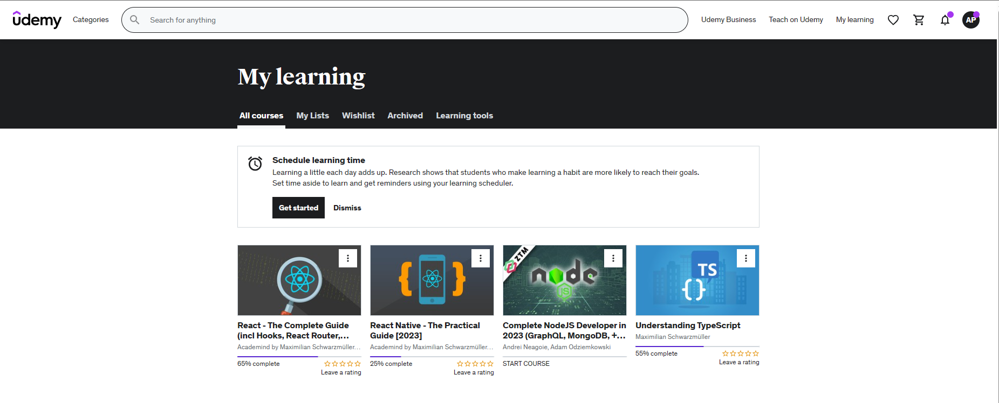

The other important part was the familiarization with the company itself. This encompassed the business model of the company, the facilities, the people involved as well as the technical aspect (learning the code of the application in question). A couple of meetings happened in person at the office of the company in Leuven whereby introductions could properly happen.

The main scope of this project was to make sure the application MyGamePlan had to offer (mainly the front-end of the web application) was up to spec for the customers of the company to be able to automate their business processes which to this day would only happen with the pen and paper.

# Realization phase:

It didn’t take long until the mentor agreed that it was time to stop learning course content and finally start learning by doing. Therefore, the first of many feature tickets were assigned and it was off to the races. It all started with smaller features which then snowballed into bigger ones. For each feature there would also be feedback from the tech lead of the company who would be the primary overseer of progress on these things via our version management tool which was Git on a GitHub repository. It is important to note that this resulted in extra time spent on a certain feature in most cases. If there was any messy code or unnecessary code for that matter, it had to go before anything new could take place.

