|  |  |
| --- | --- |
|  | |
| MyGamePlan Internship  Reflection | |
| **Bogdan Lazar** | Bachelor's degree in the ACS  field AI |
|  |
| Academic year 2022-2023  Campus Geel, Kleinhoefstraat 4, BE-2440 Geel |

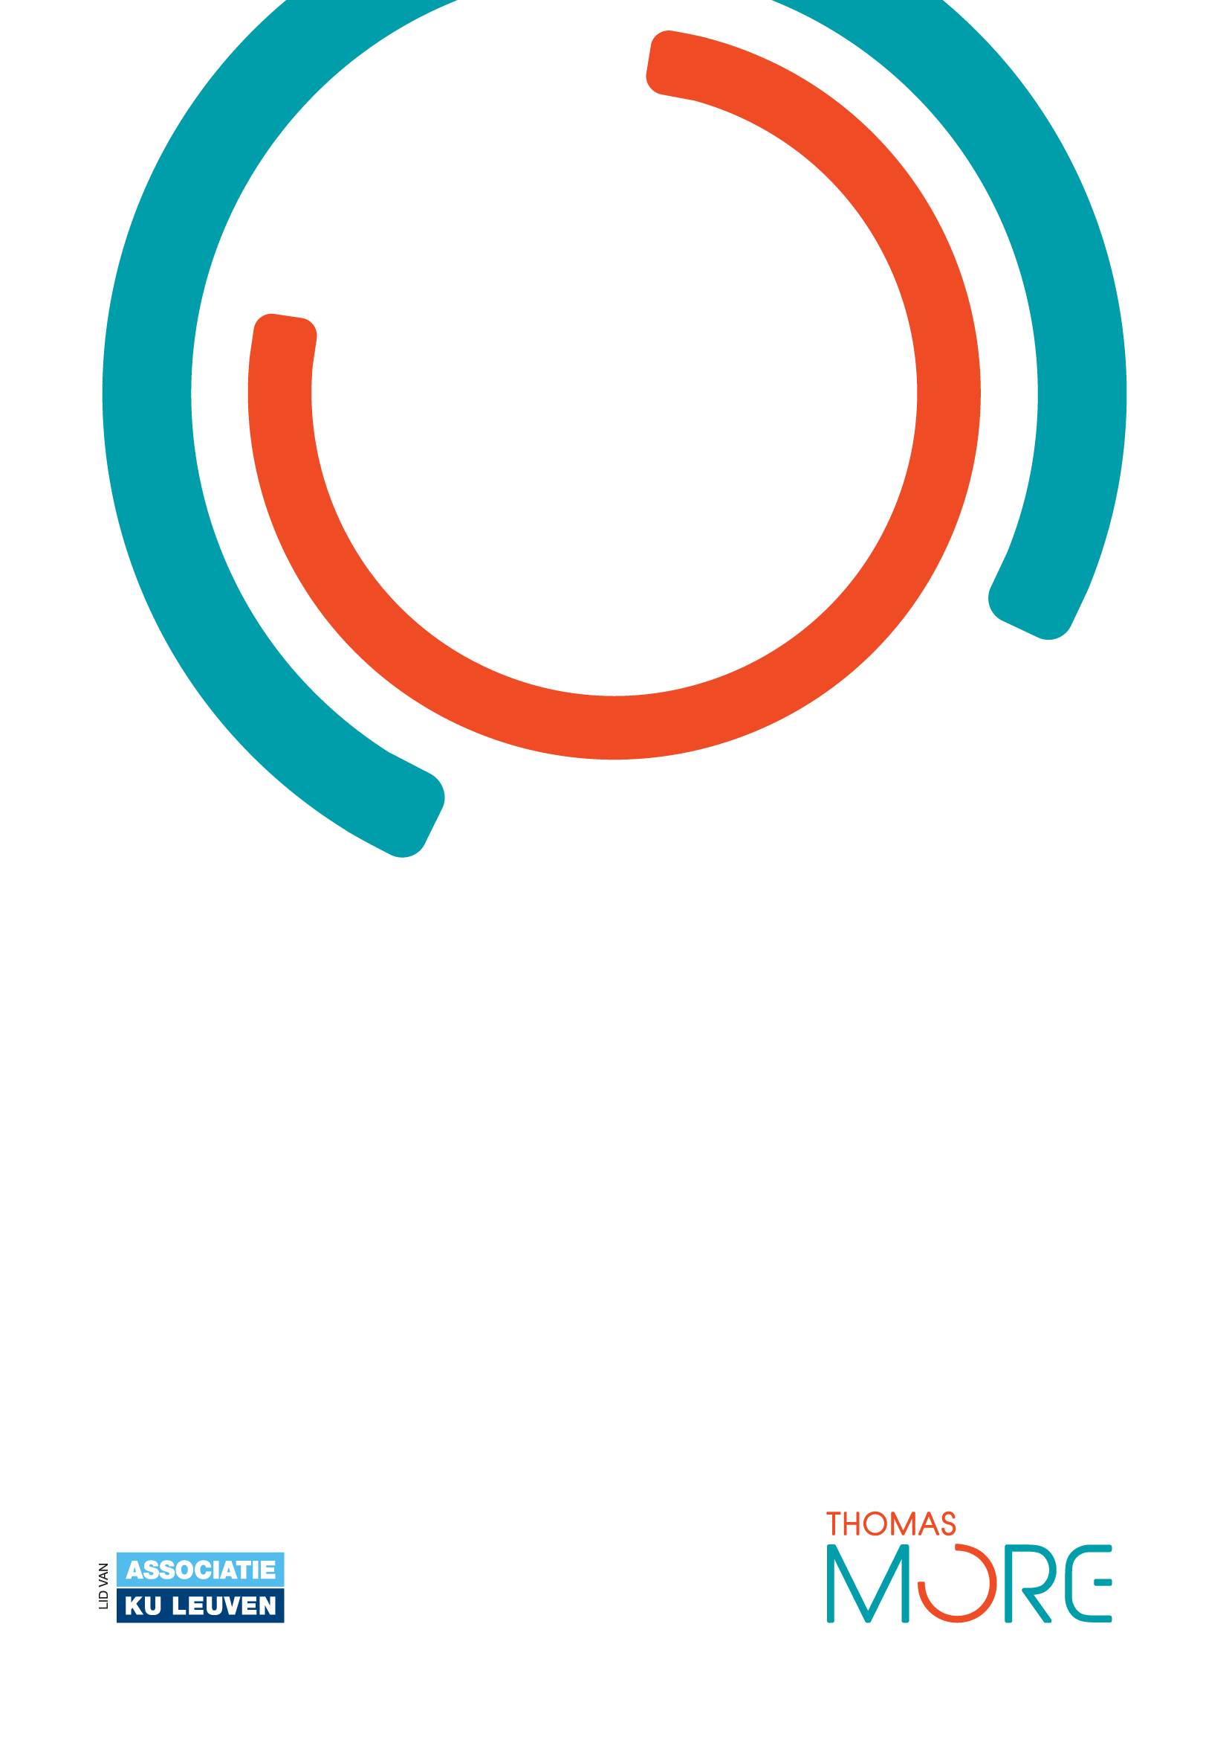

# Introduction:

This paper entails everything the reader needs to know about the experience of Bogdan Lazar, intern at MyGamePlan. The following content will reproduce to the best of one’s ability the things, technical or not, that were learned along the way, problems that were faced, the status of the project after the internship, and to what extent the intern’s contributions have impacted the organization from all aspects.

# The project:

During this project, the app provided by MyGamePlan for football teams to automate their cumbersome and old-fashioned business processes and track player performance of their own as well as other teams’, has undergone further development towards the final business scope. Specifically, a user interface refactor as well as other things to refine the code of the application were done in order to provide the best experience for the company’s customers.

The project isn’t finished. Unfortunately, with application development there is never a point at which something is completely finished. It is worth mentioning that MyGamePlan along with its product are still in a starting state and have a ways to go. It is very impressive what a team of such small size has accomplished in just a couple of months but even so the path of improvement is endless. From a personal perspective, the project still needs to have its UI refactor completed. There are still elements within the app that have been built around AtlasKit that still need to be adapted before a MaterialUI counterpart can be inserted and connected with the appropriate props without problems.

Everything that was developed during this project has been put into use. Surprisingly there hasn’t been a moment when what has been planned for with the app was discarded because of something becoming too outdated. And even if it was, it was something that got stuck before it even materialized into a real feature.

There is no real advice I would give to the leaders of the company. In fact would say their way of doing business is quite ahead of its time. This ranges from the way they work with their personnel to their ways of expanding their network.

# Personal reflection:

To me personally, this internship was a great opportunity to hone the skills I would like to put to good use in the future, as well as something that I wanted to do for a long time. I have always wanted to work as a developer and this was essentially exactly what I expected of the job. You could say it’s a dream come true.

In this internship I learned more about what it’s like to work as a developer. I also consolidated my assumption that you can’t always learn from coursework as much as you can learn from a real job assignment. I managed to not only hone my soft skills but also see what it’s like to work in a real company as an actual application developer. My technical skills in React and TypeScript were also addressed with this occasion and I can only say that they definitely improved. Some gaps were also filled in my experience with version control utilities such as Git in conjunction with the GitHub repositories of the company. Plenty of new technologies never seen in my academic curricula were also learned such as yarn (node package management tool).

I have grown in many ways on this internship. One of the key ones is my problem solving skills. We truly live in times unimaginable by anyone living not too long ago. There are so many tools especially application developers can use in order to make sure the work gets done at the right time and is on point from a quality standpoint. My communication skills were also honed as at every moment of my steps taken to provide for the application I consulted myself with the tech lead as he was the one who knew the ropes the best. The same goes for whenever I had to show off my progress to the entire team. I got my feedback from my mentor and understood where I had to improve therefore proceeding to improve in the respective areas.

The only problems I truly faced while on this project were the familiarization with the whole arsenal of tools the company was using already. This includes their Notion site, their agile board (Kanban) and other things that I wasn’t very up to speed with since it was truly an amalgamation of new things I had to get to know compared to what I had already learned in my courses. Of course, on the technical side there were the package management tools which even now are set to change to something more up to date as well as the code of the front-end application which only the tech lead knew the best as he was its largest contributor. The way I solved those problems was by not being afraid to ask questions and just embracing the struggle. The opportunity presented itself for me to learn and the best way to learn is by doing.