**Liver model.** The geometry of the liver and blood vessel network is generated at R&D Center BIOIRC from micro-CT scan of a mouse liver (Figure 1), obtained following a previously published procedure (Zagorchev et al., 2010). Micro computed tomography (micro-CT) was then used to scan the vascular structure by the Preclinical Imaging Core at the Houston Methodist Research Institute. The finite element model consists of 1D pipe FEs for larger vessels (7736 elements), 3D composite smeared elements (39832 elements), and connectivity elements (726 elements) for connecting large vessels with continuum nodes (capillary domain DOF) of smeared FEs. There are two separate tumors within liver, with a total of 316 elements. The total number of nodes is 54590. Boundary conditions for this example are:

* Inlet Pressure 3999.7 Pa (30 mmHg)
* Outlet Pressure 1333.2 Pa (10 mmHg)
* Inlet Concentration Bolus - c(t)
* Outlet Concentration 0 molar

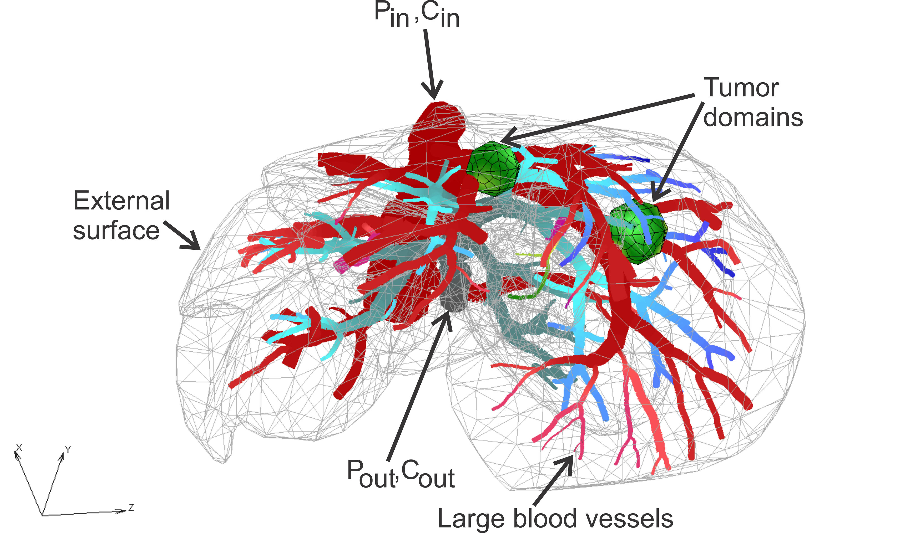

**Fig.1.** Liver model: geometry, tumor domains and pressures within large vessels.

With these boundary conditions, we have solved for pressures and concentrations within the liver and two tumors using our smeared methodology. Some of the results are summarized below.

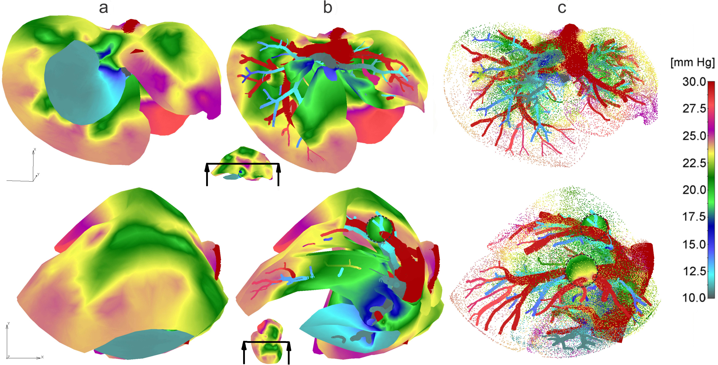

**Fig.2.** Pressure fields for two views: a) Full mesh; b) Clipped mesh; c) Dotted representation of results in tissue, and with full mesh in tumors.

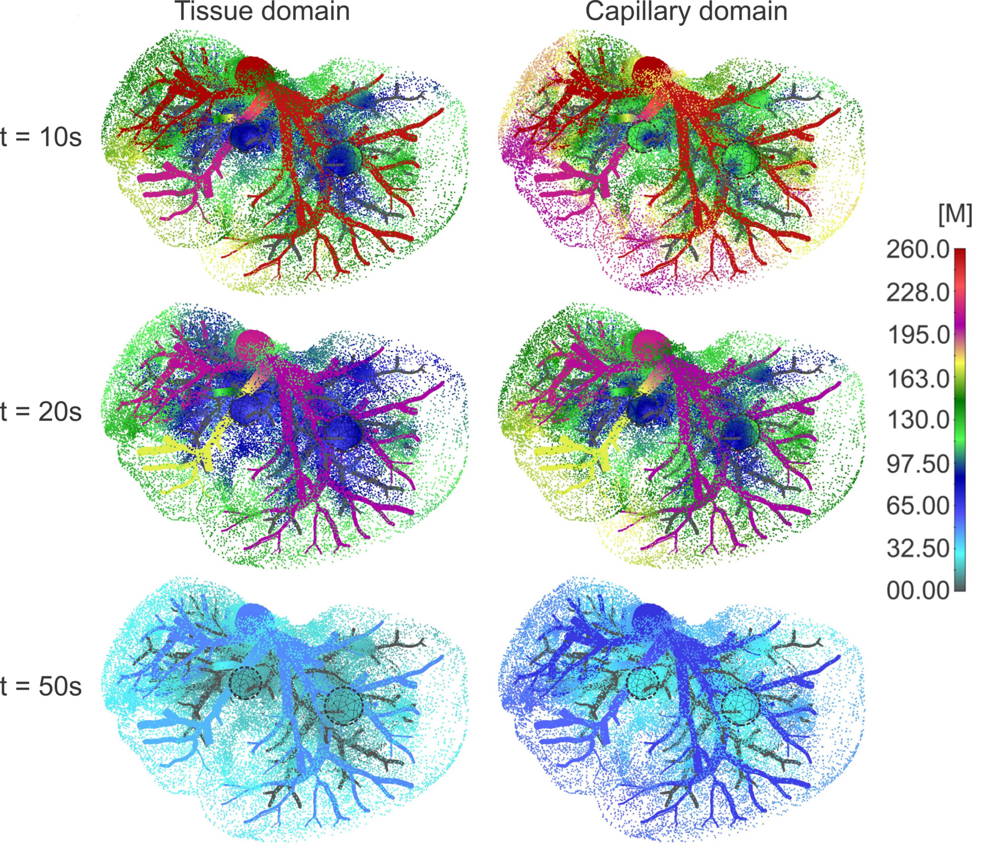

**Fig.3.** Concentration field in liver with tumors (marked with dashed lines), dotted results in tissue domain and with full mesh in tumors, for times t =10, 20 and 50s.