**PLGA.** Two different computational models are generated in order to simulate a drug transport from PLGA1 and PLGA2 implants: (a) a detailed FE model with 1D radial elements and (b) a composite smeared finite element model with two different domains: fiber domain and surrounding domain. For the purpose of the detailed FE model, the network of fibers is reconstructed using indoor software from an SEM image of drug loaded PLGA fibers with dimensions 90 µm × 90 µm, Figure 1a. By randomly duplicating and displacing the generated layer of 1D fibers into the longitudinal direction of the modeling domain, we can generate a mat of fibers within any implant (Figure 1b). Further, assuming symmetric conditions, we can model just one half of the implant. It is also reasonable to adopt a homogenous distribution (or repetition) of one small domain of the fibers, through which we can model just one part of the implant. Thus, the dimensions of our FE models are: 80 µm × 90 µm × 90 µm. The 3D FE mesh (40 × 48 × 48 divisions) consists 64,512 nodes and 36,864 elements; while the number of radial 1D elements is around 7580.

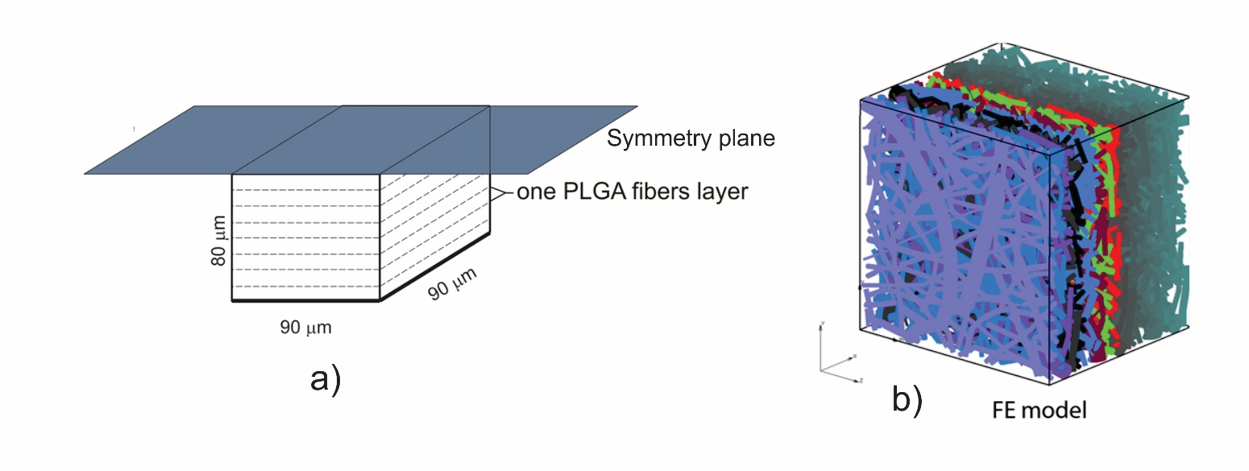

Fig. 1. FE model of PLGA implant. a) The 3D domain used in the model, with symmetry plane; b) Generated FE model using a SEM imaging sample.

It is taken that the diffusion coefficient of Span 80/RhB in pore space is as in water ( Dliquid = 0.04 µm2/s), and within fibers *Dfib* = 4 × 10−10 cm2/s (approximately 104 times lower than in water), according to Ruiz-Esparza, et al. 2014. The time period of the simulation was 75 days (15 time steps with 5 days each). Initial concentration in fibers is C0=1. The boundary conditions of the model are: Boundary conditions are: no flux through model boundaries except C = 0 at the outer boundary of the implant (boundary where mass release is measured). The mean diameter of the fibers is taken as D = 2.5 µm.

The composite smeared FE model consists of two domains: a) fiber domain—an equivalent domain of fibers; and b) surrounding domain—an equivalent “pore” space surrounding fibers. The detailed and the corresponding smeared model are shown in Figure 2.

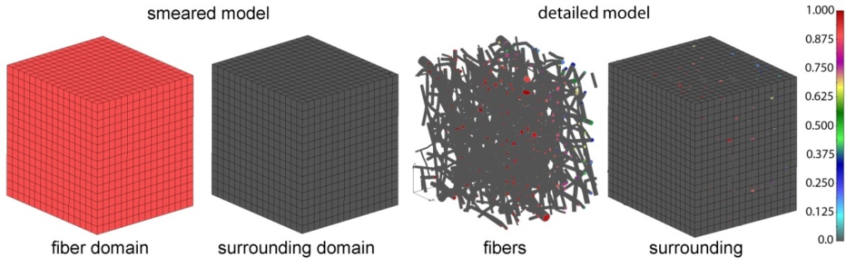

**Fig. 2.** PLGA domain modeled using a smeared composite finite element or detailed model with the mesh of fibers.

To determine the diffusion coefficient for the surrounding domain, a numerical homogenization procedure was performed according to Ziemys et al. 2011 and Kojic et al. 2014. It was found that diffusion is reduced in the surroundings due to the attractive forces between fibers and diffusion molecules, and also by the presence of fibers in the system. The equivalent diffusion coefficient in the surrounding domain and the parameters used in the composite smeared finite element (CSFE) model are:

* equivalent diffusion coefficient of drug: Dliquid = 0.004 µm2/s;
* volume fraction of fibers in PLGA layer: **= 0.4223;
* mean diameter of fibers: D = 2.5 µm;
* diffusion coefficient within PLGA fibers: Dwall = 0.04 µm2/s;
* coefficient of hydrophobicity (partitioning): P = 1.

Concentrations for both detailed and smeared models of PLGA1 are shown in Figure 3, for the fiber and the surrounding domain, in a period of 75 days. It can be seen that there are small differences between the two models; hence, the smeared modeling concept can be used for the prediction of drug transport from drug impregnated nanofibers.

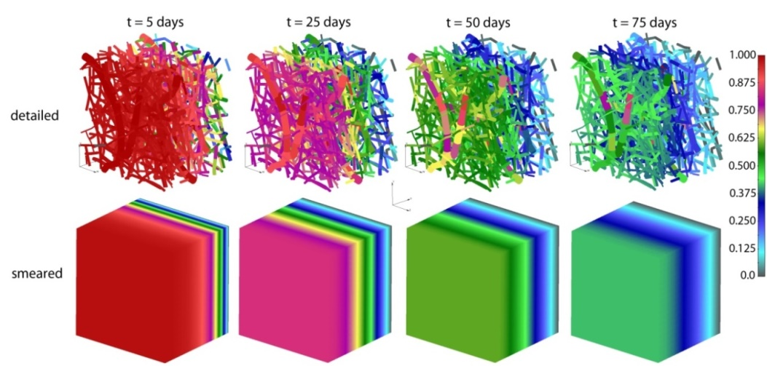

**Figure 3.** PLGA implant—concentration field in the fibers, for the detailed and smeared model, for the diffusion of Span-80/RhB complex within the PLGA implant.