**Pancreas model.** The model geometry, including large vessels and tissue, was generated at the Bioengineering R&D Center BIORC in Serbia, according to imaging data from: E. J. Koay, MD Anderson Cancer Center, Houston. The model is shown in Fig. 1, where we

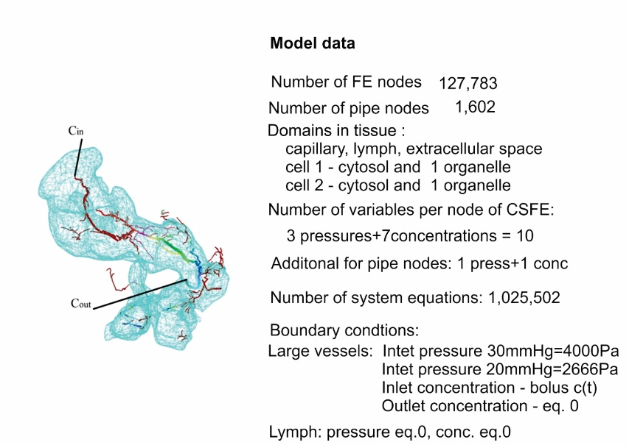

Fig. 1. Model of pancreas, with large vessels and finite elements on the surface. Color in blood vessels corresponds to pressures. Model data include basic characteristics of the FE model.

include the basic data about the model. Other data are as follows. **Large vessels**: diameters 0.006-0.209mm, wall thickness 10% of diameter; diffusion coefficients: 1e+5 [mm2/s] in vessel, 10 [mm /s] through the wall; viscosity= 1e-3 Pa s, hydraulic coefficient of wall 1e-3 mm / (Pa s). **Capillaries**: volumetric fraction 2.47%, diameters 0.005 [mm], wall thickness 0.0005 [mm],diffusion coefficients [mm2/s]: in capillaries =10, through the wall= 0.0001. **Lymph**: volumetric fraction 2.47%, diameters: 0.005 [mm], hydraulic coefficient 1e-11 mm / (Pa s). **Extracellular space**: Darcy coefficient 1e-3 mm2 /(Pa s) , diff coefficient =10 [mm2/s]. **Cell 1**: diameter = 0.00617, volumetric fraction =28.21%, diffusion coefficient in cytoplasm and through cell membrane= 1.e-4 [mm2 /s]; Organelle: diameter = 0. 0034, volumetric fraction = 30.3%, diffusion coefficient and through organelle membrane= 1.e-4 [mm2/s]; Partitioning: extracellular space / cell membrane P=5, cell cytoplasm / organelle membrane P = 0.1; **Cell 2**: diameter = 0.00630, volumetric fraction =28.2% , diffusion coefficient in cytoplasm and through cell membrane= 1.e-4 [mm2/s]; organelle: diameter = 0.00347, volumetric fraction = 30.3%, diffusion coefficient and through organelle membrane= 1.e-4 [mm2/s]; Partitioning: extracellular space / cell membrane P=10, cell cytoplasm / organelle membrane P = 0.1.

Since we use pressure and concentration in lymph as prescribed (equal to zero), the “degrees of freedom” of the lymph domain do not enter into the system of equations in this example. We selected data in a way that they fall in a realistic range, and assumed the only significant difference between the two groups of cells was that for Cell 1 group partitioning is P=5, while for the Cell 2 group P=10 at the cell membranes. Since the partitioning coefficient is defined as the ratio between concentration in the membrane wall and concentration in the extracellular space, it follows that, under the same other conditions, concentration in the cell interior of Cell 2 will be half of the concentration within Cell 1. Also, the partitioning at the organelle membrane is defined as the ratio between concentration within the membrane wall and in the cytosol (for P=0.1 we will have that concentration in the organelle is 10 times larger than in cytosol). Further, we show some typical results.

Fig. 2 shows the concentration field at the surface of elements for five different time points and for all continuum domains calculated within CSFEs. As can be seen, there is a drastic difference between the values of the two cell groups, coming as a consequence of partitioning, discussed above.

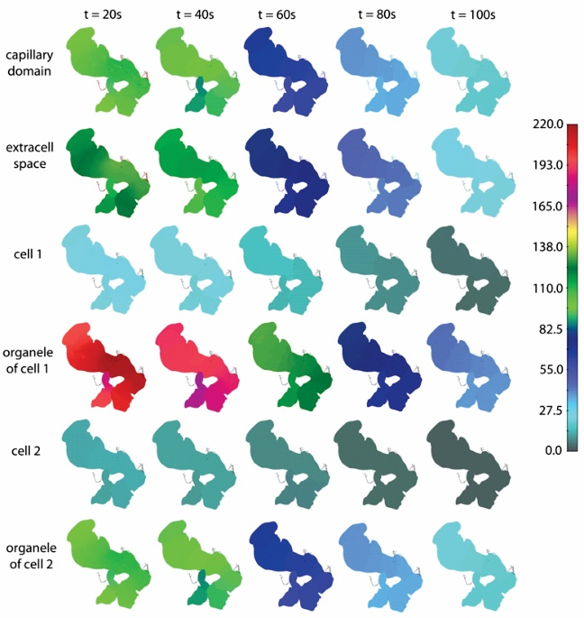

Fig. 2. Concentration field within elements CSFE at the pancreas surface, for five selected time points. Maximum concentration, among the shown five time points, at each domain at t=20s when concentration Cin reaches maximum