DOCUMENTATION

ASSIGNMENT 2

STUDENT NAME: .Palacian Bogdan……
GROUP: 30425……

CONTENTS

1. Assignment Objective 3
2. Problem Analysis, Modeling, Scenarios, Use Cases 3
3. Design 3
4. Implementation 3
5. Results 3
6. Conclusions 3
7. Bibliography 3

Assignment Objective
Design and implement an application aiming to analyze queuing-based systems by (1) simulating a series of N clients arriving for service, entering Q queues, waiting, being served and finally leaving the queues, and (2) computing the average waiting time, average service time and peak hour.

Sub-objectives:
Sub-objective | Description | Section
Implement Object-Oriented Design | Organize functionality into classes and packages, adhering to object-oriented principles. | Source Code
Develop a Random Client Generator | Create a method to generate random clients based on user-defined parameters. | Simulation Manager
Implement Multithreading | Utilize threads for parallel processing of clients and efficient queue management. | Source Code
Ensure Thread Safety using Synchronized Data Structures | Use synchronized data structures to ensure safe access to shared resources. | Source Code
Log Events to a .txt File | Implement logging functionality to record the state of clients and queues at each simulation time step. | Simulation Manager
Limit Class and Method Line Counts | Ensure that classes and methods are concise and adhere to maximum line limits. | Source Code
Follow Java Naming Conventions | Use proper naming conventions for classes, variables, and methods according to Java standards. | Source Code
Provide Quality Documentation | Create comprehensive documentation addressing all sections of the provided structure. | Documentation
Develop Graphical User Interface (GUI) | Create a GUI for simulation setup and real-time queue evolution display. | Simulation Frame
Test Application on Various Input Data Sets | Ensure the application runs correctly on different input data sets and generates corresponding logs of events. | Source Code

Problem Analysis, Modeling, Scenarios, Use Cases

Problem Analysis:
The main objective of the assignment is to design and implement a queue management application that minimizes the waiting time for clients in queues. The application simulates clients arriving for service, entering queues, waiting, being served, and leaving queues.

Functional Requirements:
- Input Data Collection:
  - Collect information from the user regarding:
    - Number of clients (N)
    - Number of queues (Q)
    - Simulation interval (maximum simulation time)
    - Minimum and maximum arrival time for clients
    - Minimum and maximum service time for clients
- Client Generation:
  - Generate a random set of clients based on the provided input data.
- Queue Management:
  - Assign clients to queues to minimize waiting time.
  - Ensure that clients are added to the queue with the shortest waiting time when their arrival time equals or exceeds the simulation time.
- Simulation Execution:
  - Simulate the passage of time and the processing of clients within the queues.
  - Track the total time spent by clients in the queues and compute the average waiting time.
Non-Functional Requirements:
The application of the queue management app should have an intuitive design and it should be easy to use.
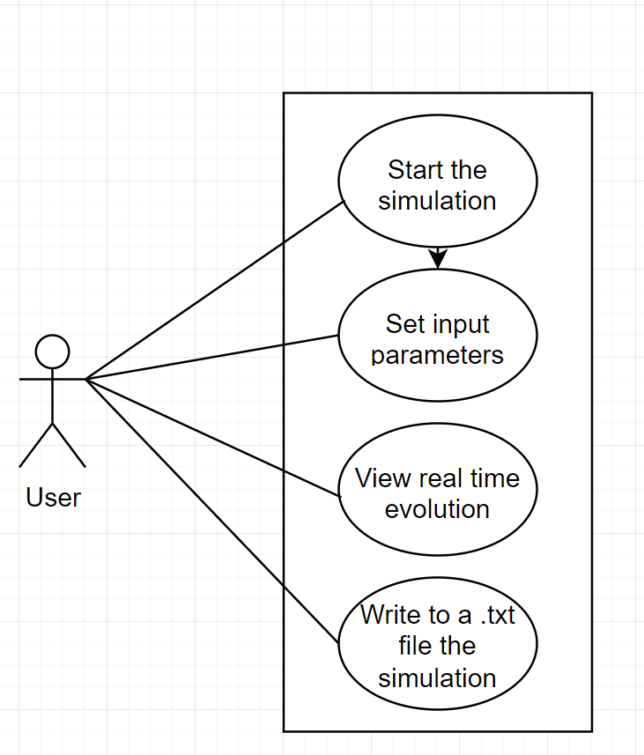
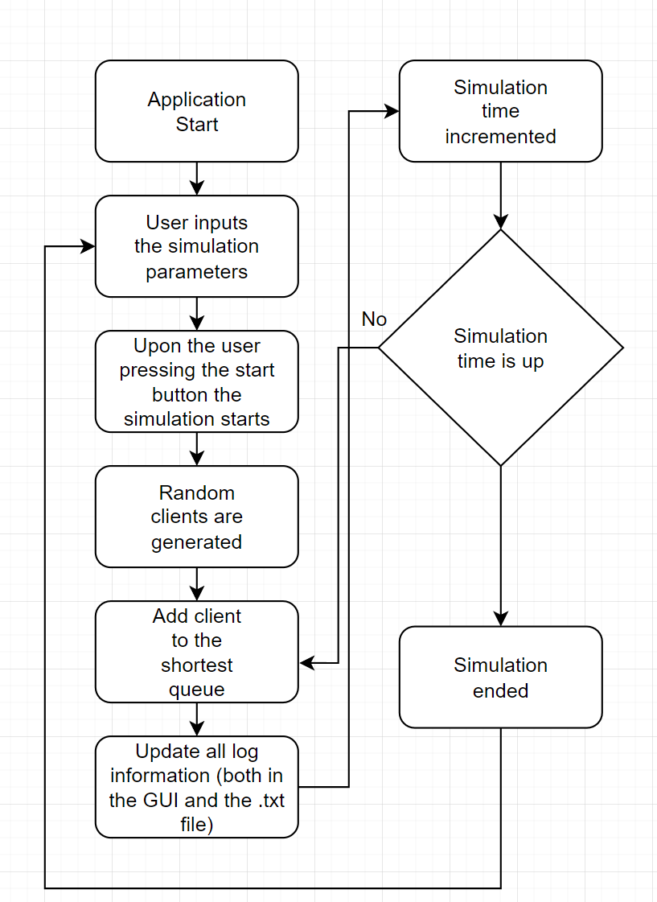

Design

OOP Design:
- SimulationFrame: Handles the graphical user interface for inputting simulation parameters.
- Model Package: Contains classes representing the core entities of the simulation, including Client, Queue, and GeneralInfo.
- Logic Package: Implements the main simulation logic, including the Scheduler, SimulationManager, and Strategy interface for queue management.
- Strategy Package: Contains concrete implementations of queue management strategies.
- Util Package: Includes utility classes for file logging and random client generation.

UML Diagrams:
- Package Diagram:
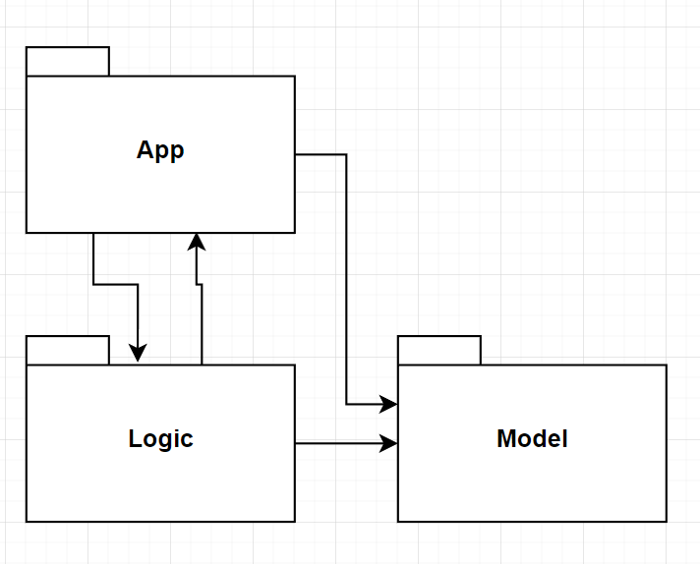

- Class Diagram:
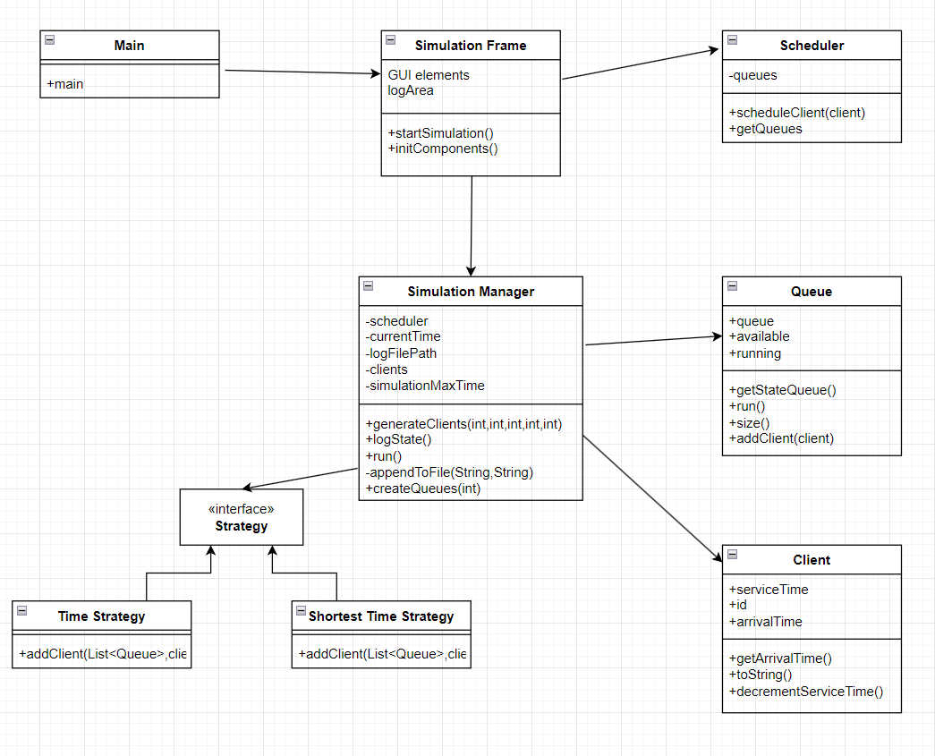

Used Data Structures:
- BlockingQueue: Utilized in the Queue class to manage clients waiting for service in a thread-safe manner.
- List: Employed for storing clients and queues, allowing for dynamic resizing and efficient iteration.

Defined Interfaces:
- Strategy Interface: Provides a contract for implementing different strategies for assigning clients to queues, promoting flexibility and extensibility.

Used Algorithms:
- Shortest Queue Strategy: Algorithm for assigning clients to the queue with the fewest clients, implemented to minimize waiting time effectively.
This design promotes modularity, encapsulation, and abstraction, enabling the application to manage queues efficiently while facilitating future enhancements and modifications.

Implementation
SimulationFrame:
- This class represents the graphical user interface (GUI) of the application.
- It contains text fields for inputting parameters such as the number of clients, number of queues, arrival time range, service time range, and simulation max time.
- The startSimulation method is crucial, as it triggers the simulation process based on the input parameters provided by the user.
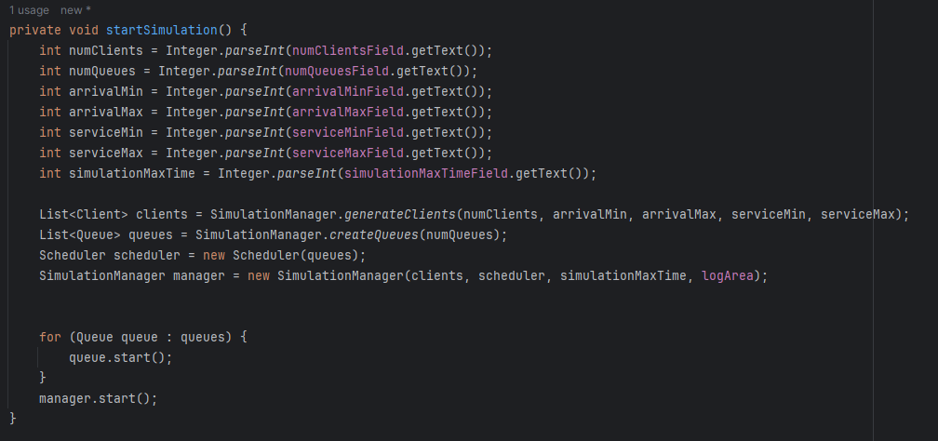
An important aspect of this function is that it passes to the Simulation Manager the logArea so it can be modified accordingly.Also this is tasked with the creation and start of the queues.

Scheduler:
- The Scheduler class manages the assignment of clients to queues.
- Its primary method, scheduleClient, determines which queue a client should be assigned to based on the shortest queue strategy(the queue with the least amount of clients).
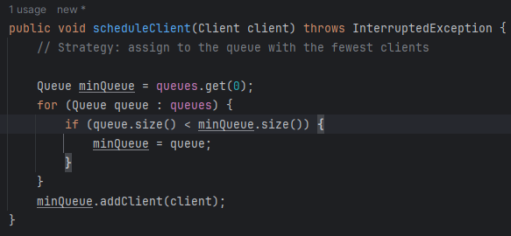
I will not touch on Strategy,TimeStrategy and Selection Policy as they are not implemented.

SimulationManager:
- This class controls the simulation process, including generating clients, creating queues, and managing the simulation time.
- The run method contains the main logic of the simulation, where clients are assigned to queues based on their arrival times in the following way: an iterator goes through all the clients waiting to be added to a queue and adds the ones whose arrival time matches the simulation time. After a clint is added to queue it is deleted from the list of waiting clients. Also thread safety is assured my the sleep command which synchronises the simulation thread with all the threads of the queues.
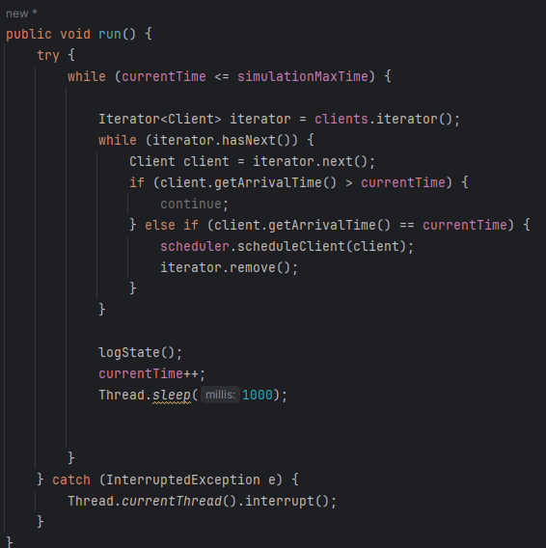
- The logState method is responsible for logging the current state of clients and queues at each time step.The logging is done on all three output methods: console, log area of the GUI and a text file whose path is specified in the code(it will append all simulations to this file if the file path remains the same).The method builds a string that displays the current simulation time, the clients waiting to be added to a queue and the states of all queues(the clients that are in the line).The method appendToFile is used to update the log to the text file.
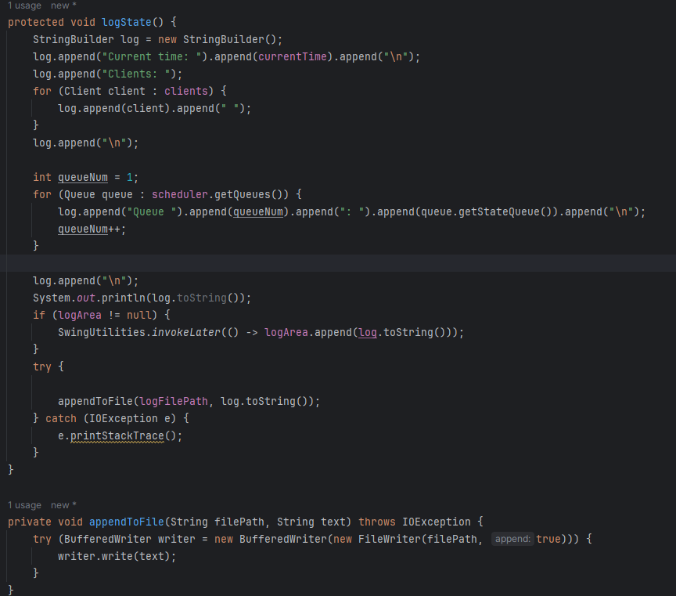

- The method generateRandom clients does as the name implies, using Random next int it generates the clients as the parameters specify.
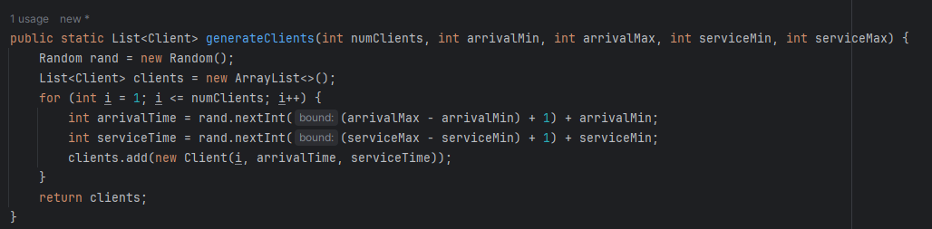

Queue:
- Represents an individual queue in the system.
- The run method defines the behaviour of a queue. The queue always looks at the first client it has and decrements its Service Time until it reaches 0,then it removes the client and starts processing the next one.
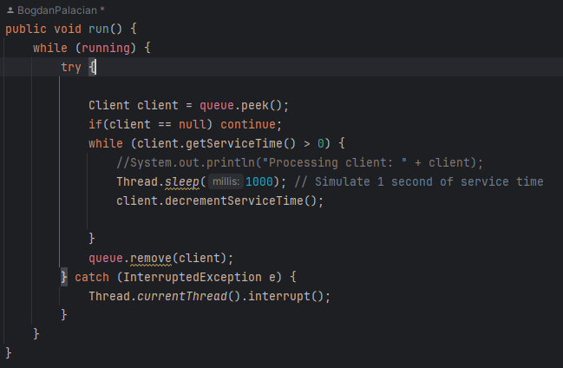
- The addClient method adds a client to the queue, and the size method returns the current size of the queue.
- The getStateQueue method retrieves the state of the queue, including the clients currently waiting in it(used to display the real time simulation behaviour)
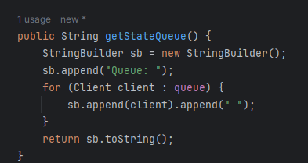

Client:
- Represents a client with attributes such as ID, arrival time, and service time.
- The method override of toString allows for easier debugging of the application and it is also used in the log
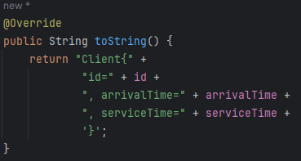

Results

As the requirements states the application was tested for 3 different data sets:
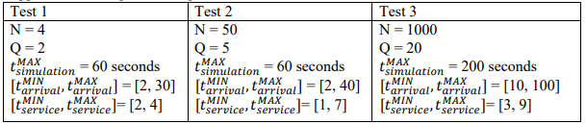
The application behaves similarly for Test 1 and 2 as it finishes processing the clients before the simulation time end(the simulation time still advances until the specified max time). For test number 3 the clients are not finished processing, however when reaching the max time the simulation stops(in the background the queues are still processing the clients that are in them as in a real store,but no more clients are added to the queues).

Conclusions

In conclusion, the development of the queue management application has provided valuable insights into various aspects of software engineering, including object-oriented design, multithreading, and user interface development. Through this assignment, several key takeaways and areas for future development have emerged.
Firstly, the implementation successfully addressed the core requirements of the assignment by creating a functional simulation of a queue management system. The application efficiently manages client arrivals, queue assignments, and service times, demonstrating effective use of object-oriented principles and multithreading techniques.
However, there are areas for improvement and future development. One notable aspect is the incorporation of different strategies for client queue assignment, such as the shortest time strategy. Implementing the strategy pattern and allowing users to select from multiple queue assignment strategies would enhance the flexibility and robustness of the application, catering to diverse use cases and scenarios.
Additionally, the application currently lacks features for displaying simulation results, such as average waiting time, average service time, and peak hour analysis. Integrating these functionalities into the graphical user interface would provide users with valuable insights into the performance of the queue management system, facilitating informed decision-making and optimization efforts.
Furthermore, future developments could focus on enhancing the scalability and performance of the application to handle larger datasets and simulate more complex scenarios. This may involve optimizing data structures and algorithms, implementing caching mechanisms, or leveraging cloud computing resources for distributed processing.
Moreover, improvements to the user interface, such as interactive visualizations and real-time analytics, could enhance the user experience and make the application more intuitive and user-friendly.
Overall, the development of the queue management application has been a valuable learning experience, providing hands-on exposure to various software engineering concepts and practices. Moving forward, continued refinement and expansion of the application will contribute to its usability, effectiveness, and applicability in real-world queue management scenarios.

Bibliography
http://docs.oracle.com/javase/tutorial/essential/concurrency/index.html
http://www.tutorialspoint.com/java/util/timer_schedule_period.html
http://www.javacodegeeks.com/2013/01/java-thread-pool-example-using-executors-andthreadpoolexecutor.html
https://app.diagrams.net
https://www.youtube.com/watch?v=r_MbozD32eo
https://www.youtube.com/watch?v=d3xb1Nj88pw

