Interim Report: The development of the gamified learning platform
Bogdan Palcau
Computer Science, University of Northampton
Northampton, United Kingdom
bogdan.palcau21@my.northampton.ac.uk

Introduction / The problem
Cybersecurity education today focuses on theoretical knowledge, which leaves a gap in practical knowledge for most learners. To address this issue, this project proposes a practical solution that teaches web vulnerabilities and safe coding practices. Despite the growth of the cyber industry to around 143,000 people in the UK alone, a gap remains in skill, with around 49% of businesses reporting a lack of technical skills among the people they recruit (Cyber Security Labour Market Survey, 2025). Employers want to hire individuals with more hands-on knowledge and those who know how to use practical tools, but universities consistently prioritize theory and struggle to provide real infrastructure for students to learn hands-on without running into legal issues. Platforms that teach cybersecurity often lack structured learning for students to progress, which can be overwhelming for new learners or require virtualized labs that could pose security risks and increase costs. This project researches whether a browser-based solution that includes guided progression and gamification can improve retention, engagement, and practical understanding. Additionally, we are looking into whether the developed solution can also address the drawbacks of other cybersecurity platforms to reduce security risks and provide a better structure for learners.
1b. Significance of the project
This project was developed for people who are looking to get into the field of cybersecurity but are looking for a more interactive learning method. While tools such as TryHackMe and Hack the Box (TryHackMe, 2024; HackTheBox, 2024) provide gamified learning experiences, they are not structured enough for new learners who do not know where to start. They do provide a few paths, but they are inconsistent, and users are expected to know where to start or have some previous knowledge. Additionally, they use virtualisation, which can be risky due to security reasons, as a user can always hack a real system by mistake. Virtualisation also adds the need for more processing power and computing resources, which can be expensive. The solution developed provides a more guided learning experience, where users can go through challenges in a certain order based on their level of expertise (skill level), such as beginner, intermediate or expert, while being supported by the other gamification elements such as achievements, streaks or XP. Additionally, it solves the virtualisation issues by using simulated environments that are not real and built using JavaScript, which means a user can never hack an actual system and reduces the need for computing resources. This makes the learning process more engaging for the learners. In terms of novelty, most platforms rely on virtualised labs; this project uses a lightweight browser to teach cybersecurity concepts such as web vulnerabilities and safe coding practices. We reduce the risk of running into legal issues and the need for computing resources such as servers.

Background/ literature review

2.1 The cybersecurity skill gap
Cybersecurity has become more important in recent times due to the growth in the number of cyberattacks and the need for skilled professionals to combat these. As threats become more and more sophisticated, the need for effective teaching methods has also increased and learning beyond theory has become crucial. Research in cybersecurity education has found that the majority of learners would benefit from a more hands-on, practical environment where they can learn by doing, and show how vulnerabilities work in real scenarios (Chothia and Novakovic, 2015) But simply giving access to the tools can be counterproductive for beginners and new graduates. This helps support objective 1 below, as it addresses the current limitations of the current platforms.

2.2 Cognitive Load Theory
The research “Cognitive Load Theory” (Sweller, 1988) (Paas, Renki & Sweller, 2003) shows that new learners are given a complex interface (like the Linux shell) and also information on how to use it, which can be overwhelming for their cognitive capacity and make them lose information throughout the learning experience. Most existing platforms nowadays adopt this “make it or leave it” approach. To help learners easily learn complex tasks without being overwhelmed, this project uses a hint system which can help provide a temporary support structure for the users. Additionally, instead of just providing a generic error like the other solutions presented in this report, the terminal provides guidance to help reduce the cognitive load and allow users to focus on the cybersecurity concept better. This theory is directly linked to the guided terminal and the hint system. This helps support objective 2 below, as it helps define critical success factors needed to reduce cognitive load for new learners.

2.3 gamification and self-determination theory
In technical subjects such as cybersecurity, hands-on learning has been shown to improve retention and engagement. The gamification was also identified as a good method to improve engagement and keep users motivated, improving retention in the learning of the subject. (Dicheva et al. 2015). To ensure we gain the retention of the users long-term, the proposed solution uses mechanics based on the Self-Determination Theory (SDT), which says that motivation is reliant on three psychological requirements: Autonomy, Competence and Relatedness (Ryan & Deci, 2000). The solution was developed to address these needs directly, for example:
- It provides autonomy – Unlike most linear courses present in universities nowadays, the solution provides autonomy to the user to be able to choose their own path based on their interest. This helps provide a sense of controlled learning and keeps the user engaged with topics they consider interesting.
- Reward system – instead of just rewarding skill, the website rewards consistency. This way, we create a sense of achievement for our users even when they struggle to complete the course.
These principles are implemented as the project uses self-determination techniques such as XP, streaks and skill levels. This helps support objective 3 by defining how gamification can improve user engagement and their retention.

2.4 limitations of existing platforms
Several platforms exist today that already provide gamification elements, such as TryHackMe and Hack the Box. (TryHackMe, 2024; HackTheBox, 2024) But these platforms assume prior knowledge and do not provide a clear path a user can follow to become a cybersecurity professional. This shows a gap in the domain for a platform that provides both a clear path and gamification elements for new learners entering cybersecurity. This helps achieve object 1 below even further as it analyses weaknesses of the existing platforms and evidentiates on what the developed solution can do better.

2.5 Web vulnerabilities in teaching
Looking at attack vectors, web applications are usually one of the most common targets for cyberattacks (OWASP, 2025), which makes them an excellent domain for teaching cybersecurity. A few vulnerabilities could be exploited here, such as SQL injection, cross-site scripting or improper input handling, which are often among the most exploited vulnerabilities within cybersecurity.
But learning about vulnerabilities alone is not enough; learners must also master how to build safe web applications through safe coding practices. By learning both how vulnerabilities are being exploited and how they can be prevented, learners gain a more comprehensive understanding of web security. It matches objective 3 by justifying how web vulnerabilities and safe code practices were chosen as the focus of the challenges.

2.6 Legal, ethical and technical constraints of cybersecurity training
In platforms such as OWASP Juice Shop, users are usually presented with many challenges without a clear learning path, which can lead to confusion and frustration. This helps highlight the need for a platform that combines both vulnerable web environments with structured learning and gamification. Web vulnerabilities are used to teach cyber because they can be easily demonstrated by simplifying using a web browser without requiring a real system or real architecture that can be expensive for training purposes. The use of simulated environments is also important for ethical reasons and for keeping things legal. By creating simulated environments where the user does not interact with real systems, we avoid the legal issues that might come with it, and we reduce costs significantly. Looking at the technical side, this requires us to move away from virtualisation and more towards a simulated environment that is not real because virtualisation requires a significant amount of computing resources and introduces security risks (for example, TryHackMe consistently warns users not to use it to exploit real systems). In contrast, the website uses a JavaScript-based solution to help solve this. Additionally, this also helps ensure compliance with the Computer Misuse Act (legislation.gov.uk, 1990) as it's impossible for an actual student to scan an external target. There has been proven success on websites such as TryHackMe and Hack The Box. This project further improves on their solution by using a lightweight simulation that offers a more accessible and legally secure solution for beginners. The website also teaches safe coding practices, which helps them understand not only how a system can fail but how to design a secure solution from the start. Studies carried out in security education show that showing students both an insecure and a secure environment improves their understanding of why these happen. This also helps learners see the direct impact of the changes made and why input validation, sanitisation and proper authentication systems are important. The approach helps promote users’ defensive thinking. Teaching secure coding practices is just as important as students' understanding of vulnerabilities, as it helps promote students to create more secure solutions and is essential for those looking to enter into software development or web development roles. Using a secure coding solution in the challenges helps students understand how to prevent vulnerabilities in real applications. Finally, another factor that causes fear among new students is learner confidence. Beginners hesitate to practice because they fear breaking something. The website provides a simulated environment that removes this fear, as the environment is not real and creates a more effective learning experience. This helps students not fear practising new concepts and improves their confidence over a longer period of time
These constraints successfully justify the reasoning behind using a browser simulation rather than an actual virtualised environment. This helps objective 3 as it justifies the choice of using a browser simulation and not a virtualised environment.
Aim and objectives
The goal of this project is to develop a gamified web solution that helps teach web vulnerabilities and safe coding practices through a simulated environment that can be run in a web browser. The platform would combine both practical environments with structured progression to improve learner engagement and deepen understanding of cyber concepts. The goal is to also retain the users over a longer period of time through the use of streaks and skill levels, which could be lost if the user becomes inactive.
Objectives:
- Identify the limitations of current cybersecurity training platforms in the market through secondary research
- Define the critical success factors (CSFs) required for the project to be effective
- Develop and test a gamified simulated learning environment for web hacking and for safe-coding practices training based on the CSFs
- Evaluate if the platform is effective by gathering user feedback and performing testing
- Recommend best practices for beginner cybersecurity education platforms

Evidence of progress – what has been done so far:
- Created the overall design of the solution
- Creation of the database with essential data
- Created the authentication system (login/register/logout)
- Implementation of the dashboard and progression tracking
- Developed a few interactive challenges (terminal, web exploitation and SIEM)
- Integration of a few gamification elements, such as XP and streaks.
- Deployed the solution using XAMPP
- A hint system that tells the user how they could get the answers if struggling
- Challenges are restricted based on skill level
Evidence – authentication system
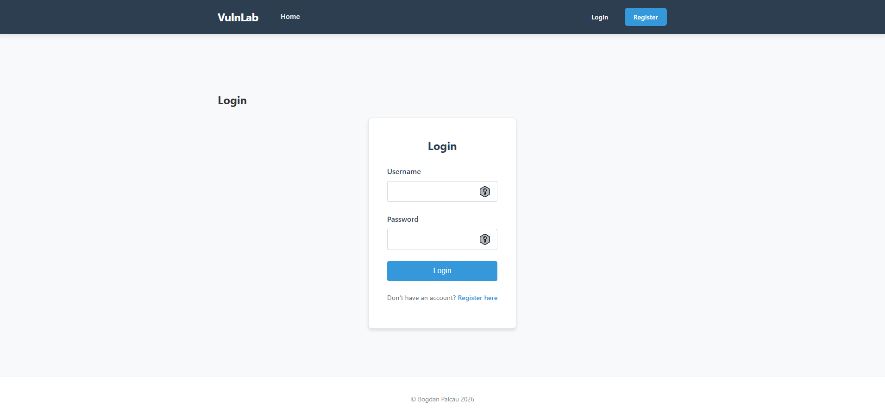
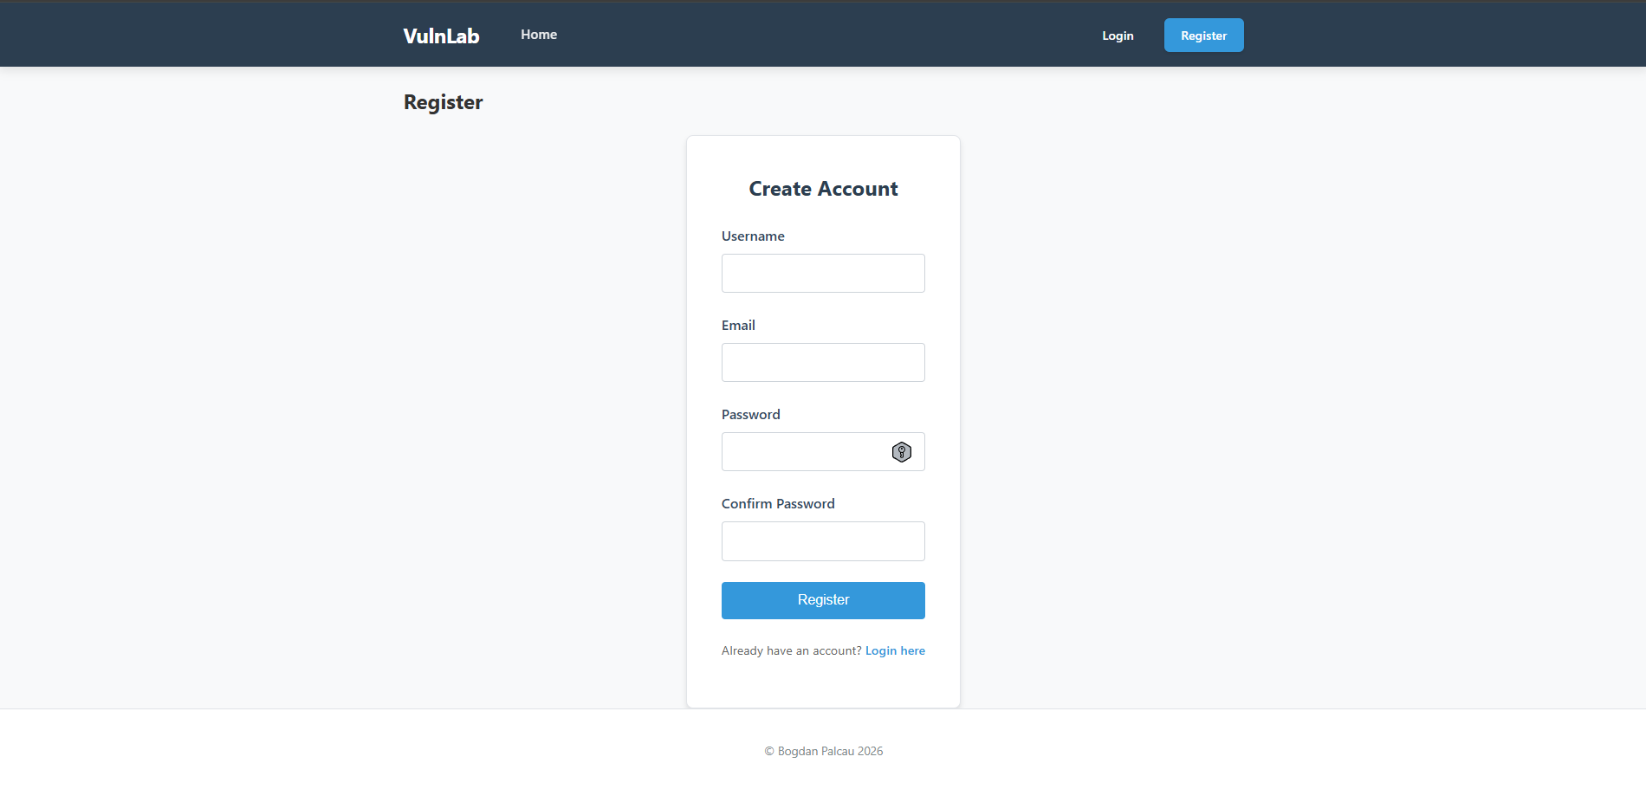
Dashboard and progression tracking + gamification elements
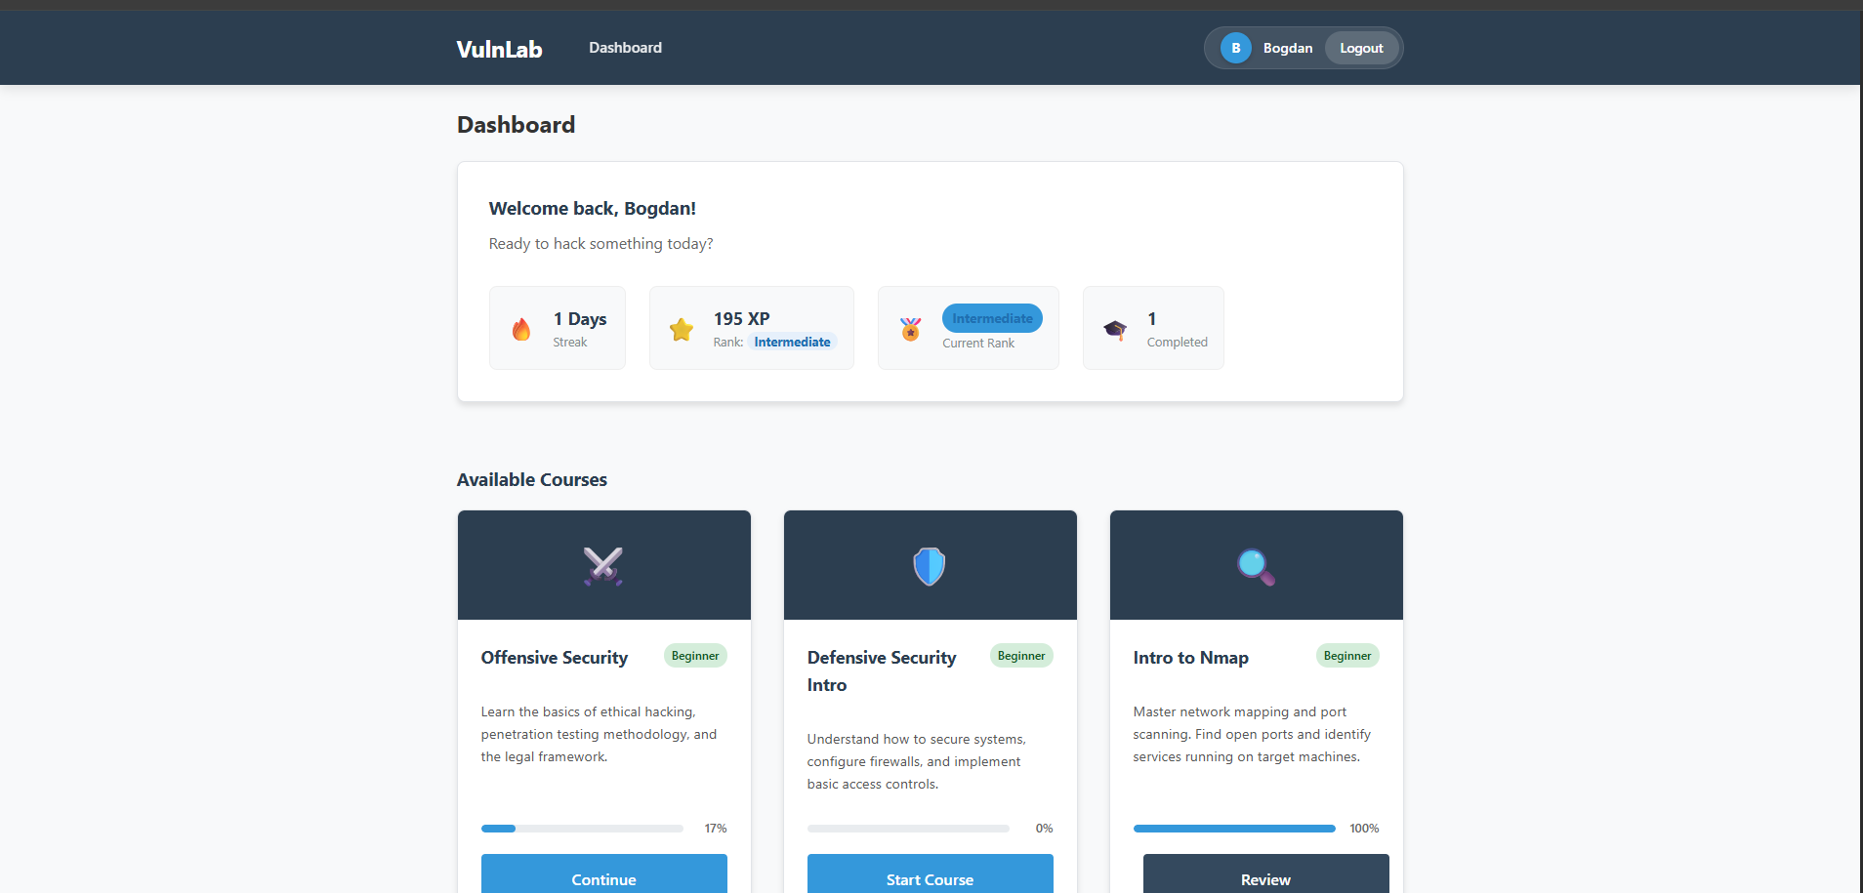
Interactive challenges:
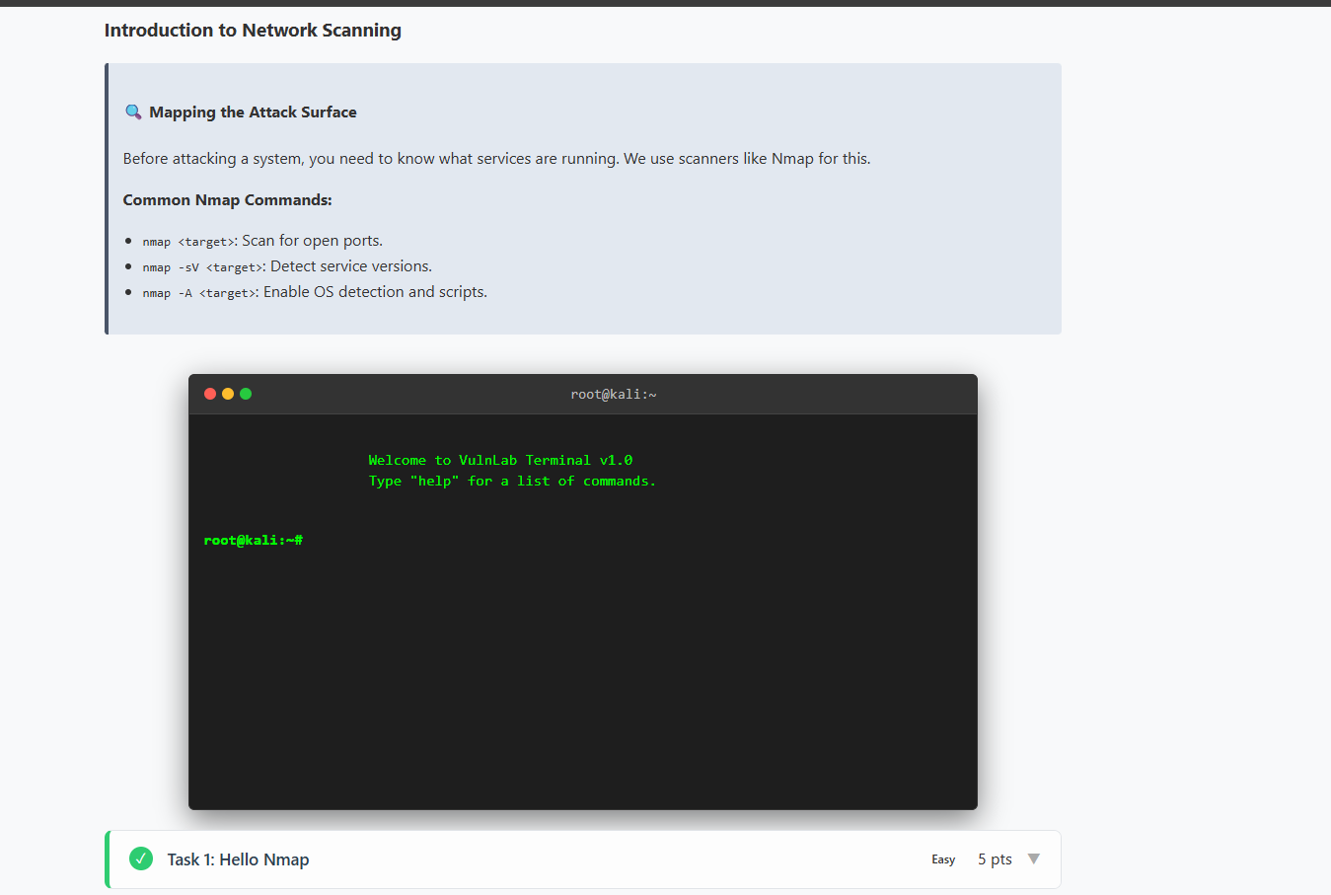
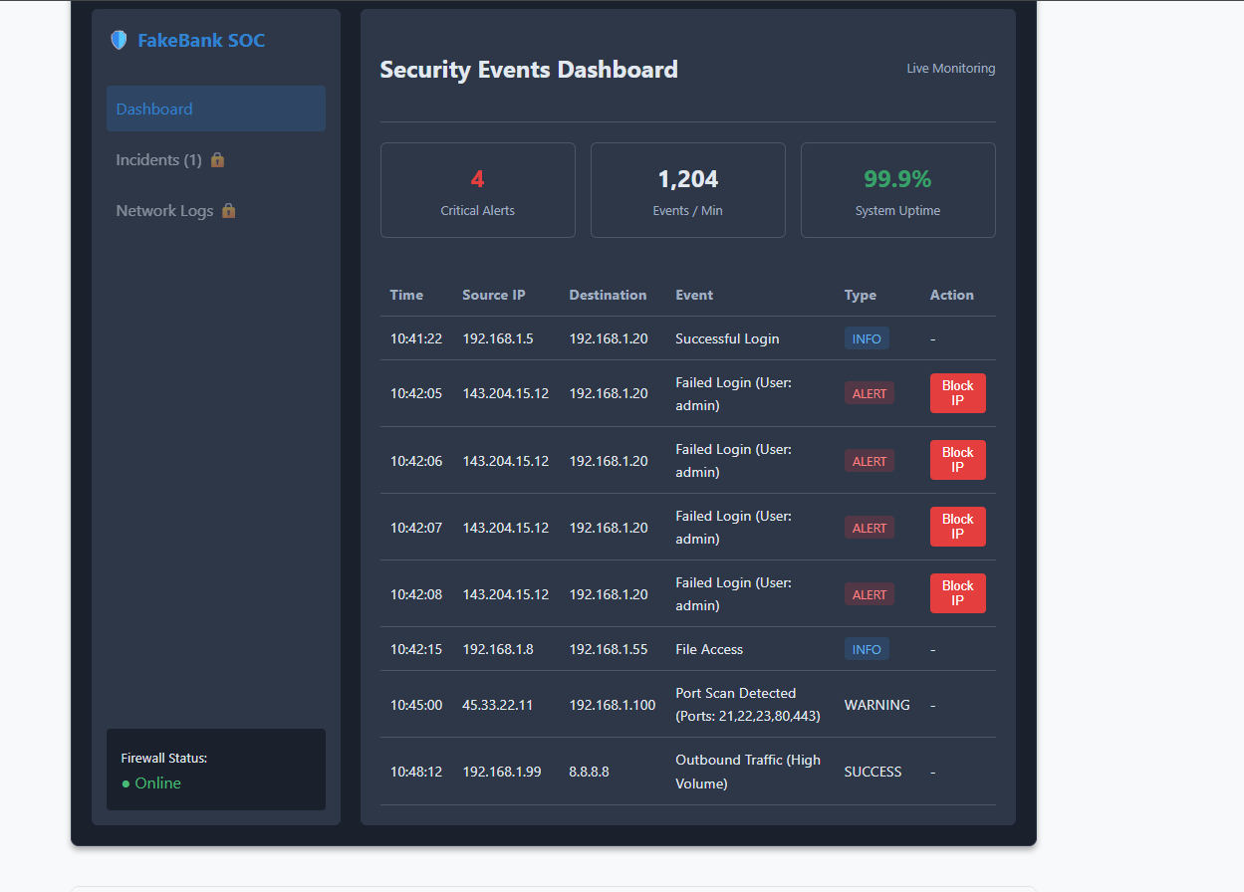
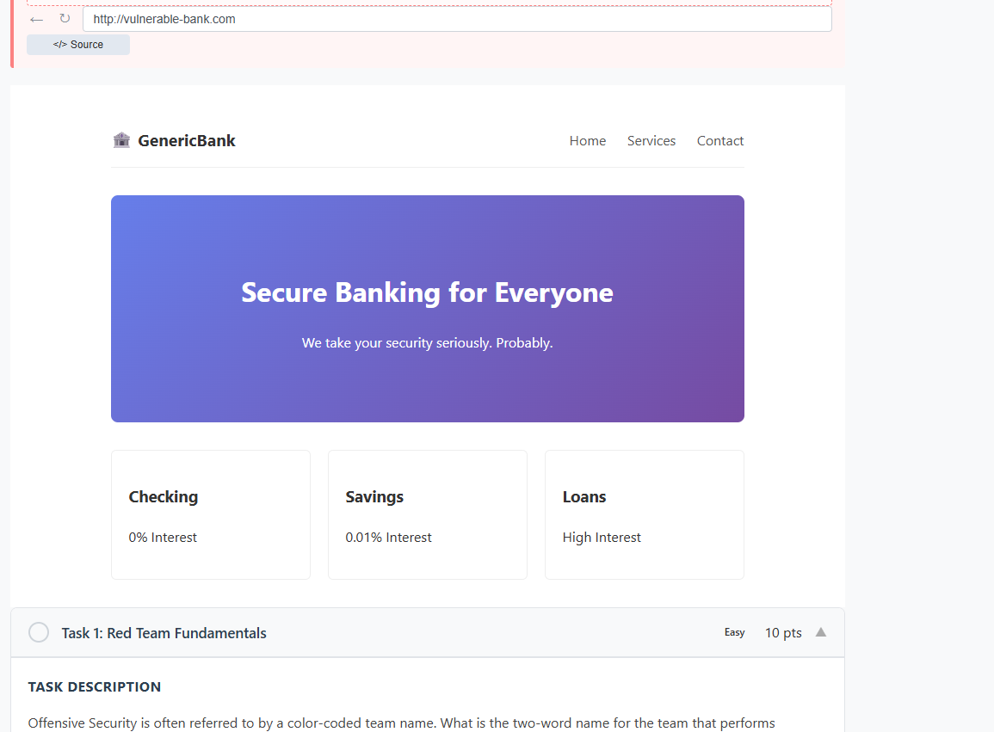
Hint system:
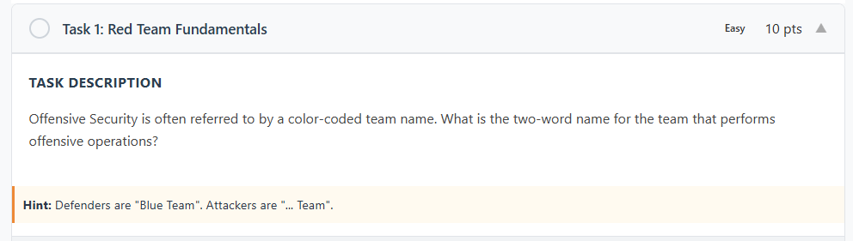
Challenges restricted based on skill level: (it currently says coming soon instead of locked – this will be fixed)
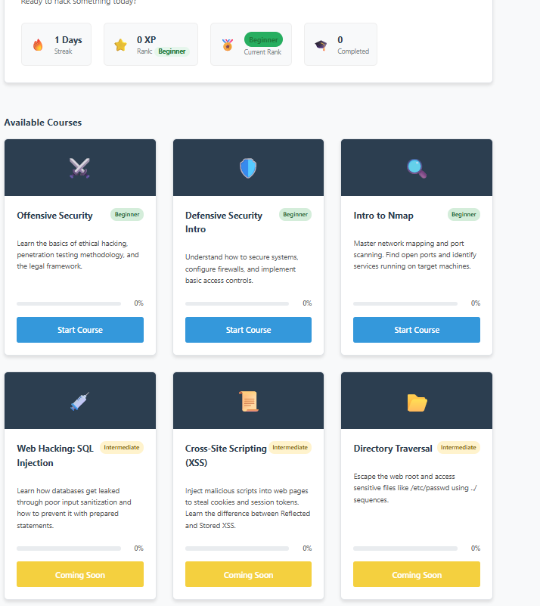
Plan to complete:
- Develop more challenges
- User testing and collection of feedback
- If the user is inactive, streaks could be lost, and the skill level goes down
- The addition of tournaments and competitions for users to show off their skills
- Evaluation of learning effectiveness by using user feedback
- Final system improvements based on the testing carried out

Target audience
The target audience for this platform will be new graduates and beginners who are looking to get into cybersecurity and do not have prior knowledge of the field. These learners require more guided learning to understand the material. This target audience fits my project's goals, as the project was designed to teach people who lack knowledge of the subject and would benefit from interactive learning.
Methodology

The following methodology was selected because SDLC requires continuous testing and improvement of the interactive features. The experimentation will consist of the user-based evaluation (how users find the basic usability + learning effectiveness + competition rates of challenges). An approach that could also be used is a virtualised environment but browser simulation was preferred due to being able to reduce the use of resources, simplify the project and avoid unauthorised access with other real systems.
proposed data collection plan
Data for this project will be collected based on how the users interact with the platform, which will include: challenges completed, user engagement and feedback provided regarding usability and understanding of cyber concepts. The data will be used to see if the platform effectively improves practical understanding of web vulnerabilities and safe coding practices.
proposed design and implementation plan
The project has been made using the Software Development Life Cycle approach. The model was used to help develop the project through clear steps, including research, planning, design, implementation and testing. This approach was chosen because it helps track the progress in an organised manner, and it helps us make sure that each step builds on the previous one.
An iterative development style was also used; parts of the system were first built, then tested and improved on and not everything at once. The approach has been helpful in the development of the challenges and the gamification elements, as adjustments have been made based on how the system behaves when tested.
The choice of technologies used was made based on suitability. As we are building a web solution, PHP and MySQL were selected for the development of the backend due to their strong integration with XAMPP and because they are well-suited for building database-driven web applications. HTML, CSS and JavaScript were also used to create a user-friendly interface in the browser and due to their interactive nature, which could help develop better gamification mechanics.

criteria for success

The platform will be considered successful only if the following requirements are met:

- Users will successfully be able to complete challenges by simply using the instructions provided and the hint system without any additional external help
- XP, streaks and skill levels update correctly
- User feedback is positive, and they find the learning material good and the usability
- The platform successfully loads challenges in the defined 3-second window as mentioned above
- Users' understanding of web vulnerabilities and safe coding practices improves by using the platform

analysis and specification of requirements
Before starting the development, key requirements were identified to make sure the project successfully meets its goal of educating the audience and keeping them retained. As mentioned in the literature review, the system will need a good user authentication system, a way to track progress, interactive challenges and a way to keep users retained (such as streaks or losing skill level for not playing).
For the functional requirements, the user must be able to register, log in, and log out. The user must also be able to access challenges based on their skill level, track their progress, earn rewards such as XP or further their streaks. The system also needs to simulate realistic challenges that can be demonstrated without accidentally performing an illegal action, so JavaScript was used to simulate these rather than an actual system. This choice in architecture helps fill the requirements for security shown below, as it creates a realistic environment that cannot be abused and is compliant with the Computer Misuse Act.
For the non-functional requirements, usability and accessibility in a web browser were deemed important and developed around them. The system currently uses a user-friendly interface that is easy to read and navigate, making it easy for less technical users to use it. Additionally, strict technical constraints were also made to ensure the data remains safe. The password is protected using bcrypt hashing to help be compliant with GDPR and avoid sanctions. A 3-second load time was also defined as a requirement to help avoid user frustration.

Table 1
Below, a table was created to summarise the requirements:
Type of requirement | Description | Justification | Benefits
Functional requirement | The system must provide a simulated CLI for users to execute commands in and practice | This is essential for hands-on learning and helps us achieve the goal of the project | Better retention helps students memorise faster and gain experience
Functional | The system must include user progress, XP, current skill level and daily streaks | This is required to successfully implement the Self-Determination theory mentioned before | Gives students a progression path which leads to satisfaction and retention.
Functional | The website’s flags must be protected from unauthorised access via direct URL access. | It helps create a fair environment where people cannot cheat their way to the top. | Better academic integrity, without it, users could get frustrated.
Non-functional | All passwords must be hashed for security with Bcrypt | This is standard practice to be compliant with GDPR | Avoid compliance sanctions and protect user data
Non-functional | The simulations must be able to load in under 3 seconds | It creates a smooth environment that avoids frustration | Helps avoid frustration

Design
The system was made using a modular design, thanks to the use of PHP, making it easier to expand and manage later. A central layout is used to maintain the same structure within the pages, which means we can make changes in one place and not affect the rest, meaning repetition can be avoided across pages.
The platform has also been divided into separate components such as authentication pages, dashboard, course pages and challenge environments. Each part performs a specific role, which helps keep the code easier to maintain. Also, a database connection file is being used to handle the communication with the database, which helps data to be stored and retrieved more efficiently.
The challenge environments have also been made in separate modules of JavaScript and CSS, allowing for managing the simulations (like terminal, SIEM interface and web exploitation) without interfering with the rest of the system and managing each individually.

implementation
The implementation was done using PHP, MySQL, HTML, CSS and JavaScript and deployed using a local-hosting solution, XAMPP. The system is divided into multiple files, each responsible for a specific function within the project.
The “dashboard.php” page is responsible for showing the user's progress and challenges a user needs to complete to reach the next level and unlock a higher skill level with more challenges. While the gamification features are handled by the “gamification.php” file, where XP, streaks and level progression are handled.
The file called “layout.php” acts as a template for all the pages within the system, making sure we maintain the same structure and design across all the pages within the website. User authentication is done using “login.php”, “register.php” and logout.php, these are linked to the database using db.php. The database (database.sql) stores data, progress, XP, streaks and skill level.
The interactive challenges are made using JavaScript, and several modules have been used for these. For example, “terminal.js” is responsible for the terminal, while “webhack.js” and “siem.js” handle their specific challenges to provide an interactive environment for these. These allow the user to interact with the challenges and provide a fun experience that can help improve retention over time.

proposed test evaluation plan
To start with, the system was tested during the development phase to rule out any bugs or errors and make sure everything is running as expected. The testing included features of my web solution, such as an authentication system, a dashboard, progress tracking, and gamification, to confirm that there aren’t any uncaught errors.
For the main testing phase, functional testing will be done based on:
- User registration, login and logout functionality are working
- Password hashing is in place and it protects user data. We should also be able to protect the session of the user.
- Challenge access restrictions are based on skill level
- XP increases after completing challenges
- Daily streak updates as the user uses the website everyday
- Skill level progression after the required amount of the XP is reached
- Protection of challenges from direct URL access to improve integrity
- Correct loading of simulations under 3-seconds
This testing will be carried out manually and this should confirm the web solution behaves as expected. This will be done on a testing table that will confirm the findings and provide evidence.
User evaluation testing will be made with a small group of volunteers; these should lack expertise in cybersecurity and be new to the subject in order to proper assess the quality of teaching the web solution provides.
The following key points will be measured:
- Completion rate of challenges and time taken to do so
- If hints are effective
- User feedback on user experience and clarity of the content
- If user notice any improvement in understanding the web vulnerabilities
These results wil also be collected in a short feedback form that will be completed by the participants. The results will be shown as a testing table in the final submission.

Professional, social, legal and ethical issues

This project adheres to strict ethical guidelines related to cybersecurity and software development. For starters, the platform only uses simulated environments created with the use of JavaScript and CSS and does not use a real system to avoid legal issues. All challenges run locally within the same website and within the web browser.
From a legal perspective, when looking at the Computer Misuse Act, the project is fully compliant as it does not interact with or exploit any real systems. The data collected is limited to only necessary information such as usernames, progress, XP, password and skill level. This helps follow data minimisation, which is related to GDPR.
Socially, the project's goal is to make sure education in cybersecurity is being made accessible to beginners and professionals of all levels. The project provides a gamified experience that helps improve retention for those looking to get into cybersecurity. On a more professional level, the project follows good software development practices and uses GitHub for version control to make sure it can be restored safely if broken. The projects also safely store user data by making sure all passwords are being hashed.

resource requirements
The project requires XAMPP, HTML, MySQL, HTML, CSS, and JavaScript to be successfully run with all the interactive features. Additionally, the program requires GitHub for version control, so in case an error happens during the development process, it can be rolled back. No additional financial resources are required, as the solution developed does not use any server for virtualisation or require any paid staff to be present. However, it does require a local machine as it needs to be run through XAMPP. Finally, user testing will be done using volunteer participants and only using a web browser.

Gannt chart


outline of final report structure
The dissertation follows this structure:
- Introduction
- Literature review/background
- Aim and objectives
- Methodology
- Design
- Implementation
- Professional, social and legal issues
- Evaluation against objectives
- Resource requirements
- References

References

Chothia, T. and Novakovic, C. (2015). An offline capture the flag-style virtual machine and an assessment of its value for cybersecurity education. In: 3GSE '15: Proceedings of the 2015 USENIX Summit on Gaming, Games, and Gamification in Security Education. [online] Available at: https://research.birmingham.ac.uk/en/publications/an-offline-capture-the-flag-style-virtual-machine-and-an-assessme/ [Accessed: 7 April 2026].
Dicheva, D., Dichev, C., Agre, G. and Angelova, G. (2015). Gamification in education: a systematic mapping study. Educational Technology & Society, 18(3), pp.75–88. Available at: https://eric.ed.gov/?id=EJ1070047 [Accessed: 7 April 2026].
HackTheBox (2024). Hack The Box: Hacking Training for the Best. [online] Available at: https://www.hackthebox.com [Accessed: 7 April 2026].
OWASP (2025). OWASP Top Ten. [online] Available at: https://owasp.org/www-project-top-ten/ [Accessed: 7 April 2026].
Paas, F., Renkl, A. and Sweller, J. (2003). Cognitive load theory and instructional design: recent developments. Educational Psychologist, 38(1), pp.1–4. doi: https://doi.org/10.1207/s15326985ep3801_1
Ryan, R.M. and Deci, E.L. (2000). Self-determination theory and the facilitation of intrinsic motivation, social development, and well-being. American Psychologist, 55(1), pp.68–78. Available at: https://psycnet.apa.org/record/2000-13324-007 [Accessed: 7 April 2026].
Sweller, J. (1988). Cognitive load during problem solving: effects on learning. Cognitive Science, 12(2), pp.257–285. doi: https://doi.org/10.1207/s15516709cog1202_4
TryHackMe (2024). TryHackMe: Cyber Security Training. [online] Available at: https://tryhackme.com [Accessed: 7 April 2026].
UK Government (1990). Computer Misuse Act 1990. [online] London: The Stationery Office. Available at: https://www.legislation.gov.uk/ukpga/1990/18 [Accessed: 7 April 2026].
UK Government (2025). Cyber Security Skills in the UK Labour Market 2025. [online] London: Department for Science, Innovation and Technology. Available at: https://www.gov.uk/government/publications/cyber-security-skills-in-the-uk-labour-market-2025/cyber-security-skills-in-the-uk-labour-market-2025 [Accessed: 7 April 2026].

