DOCUMENTATION

ASSIGNMENT 2

STUDENT NAME: Săvianu Bogdan-Casian
GROUP: 30223

CONTENTS

1. Assignment Objective 3
2. Problem Analysis, Modeling, Scenarios, Use Cases 3
3. Design 3
4. Implementation 5
5. Results 7
6. Conclusions 8
7. Bibliography 8

Assignment Objective
The main objective of this assignment was to implement an application that finds out the shortest average waiting time for the customers in the lines of a supermarket.
The objective was reached by modelling each queue as its own thread working independently from the others and implementing two different strategies for adding the customers to the queues, the shortest time method and the shortest queue one, which is used in case there are multiple queues with the minimum waiting time. Other smaller objectives were logging the events of the simulation in a .txt file and having a dynamic GUI that shows the contents of the queues at all times.

Problem Analysis, Modeling, Scenarios, Use Cases
After careful consideration I modeled my problem as a list of clients and a list of servers, each server containing a queue to which clients are added according to the chosen strategy.
The way a use case would take place is:
-the simulation time reaches the arrival time of a client;
-we find the queue with the shortest waiting time;
-if multiple, we then switch the strategy to the shortest queue one among the one found at the previous step;
-we add the client to the suitable queue and add the sum of the service times of the clients in front of him to the average time;
-after the client’s service time reaches 0, we remove it from the queue;
-we let the simulation finish and then divide the average time by the total number of clients in the simulation and we have our answer.

Design
I started the design by modelling the problem into to Client and Server classes, then I created the strategies to add the clients to servers. In order to select the correct strategy I created the Scheduler class that determines which strategy is to be used and dispatches the given client to the correct method of addition to the queue.
After these steps were done I was able to implement the SimulationManager class and test everything up to this point. Then, the next thing I did was implement a way to write the events in a .txt file.
Once all things worked fine it was time for the GUI. I have two different GUI classes, one is the one where I add the details of the simulation, such as the time limit, processing times, etc. The other is for displaying the content of the queues at the current time.
At the end, I created another class responsible for calculating the average waiting/service times and the peak hour and I display those at the end of the simulation.

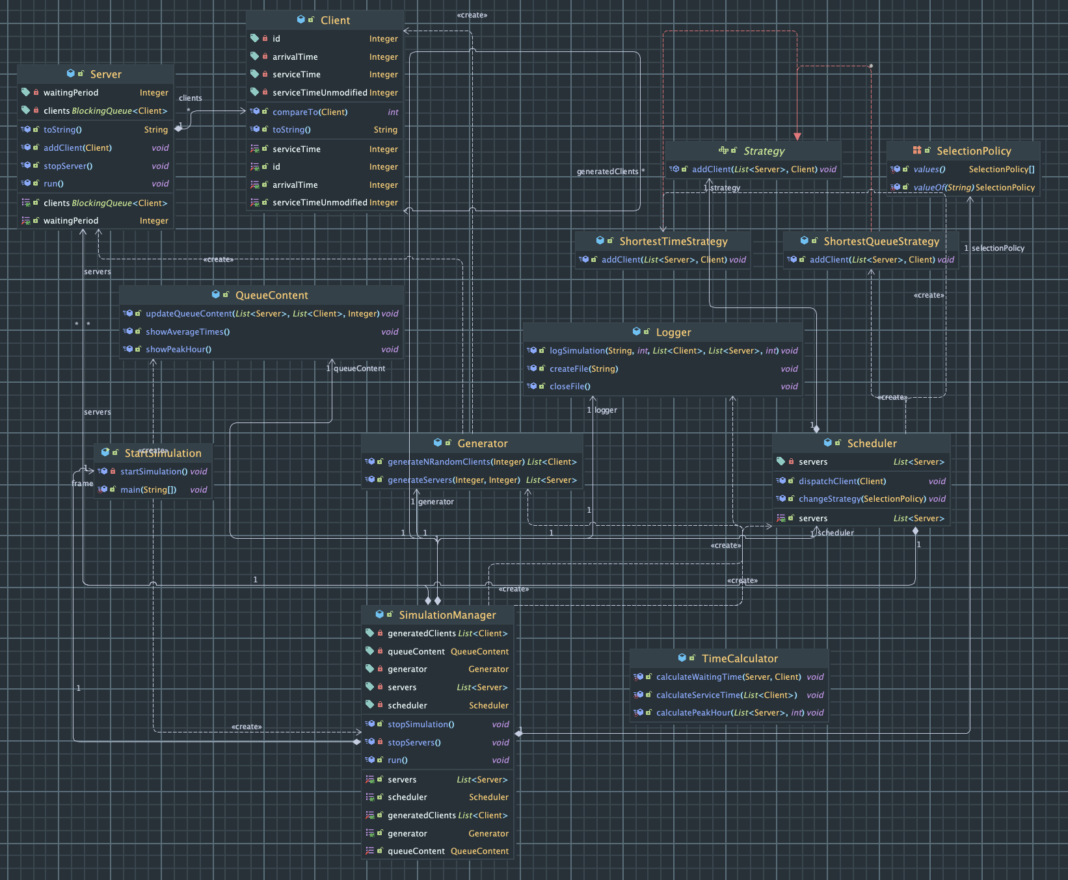

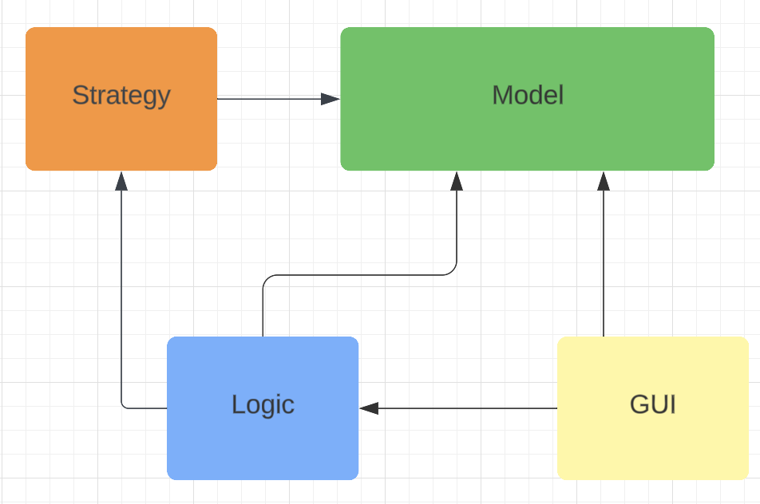

Implementation
Client - three fields: id, arrivalTime, serviceTime;
Server – BlockingQueue<Client>, Integer waitingPeriod, bool isRunning;
- has a method addClient and the run method where it decreases the service time of the leading client and removes him when the time reaches 0;
Generator – generates the random clients and the necessary servers;
Strategy interface – abstract method addClient;
ShortestTime/QueueStrategy – implement the addClient method from the interface accordingly
SelectionPolicy – enum used to choose the strategy;
Scheduler – chooses the appropriate strategy and dispatches the clients;
TimeCalculator – calculates the average waiting and service times and the peak hour;
Logger – writes the events to a file
SimulationManager – stores information about the clients and queues at all times
- is used by the logger and the GUI to get their information
StartSimulation – this is the GUI class where the information is entered and then sent to the
SimulationManager to do its job.
QueueContent – shows the contents of the queues and updates the interface at each interval of time.
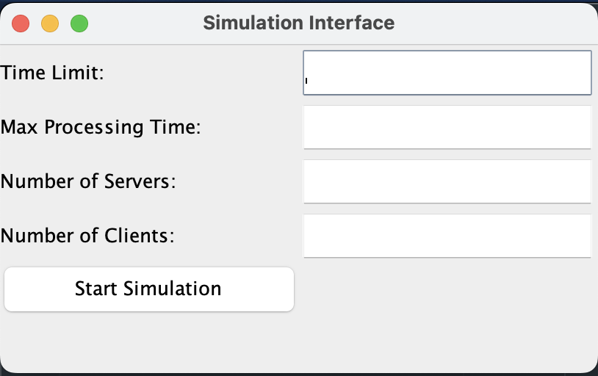

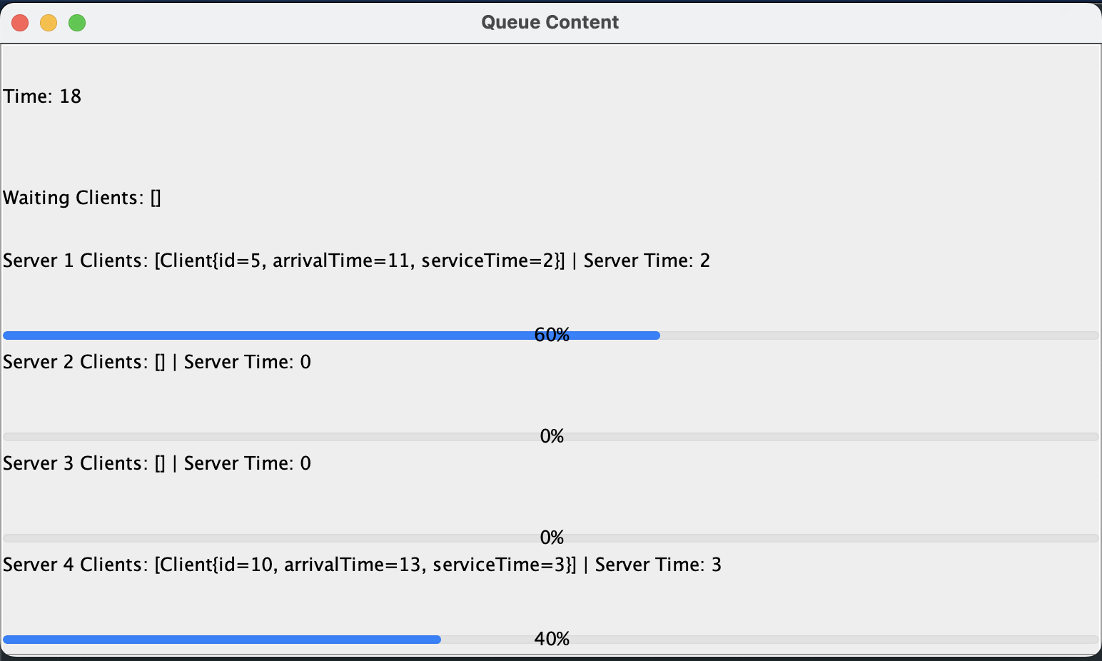

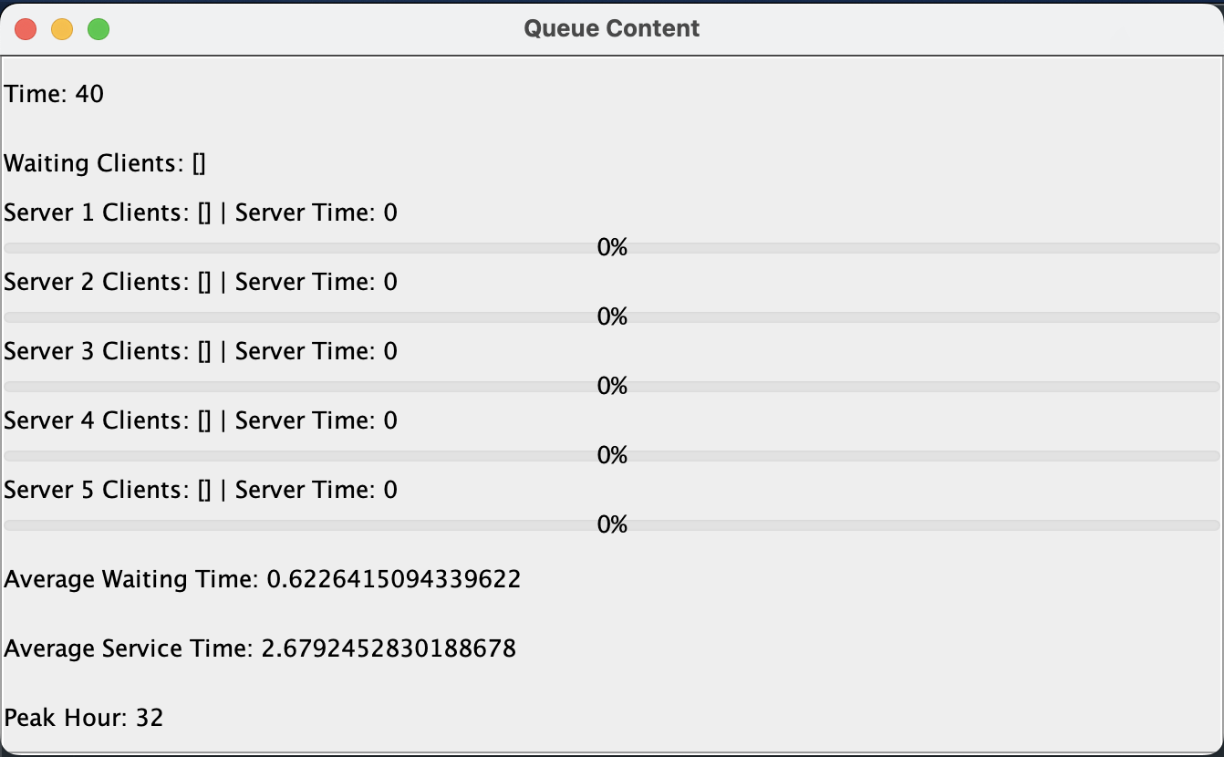

This last one is at the end when the simulation is finished. It shows the average waiting/service times and the peak hour.

Results

I tested my application with the suggested tests and a lot of tests of my own and it behaves as expected.

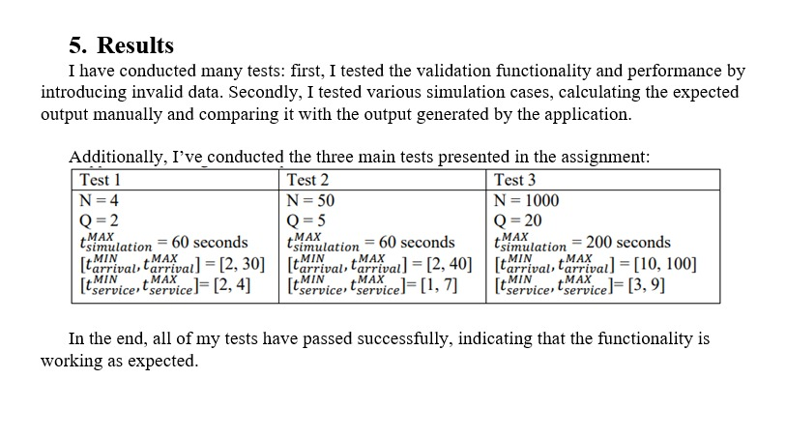

Conclusions
The most important conclusion I gathered from working on this assignment is that working
with threads is harder than a lot of people would think and there are so many things that could go wrong. Also when getting unexpected behavior it is harder to find the cause because of the parallelism.
All in all, this assignment helped me deepen my understanding of threads by a lot. In the future I would like to add a functionality where a server breaks randomly and all its clients have to be dispatched to the other remaining servers.

Bibliography
https://dsrl.eu/courses/pt/
https://www.geeksforgeeks.org/scheduledexecutorservice-interface-in-java/
https://docs.oracle.com/javase/8/docs/api/java/lang/Thread.html

