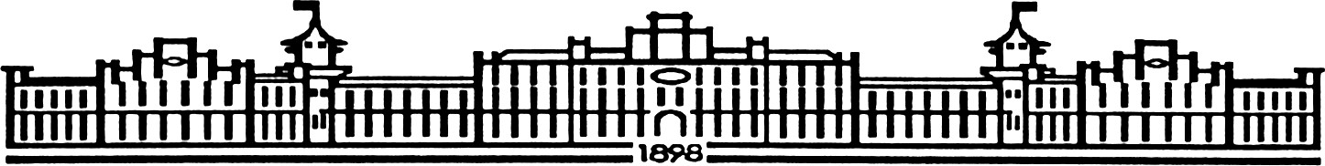

МІНІСТЕРСТВО ОСВІТИ І НАУКИ УКРАЇНИ НАЦІОНАЛЬНИЙ ТЕХНІЧНИЙ УНІВЕРСИТЕТ УКРАЇНИ “КИЇВСЬКИЙ ПОЛІТЕХНІЧНИЙ ІНСТИТУТ

імені ІГОРЯ СІКОРСЬКОГО”

Факультет прикладної математики

Кафедра програмного забезпечення комп’ютерних систем

Лабораторна робота № 6

з дисципліни “Імпорт тривимірних моделей у середовище програмування java 3D, обробка та маніпуляція цих зображень.”

Виконав

студент III курсу групи КП-81

Шапошник Богдан Ігорович

(*прізвище, ім’я, по батькові*)

варіант № 20

Зарахована “ ” “ ” 20 р.

викладачем

Шкурат Оксаною Сергіївною

(*прізвище, ім’я, по батькові*)

Київ 2021

# Варіант завдання

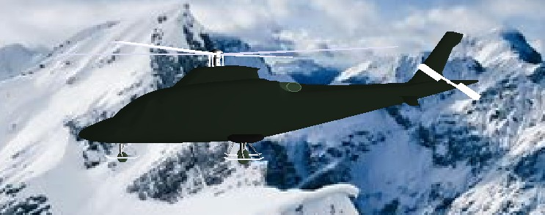**Варіант: 20** гелікоптер **Результат:**

# Лістинг коду програми

package sample;

import javax.vecmath.*;

import com.sun.j3d.utils.universe.*; import javax.media.j3d.*;

import com.sun.j3d.utils.behaviors.vp.*; import com.sun.j3d.utils.image.TextureLoader; import javax.swing.JFrame;

import com.sun.j3d.loaders.*;

import com.sun.j3d.loaders.objectfile.*;

import java.awt.*;

//

public class Main extends JFrame

{

private final String helicopterPath = "helicopter.obj"; private final String backgroundPath = "bg.jpg";

public Canvas3D myCanvas3D;

public Main()

{

this.setDefaultCloseOperation(JFrame.EXIT_ON_CLOSE);

myCanvas3D = new Canvas3D(SimpleUniverse.getPreferredConfiguration()); SimpleUniverse simpUniv = new SimpleUniverse(myCanvas3D); simpUniv.getViewingPlatform().setNominalViewingTransform(); createSceneGraph(simpUniv);

addLight(simpUniv);

OrbitBehavior ob = new OrbitBehavior(myCanvas3D); ob.setSchedulingBounds(new BoundingSphere(new

Point3d(0.0,0.0,0.0),Double.MAX_VALUE));

simpUniv.getViewingPlatform().setViewPlatformBehavior(ob);

setTitle("Helicopter"); setSize(948,604);

getContentPane().add("Center", myCanvas3D); setVisible(true);

}

public void createSceneGraph(SimpleUniverse su)

{

BranchGroup theScene = new BranchGroup();

Background background = new Background(new TextureLoader(backgroundPath, myCanvas3D).getImage());

background.setImageScaleMode(Background.SCALE_FIT_MAX); background.setApplicationBounds(new BoundingSphere(new Point3d(0, 0, 0),

Double.MAX_VALUE));

background.setCapability(Background.ALLOW_IMAGE_WRITE); theScene.addChild(background);

Scene helicopter = null; try

{

ObjectFile f = new ObjectFile(ObjectFile.RESIZE); f.setBasePath("D:/maokg/lab6");

helicopter = f.load("helicopter.obj");

}

catch (Exception e)

{

System.out.println("File loading failed:" + e);

}

Transform3D scaling = new Transform3D(); scaling.setScale(1.0/2);

Transform3D helicopterTransform = new Transform3D(); helicopterTransform.rotY(Math.PI*2); helicopterTransform.mul(scaling);

TransformGroup helicopterTransformGroup = new TransformGroup(helicopterTransform);

TransformGroup sceneGroup = new TransformGroup();

assert helicopter != null;

BranchGroup helicopterSceneGroup = helicopter.getSceneGroup(); helicopter.getNamedObjects().forEach((key, value) -> System.out.println(key + "

: " + value));

helicopterSceneGroup.removeChild((Shape3D)helicopter.getNamedObjects().get("cylinder.0 03_cylinder.004"));

helicopterSceneGroup.removeChild((Shape3D)helicopter.getNamedObjects().get("cylinder.0 04_cylinder.005"));

helicopterSceneGroup.removeChild((Shape3D)helicopter.getNamedObjects().get("cylinder.0 02"));

sceneGroup.addChild(helicopter.getSceneGroup());

sceneGroup.setCapability(TransformGroup.ALLOW_TRANSFORM_WRITE); helicopterTransformGroup.addChild(sceneGroup); theScene.addChild(helicopterTransformGroup);

Shape3D mainBody = (Shape3D) helicopter.getNamedObjects().get("cube"); setAppearance(new Color(15, 20, 15), mainBody);

Shape3D decal = (Shape3D) helicopter.getNamedObjects().get("cylinder"); setAppearance(new Color(30, 40, 30), decal);

Shape3D glass1 = (Shape3D) helicopter.getNamedObjects().get("cube.006_cube.007");

setAppearance(new Color(180, 180, 200), glass1);

Shape3D glass2 = (Shape3D) helicopter.getNamedObjects().get("cube.007_cube.008");

setAppearance(new Color(180, 180, 200), glass2);

Shape3D glass3 = (Shape3D) helicopter.getNamedObjects().get("cylinder.004_cylinder.005");

setAppearance(new Color(180, 180, 200), glass3);

Shape3D smallPropeller = (Shape3D) helicopter.getNamedObjects().get("cylinder.002");

setAppearance(new Color(180, 180, 200), smallPropeller);

Shape3D bigPropeller = (Shape3D) helicopter.getNamedObjects().get("cylinder.003_cylinder.004");

setAppearance(new Color(180, 180, 200), bigPropeller);

Shape3D otherParts = (Shape3D) helicopter.getNamedObjects().get("cube.001_cube.002");

setAppearance(new Color(15, 20, 15), otherParts);

Shape3D anotherParts = (Shape3D) helicopter.getNamedObjects().get("torus"); setAppearance(new Color(30, 40, 30), anotherParts);

Shape3D rocketHeadings = (Shape3D) helicopter.getNamedObjects().get("cube.004_cube.005");

setAppearance(new Color(10, 10, 10), rocketHeadings);

Shape3D rockets = (Shape3D) helicopter.getNamedObjects().get("torus.001"); setAppearance(new Color(30, 40, 30), rockets);

Transform3D transformForBigPropeller = new Transform3D(); transformForBigPropeller.setTranslation(new Vector3f(-0.22f, 0, 0));

helicopterSceneGroup.addChild(applyRotationForShape( (Shape3D)helicopter.getNamedObjects().get("cylinder.003_cylinder.004"), transformForBigPropeller,

1000

));

helicopterSceneGroup.addChild(applyRotationForShape( (Shape3D)helicopter.getNamedObjects().get("cylinder.004_cylinder.005"), transformForBigPropeller,

1000

));

Transform3D transformForSmallPropeller = new Transform3D(); transformForSmallPropeller.rotX(Math.PI/2); transformForSmallPropeller.setTranslation(new Vector3f(0.85f, 0.068f, 0));

helicopterSceneGroup.addChild(applyRotationForShape( (Shape3D)helicopter.getNamedObjects().get("cylinder.002"), transformForSmallPropeller,

500

));

Transform3D transformMove = new Transform3D(); transformMove.rotY(Math.PI);

Alpha crawlAlpha = new Alpha(

1, Alpha.INCREASING_ENABLE,0,0, 7000,0,0,0,0,0

);

PositionInterpolator positionInterpolator = new PositionInterpolator( crawlAlpha, sceneGroup, transformMove, -9.0f, 6.5f

);

BoundingSphere bs = new BoundingSphere(new Point3d(0,0,-600), Double.MAX_VALUE);

positionInterpolator.setSchedulingBounds(bs); sceneGroup.addChild(positionInterpolator);

//com theScene.compile();

su.addBranchGraph(theScene);

}

//com

private void setAppearance(Color color, Shape3D shape) { Appearance app = new Appearance();

Color3f color3f = new Color3f(color);

app.setMaterial(new Material(color3f, color3f, color3f, color3f, 150.0f)); shape.setAppearance(app);

}

//com

private Node applyRotationForShape(Shape3D shape, Transform3D transform, int rotateDuration) {

TransformGroup transformGroup = new TransformGroup(); transformGroup.addChild(shape.cloneTree());

Alpha alpha = new Alpha(Integer.MAX_VALUE, Alpha.INCREASING_ENABLE,0,0, rotateDuration,

0,0,0, 0,0);

RotationInterpolator rotationInterpolator = new RotationInterpolator(alpha, transformGroup,

transform, (float) Math.PI * 2, 0.0f);

BoundingSphere bound = new BoundingSphere(new Point3d(), Double.MAX_VALUE); rotationInterpolator.setSchedulingBounds(bound);

transformGroup.setCapability(TransformGroup.ALLOW_TRANSFORM_WRITE); transformGroup.addChild(rotationInterpolator);

return transformGroup;

}

public void addLight(SimpleUniverse su)

{

BranchGroup bgLight = new BranchGroup();

BoundingSphere bounds = new BoundingSphere(new Point3d(0.0,0.0,0.0), 100.0); Color3f lightColour1 = new Color3f(1.0f,1.0f,1.0f);

Vector3f lightDir1 = new Vector3f(-1.0f,0.0f,-0.5f);

DirectionalLight light1 = new DirectionalLight(lightColour1, lightDir1);

light1.setInfluencingBounds(bounds);

bgLight.addChild(light1); su.addBranchGraph(bgLight);

}

public static void main(String[] args)

{

Main helicopter = new Main();

}

}