**Galaxy Impact**

Bogdan Teodorov

**Summary**

"Galaxy Impact" is an immersive 2D space shooter designed for PC gaming enthusiasts, offering a nostalgic nod to classic arcade titles while introducing a fresh and visually captivating experience. Players take command and navigate through a beautifully rendered galactic landscape filled with intense, retro-inspired space battles. The game seamlessly combines classic 8-bit graphics with the beloved gameplay mechanics of classic 2D shooters, creating a thrilling and accessible gaming experience.

As players progress, they encounter waves of enemy spacecraft and formidable boss challenges, each demanding a unique combination of reflexes and strategic decision-making. "Galaxy Impact" boasts an array of upgradable weapons and unlockable abilities, allowing players to tailor their spacecraft to their preferred playstyle. The game's engaging narrative unfolds as players explore the mysteries of the galaxy, providing an added layer of depth to the action-packed gameplay.

**Overview**

"Galaxy Impact" is a thrilling 2D space shooter game designed for PC, immersing players in a visually stunning intergalactic adventure. Set against the backdrop of a vast and mesmerizing galaxy, players pilot customizable spaceships through challenging levels, engaging in intense battles against waves of enemy spacecraft and colossal boss encounters. The gameplay is inspired by classic arcade to recreate a nostalgic yet innovative experience and vibe.

Players embark on a quest to uncover the mysteries of the galaxy, facing numerous obstacles, upgrading their ships with powerful weapons, and confronting intelligent adversaries. The narrative unfolds gradually, providing a sense of purpose and depth to the fast-paced action.

**The Quest**

The main quest in "Galaxy Impact" involves players navigating through various levels of increasing difficulty, each presenting unique challenges and enemies. Obstacles range from swarms of enemy spacecraft to formidable boss encounters, testing players' reflexes and strategic thinking. To progress, players must upgrade their ships, unlock new abilities, and strategically utilize power-ups. The final objective is to uncover the secrets of the galaxy, with each level contributing to the overarching narrative. The game is broken into levels, offering a structured yet progressively challenging gameplay experience.

**Main Character**

The main character is a skilled space pilot, who is eager to discover various mysteries hidden within the galaxy. Piloting a spacecraft, player navigates through the galaxy, facing adversaries and upgrading its ship as he/she progresses. The main character's abilities evolve with gameplay, unlocking new weapons, defensive capabilities, and special maneuvers.

**Sketch of Main Character**

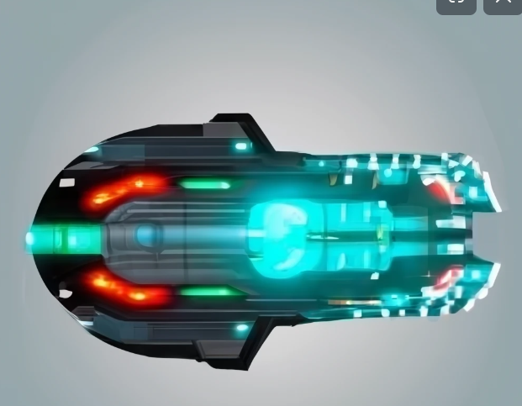

Armed to the teeth, the spaceship is equipped with an array of energy weapons, missiles, and defensive systems. Each weapon has its unique visual signature, from laser beams slicing through the void to explosive missiles creating vibrant bursts of color. As player progresses, he/she can unlock and upgrade these weapons to be able to surpass any challenges standing on the way to discover secrets of galaxy .

**Opponents**

Opponents in "Galaxy Impact" vary in intelligence and tactics. Enemy spacecraft exhibit diverse attack patterns, utilizing evasive maneuvers, formations, and strategic retreats. Boss encounters present formidable challenges, requiring players to adapt their strategies.

**Sketch of Opponents**

Regular enemies will be small, nimble spaceships with a sleek design armored with laser guns or heavy weaponry depending on the type of enemy. Some of them will have non linary pattern to make them challenging targets.

Bosses will look like large and heavily armored battleships with imposing presence. Multiple weapon emplacements, including heavy lasers and missile launchers. Some of them will be able to summon support ships to make battle more fascinating.

**Environment**

The game is set in a visually captivating galactic environment, featuring vibrant nebulae, asteroid fields, and cosmic phenomena. Each level offers a unique backdrop, from outer space battles to futuristic urban landscapes. The dynamic environment enhances the overall gaming experience, providing a sense of scale and diversity.

**Menus**

The initial menu screen of "Galaxy Impact" is designed for seamless navigation, providing players with quick access to key features:

**Start:** Launches the game and immerses players into the heart of the galactic action. From here, they embark on their quest, facing waves of opponents, and progressing through captivating levels.

**Load Level:** Allows players to resume their progress by loading their most recent game state. This feature ensures continuity, enabling players to pick up where they left off in their intergalactic journey.

**High Score:** Displays the leaderboard showcasing the top scores achieved by players. Compete with friends and the global gaming community to secure a place among the galaxy's elite pilots. Regular updates keep the competition fresh and exciting.

Each option is accompanied by an intuitive interface, enhancing the overall user experience and ensuring that players can effortlessly navigate through the menu to dive back into the thrilling world of "Galaxy Impact."

**Controls**

The game interface includes intuitive controls, allowing players to navigate their ships with precision. Controls include directional movement using standard keys for moving, mouse button for shooting, and extra keys for the activation of special abilities. The interface is designed for simplicity, providing a smooth and responsive gaming experience.

**Sounds**

"Galaxy Impact" features a dynamic soundtrack that complements the fast-paced gameplay, with music intensifying during action sequences and relaxing during exploration. Background sounds include the hum of the spacecraft, laser blasts, and the ambient noises of the galactic environment. The immersive sound design enhances the overall atmosphere and engagement.

**Sales Pitch**

Embark on an epic intergalactic journey with "Galaxy Impact," a 2D space shooter designed for PC gaming enthusiasts seeking a nostalgic yet innovative experience. Immerse yourself in the captivating world of retro-inspired space battles, seamlessly blending classic 8-bit graphics with modern gameplay mechanics. As a skilled space pilot, customize your spacecraft, upgrade your arsenal, and navigate through visually stunning galactic landscapes filled with intense challenges and formidable adversaries.

Uncover the mysteries of the galaxy as you progress through levels of increasing difficulty, facing swarms of nimble enemy spacecraft and engaging in colossal boss battles. Adapt your strategies, unlock new weapons, and strategically utilize power-ups to overcome obstacles and reveal the secrets hidden within the vast cosmic expanse.

The main character, a skilled space pilot eager to explore the unknown, evolves with gameplay, unlocking unique weapons and special maneuvers. Arm your spaceship with a variety of energy weapons and missiles, each with its own visually striking signature. As you progress, unleash the full potential of your spacecraft, surpassing challenges and becoming a true galactic force.

Challenge your reflexes and strategic thinking against opponents with varying intelligence and tactics. Regular enemies, small and nimble, exhibit diverse attack patterns, while bosses present formidable challenges with their imposing presence and intricate attack strategies. The dynamic galactic environment, featuring vibrant nebulae and cosmic phenomena, enhances the overall gaming experience, providing a sense of scale and diversity.

Dive into the heart of the action with seamless navigation through an intuitive menu. Start your quest, resume your progress, and compete for a place among the galaxy's elite pilots on the global leaderboard. The controls, designed for precision and responsiveness, ensure a smooth gaming experience, while the dynamic soundtrack and immersive sound design enhance the atmosphere, making "Galaxy Impact" an unforgettable gaming adventure.

"Galaxy Impact" is not just a game; it's a thrilling odyssey through space, a fusion of classic arcade charm and modern gaming excitement. Join the quest, embrace the challenge, and become the master of the galaxy. Are you ready to make an impact? Buy "Galaxy Impact" now and embark on an unforgettable journey through the stars!