# TQA_ChatGPT Activity Package Version 1.0.0-alpha.4

*Author : Bogdan Todic  
Tquila Automation LTD  
March 2023*

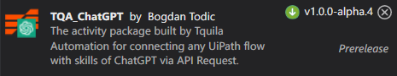

1. Get ChatGPT Response Activity  
  
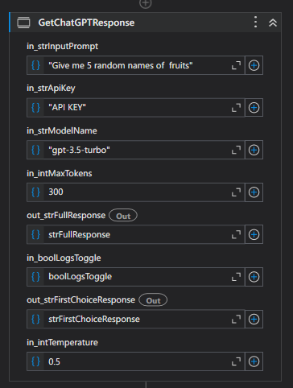

This library activity uses the UiPath Invoke Code activity to call the OpenAI GPT-3.5 model API with input parameters including the prompt, model name, maximum tokens, and API key. The workflow validates input parameters and logs relevant information using the Log Message activity. It catches exceptions and throws error messages with the relevant information if there is an error in the API call or JSON parsing.

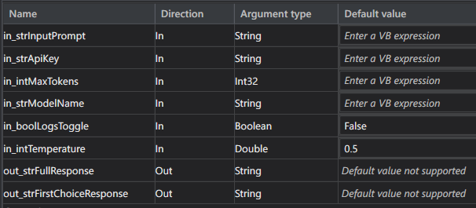

Input Parameters:

In_strInputPrompt (string) - The text prompt for the GPT-3.5 model to generate output from.

In_strApiKey (string) - The API key for the OpenAI API, which is required for authentication and authorization.

In_strModelName (string) - The name of the GPT model to use for generating output.

In_intMaxTokens (int32) - The maximum number of tokens to generate in the model output.

In_boolLogsToggle (Boolean) – True to enable trace logs, false to disable them.

In_intTemperature (Double) - What sampling temperature to use with GPT, between 0 and 2. Higher values like 0.8 will make the output more random, while lower values like 0.2 will make it more focused and deterministic.

Output Parameters:

Out_strFullResponse: The generated text response from the GPT-3.5 model In Json format.

Out_strFirstChoiceResponse : Answer from GPT extracted from the full response in string format.   
  
Output Logs: (input prompt example: "Give me 5 random names of fruits")

