Junior Front-End Developer

Bogdan Zafiescu

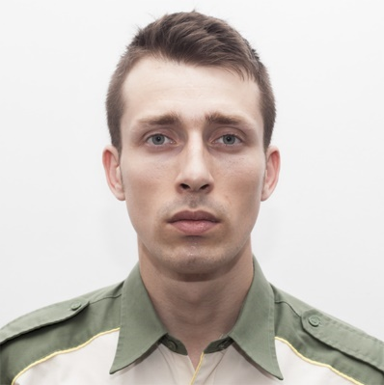

**As a dedicated learner who has now become a Junior Frontend Developer, I have developed a genuine passion for coding and the art of crafting captivating websites. My journey started with a strong desire to understand web development, and through continuous learning and practical experience, I've grown into a budding professional in this field. I specialize in creating user-friendly and visually appealing websites, and my main goal is to make a positive impact on users' web experiences. I'm excited about embracing new challenges and opportunities as I continue to grow and excel in this ever-evolving industry.**

+40 799 375 358

<https://bogdanzafiescu.github.io/Portfolio/>

BogdanZafiescu@outlook.com

* Completed fundamental course in Java
* Basic knowledge of C
* Competent in using Windows operating system
* Familiarity with virtualization technologies (VMWare, Virtual Box)
* Familiarity with remote desktop technologies
* Hardware knowledge
* Web development using HTML, CSS, and JavaScript
* Experience with responsive design
* Fundamental knowledge of jQuery
* Familiarity with Google Maps API, including markers and information windows
* Basic understanding of Bootstrap 5
* Familiarity with HTTP requests and AJAX data transfer
* Basic knowledge of Photoshop and GIMP

Web Skills

Linux skills

* Completed fundamental course in Linux(ubuntu)
* Experience with Linux command line
* Basic Linux system administration, networking and security.
* Fundamental knowledge of FTP and HTTP/HTTPS server and client
* Experience with other Linux distros (Debian, Manjiro and Fedora)

**1**

Additional technical skills

Personal Profile

Education and Training

**Technical:**

* Codecademy certificate of completion: Learn CSS Course (2022)
* Codecademy certificate of completion: Learn HTML Course (2022)
* Bit Academy certificate of completion: Frontend Web Development – HTML & CSS (2022)
* Bit Academy certificate of completion: Frontend Web Development JavaScript (2022)
* Bit Academy certificate of completion: Java Programming Fundamentals (2019)
* Cisco Networking Academy certificate of completion: NDG Linux Unhatched (2021)
* Linked In Learning certificate of completion: Learning Java (2019)

**Other:**

* 2009 - 2010 Romanian Aviation Academy, Flight Attendant Certificate & license
* 1999 - 2003 Henri Coanda Technical College of Aeronautics, Highschool Diploma, Baccalaureate Diploma
* 2003 - Machine Repair and Maintenance Certificate

Work Experience

**Quality Control for Apple @ Syncreon, Tilburg, Netherlands 2020 - 2021**

* Conducted thorough quality control checks on Apple products to ensure they met the company's standards.
* Inspected products for scratches, dents, and other damage, and ensured that they were clean and functional.

**Quality Control @ Intrarom, Romania, Bucharest 2019-2020**

* Conducting various tests on Fixed Wireless Access devices
* Monitoring results and recording any failures or errors

**Lift Operator && Ticket Checker @Killington Pico Ski Resort, Vermont, USA 2018 - 2019**

* Ensured the safety and enjoyment of guests by maintaining lift operations and verifying tickets.

**Cosmetics Sales Specialist**

**@ Soap and Co, London, United Kingdom, 2017 – 2018 &&**

**Sakare Cosmetics, Berlin, Germany 2016 – 2017**

* Provided exceptional customer service, personalized product recommendations, and exceeded sales targets using ethical practices.

**2**

More Experience

**Assistant Waiter @ Carnival Cruise Lines, Miami, Florida, USA**

**2013 - 2016**

* Assisted in restaurant food service aboard Carnival cruise ships, ensuring excellent customer experience.

**Junior Dental Technician @ Dent Total, Romania, Bucuresti**

**2008 - 2009**

* Assisted in the fabrication of dental prosthetics and maintained laboratory equipment.

**Junior Video Editor @ Multi Media Est SRL, Bucharest, Romania**

**2006 - 2008**

* Received tapes and copied them using various media equipment.
* Made necessary modifications as requested by directors and transferred final products to digital disks or uploaded to FTP servers.

**IT Technician @ Victor PC Repair, Bucharest, Romania 2004 - 2006**

* Performed maintenance on PCs and replaced parts such as motherboards, processors, etc.
* Cleaned and optimized computer performance.
* Installed software and operating systems for clients.
* Assisted clients in building their home networks and connecting to neighboring networks.
* Changed cartridges and installed printers.
* Configured clients' firewalls and provided technical advice on security best practices.

Languages

Hobbies

**IT,**

**DIY,  
Hiking,**

**Group Activities,**

**Coffee**

**English**: B2

**French**: A2

**Italian**: A1

**3**