Приклад. Голосування за допомогою радіо кнопок

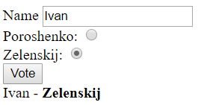

<!DOCTYPE html>

<html lang="en">

<head>

<meta charset="UTF-8">

<meta name="viewport" content="width=device-width, initial-scale=1.0">

<meta http-equiv="X-UA-Compatible" content="ie=edge">

<title>Document</title>

<script>

function vote() {

const div = document.getElementsByTagName("div")[0]

const userName = document.getElementById("userName").value

if (document.getElementById("Pr").checked)

div.innerText = `${userName} - <b> Poroshenko </b>`

else

div.innerHTML = `${userName} - <b> Zelenskij</b>`

}

window.onload = function () {

document.querySelector("button").onclick = vote

}

</script>

</head>

<body>

<label>

Name

<input type="text" id="userName" placeholder="Type your name here">

</label> <br>

<label>

Poroshenko:

<input type="radio" name="president" id="Pr">

</label><br>

<label>

Zelenskij:

<input type="radio" name="president" id="Zl" checked>

</label><br>

<button>

Vote

</button>

<div>

</div>

</body>

</html>

Приклад. Голосування з використанням select

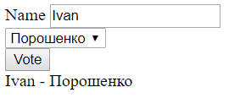

<!DOCTYPE html>

<html lang="en">

<head>

<meta charset="UTF-8">

<meta name="viewport" content="width=device-width, initial-scale=1.0">

<meta http-equiv="X-UA-Compatible" content="ie=edge">

<title>Document</title>

<script>

function vote() {

const div = document.getElementsByTagName("div")[0]

const userName = document.getElementById("userName").value

div.innerText = `${userName} - ${document.getElementById("Pr").value}`

}

window.onload = function () {

document.querySelector("button").onclick = vote

}

</script>

</head>

<body>

<label>

Name

<input type="text" id="userName" placeholder="Type your name here">

</label> <br>

<select id="Pr">

<option value="Порошенко">Порошенко</option>

<option value="Зеленский">Зеленский</option>

</select>

<br>

<button>

Vote

</button>

<div>

</div>

</body>

</html>

Приклади.

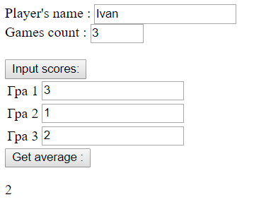

<!DOCTYPE html>

<html lang="en">

<head>

<meta charset="UTF-8">

<meta name="viewport" content="width=device-width, initial-scale=1.0">

<meta http-equiv="X-UA-Compatible" content="ie=edge">

<title>Document</title>

<script>

function getTable(rowCount) {

let tbl = document.createElement("table")

for (let i = 0; i < rowCount; i++) {

let tr = document.createElement("tr")

//------ td 1

let td = document.createElement("td")

td.innerText = `Гра ${i + 1}`

tr.appendChild(td)

//------ td 2

td = document.createElement("td")

let inp = document.createElement("input")

inp.type = "number"

td.appendChild(inp)

tr.appendChild(td)

//----------

tbl.appendChild(tr)

}

return tbl

}

function createTable() {

const rowCount = parseInt(document.getElementById("gameCount").value)

let table = getTable(rowCount)

document.getElementById("container").appendChild(table)

}

function getScore() {

//let inputs= document.getElementById("container").getElementsByTagName("input")

let inputs = document.querySelectorAll("#container input")

let s = 0

for (let i = 0; i < inputs.length; i++) {

s += parseInt(inputs[i].value)

}

document.getElementById("res").innerText = s / inputs.length

}

window.onload = function () {

document.querySelector("#inpScr").onclick = createTable

document.getElementById("avg").onclick = getScore

}

</script>

</head>

<body>

<label>

Player's name :

<input type="text" id="userName" placeholder="Type your name here">

</label> <br>

<label>

Games count :

<input type="number" id="gameCount" value="1" min="1" max="10">

</label> <br>

<br>

<button id="inpScr">

Input scores:

</button> <br>

<div id="container">

</div>

<button id="avg">

Get average :

</button> <br>

<p id="res"></p>

</body>

</html>