The hip replacement model: a user guide
Qian Xin and Howard Thom
2026-10-28

What the model is
This package contains a cohort Markov model of total hip replacement, a simplified version of the model published by Fawsitt et al. (2019) that compared prosthetic implant combinations using data from the UK National Joint Registry (NJR) and the Swedish Hip Arthroplasty Register (SHAR). It is used as the worked example in the tutorial on modularisation, optimisation, documentation and testing of health economic models in R, and this guide walks through running it from end to end.
The model compares four implant combinations for men aged 65 to 74 having a first total hip replacement:
Implant | Bearing surface | Head size | Fixation
Cemented | Metal-on-polyethylene | Small | Cemented
Uncemented | Ceramic-on-polyethylene | Small | Uncemented
Hybrid | Ceramic-on-polyethylene | Large | Hybrid
Reverse hybrid | Ceramic-on-polyethylene | Small | Reverse hybrid
Patients enter the model at age 65 in the post-THR state and are followed for 30 one-year cycles. Each year they may stay where they are, have a revision operation, or die.

Health states
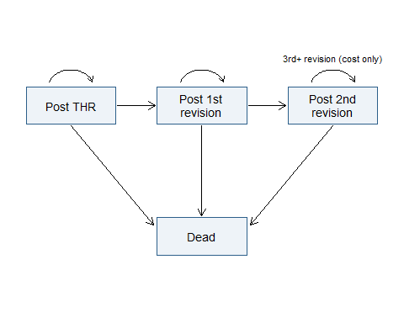
Model structure. Patients may need a first and then a second revision; the post-2nd-revision state also carries the cost of any further revisions. Death is possible from every living state.
The four states are:
- Post THR: living with the primary implant. Each year there is a small, implant-specific probability of a first revision.
- Post 1st revision: living with the implant from the first revision. The probability of a second revision is the same for all implants.
- Post 2nd revision: living after two or more revisions. Patients stay in this state, but each year they face a probability of a further revision that is charged as a cost without a change of state.
- Dead: the absorbing state, reached from any living state with the age-specific probability from the UK life table.

Setting up
The model functions are loaded with devtools::load_all(), which makes every function in the R/ folder available without installing the package. In this repository the functions that take a model_settings list are in paper/R/, alongside the original package functions, so they are sourced from there.
library(readxl)
for (function_file in list.files("paper/R", pattern = "\\.R$", full.names = TRUE)) {
source(function_file)
}
All structural settings of the model are collected in a single list that is passed to every function. Changing the number of samples, the time horizon or the discount rate means changing it here and nowhere else.
model_settings <- list(
n_samples = 1000,
n_cycles = 30, # 30 one-year cycles
cycle_length = 1, # years
initial_age = 65, # cohort starts at age 65
discount_rate = 0.035, # 3.5% per year
state_names = c("post_thr", "post_1st_rev", "post_2nd_rev", "dead"),
implant_names = c("cemented", "uncemented", "hybrid", "reverse_hybrid"),
data_directory = "data" # data may be stored separately if sensitive
)

Input data
All inputs are held in one workbook, data/hips_input_data.xlsx, with a sheet for each type of parameter. Keeping them there, rather than in the code, means a reviewer can check every number without running anything, and the file can be stored separately if the data are sensitive. The sheets are:
input_file <- file.path(model_settings$data_directory, "hips_input_data.xlsx")
excel_sheets(input_file)
#> [1] "log_rates_1st_revision" "other_log_rates" "costs" "state_utilities"
#> [5] "uk_lifetables"
First revision rates are the only inputs that differ between implants. They are stored as log rates with a standard error, and sampled on the log scale:
knitr::kable(read_excel(input_file, sheet = "log_rates_1st_revision")[, c("Implant", "Mean", "SE")],
digits = 3, caption = "Log rates of first revision by implant (NJR/SHAR)")
Log rates of first revision by implant (NJR/SHAR)
Implant | Mean | SE
cemented | -5.365 | 0.031
uncemented | -5.808 | 0.031
hybrid | -5.607 | 0.031
reverse_hybrid | -5.519 | 0.031
Second and higher revision rates are shared across implants, costs are fixed, and state utilities are sampled from normal distributions:
knitr::kable(read_excel(input_file, sheet = "other_log_rates")[, c("Parameter", "Value")],
digits = 3, caption = "Log rates of second and higher revision")
Log rates of second and higher revision
Parameter | Value
log_hazard_2nd_revision | -3.144
log_hazard_2nd_revision_se | 0.073
log_hazard_higher_revision | -2.849
log_hazard_higher_revision_se | 0.053
knitr::kable(read_excel(input_file, sheet = "costs")[, c("Resource", "Cost")],
caption = "Costs (GBP, 2015-16 prices)")
Costs (GBP, 2015-16 prices)
Resource | Cost
cost_cemented | 756.00
cost_uncemented | 2386.00
cost_hybrid | 1597.00
cost_reverse_hybrid | 1446.00
cost_revision_with_implant | 8595.83
cost_revision_other_resource | 409.12
cost_revision | 9004.95
knitr::kable(read_excel(input_file, sheet = "state_utilities")[, c("State", "Mean", "SE")],
caption = "Health state utilities (UK PROMs)")
Health state utilities (UK PROMs)
State | Mean | SE
post_thr | 0.762 | 0.004
post_1st_rev | 0.575 | 0.009
post_2nd_rev | 0.575 | 0.009
dead | 0.000 | 0.000
Mortality is taken from the uk_lifetables sheet, which the transition matrix function reads itself because it is fixed and does not need to be sampled.

Running the model
The analysis is five function calls, each returning one object that the next one needs. Setting the seed first makes the probabilistic samples reproducible.
set.seed(123456)
input_parameters <- generate_input_parameters(model_settings)
transition_matrices <- generate_transition_matrices(input_parameters, model_settings)
state_costs <- generate_state_costs(input_parameters, model_settings)
state_qalys <- generate_state_qalys(input_parameters, model_settings)
model_output <- generate_net_benefit(transition_matrices, state_costs,
state_qalys, input_parameters,
model_settings, lambda = 20000)
input_parameters has one row per probabilistic sample and one column per parameter:
dim(input_parameters)
#> [1] 1000 15
head(input_parameters[, 1:6], 3)
#> log_rate_1st_revision_cemented log_rate_1st_revision_uncemented log_rate_1st_revision_hybrid
#> 1 -5.339127 -5.786244 -5.582067
#> 2 -5.373530 -5.811800 -5.550911
#> 3 -5.375977 -5.778090 -5.563690
#> log_rate_1st_revision_reverse_hybrid log_rate_2nd_revision log_rate_higher_revision
#> 1 -5.506783 -3.114148 -2.868140
#> 2 -5.529211 -3.191420 -2.937931
#> 3 -5.524179 -3.111630 -2.844167
model_output is a list of four matrices, each with one row per implant and one column per sample: total_costs, total_qalys, net_benefit and incremental_net_benefit (relative to the first implant, cemented).
str(model_output, max.level = 1)
#> List of 4
#> $ total_costs : num [1:4, 1:1000] 1563 2910 2236 2133 1520 ...
#> ..- attr(*, "dimnames")=List of 2
#> $ total_qalys : num [1:4, 1:1000] 10.2 10.3 10.3 10.3 10.4 ...
#> ..- attr(*, "dimnames")=List of 2
#> $ net_benefit : num [1:4, 1:1000] 203170 202587 202952 202925 205847 ...
#> ..- attr(*, "dimnames")=List of 2
#> $ incremental_net_benefit: num [1:4, 1:1000] 0 -583 -218 -245 0 ...
#> ..- attr(*, "dimnames")=List of 2

Results
Discounted lifetime costs and QALYs per patient, averaged over the probabilistic samples:
lambda <- 20000
results <- data.frame(
Implant = model_settings$implant_names,
`Mean cost (GBP)` = rowMeans(model_output$total_costs),
`Mean QALYs` = rowMeans(model_output$total_qalys),
`Net benefit (GBP)` = rowMeans(model_output$net_benefit),
check.names = FALSE, row.names = NULL)
results$`Incremental net benefit vs cemented (GBP)` <-
results$`Net benefit (GBP)` - results$`Net benefit (GBP)`[1]
knitr::kable(results, digits = c(0, 0, 3, 0, 0),
caption = "Mean discounted costs, QALYs and net benefit at GBP 20,000 per QALY")
Mean discounted costs, QALYs and net benefit at GBP 20,000 per QALY
Implant | Mean cost (GBP) | Mean QALYs | Net benefit (GBP) | Incremental net benefit vs cemented (GBP)
cemented | 1541 | 10.307 | 204591 | 0
uncemented | 2897 | 10.344 | 203980 | -611
hybrid | 2220 | 10.329 | 204355 | -236
reverse_hybrid | 2122 | 10.321 | 204306 | -285
The cost-effectiveness plane shows each sample’s incremental cost and QALYs for the three alternatives relative to the cemented implant:
inc_costs <- sweep(model_output$total_costs, 2, model_output$total_costs[1, ])[-1, ]
inc_qalys <- sweep(model_output$total_qalys, 2, model_output$total_qalys[1, ])[-1, ]
colours <- c("#D55E00", "#0072B2", "#009E73")
par(mar = c(4.5, 4.5, 1, 1))
plot(NA, xlim = range(inc_qalys), ylim = range(inc_costs),
xlab = "Incremental QALYs vs cemented", ylab = "Incremental cost vs cemented (GBP)")
abline(h = 0, v = 0, col = "grey70")
abline(a = 0, b = lambda, lty = 2)
for (i in 1:3) points(inc_qalys[i, ], inc_costs[i, ], pch = 16, cex = 0.4, col = adjustcolor(colours[i], 0.5))
legend("topleft", legend = rownames(inc_costs), col = colours, pch = 16, bty = "n")
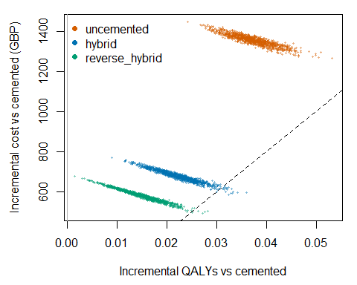
Cost-effectiveness plane: incremental costs and QALYs versus the cemented implant, one point per probabilistic sample. The dashed line is the GBP 20,000 per QALY threshold.
The cost-effectiveness acceptability curve gives the probability that each implant has the highest net benefit across a range of thresholds:
thresholds <- seq(0, 50000, by = 1000)
ceac <- sapply(thresholds, function(wtp) {
nb <- model_output$total_qalys * wtp - model_output$total_costs
best <- apply(nb, 2, which.max)
tabulate(best, nbins = length(model_settings$implant_names)) / model_settings$n_samples
})
par(mar = c(4.5, 4.5, 1, 1))
matplot(thresholds / 1000, t(ceac), type = "l", lty = 1, lwd = 2, col = c("grey40", colours),
xlab = "Willingness to pay (GBP thousand per QALY)", ylab = "Probability cost-effective",
ylim = c(0, 1))
legend(0, 0.8, legend = model_settings$implant_names, col = c("grey40", colours), lwd = 2, bty = "n")
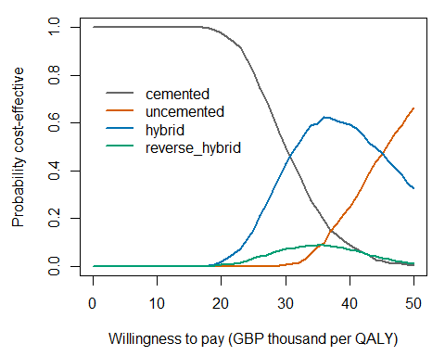
Cost-effectiveness acceptability curves.
The same results can be passed to the BCEA package for a fuller analysis, including the expected value of perfect information:
library(BCEA)
hips_bcea <- bcea(e = t(model_output$total_qalys), c = t(model_output$total_costs),
ref = 1, interventions = model_settings$implant_names, Kmax = 50000)
summary(hips_bcea)
ceplane.plot(hips_bcea)
ceac.plot(hips_bcea)
evi.plot(hips_bcea)

Reading the results
The cemented implant is the cheapest and the uncemented the most effective, but the QALY differences between implants are small (a few hundredths of a QALY over a lifetime) while the cost differences run to over GBP 1,000, driven mainly by the price of the primary implant. At GBP 20,000 per QALY the cemented implant has the highest expected net benefit and is almost certain to be the cost-effective choice. The acceptability curves show that this depends on the threshold: above about GBP 28,000 per QALY the hybrid implant becomes the most likely to be cost-effective, and above about GBP 42,000 the uncemented implant does. This matches the finding of the full model by Fawsitt et al. that cemented metal-on-polyethylene implants were the most cost-effective option for this age group.
Because the probabilistic samples are drawn with a fixed seed, re-running this vignette reproduces these numbers exactly. Changing n_samples in model_settings will change them slightly; increasing it narrows the Monte Carlo error of the means.

Going further
- generate_net_benefit() has a method argument. The default runs the original nested loops; method = "vectorised" gives the same results several times faster and is the version to use for large probabilistic or value-of-information analyses.
- optimisation/time_comparisons.R benchmarks all the optimisation methods described in the tutorial.
- ?generate_input_parameters and the other help pages document each function’s arguments and return values.

References
Fawsitt CG, Thom HHZ, Hunt LP, et al. Choice of prosthetic implant combinations in total hip replacement: cost-effectiveness analysis using UK and Swedish hip joint registries data. Value in Health 2019;22(3):303-12.

