**TALLER 19**

**1.**

|  |  |
| --- | --- |
| **Service** | **Description** |
| **Amazon Aurora** | **(Relational)** MySQL and PostgreSQL-compatible relational database built for the cloud. |
| **Amazon Relational Database Service (RDS)** | **(Relational)** Amazon RDS is available on several database instance types - optimized for memory, performance or I/O - and provides you with six familiar database engines to choose from, including Amazon Aurora, PostgreSQL, MySQL, MariaDB, Oracle Database, and SQL Server. |
| **Amazon Redshift** | **(Relational)** Redshift makes it simple and cost effective to run high performance queries on petabytes of structured data. |
| **Amazon DynamoDB** | **(Key-value)** Fast and flexible NoSQL database service for any scale. |
| **Amazon ElastiCache for Memcached** | **(In-memory)** Managed, Memcached-compatible, in-memory store. Sub-millisecond latency to power real-time applications. |
| **Amazon ElastiCache for Redis** | **(In-memory)** Redis compatible in-memory data store built for the cloud. Power real-time applications with sub-millisecond latency. |
| **Amazon DocumentDB (with MongoDB compatibility)** | **(Document)** Fast, scalable, highly available MongoDB-compatible database service. |
| **Amazon Keyspaces (for Apache Cassandra)** | **(Wide column)** Managed Cassandra-compatible database. |
| **Amazon Neptune** | **(Graph)** Amazon Neptune is a fast, reliable, fully managed graph database service that makes it easy to build and run applications that work with highly connected datasets. |
| **Amazon Timestream** | **(Time series)** Amazon Timestream is a fast, scalable, and serverless time series database service for IoT and operational applications that makes it easy to store and analyze trillions of events per day up to 1,000 times faster and at as little as 1/10th the cost of relational databases. |
| **Amazon QLDB** | **(Ledger)** Fully managed ledger database that provides a transparent, immutable, and cryptographically verifiable transaction log. Owned by a central trusted authorit. |

**Fuente:** [**https://aws.amazon.com/products/databases/**](https://aws.amazon.com/products/databases/) **2.**

|  |  |  |
| --- | --- | --- |
| **Service** | **Description** | **Pricing** |
| **Amazon Relational Database Service (RDS)** | **(Relational)** Amazon RDS is available on several database instance types - optimized for memory, performance or I/O - and provides you with six familiar database engines to choose from, including Amazon Aurora, PostgreSQL, MySQL, MariaDB, Oracle Database, and SQL Server. | Amazon RDS is free to try. Pay only for what you use. There is no minimum fee. You can pay for Amazon RDS using On-Demand or Reserved Instances. |
| **Amazon ElastiCache for Memcached** | **(In-memory)** Managed, Memcached-compatible, in-memory store. Sub-millisecond latency to power real-time applications. | Pay only for what you use. There is no minimum fee. Depends on node type. |
| **Amazon ElastiCache for Redis** | **(In-memory)** Redis compatible in-memory data store built for the cloud. Power real-time applications with sub-millisecond latency. | Pay only for what you use. There is no minimum fee. Depends on node type. |
| **Amazon DynamoDB** | **(Key-value)** Amazon DynamoDB is a key-value and document database that delivers single-digit millisecond performance at any scale. It's a fully managed, multiregion, multimaster, durable database with built-in security, backup and restore, and in-memory caching for internet-scale applications. | DynamoDB charges for reading, writing, and storing data in your DynamoDB tables, along with any optional features you choose to enable. DynamoDB has two capacity modes and those come with specific billing options for processing reads and writes on your tables: on-demand and provisioned. |

DynamoDB y RDS differ mainly in their mechanism of storage and retrieval of data, which is relational and non-relational respectively. ElastiCache is different because its way of storing data, which in this case is directly into memory, because these kind of databases are used mainly for real-time access to data.

**Fuente: https://aws.amazon.com/products/databases/**

**7.**

Creates a standby in a different Availability Zone (AZ) to provide data redundancy, eliminate I/O freezes, and minimize latency spikes during system backups.

**Fuente:** AWS RDS

**8.**

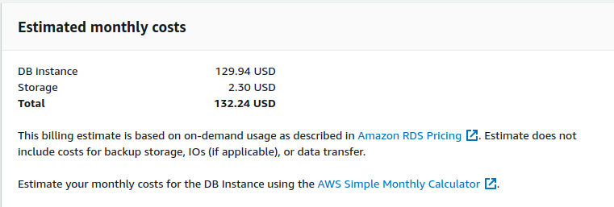

**9.**

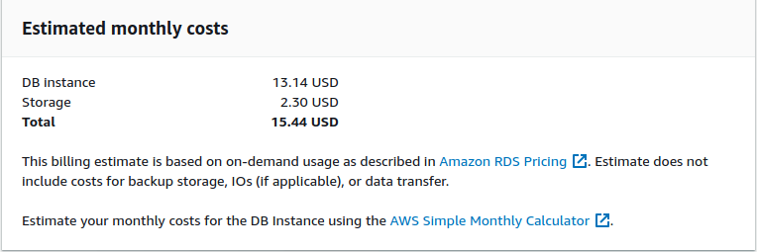

**10.**

