Install Nginx, configure it to serve static pages and dynamic pages

1.First we need to set up our inventory file so we can have connection between our Mac Host and our ubuntu

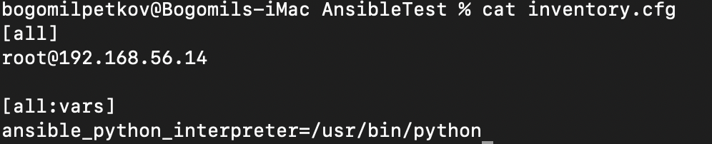

The ansible_python_interpreter=/usr/bin/python3 is there so Ansible will use Python 3 on the remote machine

2.We will create a playbook nginx_install.yml that will install nginx

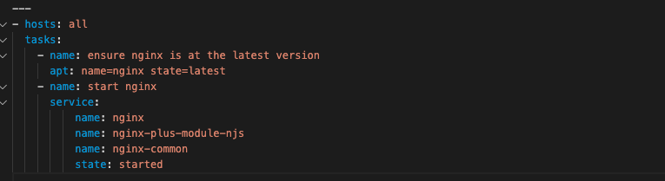

Ansible-playbook -vvv -I inventory.cfg –limit [root@192.168.56.14](mailto:root@192.168.56.14) Nginx/nginx_install.yml

3.After the installation we can do some configurations. We will make static_site.cfg where we will indicate the server ports listening on 80

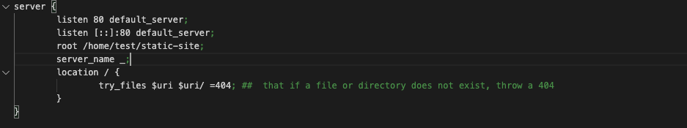

4.I’ve created a simple html website for testing purposes



5. Now we will create our complete nginx installation playbook

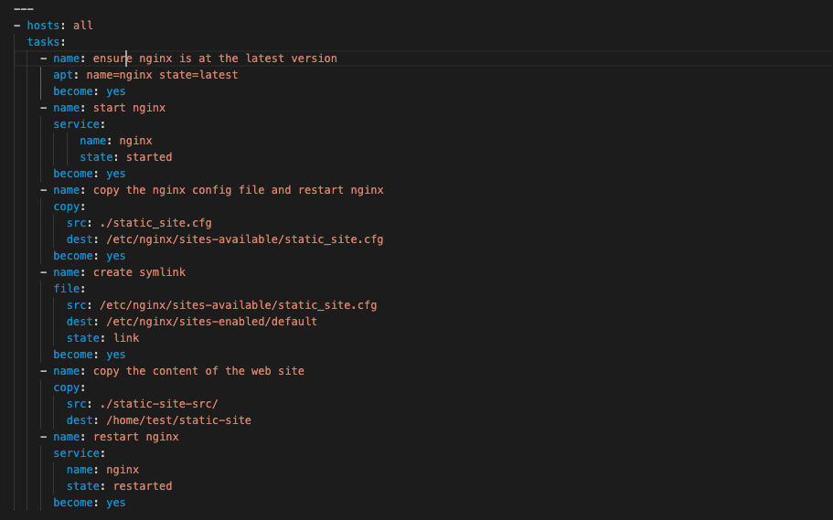

6. The playbook was successfully run

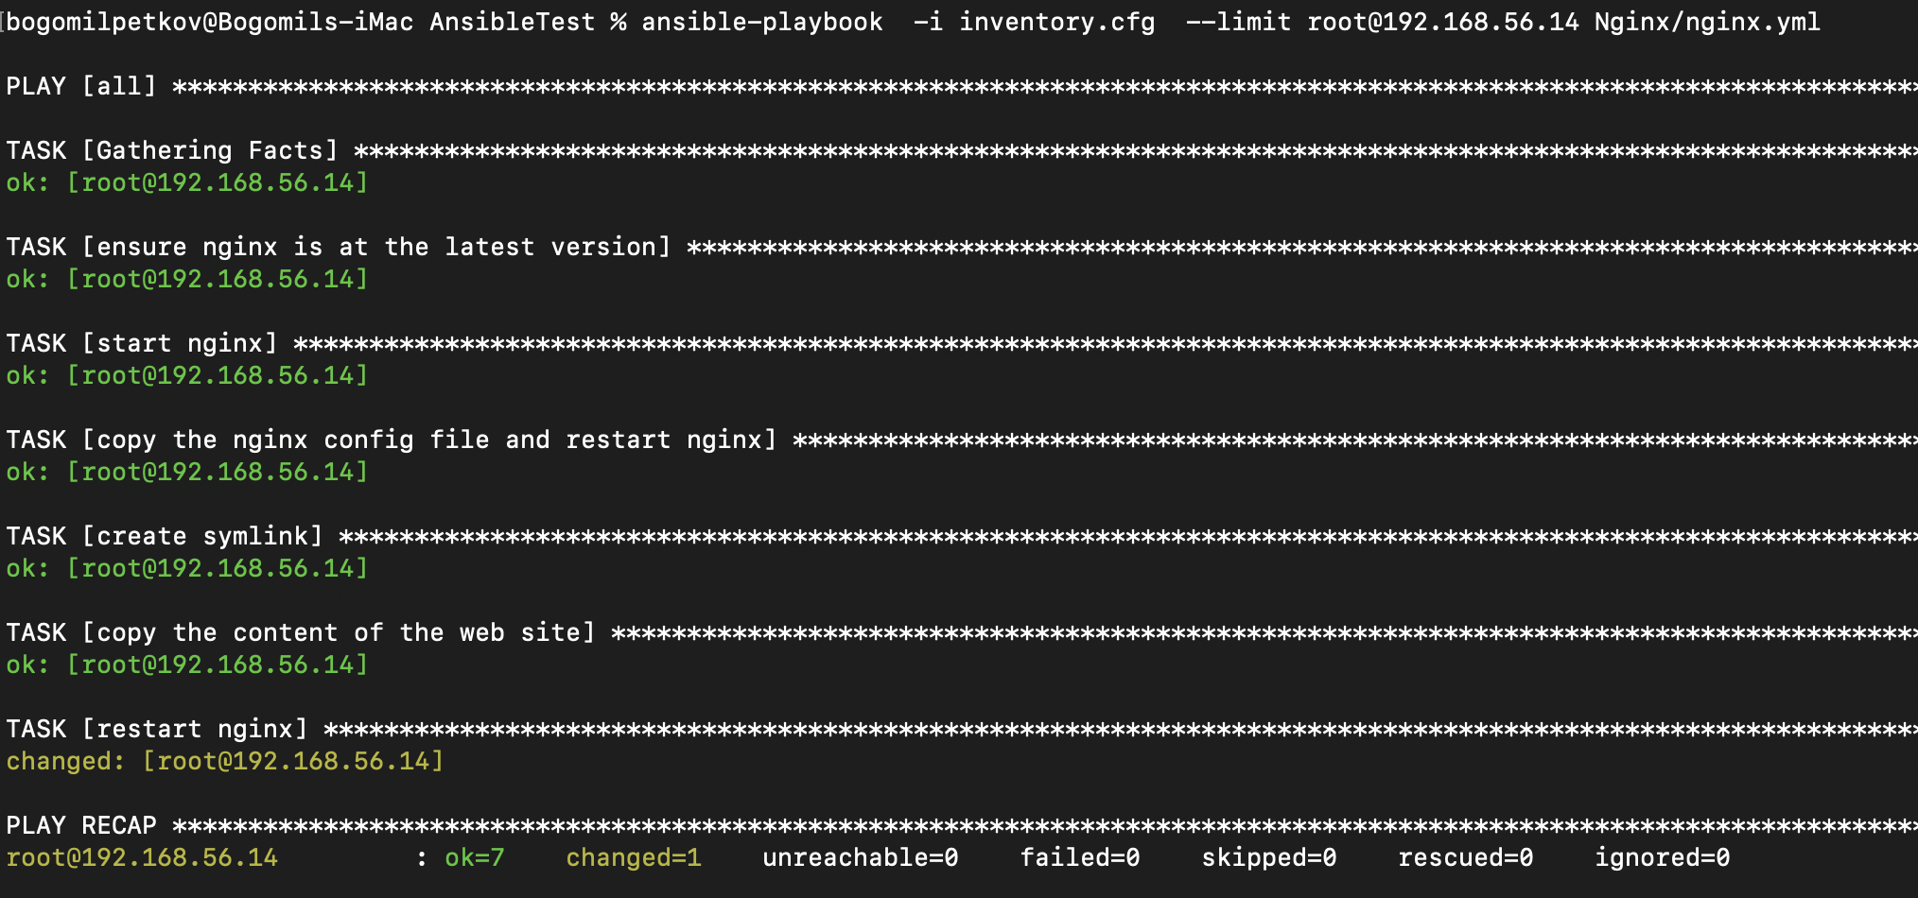

Folder Structure

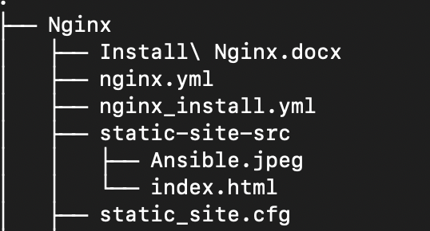

7.After you run 192.168.56.14:80 , Up and running

