Install PostgreSQL DBMS and create DB, user for DB, set users password.  
  
  
  
  
1. Let’s assume that we have ansible already installed on our host (MAC) and on our ubuntu 18.04 server and we will create an inventory file where we will put the IP of our Ubuntu server

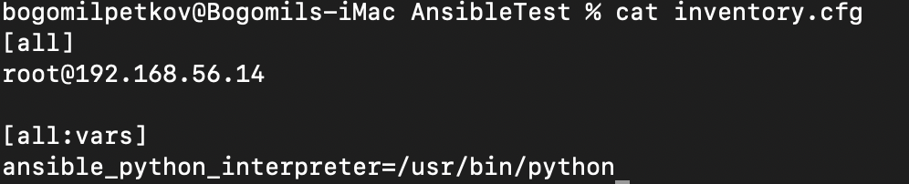

2. I tested the connection and it’s successful

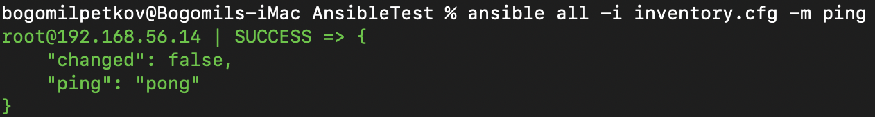

3. I will create a playbook called ansible_playbook.yml that will be used to create the PostgreSQL Server

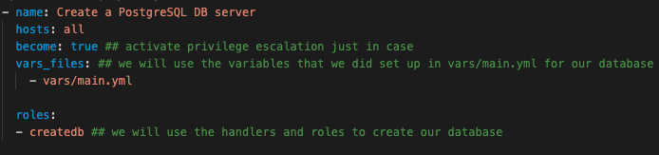

4.I will create a playbook called main.yml where we will store our database variables

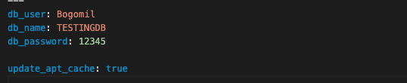

We have set the variables for our database user name ,database name and database password.

5 I created a handler which will restart PostgreSQL once the database is updated

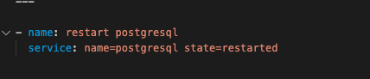

6. This is our set of tasks that we to accomplish

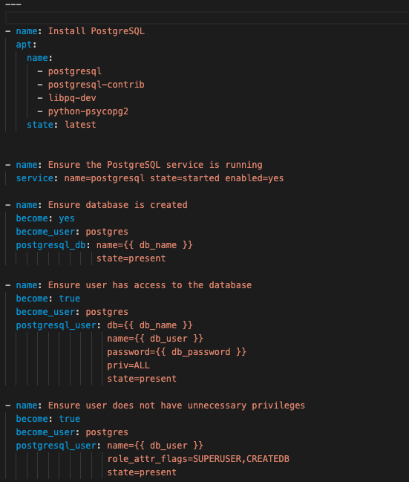

It will install PostgreSQL, Run the PostgreSQL service, Create the database, Manage permissions for user and test if the database is available. I will play the playbook by using this command from my MAC host

ansible-playbook -vvv -i inventory.cfg --limit root@192.168.56.14 Postgresql/ansible_playbook.yml

7.Our folder structure

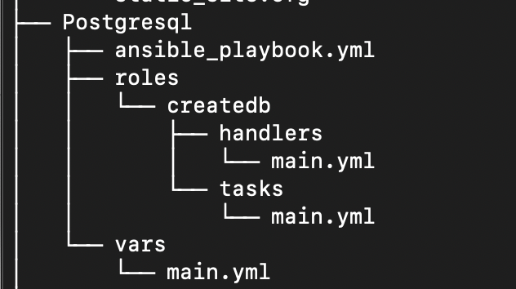

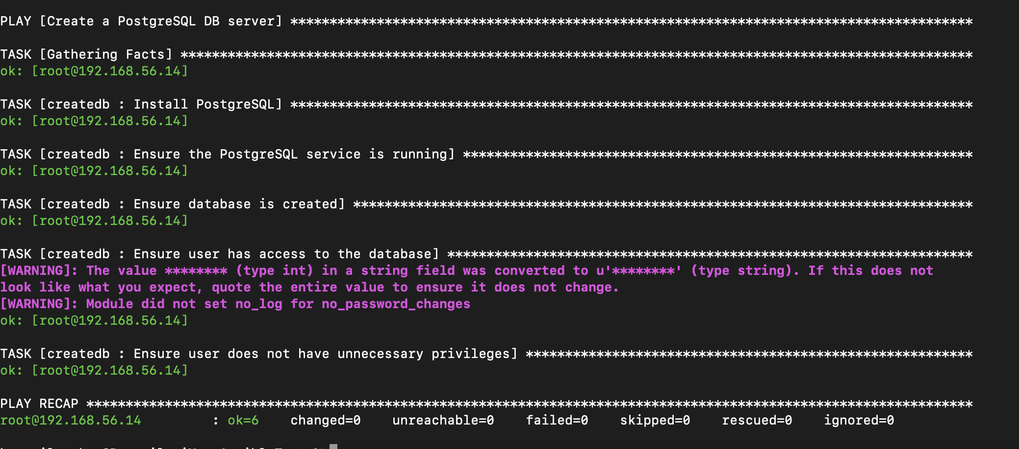

Our BOGOMILDB has been created

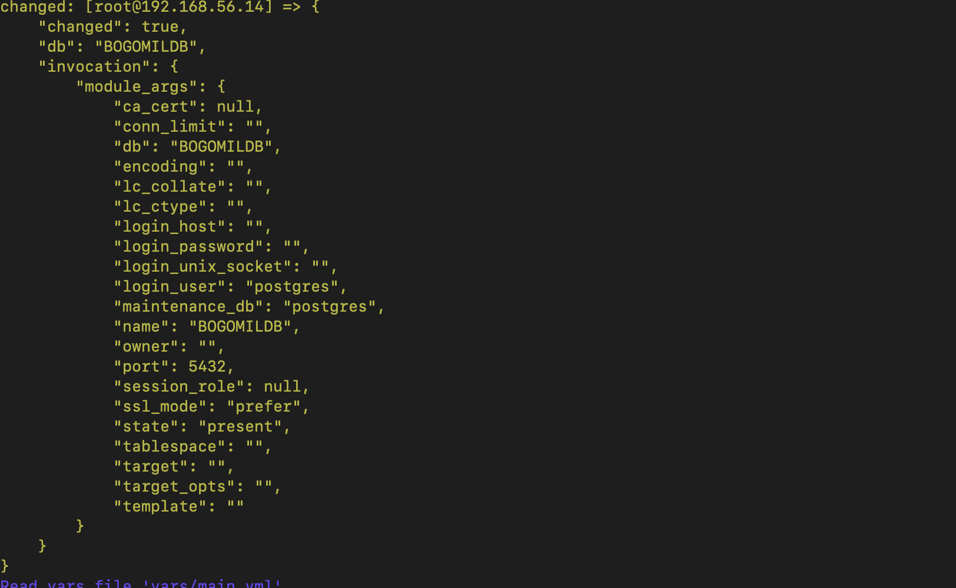

Our Bogomil user has been created

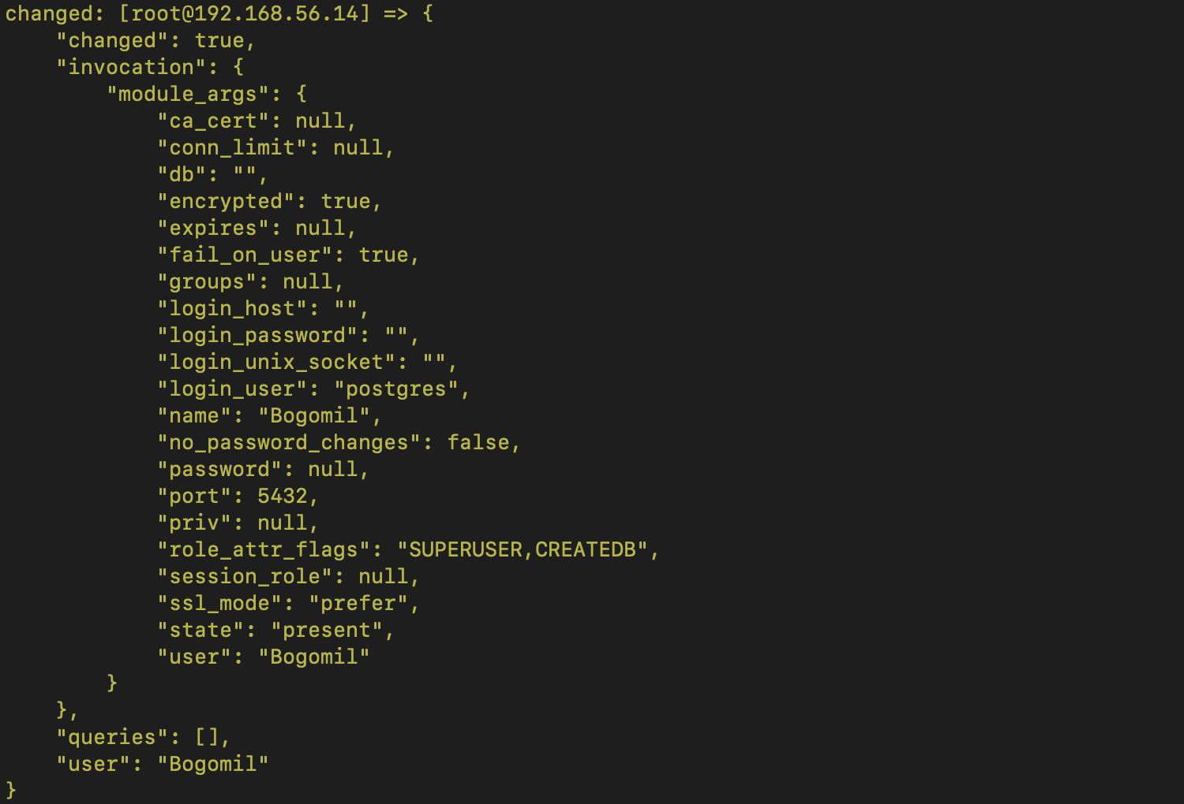

Granting permissions to the user

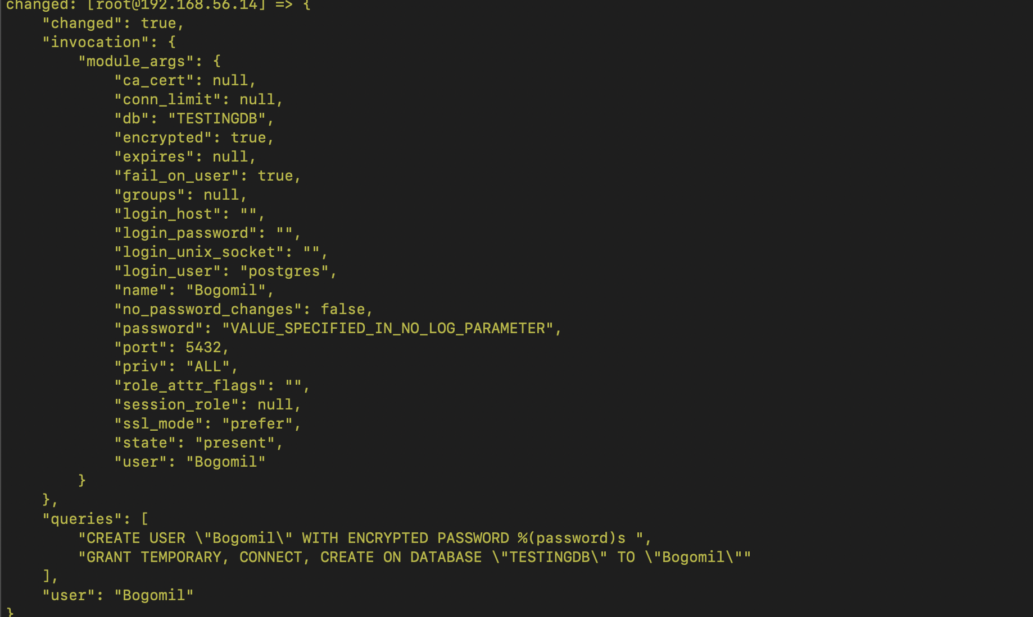

I logged to the ubuntu server to check if the database has been created and the user has been added.

