Install simple Python application which would serve "Hello World!".

1.First we need to set up our inventory file so we can have connection between our Mac Host and our ubuntu

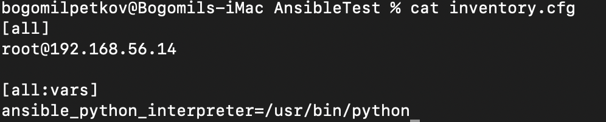

2. We have a simple Python hello world application

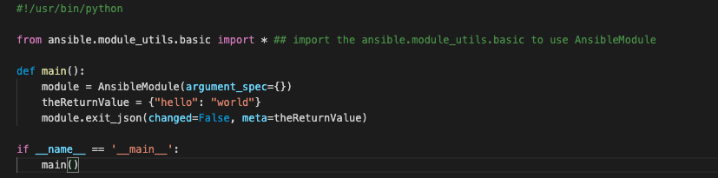

3. Create a playbook to call your module with hello_world.yml

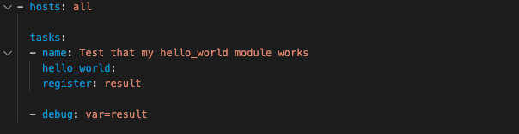

4. We will execute this command

ansible-playbook -i inventory.cfg --limit root@192.168.56.14 Python/hello_world.yml

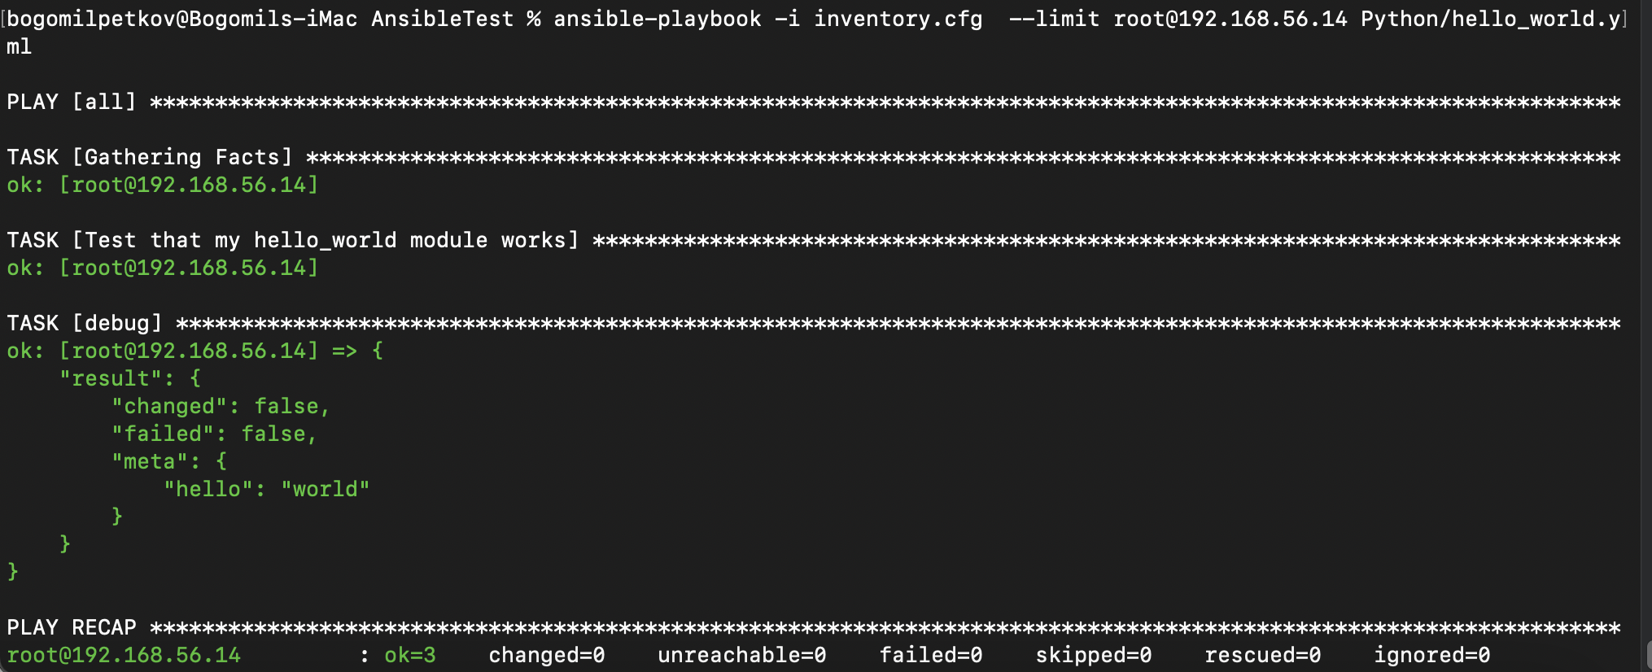

This is our hello world module

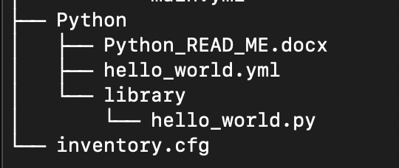

This is our structure