Our plan is divided into two parts.

1. The first is to devise a way of tracking students over the next five years. There are several objects, namely, teacher, student and course. These objects contain other objects respectively. For example, the student Object contains objects such as course selection plan, future performance, etc. It can contain the situation of a student inside and outside the school, so as to track the specific information of a student. At the same time, each object contains certain properties, some of which are basic information, and some of which are factors that need to be considered when studying the influence. In order to reflect the influence of courses or teachers on students, it is necessary to list some attributes of teachers and courses that may affect students, such as academic level of teachers, evaluation scores of students, difficulty of courses, course content and so on. At the same time, it is also necessary to consider their impact on students' feedback, such as teacher-student interaction frequency, course attendance rate and so on.

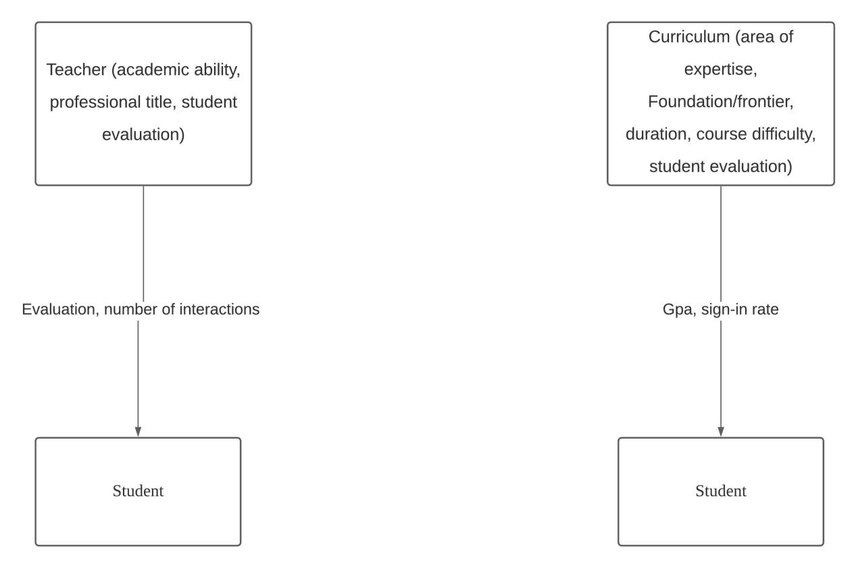

1. The second part is for students. Objects in this part include schools, academic units, courses and teachers. Students can extract attributes and rank preferences by selecting one or more of them. For example, a school contains attributes such as geographical location, academic reputation, overall ranking, and so on.

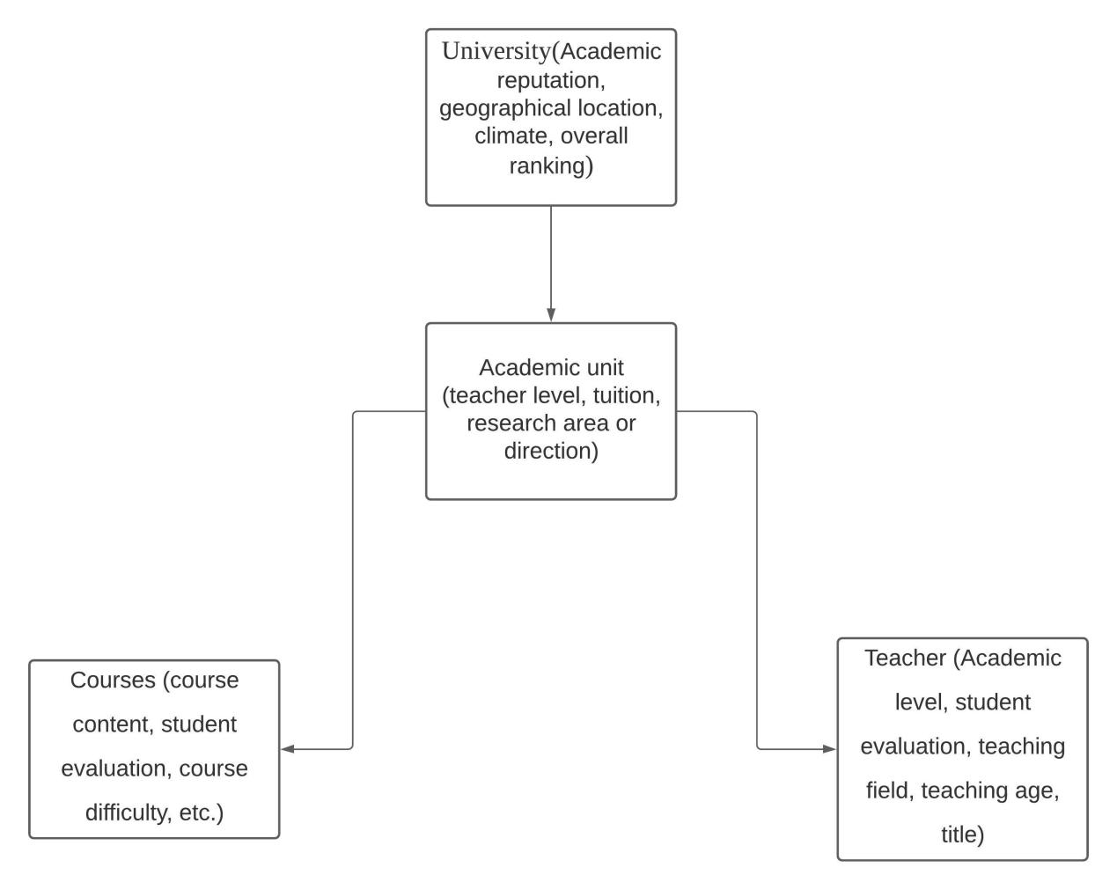

The two modules are directly connected, so they can form a whole, as shown in the object diagram. With this framework in place, we can consider the design of the ranking and tracking panels. This panel contains several functions, starting with the ability to enter, modify, and delete values. Secondly, other functions include selecting the attributes they need, selecting the objects they need, and then ranking them according to certain rules and displaying them.