Australian Airline Performance Analysis
Data-Driven Findings Report
Prepared by: Bohan Yang
Dataset period: 2023-2026
Tools used: SQL Server, SSMS, Power BI, Microsoft Excel

Purpose
This report summarises key findings from the Australian Airline Performance Analysis Power BI dashboard. The report focuses on operational performance, punctuality, cancellation patterns, airport performance and route-level issues. It is intended to communicate the findings in a concise, business-focused format supported by dashboard metrics.

Table of Contents
1. Executive Summary
2. Data and Methodology
3. Key Findings
4. Executive Dashboard Findings
5. Airline and Route Findings
6. Airport Operations and Trend Findings
7. Business Recommendations
8. Limitations and Data Quality Notes
9. Conclusion

1. Executive Summary
Across the analysed 2023-2026 period, the Australian domestic airline network recorded approximately 6 million scheduled flights across 10 airlines and 129 routes. Overall punctuality was moderate, with arrival on-time performance at 73.54% and departure on-time performance at 73.47%. The overall cancellation rate was 2.36%.
The strongest performance was observed among smaller and regional operators, with Hinterland achieving the highest average arrival on-time performance at 88%. In contrast, larger carriers and some regional operators experienced higher operational complexity, reflected in lower punctuality or higher cancellation rates. Cancellation risk was not evenly distributed across the network; Skytrans Australia and Bonza recorded the highest airline-level cancellation rates at 6.3% and 6.2% respectively.
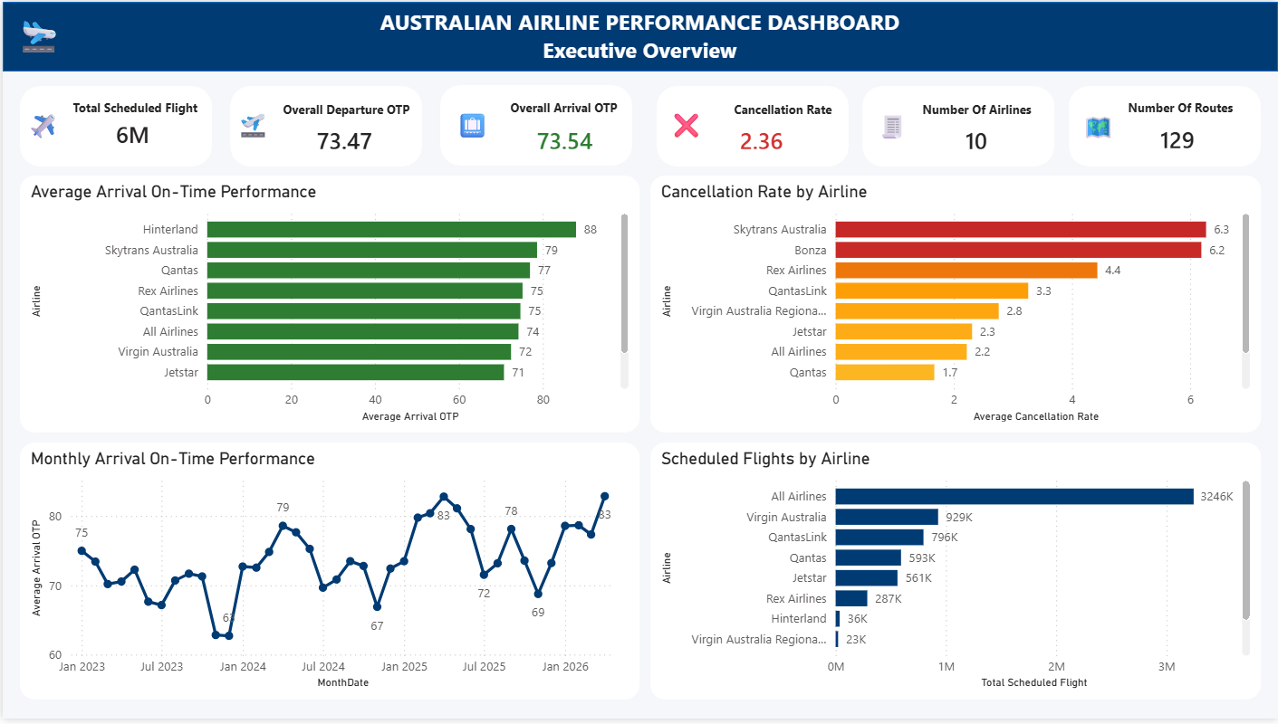
Airport and route-level analysis indicates that performance issues are concentrated in specific operational areas. Port Lincoln, Emerald and Ayers Rock performed strongly as departure airports, while Ayers Rock, Newman and Port Lincoln were the strongest arrival airports. Monthly trends show that cancellation rates peaked in August at 3.76%, while monthly flight volumes were highest in March and April, suggesting that seasonal demand and operational pressure influence reliability.

2. Data and Methodology
The analysis used Australian domestic airline on-time performance data covering 2023-2026. SQL Server was used to clean and model the dataset, while Power BI was used to create three dashboards: Executive Overview, Airline & Route Analysis, and Airport Operations & Trends.
Metric | Definition / Use
Arrival OTP | Percentage of arrivals completed on time.
Departure OTP | Percentage of departures completed on time.
Cancellation Rate | Percentage of scheduled flights that were cancelled.
Scheduled Flights | Total number of planned flight sectors.
Flights Flown | Total number of scheduled sectors that actually operated.

3. Key Findings
- The network-level arrival OTP was 73.54%, which provides a useful baseline for comparing individual airlines, routes and airports.
- Hinterland recorded the highest visible airline arrival OTP at 88%, followed by Skytrans Australia at 79% and Qantas at 77%.
- Skytrans Australia and Bonza recorded the highest visible airline cancellation rates at 6.3% and 6.2%, substantially above the network-level cancellation rate of 2.36%.
- The strongest visible departure airports by OTP were Port Lincoln (84%), Emerald (83%) and Ayers Rock (82%).
- The strongest visible arrival airports by OTP were Ayers Rock (87%), Newman (85%) and Port Lincoln (82%).
- Monthly cancellation rates peaked in August at 3.76% and were lowest in May at 1.73%, indicating that operational risk varies across the year.
- Monthly scheduled flight volume was highest in March (660K) and April (655K), while June recorded the lowest visible monthly volume (477K).

4. Executive Dashboard Findings
The Executive Overview dashboard provides the overall operational baseline for the report. It shows that the network operated at approximately 73.5% on-time performance for both departures and arrivals, with a 2.36% cancellation rate.
Executive KPI | Value
Total scheduled flights | Approx. 6M
Overall departure OTP | 73.47%
Overall arrival OTP | 73.54%
Overall cancellation rate | 2.36%
Number of airlines | 10
Number of routes | 129

At airline level, the dashboard shows a clear gap between high-performing regional airlines and lower-performing larger operators. Hinterland achieved an average arrival OTP of 88%, which is approximately 14 percentage points above the network benchmark shown by the All Airlines value of 74%. Jetstar recorded the lowest visible arrival OTP on the dashboard at 71%, approximately 3 points below the benchmark.
Airline | Average Arrival OTP
Hinterland | 88%
Skytrans Australia | 79%
Qantas | 77%
Rex Airlines | 75%
QantasLink | 75%
All Airlines benchmark | 74%
Virgin Australia | 72%
Jetstar | 71%

Cancellation performance is more uneven. Skytrans Australia (6.3%) and Bonza (6.2%) recorded cancellation rates more than double the overall cancellation KPI of 2.36%. This suggests that cancellation risk is concentrated among selected operators rather than distributed evenly across all airlines.
Airline | Average Cancellation Rate
Skytrans Australia | 6.3%
Bonza | 6.2%
Rex Airlines | 4.4%
QantasLink | 3.3%
Virgin Australia Regional Airlines | 2.8%
Jetstar | 2.3%
All Airlines benchmark | 2.2%
Qantas | 1.7%
Virgin Australia | 1.6%

5. Airline and Route Findings
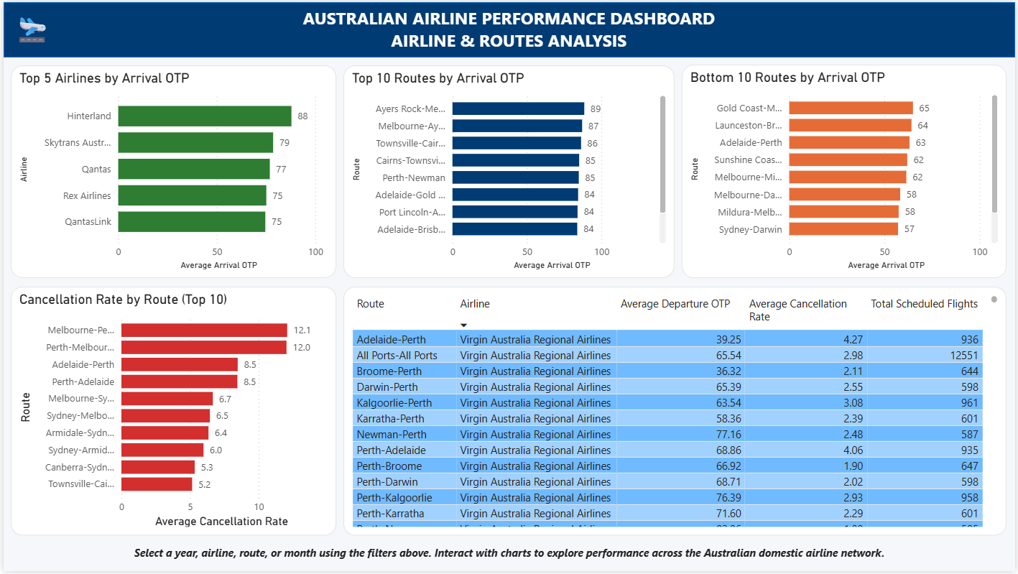
The Airline & Route Analysis dashboard provides a more detailed view of route-level performance. The top visible routes by arrival OTP are regional or short-haul airport pairs, including Ayers Rock-Melbourne at 89%, Melbourne-Ayers Rock at 87%, and Townsville-Cairns at 86%. These routes outperform the network benchmark and may provide useful operational benchmarks.
Top visible route | Arrival OTP
Ayers Rock-Melbourne | 89%
Melbourne-Ayers Rock | 87%
Townsville-Cairns | 86%
Cairns-Townsville | 85%
Perth-Newman | 85%
Adelaide-Gold Coast | 84%
Port Lincoln-Adelaide | 84%
Adelaide-Brisbane | 84%

The worst visible routes by arrival OTP include Sydney-Darwin (57%), Mildura-Melbourne (58%), Melbourne-Darwin (58%), Melbourne-Mildura (62%) and Sunshine Coast routes (62%). These routes sit well below the overall arrival OTP of 73.54%, indicating targeted opportunities for operational review.
Worst visible route | Arrival OTP
Sydney-Darwin | 57%
Mildura-Melbourne | 58%
Melbourne-Darwin | 58%
Melbourne-Mildura | 62%
Sunshine Coast route | 62%
Adelaide-Perth | 63%
Launceston-Brisbane | 64%
Gold Coast-Melbourne | 65%

The route detail table highlights several low-performing services operated by Virgin Australia Regional Airlines. Adelaide-Perth recorded a departure OTP of 39.25% and a cancellation rate of 4.27%. Broome-Perth recorded an even lower departure OTP of 36.32%. These figures indicate that some regional routes face severe reliability challenges and should be prioritised for deeper operational investigation.
Route | Airline | Departure OTP | Cancellation Rate | Scheduled Flights
Adelaide-Perth | Virgin Australia Regional Airlines | 39.25% | 4.27% | 936
Broome-Perth | Virgin Australia Regional Airlines | 36.32% | 2.11% | 644
Perth-Adelaide | Virgin Australia Regional Airlines | 68.86% | 4.06% | 935
Kalgoorlie-Perth | Virgin Australia Regional Airlines | 63.54% | 3.08% | 961
Newman-Perth | Virgin Australia Regional Airlines | 77.16% | 2.48% | 587

6. Airport Operations and Trend Findings
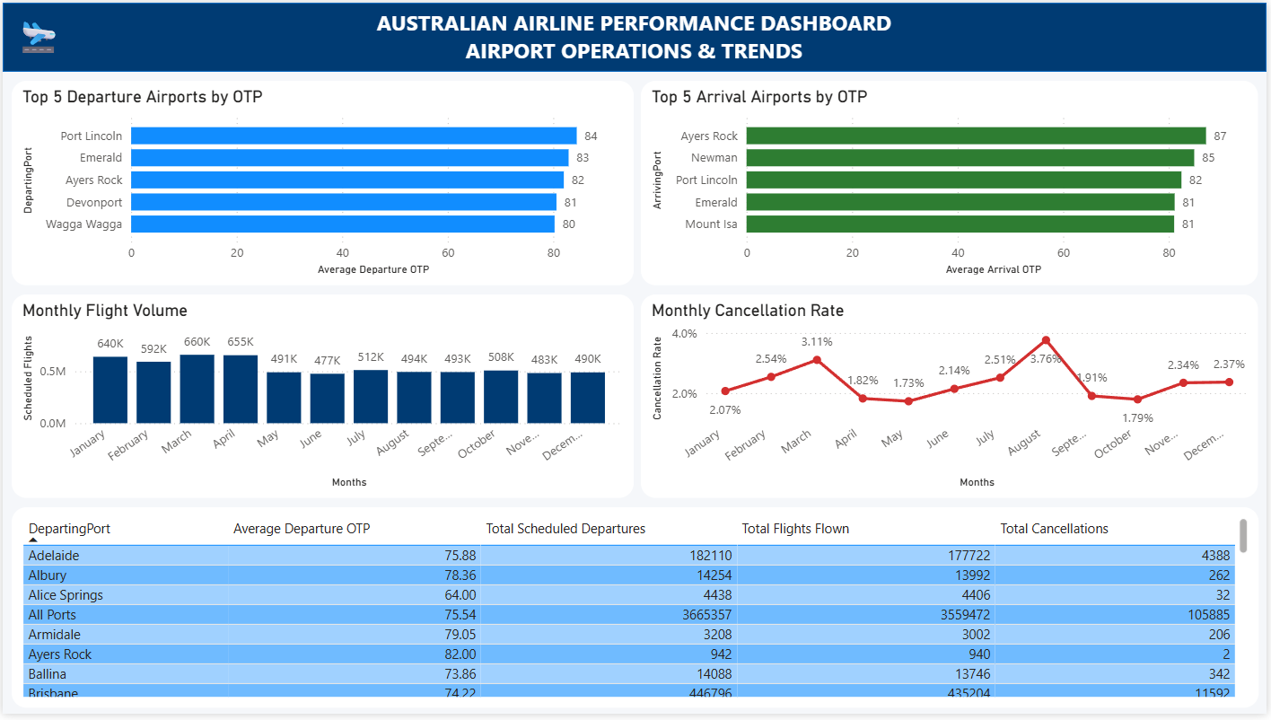
Airport-level performance shows that some regional airports achieved stronger operational reliability than major hubs. Port Lincoln had the highest visible departure OTP at 84%, followed by Emerald at 83% and Ayers Rock at 82%. For arrivals, Ayers Rock led the visible ranking at 87%, followed by Newman at 85% and Port Lincoln at 82%.
Airport | Departure OTP
Port Lincoln | 84%
Emerald | 83%
Ayers Rock | 82%
Devonport | 81%
Wagga Wagga | 80%

Airport | Arrival OTP
Ayers Rock | 87%
Newman | 85%
Port Lincoln | 82%
Emerald | 81%
Mount Isa | 81%

Monthly trend analysis shows that flight volume and cancellation rates vary across the year. March recorded the highest visible scheduled flight volume at 660K, followed by April at 655K and January at 640K. Cancellation rates peaked in August at 3.76%, while May was the lowest at 1.73%. This pattern suggests that operational risk is not solely driven by flight volume, as the highest cancellation month did not coincide with the highest flight volume month.
Month | Scheduled Flights | Cancellation Rate
January | 640K | 2.07%
February | 592K | 2.54%
March | 660K | 3.11%
April | 655K | 1.82%
May | 491K | 1.73%
June | 477K | 2.14%
July | 512K | 2.51%
August | 494K | 3.76%
September | 493K | 1.91%
October | 508K | 1.79%
November | 483K | 2.34%
December | 490K | 2.37%

The airport table provides additional operational context. All Ports recorded 3,665,357 scheduled departures, 3,559,472 flights flown and 105,885 cancellations. Brisbane recorded 446,796 scheduled departures, 435,204 flights flown and 11,592 cancellations. These higher-volume airports require a different operational focus from smaller airports such as Ayers Rock, which had only 942 scheduled departures and 2 cancellations in the visible table.
Airport | Departure OTP | Scheduled Departures | Flights Flown | Cancellations
All Ports benchmark | 75.54% | 3,665,357 | 3,559,472 | 105,885
Brisbane | 74.22% | 446,796 | 435,204 | 11,592
Adelaide | 75.88% | 182,110 | 177,722 | 4,388
Ayers Rock | 82.00% | 942 | 940 | 2

7. Business Recommendations
The recommendations below focus on practical operational actions supported by the dashboard findings.
Priority | Recommendation | Rationale
High | Review consistently underperforming regional routes such as Adelaide-Perth and Broome-Perth. | These routes show very low departure OTP and elevated cancellation rates compared with the network average.
High | Investigate cancellation drivers for Skytrans Australia, Bonza and Rex Airlines. | These airlines have cancellation rates above the overall network level, with Skytrans and Bonza exceeding 6%.
Medium | Benchmark practices from high-performing airports such as Port Lincoln, Ayers Rock and Emerald. | These airports show strong OTP and may provide operational practices that can be adapted elsewhere.
Medium | Use monthly cancellation trends for seasonal planning. | August shows the highest cancellation rate at 3.76%, indicating a need for targeted planning around high-risk periods.
Medium | Separate aggregate rows from operational entities in future analysis. | All Airlines and All Ports are useful benchmarks but should not be interpreted as individual airlines or airports.

8. Limitations and Data Quality Notes
- The Power BI dashboard includes aggregate categories such as All Airlines and All Ports. These are useful benchmarks but should not be interpreted as individual operators or airports.
- The analysis is based on operational performance metrics and does not include weather, maintenance, air traffic control, passenger demand or aircraft utilisation data.
- Some route labels are truncated in the dashboard visuals; final reporting should use full route names where available from the underlying dataset.
- The report interprets visible dashboard values from the submitted Power BI report. If the report is filtered, values may change accordingly.
- Future analysis should include year-over-year changes, rolling averages and external operational factors to explain the causes of delay and cancellation patterns.

9. Conclusion
The analysis shows that Australian domestic airline performance is broadly stable but uneven across airlines, routes and airports. Network-level arrival OTP was 73.54%, while cancellation rates averaged 2.36%. However, selected airlines and routes experienced substantially higher cancellation or delay risk. The strongest operational performers were often regional airports and smaller operators, suggesting that network complexity and congestion play important roles in reliability outcomes.
From a business perspective, the most meaningful improvement opportunities are targeted rather than network-wide. Management should focus on underperforming regional routes, high-cancellation airlines, seasonal cancellation peaks and benchmarking operational practices from the best-performing airports and routes. The Power BI dashboards provide a strong foundation for ongoing monitoring and can be expanded with predictive analytics in future project iterations.

