# Systematic Experimentation – Sugarscape-2 and 3

## Aim

Compared to the SugarScape-2 model, the SugarScape-3 model introduces an extra mechanism: the aging death. From the perspective of real-world analogy, individuals in the Sugarscape-3 model resemble "living entities" more than "organizations or nations". Given this context, this systematic experimentation proposes the following question:

From the standpoint of competition intensity, how could different initial population size and maximum vision range affect the Gini coefficient and group survival rates differently in these two models?

## 2 Methods

### 2.1 Prerequisites

To focus more on investigating model’s competition intensity, it is necessary to mitigate the influence of other variables, particularly on resource restrictions and death mechanisms.

Therefore, some codes modification is required to validate following two prerequisites:

#### 2.1.1 Theoretically enough but not infinite resources

In the original sugar map, nearly one-third of the patches were assigned a sugar resource value of zero, meaning that some “unlucky individuals” could be born on these zero-resource patches. Given that their metabolism defaults to a range between 1 and 3, this scenario could lead to immediate death upon birth.

To address this issue and ensure that the environment's resources are relatively enough, we modified the initial map by adding 3 to both the initial resource amount and the maximum resource limit of all patches. This adjustment ensures that under a certain population threshold, individuals should not die from starvation, as the total sugar resources available on the map exceed the collective expected sugar consumption of all individuals. This way, the cause of death can largely be attributed to competition, aligning with the research goal.

#### 2.1.2 Theoretically only competition leading to death

In the original version of Sugarscape-3, regardless of whether an individual dies from starvation or aging, a new individual is randomly generated to maintain a stable population size. We modified the codes aiming to better focus on the effects of competition and accurately measure deaths caused solely by starvation due to competition.

After codes’ modification, new individuals are only born when an existing individual dies of aging. This adjustment allows for a clearer analysis of the impact of competition on survival within the model, because every turtle’s death could be only directly attributed to competition.

### 2.2 Parameters

In this experiment, the two parameters selected are ‘initial population’ and ‘max vision’. Within the behaviour space, the range for initial population is set from 100 to 1000, with a step size of 20; While max vision is defined with a range from 2 to 13, with a step size of 1, meaning that the upper limit for the randomly assigned vision value of each turtle at birth is 13.

To facilitate a more intuitive comparison between the two versions of the model, it is essential to control other variables, such as "minimum sugar endowment", "metabolism range", etc, ensuring they share completely same pattern.

### 2.3 Metrics

Based on the research objectives outlined, we will investigate the "competition intensity" of the two models using the following two metrics:

#### 2.3.1 Survival-ratio

This metric is calculated by the ratio between the count of current turtles and the initial population, aiming to reflect the number of individuals that starve to death due to resources on their intended path being occupied and harvested by other individuals.

#### 2.3.2 Gini-index

We have transferred the definition and equation of the Gini index from Sugarscape-3 to Sugarscape-2, which allows us to observe the differences more intuitively in performance on the topic of "wealth disparity", especially after introducing new “aging” mechanism in Sugarscape-3.

## 3 Results

Each parameter combination mentioned above will be simulated 10 times through the behaviour space(repetition=10), and the average value of the metrics from these ten simulations will be calculated at the end.

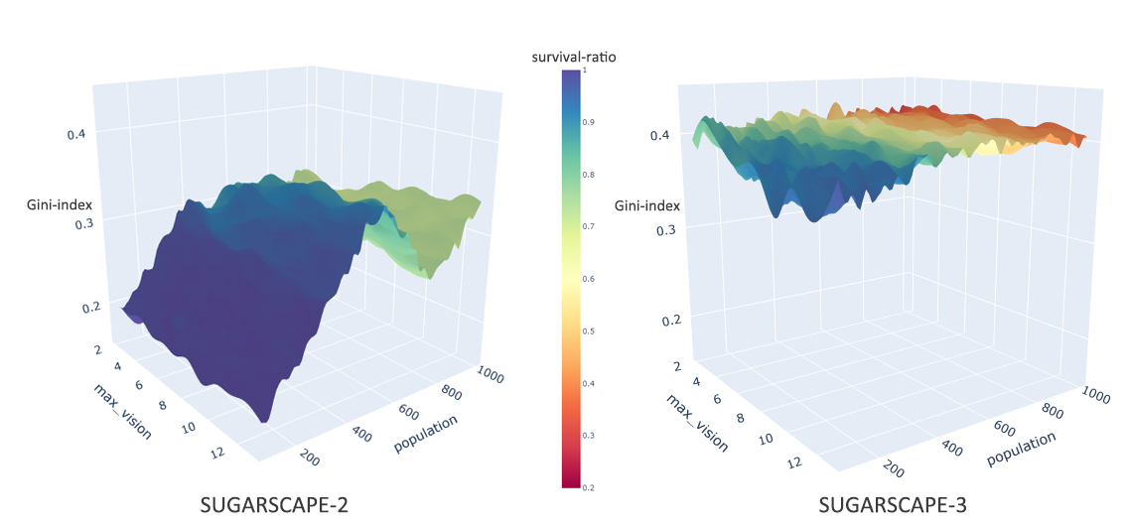

Figure 1 Parameter Space Surface of the Model when ticks=2000

Figure 1 illustrates how two dependent variables manifest distinct model characteristics at tick=2000 based on various combinations of independent variables. After interpolating the data into a three-dimensional surface, the X and Y axes represent different parameters (independent variables). The Z-axis height corresponds to levels of the ‘Gini-index’, while the colour gradient denotes the ‘survival ratio’, which is the proportion of individuals alive at the settlement moment compared to the initial population.

Generally, Sugarscape-2 exhibits a lower Gini-index and a higher survival ratio compared to Sugarscape-3 (Figure 1). This suggests that the introduction of the "aging-dying-rebirth" mechanism contributes to an increase in inequality and class differences among individuals.

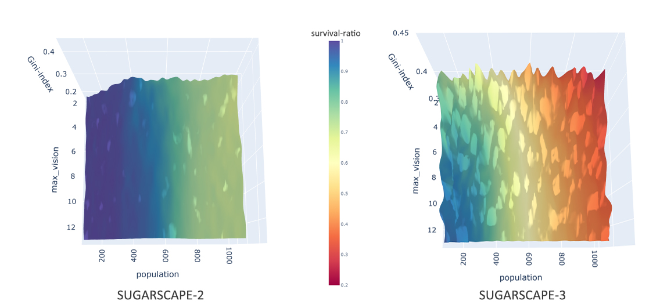

Figure 2 Correlation between survival-ratio and parameters

Additionally, initial-population has significant positive correlation to survival-ratio, which could be easily interpreted as the finite resources resulting in certain threshold for individual maximal amount. Yet, if we focus on survival-ratio’s correlation relating to max-vision (Figure 2), there is seemingly no correlation between max-vision and survival-ratio in Sugarscape-2. While in Sugarscape-3, higher max-vision would contribute to higher survival-ratio despite that population still makes the most difference towards survival-ratio.

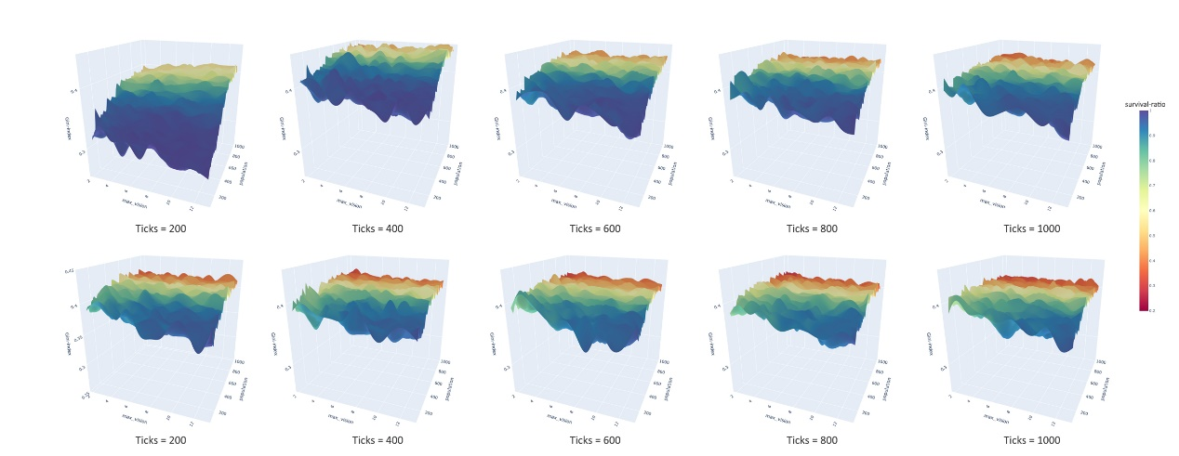

Figure 3 Parameter Space of Sugarscape-3 in Ticks Time Series

Specifically, Figure 3 illustrates different status for parameter space surface in different ticks of Sugarscape-3. If we focus on characteristic changes of Sugarscape-3 at different ticks, we could find:

* If setting a larger initial population, Gini-index tends to converge more quickly to a specific value at an earlier tick. We could identify this more clearly in Figure 5 where X axis represents the ticks time.
* If Sugarscape-3 model is allowed to run for a sufficiently long duration, the overall Gini index tends to converge to a specific value around 0.42. At this point, neither of the two parameters, max-vision or initial-population, could significantly influences the final Gini index. However, the survival ratio remains correlated.
* The highest Gini-index occurs when ticks = 400, suggesting that the “aging death” mechanism in Sugarscape-3 may lead to abrupt and significant changes in certain metrics at specific tick intervals. This phenomenon can be more clearly observed in Figure 5.

## 4 Discussion

Due to word-limits constraints, the following discussion will mainly focus on results which don’t align with our common sense and try to explore the potential explanations behind them.

### 4.1 Gini-index Turning Point of Sugarscape-2

Commonly, we would instinctually assume that a larger initial population would result in more intense competition, leading to a wider wealth gap, a higher Gini index, and a lower survival rate.

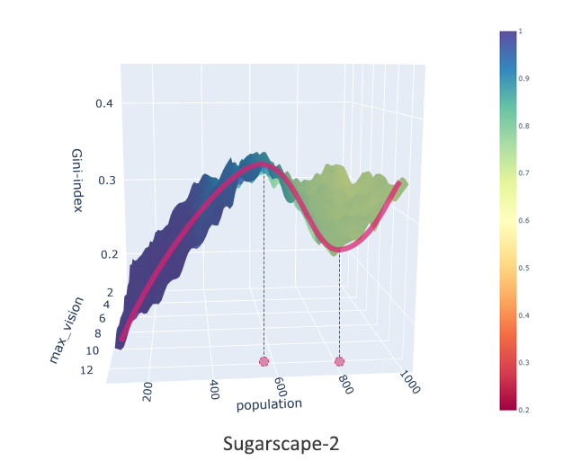

Figure 4 Peculiar Turning Point of Gini-index in Sugarscape-2

However, in Sugarscape-2(Figure 4), there is a peculiar turning point in the Gini-index around initial-population of 800 after reaching the peak around 600. At the same time, the survival-ratio also appears to stabilize and does not decrease further.

To explain this interesting turning point, we could simplify the simulation as shown in Figure 5. Each turtle, with the initial sugar 5 and mean metabolism 2(since metabolism’s range is [1, 3]), is allocated 3 or 4 patches in one-dimension direction. And each patch’s sugar is initialized as 3 as we modified the sugar-map above. We could find that in scenario A, turtle starts to repeating same loop from 7th tick to 11th tick, during which its sugar is remaining the same as 11. Also, in scenario B, turtle’s looping would gradually increase its own sugar from 8 to 10, consequently eliminate the risks to death.

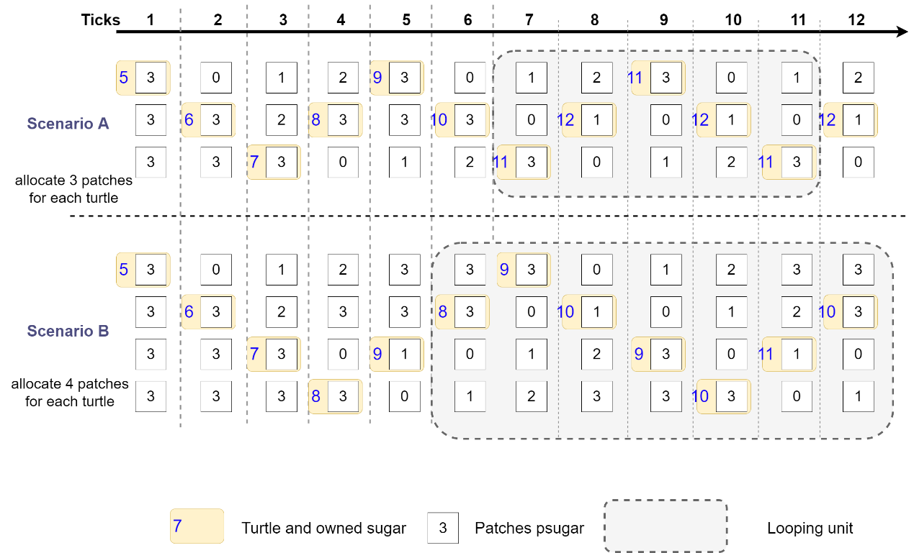

Figure 5 Simplified simulation for single turtle in Sugarscape-2

This could imply that, based on our parameter settings, the 3-patches system could maintain a delicate and fragile balance. Any additional disturbances can possibly prevent turtles from sustaining their sugar resources, leading to their death.

From another perspective, the 3-patches system is highly equitable since it is difficult for each turtle to accumulate wealth, with their wealth net-profit consistently hovering around zero. As we know default patches number of Sugarscape model is 2500, which means if we applied it to 3-patches system, the suitable population should just be 2500/3≈800, perfectly aligning with our experiment results! This could potentially explain why the Gini index reaches a minimal value around a population of 800.

### 4.2 Periodic Oscillations of Sugarscape-3

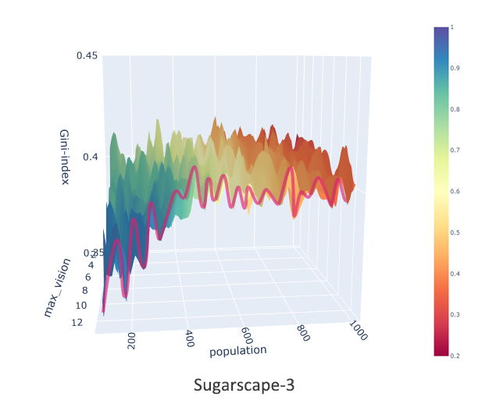

Figure 6 Periodic Oscillations of Gini index in Sugarscape-3 (Z-axis slightly different from Figure 1)

From Figure 6, we can observe that the Sugarscape-3 exhibits unique periodic fluctuation characteristics, which may be associated with the cyclical nature of individual deaths (with a die age randomly set between 60 and 100).

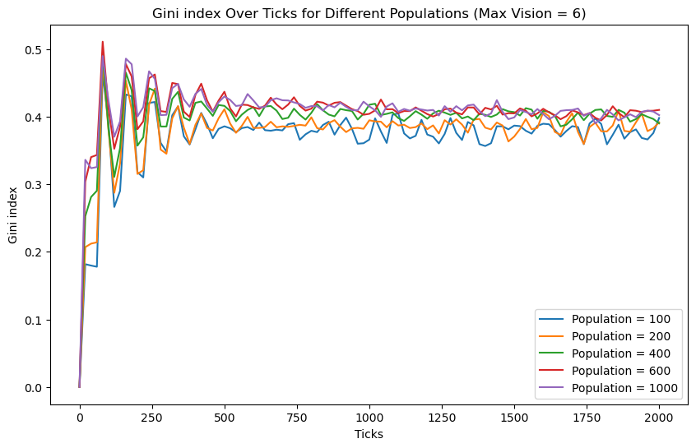

Figure 7 Gini index’s fluctuation along with ticks

We could have clearer signs from Figure 7 that Gini index is fluctuating as ticking every 80 times, especially in first 4 or 5 generations. This could be possibly attributed to that at the end of a specific cycle (with the average turtle lifespan being 80), the wealth of a portion of the population is abruptly reset to zero. Under these circumstances, the overall wealth distribution undergoes significant discrete changes. However, the reason why fluctuations over time series map onto the parameter spaces of initial population and maximum vision remains challenging to explain.

### 4.3 Comparison Model’s Difference

Overall, in Sugarscape-2, the Gini index shows a stronger correlation with our predetermined parameter spaces. As the population increases and maximum vision decreases, the wealth disparity among individuals within the model grows. Conversely, in Sugarscape-3, the introduction of an aging-death mechanism means that after a certain period, all reborn individuals must start from scratch, effectively levelling the playing field. Therefore, in this scenario, population and maximum vision primarily affect survival rates without significantly impacting wealth disparity.

## 5 Conclusion

### 5.1 Model’s Extension

Since sugarscape-2 and sugarscape-3 are basic simulation models in social and economic sections, more parameters and mechanism need to be considered if expecting it projected onto real-world situations. Nevertheless, we could still find some specific scenarios aligning with model’s characteristics.

For the real estate development industry, the mechanisms of Sugarscape-2 are more similar because there is a finite demand for housing construction among the entire human population, and limited resources are competed for and divided by companies that can exist constantly.

### 5.2 Summary

Overall, by comparison, sugarscape-3 demonstrates greater homogeneity across the parameter space, also is less capable of feeding individuals based on same population.

To summarize, let’s return to the original research objective to focus on the competition intensity. Sugarscape-3, compared to Sugarscape-2, under the same parameters, exhibits a higher Gini-index and a lower survival-ratio. This means that it presents a more competitive and "unfair" environment.