Melrowe team: Project architecture

# General info about technological stack used in project development:

**Back-end:** .NET 4.6, Entity Framework.

**Front-end:** Angular.

**DataBase:** MS SQL.

# Entity-relationship model

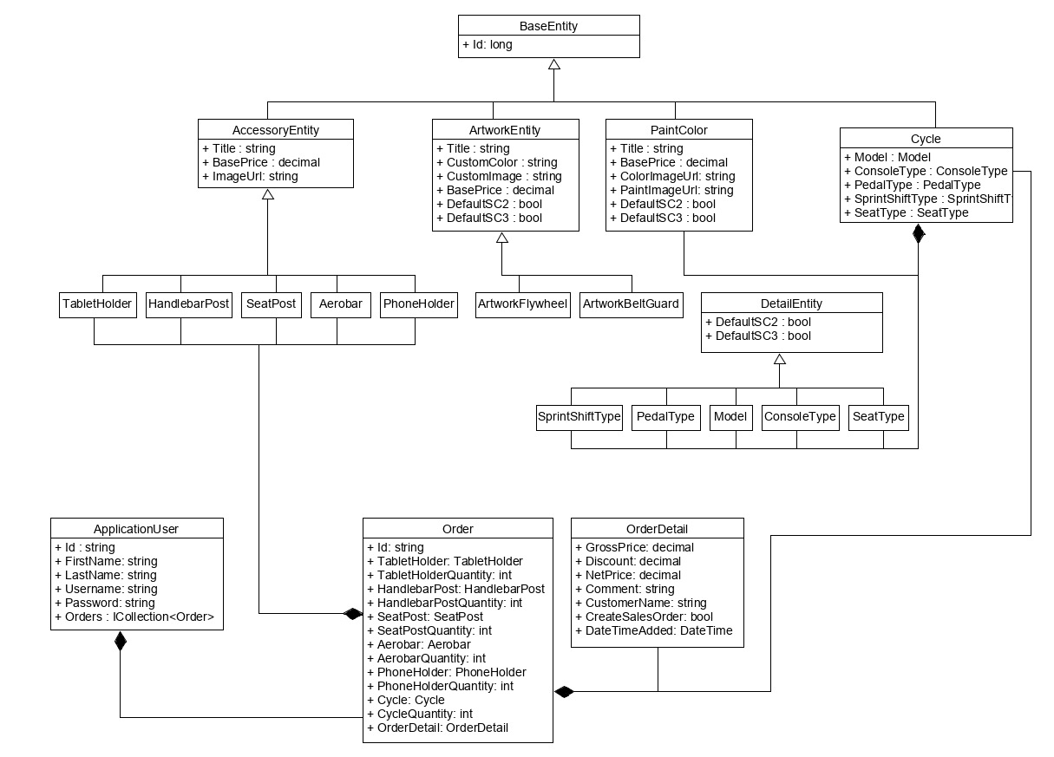In the diagram below we present our entity-relationship model.

**Components diagram**

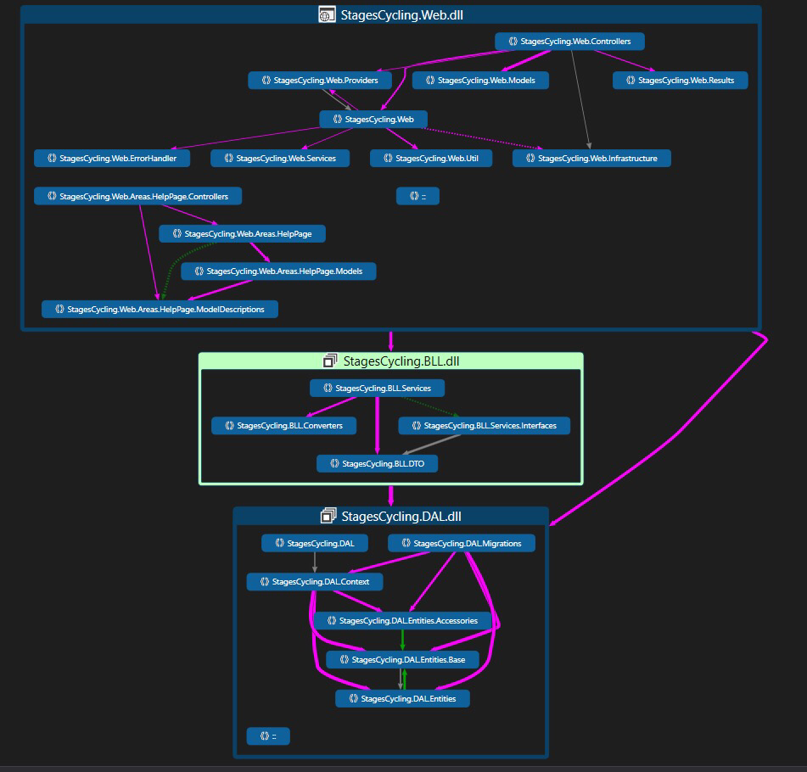The diagram below presents components that make up the whole product and used in development.

**Sequence diagram**

The diagram below presents Sequence diagram used in project development.

